Evaluating the performance of satellite-derived evapotranspiration products across varying bioclimates in South Africa

Liam S Cogill^{1,2,3*}, Michele Toucher⁴, Piotr Wolski⁵, Karen J. Esler², Alanna J. Rebelo^{1,2,3}

¹ Agricultural Research Council, Natural Resources and Engineering, Water Science Unit, Cedara Research Station, 3245, KwaZulu-Natal, South Africa
² Stellenbosch University, Conservation Ecology and Entomology Department, Private Bag X1, Matieland, 7602, South Africa
³ ASSET Research (Africa’s Search for Sound Economic Trajectories), Farm 159, Knysna Road, Knysna District, South Africa
⁴ SAEON Michele details here
⁵ UCTPiotr details here
* Corresponding author: lscogill4@gmail.com

11 December 2024

Abstract

Evapotranspiration constitutes a vital component of the hydrological cycle and should be considered when making land-use decisions, particularly in water-scarce regions. Being able to quantify evapotranspiration spatially for resource-constrained regions in the Global South which have limited monitoring data, would be highly beneficial for informing water resource management. Freely available satellite-derived evapotranspiration products offer an opportunity to achieve this. This study evaluated the performance of a series of freely available satellite-derived evapotranspiration products namely, TerraClimate, NASA’s PT-JPL, WaPOR, SMAP, GLDAS, FLDAS, SSEBop, and MOD16. At monthly time steps, evapotranspiration estimates from these products were validated using field-measured evapotranspiration from 14 flux tower stations across several different bioclimates in a country in the Global South: South Africa. The top five satellite-derived evapotranspiration products performed well (r_{s}: 0.75 - 0.83), some performing better in certain bioclimates, but with WaPOR and FLDAS emerging as superior in many cases. An ensemble was produced by taking the mean and variability of the top five best performing products, and this matched or outperformed the best-performing individual products in each case, achieving an average r_{s} of 0.85, a Kling-Gupta Efficiency of 0.67, and a Percent Bias of -15.47. The ensemble also performs satisfactorily across all validated bioclimates and can provide evapotranspiration estimates for the region at relatively fine spatial (100 m) and temporal (one month) scales. These results and this ensemble model of satellite-derived evapotranspiration can now be further explored to better understand relative water-use of different vegetation types, and improve water resource management in water-scarce, resource constrained nations.

Keywords: semi-arid, flux-tower, remote sensing, ensemble product, land-use, water resource management

Introduction

Evapotranspiration is defined as a combination of evaporation from the earth’s surface and transpiration by vegetation in the landscape (Wang & Dickinson, 2012; Zhang et al., 2018; Ayyad et al., 2019). In arid and semi-arid regions, it often represents the largest component of the hydrological cycle, accounting for 90% or more of the annual precipitation (Last et al., 2004; Huxman et al., 2005) and is therefore crucial to quantify for informing water resource management in water scarce regions (Zhang et al., 2016; Dzikiti et al., 2019). Field-based methods such as eddy covariance flux towers, surface renewal systems, scintillometry and lysimetry, can be used to measure evapotranspiration at very fine spatiotemporal resolutions but have relatively small spatial footprints (10⁻¹ to 10² m). Additionally, these systems require significant investment for the necessary instrumentation and skilled technicians for installation and maintenance (Ramoelo et al., 2014; Weerasinghe et al., 2020; Aldworth et al., 2022). The instrumentation is also vulnerable to severe weather, vandalism, and theft, which can result in data gaps. These methods are also often based on assumptions that may not hold in natural systems, or systems in the Global South, such as homogeneity of vegetation structure, gentle topography and moist soils (Glenn et al., 2007; Gokmen et al., 2012). In particular, arid and semi-arid regions may often have dry soils, which can lead to poor functioning of soil heat flux plates (Massman, 1992; Unland et al., 1996; Hübener et al., 2005).

The proliferation of satellite-derived evapotranspiration products offers an opportunity to overcome the spatial constraints of in-field methods (Glenn et al., 2007; Zhang et al., 2016; Wu et al., 2020; Bhattarai & Wagle, 2021). Many satellite-derived evapotranspiration products such as TerraClimate (Abatzoglou et al., 2018), PT-JPL (Cawse-Nicholson & Anderson, 2021), WaPOR (FAO, 2020), SMAP (Glassy et al., 2022), GLDAS (Rodell et al., 2004), FLDAS (McNally et al., 2017), SSEBop (Senay, 2018), and MOD16 (Running et al., 2019) are easily accessible and freely available (Bariş & Tombul, 2024). This is significant for parts of the Global South where resources are constrained (Ghiat et al., 2021; Aldworth et al., 2022). However, before using these products, it is essential to validate them across diverse bioclimatic regions to ensure accuracy and applicability (Long et al., 2014; Gwate et al., 2018; Blatchford et al., 2020; Melo et al., 2021). Each product relies on specific and different algorithmic and climatological inputs to produce estimates (Bhattarai & Wagle, 2021). WaPOR and MOD16 use the Penman-Monteith model to estimate evapotranspiration integrating the energy balance (net radiation, soil heat flux, and sensible heat flux), and water balance (vapor pressure deficit and aerodynamic resistance) along with biophysical parameters like albedo, land surface temperature, and humidity (Zotarelli et al., 2010).
In contrast, PT-JPL uses the Priestley-Taylor model which simplifies the Penman-Monteith approach by focusing on the energy balance, assuming humid conditions and relying primarily on temperature and solar radiation. It also incorporates variables such as NDVI and LAI (Cawse-Nicholson & Anderson, 2021) .Others, like SMAP, FLDAS, and GLDAS, adopt land surface models which incorporate biophysical and atmospheric dynamics and empirical equations (McNally et al., 2017). Lastly, TerraClimate uses the Thornwaite-Mather climatic water balance model which incorporates soil moisture storage, precipitation and runoff (derived from the Climate Research Unit precipitation product), into an estimation of water deficit and surplus (Wang-Erlandsson et al., 2016).

Another important consideration for satellite-derived evapotranspiration products is temporal and spatial resolution and footprint, which may range from fine spatial scales of 70-100 m (e.g. PT-JPL and WaPOR) to coarser scales of 11-30 km (e.g. SMAP and GLDAS). Also, some products such as MOD16 and SMAP are more easily accessible than others, for example via the Google Earth Engine platform (Gorelick et al., 2017), while others such as SSEBop must be manually extracted from a database (Huntington et al., 2017). Some of these aspects will impact the performance of these satellite-derived evapotranspiration products, however others will affect their utility (Bhattarai et al., 2016). Since each product has different strengths and weaknesses and may perform better in certain cases, or bioclimates (Weerasinghe et al., 2020), it may be more effective to create an ensemble model using multiple products rather than selecting a single “best” one (Melton et al., 2022). This approach could balance out individual product limitations or help account for blind spots (areas with no validation data), whereas using a single product may introduce uncertainties that are difficult to quantify. A similar concept has been applied to the Western USA, where an ensemble model for evapotranspiration, called OpenET, has been produced and validated for croplands (Volk et al., 2024). The OpenET ensemble has shown to perform well across various croplands in different bioclimates at a monthly time step with a mean coefficient of determination of 0.90 and mean bias error of -5.33 mm/month (Volk et al., 2024).

One common challenge for the Global South, is that most satellite-derived evapotranspiration products have been developed elsewhere, in biomes that may differ considerably using assumptions that may not hold (Wu et al., 2020). For example, some studies have found that the performance of satellite-derived evapotranspiration products, such as MOD16 can be less accurate (Velpuri et al., 2013; Ramoelo et al., 2014; Hu et al., 2015; Qian et al., 2023), particularly underestimating (Jovanovic et al., 2015) evapotranspiration in very hot or semi-arid regions . Given the development of these models elsewhere, and the paucity of research validating these products, it is unknown how well these different satellite-derived evapotranspiration products will perform in the Global South (Tadesse et al., 2015; Ayyad et al., 2019; Du et al., 2019; Weerasinghe et al., 2020). This study aimed to evaluate the performance of satellite-derived evapotranspiration products across South Africa, a water scarce, resource-constrained nation in the Global South. Two research questions are investigated: (1) which satellite-derived evapotranspiration products should be considered for an ensemble that can satisfactorily estimate evapotranspiration across various bioclimates in South Africa? and (2) how well does an ensemble perform when compared to individual satellite-derived evapotranspiration products? By addressing the gap in understanding how these products perform in a poorly explored region, this research contributes novel insights into the suitability and potential of an ensemble for the region.

Methods

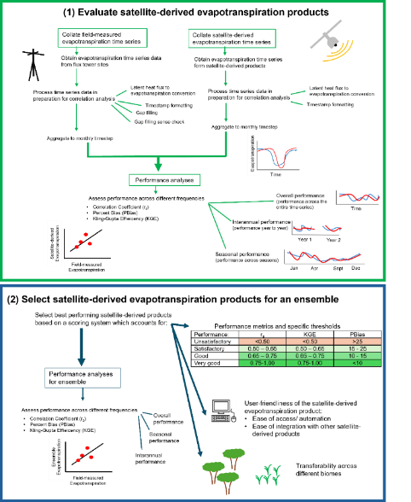
The methodology for this study comprises two parts, outlined in the conceptual framework (Figure 1). In the first part, satellite-derived evapotranspiration products were validated against field-measured observations at a monthly time-step. Here, field-measured evapotranspiration time series datasets from local flux towers across South Africa as well as satellite-derived evapotranspiration product time series datasets for the same flux tower locations are collated and processed. Metrics used for the validation included correlation analysis (Spearman Correlation Coefficient), Percent Bias and Kling-Gupta Efficiency applied overall, for log transformed data, and for annual and seasonal performance. In the second part, the best performing satellite-derived evapotranspiration products were identified and integrated into a mean ensemble model for South Africa. The selection process included assessing each individual satellite-derived evapotranspiration products performance across the flux tower sites, as well as across different bioclimates, and included considerations such as accessibility and spatial scale. This ensemble model was then also validated.
Figure 1. The conceptual framework of the study methodology includes two parts: (1) evaluating the performance of satellite-derived evapotranspiration products, and (2) selecting the best performing products for an ensemble and evaluating the performance thereof.

Satellite-derived evapotranspiration product validation

The validation of individual satellite-derived evapotranspiration products had three phases including (1) the collation of field-measured evapotranspiration at a monthly time-step from local flux tower stations across South Africa (section 2.1.1), (2) the collation of evapotranspiration estimates from satellite-derived evapotranspiration products at a monthly time step for each of the local flux tower stations (section 2.1.2), and (3) validation of the satellite-derived evapotranspiration products using the field-measured time series datasets (section 2.1.3).

Field-measured evapotranspiration

Data collection
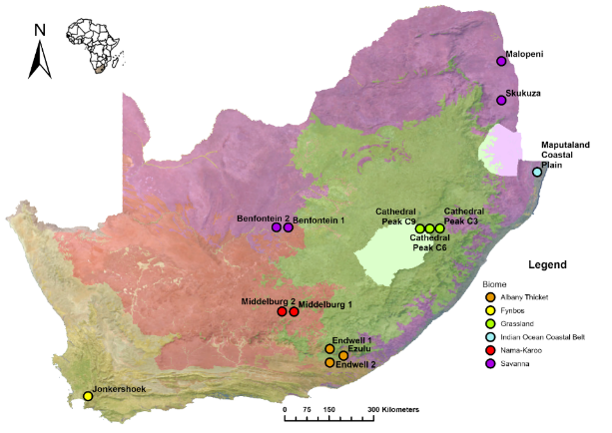
Field-measured evapotranspiration time series datasets were collected from 14 different flux tower sites from various data-providers across South Africa (Table S 1). The flux tower sites are found over six different biomes (Figure 2) and across a climate gradient, i.e. winter rainfall in the west, and summer rainfall in the east (Evaluating the performance of satellite-derived evapotranspiration products across varying bioclimates in South Africa). Each biome also aligns with a specific bioclimatic zone (Table S 2). Field-measured evapotranspiration time series datasets were typically provided in .csv format and were captured as latent heat flux (kg/m²/s) or evapotranspiration (mm) measurements either at a 30-minute or daily time-step.
Figure 2. The flux tower sites (n = 14) and their respective biome types across South Africa.

Data processing
The collected field time series datasets came with different time-stamp formats and therefore had to be reformatted to a standardised date configuration using the lubridate package and the strptime function in R (Grolemund & Wickham, 2011). Data were formatted to an ordered format of hour, minute, day, month, and year (hour:minute dd-mm-yyyy) (Grolemund & Wickham, 2011). Secondly, latent heat flux measurements had to be converted to evapotranspiration in mm using the latent heat of vaporisation factor of 2.45 MJ m² day⁻¹ (Allen et al., 1998). Thirdly, certain datasets had large gaps due to instrumentation system failure, damaging storms, or fire. Therefore, an attempt was made to gap fill these datasets with the ReddyProc package in R (Wutzler et al., 2024). This package inputs pre-processed 30-minute data and first performs a quality check and filtering which is based on the relationship between measured fluxes and friction velocity, derived from measuring high frequency wind components. This filtering is done, because without sufficient friction velocity, the eddy covariance system may fail to detect the true fluxes (Papale et al., 2006).

Missing data points can be estimated using three different methods including the Look-Up Table, Mean Diurnal Course, and Marginal Distribution Sampling approaches. The Look-Up Table method bins flux data based on similar meteorological conditions within a defined time window (±7 days) and estimates missing values as the average of the binned records. The Mean Diurnal Course method leverages the autocorrelation of fluxes by averaging values at the same time of day within a time window of adjacent days. The Marginal Distribution Sampling method utilizes covariation with meteorological variables (e.g. Tair, VPD, and Rg) and temporal autocorrelation to fill gaps (Wutzler et al., 2018). ReddyProc cannot fill large gaps (e.g. several weeks or entire seasons) and therefore some sites still had gaps after the gap filling procedure. For months in the time series where the gap-filling procedure left more than a full day’s worth of 30-minute gaps, the respective month was excluded from the final time series dataset. Lastly, the time series datasets were aggregated to a monthly time-step by summing the evapotranspiration from gap-free 30-minute or daily processed formats to total evapotranspiration per month (mm/month). The “group_by” and “sum” functions from dplyr and base R packages were used to achieve this (Wickham et al., 2023). The details of the datasets including the measurement interval, start and end date and location can be found in Table S 1.

Satellite-derived evapotranspiration

Data collection
Thirty potential satellite-derived evapotranspiration products were identified via a review process using a snowball approach (Table S 3). From this list, eight satellite-derived evapotranspiration products were short-listed based on four criteria: (i) spatial coverage over South Africa; (ii) temporal resolution of a minimum of a monthly timestep; (iii) temporal coverage from approximately 2015 – 2024 to match the time series dates of the various flux tower stations; and (iv) medium to high spatial resolution (<25km) (Table 1. 1). The datawere downloaded from various platforms as .csv files for each of the 14 flux tower site locations. Most products, such as MOD16, SMAP, TerraClimate, GLDAS, and FLDAS were obtained via the Google Earth Engine platform, whilst WaPOR estimates were obtained from the FAO-WaPOR v2 and v3 application platform and SSEBop estimates were obtained from the Climate Engine platform (Table S 4). Other details of the selected satellite-derived evapotranspiration products such as the evapotranspiration principle and algorithmic inputs are given in Table 1. 1.

Table 1. Satellite-derived evapotranspiration product specifications including the sensor, temporal resolution and coverage and spatial resolution and coverage.
Product | Sensor | Temporal resolution | Temporal coverage | Spatial resolution | Spatial coverage | ET principle | Algorithmic inputs
Terra-Climate | Various: MODIS, TRMM, NOAA, ERS 1 and 2, etc. | Monthly | 1958 - 2023 | 4.64 km | Global | Thornwaite-Mather climatic water balance model | Derived from reanalysis product inputs JRA55 WorldClim, and CRU Ts4 which include reference ET, precipitation, temperature and interpolated plant extractable soil water capacity.
SMAP | Soil Moisture Active Passive (SMAP) | 3 hourly | 2015 - present | 11 km | Global | 2x GEOS models: (i) Catchment Land Surface and Microwave Radiative Transfer Model; (ii) Ensemble-Based Land Data Assimilation Algorithm | Brightness temperatures from the SMAP L1C GEOS, hourly surface meteorology data, NOAA - CPCU gauge based precipitation data, and IMERG precipitation data
WaPOR | Various:GEOS5, MERRA, CHIRPS, Landsat, VIIRS, ERA5 (Ag), etc. | Monthly | 2009 – 2017 (v2); 2018 - present (v3) | 250 m (v2); 100 m (v3) | Continental: Africa | Penman-Monteith model | Albedo , Soil moisture stress, LST, Light Use Efficiency, NDVI, Precipitation, Solar Radiation, Land cover and other weather data
GLDAS | Various: GRACE, MODIS, TRMM, CHIRPS, etc. | 3 hourly | 2000 - present | 27.83 km | Global | Various: Land surface models (LSMs) including Noah LSM, Catchment LSM and Variable Infiltration Capacity | NOAH land surface model, GRACE, and Elevation from GTOPO30
MOD16 | MODIS | 8 day | 2000 - present | 500 m | Global | Penman-Monteith model | Daily meteorological reanalysis data along with vegetation property dynamics, albedo and land cover
PT-JPL | ECOSTRESS-ISS | ISS dependant | July 2018 – Oct 2022 | 70 m | Global | Priestley-Taylor model | LAI, NDVI , Rn (net Radiation), Relative Humidity, T(mean temp), T(max temp)
FLDAS | Various: MERRA-2, MODIS, GDAS, SMAP, TRMM, and CHIRPS, etc. | Monthly | 1982 - 2023 | 9.6 km | Global | Noah Land Surface Model | NOAH land surface model including inputs of precipitation, windspeed, solar radiation, wind speed, relative humidity, land use type, and soil moisture
SSEBop | MODIS | Monthly | 2003 - May 2022 | 1 km | Global | Operational SSEB (Simplified Surface Energy Balance) model | Combines ET fractions generated from MODIS thermal imagery with reference ET using a thermal index approach. Derived from integration of MODIS11A2 LST , maximum air temperature from WorldClim (PRISM) and reference ET from GDAS. Also, elevation from SRTM, Albedo and NDVI from MODIS

Data processing
Similarly to the field-measured time series datasets, the data were in different formats and required pre-processing before further analyses. Certain products such as WaPOR, SSEBop and TerraClimate provided evapotranspiration data in mm, while other products such as SMAP, FLDAS, GLDAS, provided evapotranspiration as latent heat (kg/m²/s). The latter had to be converted to mm, also using the latent heat of vaporisation factor of 2.45 MJ m² day⁻¹ (Allen et al., 1998). Additionally, the SMAP, GLDAS, FLDAS, TerraClimate, WaPOR, and MOD16 products evapotranspiration estimates had to be multiplied by a scaling factor of 0.1. The time series datasets for SSEBop, FLDAS, WaPOR, and TerraClimate were already at a monthly time step, while SMAP, MOD16, GLDAS, and PT-JPL datasets were aggregated to a monthly time-step also using the “group_by” and “sum” functions from the dplyr package in R (Wickham et al., 2023).

Validation of satellite-derived evapotranspiration

Metrics
A Shapiro-Wilks test was conducted in R-studio (Gross & Ligges, 2015) to test whether the monthly time series datasets followed a normal distribution. The data did not meet the assumption for normality and therefore, a Spearman correlation was performed in R (Max et al., 2022). Other performance metrics were also calculated using the hydroGOF package in R (Zambrano-Bigiarini, Mauricio, 2024). Firstly, the percentage bias (PBias) was calculated which measures the average tendency of the satellite-derived evapotranspiration product to either overestimate or underestimate the field-measured evapotranspiration. Secondly the Kling-Gupta Efficiency (KGE) was calculated, which provides an holistic measure of performance accounting for a combination of correlation, bias, and variability (Moriasi et al., 2015; Kouchi et al., 2017; Odusanya et al., 2021). It must, however, be noted that the use of KGE should be in conjunction with other performance metrics and that one needs to consider the components of KGE (such as the variability ratio) for a comprehensive evaluation of performance (Knoben et al., 2019; Althoff & Rodrigues, 2021). Performance thresholds were defined for each metric (Table 2). Performance was calculated per site, per biome, and overall. While these metrics and thresholds are commonly used and accepted, it could still produce blind spots in terms of masking systematic sensitivity to certain seasons or bioclimates (Kouchi et al., 2017).

Table 2. Performance thresholds showing for unsatisfactory, satisfactory, good or very good performance levels of the satellite-derived evapotranspiration products for the Correlation Coefficient (r_{s}), Kling-Gupta Efficiency (KGE) and Percent Bias (PBias). Colours range from green (very good) to orange (poor).
Performance | r_{s} | KGE | PBias
Unsatisfactory | <0.50 | <0.50 | >25
Satisfactory | 0.50 – 0.65 | 0.50 – 0.65 | 15 - 25
Good | 0.65 – 0.75 | 0.65 – 0.75 | 10 - 15
Very good | 0.75-1.00 | 0.75-1.00 | <10

Levels
The performance of satellite-derived evapotranspiration products was assessed at different levels which included (i) overall (biased towards high evapotranspiration), (ii) overall - log transformed (transformed to better understand trends for low evapotranspiration), (iii) interannual and (iv) seasonal variation (Table 3). Evaluating the satellite-derived evapotranspiration products at varying temporal frequencies allowed for an assessment of the satellite-derived evapotranspiration products effectiveness in capturing temporal trends in evapotranspiration across the respective sites.

Table 3. Details on the number of samples per site can be found in Table S 5, Table S 6Error: Reference source not found Table S 7.
Frequency | Sample size (n) | Transformation | Important considerations
Overall | n = 0 - 96 | - | biased towards high evapotranspiration (i.e. a bias towards the summer).
Log-transformed overall | n = 0 - 96 | log transformed (log10_{(x+1)}) | Considering evapotranspiration in winter
Interannual | n = 0 - 9 | Means calculated per year, regardless of month | Low sample size due to short datasets
Seasonal | n = 0 - 12 | Means calculated per month regardless of year | Low for some sites, had to be excluded

To evaluate how well the satellite-derived evapotranspiration products performed in estimating interannual variability, mean monthly evapotranspiration (mm/month) for each site was calculated for each year for the available time series. A mean was selected instead of an annual total, to increase the sample size by including sites that were missing some monthly data in a specific year, provided that the missing data did not exclude an entire season (e.g. wet or dry season). Sites with more years missing than a consecutive three-month period (such as Maputaland Coastal Plain and Malopeni) were regarded as incomplete and excluded from the analysis. Benfontein - Site 2, did not have enough data for a single year and this was also excluded from this analysis. For intra-annual evapotranspiration, the time series datasets were summarised to a mean monthly evapotranspiration for each month across the available time series. This meant that a mean monthly evapotranspiration was calculated for January across all years in the available time series. The same process was conducted for February, March, and subsequent months through December. The result was 12 observations per site.

Performance across bioclimate
Validation was done overall for each bioclimate to explore transferability of the approach. Performance statistics were aggregated to each bioclimate. Each of the biomes align with different Köppen-Geiger bioclimatic zones across the country, which means that when considering biome, climate is also accounted for (Table S 2).

Ensemble model development

Selection of best performing satellite-derived evapotranspiration products

To select products for the ensemble model of evapotranspiration, a systematic evaluation was conducted. This process was guided by the performance metrics which were aggregated into performance scores. The performance of each satellite-derived evapotranspiration product was assessed using the overall mean across 14 sites for three metrics at four levels, resulting in a total of 12 scores. Additionally, for each of the six bioclimates, the mean overall of the three metrics was evaluated, contributing another 18 scores. Thus, the total number of scores, combining overall and bioclimate evaluations, amounted to 30. In addition to performance, factors such as accessibility and spatial resolution were reassessed for each product. Accessibility was assessed based on the ease of obtaining data via platforms such as Google Earth Engine (GEE). The top five final selected products were combined into an ensemble model, taking the unweighted mean of all these products at a monthly timestep, and resampling all products to the highest available spatial resolution (i.e. 100 m).

Ensemble validation

The ensemble model was validated in the same way as the individual satellite-derived evapotranspiration products were. The Shapiro-Wilks test confirmed that the mean ensemble data was also non-normal. The ensemble model was also analysed across biomes. To quantify the potential improvement attributable to the ensemble, performance was compared to the performance metrics of the best performing individual satellite-derived evapotranspiration products in each case. By evaluating the ensemble, the analysis aimed to provide insights into whether the integration of multiple satellite-derived evapotranspiration products could lead to more accurate and reliable estimates, particularly in regions or seasons where individual products exhibit systematic biases or limitations.

Results

Performance of satellite-derived evapotranspiration products

Overall

The satellite-derived evapotranspiration products performed reasonably well overall, however tended to underestimate field-measured evapotranspiration (Figure 3). The highest levels of overall mean underestimation across all sites were by products such as PT-JPL (PBias = -57.15), MOD16 (PBias = -34.59), and GLDAS (PBias = -29.81) (Table 44). Additionally, this trend also holds for interannual and seasonal levels (Table 44). There are, however, instances of overestimation, for example, TerraClimate and WaPOR both overestimate field-measured evapotranspiration at the Ezulu, Middelburg and Skukuza sites (Figure 3Error: Reference source not found). Overall, the five satellite-derived evapotranspiration products that correlated best with field-measured evapotranspiration were FLDAS, SMAP, WaPOR, GLDAS, and TerraClimate with mean r_{s} ranging between 0.75 and 0.83 (Table 44). However, these products can deviate markedly from field-measured evapotranspiration at some sites and hence perform inconsistently across all sites. An example of this is WaPOR which performs well overall but is very different from field-measured evapotranspiration at the Endwell (Site 2) and Ezulu sites. TerraClimate also performs well overall except for at the Cathedral Peak Catchment 3 and 6 sites (Table S 9). FLDAS and GLDAS both achieved a mean r_{s} of 0.83, but not for the Jonkershoek site (mean r_{s} of 0.45) (Table S 9)Table 4.
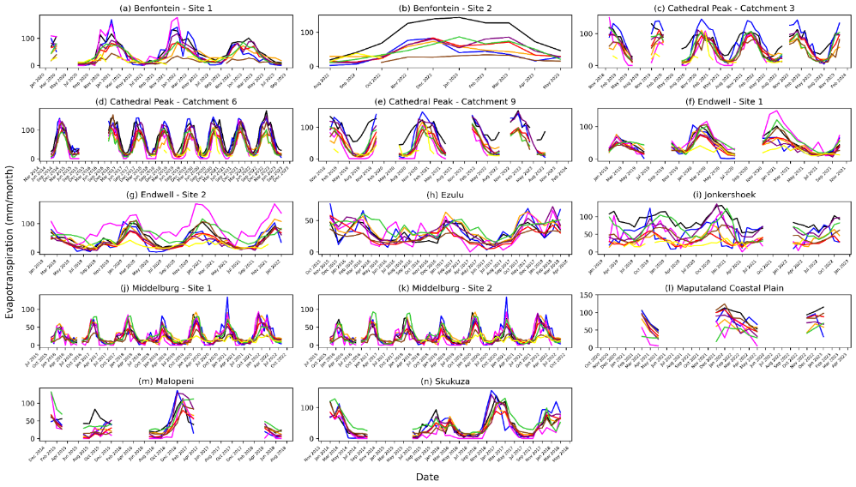
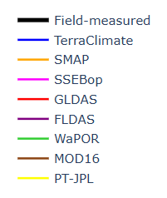
Figure 3. Monthly evapotranspiration (mm/month) time series plots for each flux tower station site showing field-measured vs satellite-derived evapotranspiration product datasets, for 14 flux tower stations in South Africa.
Table 4. Satellite-derived evapotranspiration product performance across all 14 flux tower station sites in South Africa for the mean, minimum and maximum r_{s}, KGE, and PBias at different levels which include: (i) Overall: performance over the entire dataset. (ii) Overall - Log transformed: performance of the log-transformed (Log10 (x+1)) time series, i.e. considering both summer and winter. (iii) Interannual: variation among years, and (iv) Seasonal: variation among the four different seasons. Colour scales are applied only to the means, green being high, and orange low.
(i) Overall | r_{s} |  |  | KGE |  |  | PBias
Product | mean | min | max | mean | min | max | mean | min | max
FLDAS | 0.83 | 0.49 | 0.96 | 0.62 | 0.26 | 0.88 | -17.14 | -47.21 | 12.61
GLDAS | 0.83 | 0.44 | 0.95 | 0.57 | 0.05 | 0.78 | -29.81 | -64.14 | -8.00
MOD16 | 0.79 | 0.41 | 0.96 | 0.47 | -0.11 | 0.86 | -34.59 | -76.77 | -6.78
PT-JPL | 0.61 | 0.25 | 0.77 | 0.02 | -0.11 | 0.12 | -57.15 | -74.04 | -40.25
SMAP | 0.78 | 0.37 | 0.93 | 0.54 | 0.14 | 0.81 | -21.34 | -60.71 | 24.49
SSEBop | 0.76 | 0.56 | 0.90 | 0.45 | 0.09 | 0.76 | -19.58 | -64.59 | 76.03
TerraClimate | 0.75 | -0.10 | 0.91 | 0.50 | -0.21 | 0.80 | -15.21 | -61.17 | 9.11
WaPOR | 0.81 | 0.61 | 0.93 | 0.57 | 0.32 | 0.84 | -9.90 | -56.47 | 38.63
(ii) Overall -Log transformed | r_{s} |  |  | KGE |  |  | PBias
Product | mean | min | max | mean | min | max | mean | min | max
FLDAS | 0.81 | 0.49 | 0.96 | 0.46 | -0.79 | 0.89 | -6.79 | -15.77 | 4.22
GLDAS | 0.80 | 0.44 | 0.95 | 0.53 | -0.58 | 0.89 | -10.12 | -23.37 | 3.87
MOD16 | 0.77 | 0.41 | 0.96 | 0.49 | -0.56 | 0.93 | -10.91 | -30.46 | 8.77
PT-JPL | 0.61 | 0.25 | 0.77 | 0.34 | -0.10 | 0.59 | -19.60 | -33.13 | -6.49
SMAP | 0.57 | 0.15 | 0.84 | 0.56 | -0.16 | 0.87 | -5.64 | -22.23 | 9.77
SSEBop | 0.74 | 0.56 | 0.90 | -0.78 | -3.80 | 0.73 | -20.89 | -46.84 | 16.39
TerraClimate | 0.57 | 0.01 | 0.85 | 0.09 | -1.37 | 0.62 | -9.95 | -25.83 | 4.31
WaPOR | 0.81 | 0.61 | 0.94 | 0.46 | -0.42 | 0.88 | -3.43 | -23.16 | 16.86
(iii) Interannual | r_{s} |  |  | KGE |  |  | PBias
Product | mean | min | max | mean | min | max | mean | min | max
FLDAS | 0.60 | -0.50 | 1.00 | 0.18 | -0.98 | 0.80 | -14.65 | -29.52 | 3.82
GLDAS | 0.37 | -1.00 | 1.00 | 0.19 | -1.17 | 0.72 | -30.83 | -64.60 | -10.54
MOD16 | 0.61 | -1.00 | 1.00 | 0.14 | -1.23 | 0.79 | -36.40 | -69.01 | -8.54
PT-JPL | -0.27 | -1.00 | 0.50 | -0.62 | -1.41 | -0.17 | -58.65 | -75.85 | -28.59
SMAP | 0.47 | -0.50 | 1.00 | 0.04 | -1.78 | 0.82 | -16.80 | -60.10 | 24.18
SSEBop | 0.45 | -1.00 | 1.00 | -0.22 | -1.87 | 0.52 | -18.53 | -60.66 | 76.03
TerraClimate | 0.80 | 0.50 | 1.00 | 0.32 | -0.92 | 0.78 | -9.66 | -45.37 | 7.33
WaPOR | 0.40 | -1.00 | 1.00 | 0.26 | -1.08 | 0.93 | -8.26 | -45.77 | 29.11
(iv) Seasonal | r_{s} |  |  | KGE |  |  | PBias
Product | Mean | Min | Max | Mean | Min | Max | Mean | Min | Max
FLDAS | 0.88 | 0.70 | 0.98 | 0.62 | 0.16 | 0.93 | -16.53 | -47.21 | 9.00
GLDAS | 0.85 | 0.41 | 0.99 | 0.59 | 0.07 | 0.83 | -30.93 | -64.20 | -8.32
MOD16 | 0.80 | 0.38 | 0.99 | 0.49 | -0.11 | 0.88 | -33.11 | -69.53 | -8.42
PT-JPL | 0.67 | 0.14 | 0.87 | 0.06 | -0.12 | 0.21 | -48.81 | -73.68 | -5.66
SMAP | 0.86 | 0.42 | 0.99 | 0.55 | 0.14 | 0.88 | -19.24 | -60.55 | 24.62
SSEBop | 0.81 | 0.53 | 0.96 | 0.45 | 0.06 | 0.87 | -20.04 | -67.83 | 76.03
TerraClimate | 0.81 | -0.29 | 0.99 | 0.53 | -0.41 | 0.93 | -15.25 | -61.17 | 8.24
WaPOR | 0.89 | 0.58 | 0.98 | 0.58 | 0.24 | 0.88 | -10.94 | -56.94 | 33.10
No product successfully captured the interannual variation according to the KGE score, however, there are a few satellite-derived evapotranspiration products that achieve good to very good correlations (r_{s}) and low bias levels (PBias) (Table 44). However, it is important to note that many sites had fewer than three years of observations (hence <3 samples), which may have contributed to poorer results.The best performing products at the interannual level are TerraClimate (r_{s} = 0.80 and PBias = -9.66) and FLDAS (r_{s} = 0.60 and PBias = -14.65) (Table 44), consistently showing a mean error close to zero but showed for considerable underestimation at the Jonkershoek site (Figure 4). MOD16 displayed moderate interannual correlations but larger biases (PBias = -36.40). WaPOR also showed for good overall distribution across most sites, however, considerably underestimated interannual evapotranspiration at all Cathedral Peak sites (Figure 4).
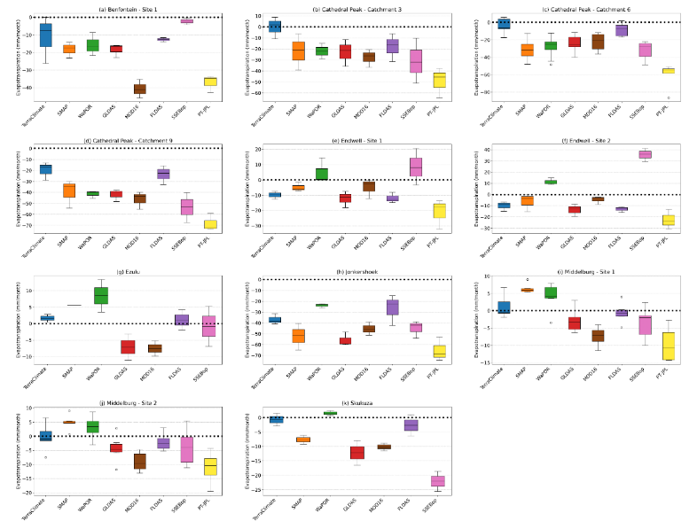
Figure 4. Box-and-whisker plots showing the error in the variation of interannual evapotranspiration (mm/month) of the satellite-derived evapotranspiration product estimates from the field measured evapotranspiration at each of the flux tower sites.

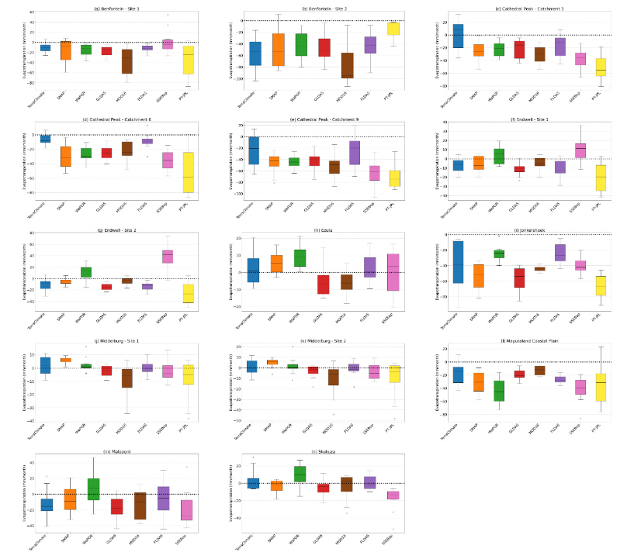
In capturing seasonal variation, WaPOR, SMAP, TerraClimate and FLDAS perform best, achieving satisfactory to very good r_{s}, KGE, and PBias scores across all sites (Table S 9). FLDAS (mean r_{s} = 0.88) and WaPOR (mean r_{s} = 0.89) were the most reliable satellite-derived evapotranspiration products for capturing seasonal variation. MOD16, SMAP, and TerraClimate also performed well, but PT-JPL consistently underperformed, with low mean KGE (KGE = 0.06) and large biases (PBias = -48.81).
Figure 5. Box-and-whisker plots showing the error in variation of seasonal evapotranspiration (mm/month) of satellite-derived evapotranspiration product estimates from the field-measured evapotranspiration across the 14 flux tower stations in South Africa.

Bioclimatic trends

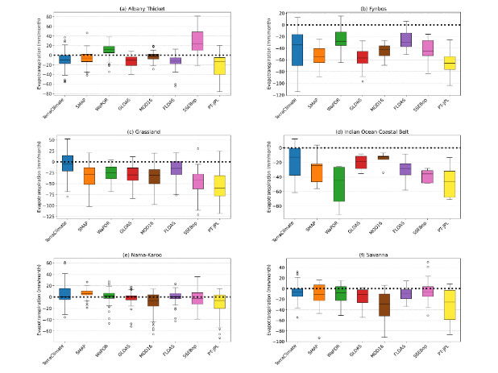
Overall, the best performing satellite-derived evapotranspiration products when analysed across measurement sites were clear, however, the trends were inconsistent when comparing across bioclimates (Table S 8). Additionally, the satellite-derived evapotranspiration products generally underestimated field-measured evapotranspiration across almost all biomes (Figure 6). FLDAS and GLDAS achieved satisfactory to very good performance (r_{s} and KGE) for each biome besides Fynbos. For the Albany Thicket Biome, SMAP, FLDAS, and MOD16 performed best, while PT-JPL and SSEBop achieved large underestimation (PBias = -48.94) and overestimation (PBias = 34.57) respectively (Table S 8). All satellite-derived evapotranspiration products underestimated field-measured evapotranspiration in the Fynbos biome, but WaPOR and MOD16 achieved very good correlation (r_{s} = 0.78 and 0.80 respectively). For the Grassland Biome, FLDAS performed consistently well and was the only product to achieve satisfactory r_{s} (0.84), KGE (0.60), and PBias (-19.09). WaPOR, MOD16, and GLDAS also performed well, achieving very good r_{s} and satisfactory KGE values, but notably underestimated field-measured evapotranspiration. The best performing product for the Indian Ocean Coastal Belt was MOD16 (r_{s} = 0.94). TerraClimate, FLDAS and GLDAS also performed well in this biome, but had larger extents of underestimation (Table S 8). For the Nama-Karoo, the two best performing products were FLDAS and WaPOR with very good r_{s} and KGE and slight overestimation (PBias of 0.35 and 7.64 respectively). The best performing product for the Savanna Biome was FLDAS. GLDAS, SSEBop and TerraClimate achieved very good correlation (r_{s} > 0.80), but greatly underestimated the field-measured evapotranspiration (Table S 8).
Figure 6. Box-whisker plots showing the error in variation of evapotranspiration (mm/month) of satellite-derived evapotranspiration product estimates from the field-measured evapotranspiration across the 6 different biomes.

Selection of satellite-derived evapotranspiration products for an ensemble model

There is no single satellite-derived evapotranspiration product that performs consistently well across all sites and biomes (Table S 8). SMAP, SEEBop, GLDAS, and MOD16 achieved above 50% out of 30 potential satisfactory scores, while TerraClimate, FLDAS and WaPOR were the best overall products, achieving above 70% out of 30 (Table 5). PT-JPL performed poorly, and SSEBop, though fair (just over 50%), is limited to Climate Engine access in South Africa; and both were therefore excluded from the ensemble. TerraClimate, SMAP, FLDAS, MOD16, and WaPOR which are accessible via Google Earth Engine with spatial resolutions of 100 m to 11 km were selected for the ensemble, which could be integrated in a single Google Colab Python notebook.

Table 5. Summarised performance scores across all 14 flux tower sites and six bioclimates in South Africa including the number of satisfactory scores for Spearman Correlation coefficient (r_{s}), Kling-Gupta Efficiency (KGE), and Percent Bias (PBias) for each satellite-derived evapotranspiration product overall and for each bioclimate. The scores at each level and bioclimate are aggregated to obtain a sum score out of 30. Each product’s data accessibility and spatial resolution are also shown.
Product | Terra-Climate | SMAP | WaPOR | MOD16 | PT-JPL | SSEB-  op | FLDAS | GLDAS
Overall | 3 | 3 | 3 | 1 | 1 | 2 | 3 | 2
Log trans-formed | 2 | 3 | 2 | 2 | 2 | 2 | 2 | 3
Interannual | 2 | 1 | 1 | 1 | 0 | 1 | 2 | 0
Seasonal | 3 | 3 | 3 | 1 | 1 | 2 | 3 | 2
Albany Thicket | 3 | 3 | 3 | 3 | 1 | 1 | 3 | 3
Fynbos | 0 | 0 | 2 | 1 | 1 | 1 | 0 | 0
Grassland | 2 | 1 | 2 | 2 | 2 | 1 | 3 | 2
Indian OC Belt | 3 | 1 | 1 | 3 | 3 | 1 | 2 | 3
Nama-Karoo | 3 | 3 | 3 | 1 | 1 | 3 | 3 | 3
Savanna | 2 | 1 | 2 | 1 | 1 | 2 | 3 | 2
Sum score (out of 30) | 23 | 19 | 22 | 16 | 13 | 16 | 24 | 20
Access-ibility | GEE | GEE | GEE(v2)/App-API(v3) | GEE | App-EARS | Climate Engine | GEE | GEE
Spatial resolution | 4.64 km | 11 km | 250m(v2)/100m(v3) | 500 m | 70 m | 1 km | 9.6 km | 27.83 km

Performance of the evapotranspiration ensemble model

Performance overall

The ensemble effectively approximated field-measured evapotranspiration, with most site values falling within the range of the ensemble (Figure 7). Notable exceptions included Benfontein (Site 2), Cathedral Peak (Catchment 9), and Jonkershoek, where substantial underestimations were observed (Table S 13). This was also evident at the interannual and seasonal levels (Figure S 40Error: Reference source not found). Despite these exceptions, the ensemble performed robustly, exhibiting high mean correlations (r_{s} = 0.71–0.85) across all sites and levels (Table 6). Additionally, it outperformed individual products in r_{s} and KGE at all levels except interannual, where limited data (<3 years) may have influenced results. While the ensemble underestimated evapotranspiration, the bias was minimal (PBias = −4.00 to -15.72).

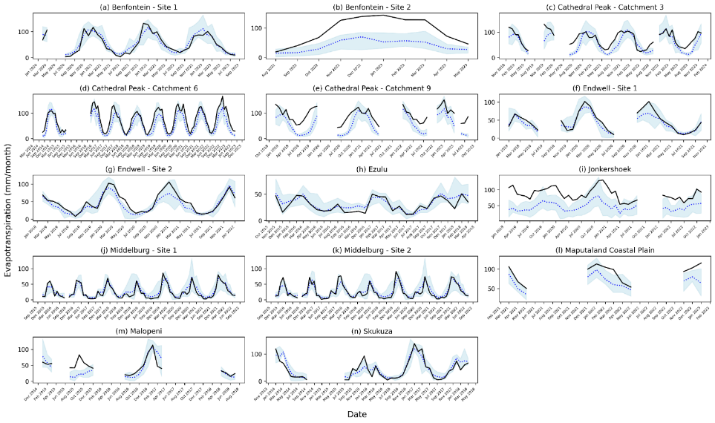
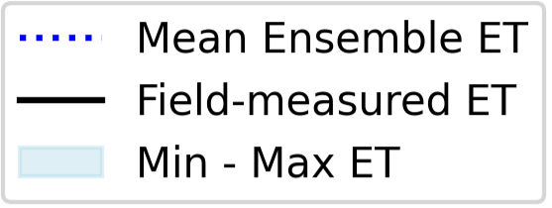
Figure 7. Monthly evapotranspiration (mm/month) time series plots for each flux tower station site in South Africa, showing field-measured vs ensemble estimates. The ensemble mean is shown along with the minimum and maximum evapotranspiration range.
Table 6. Performance scores for the ensemble mean, minimum and maximum Spearman Correlation coefficient (r_{s}), Kling-Gupta Efficiency (KGE), and Percent Bias (PBias) at different levels including (i) Overall, (ii) Overall – Log transformed (Log10 (x+1)) , (iii) Interannual, and (iv) Seasonal across the 14 flux tower stations. The best performing individual product for each metric for each frequency is also shown to compare to that of the ensemble.
(i) Overall | r_{s} |  |  | KGE |  |  | PBias
Product | mean | min | max | mean | min | max | mean | min | max
Ensemble | 0.85 | 0.65 | 0.96 | 0.67 | 0.19 | 0.87 | -15.47 | -55.40 | 11.50
Best individual product | FLDAS: 0.83 | 0.49 | 0.96 | FLDAS:  0.62 | 0.26 | 0.88 | WaPOR: -9.90 | -56.47 | 38.63
(ii) Log transformed | r_{s} |  |  | KGE |  |  | PBias
Product | mean | min | max | mean | min | max | mean | min | max
Ensemble | 0.85 | 0.65 | 0.96 | 0.64 | -0.44 | 0.92 | -4.00 | -17.14 | 8.31
Best individual product | FLDAS: 0.81 | 0.49 | 0.96 | SMAP: 0.56 | -0.16 | 0.87 | WaPOR: -3.43 | -23.16 | 16.86
(iii) Interannual | r_{s} |  |  | KGE |  |  | PBias
Product | mean | min | max | mean | min | max | mean | min | max
Ensemble | 0.71 | 0.50 | 1.00 | 0.35 | -0.53 | 0.95 | -12.27 | -47.08 | 11.59
Best individual product | TerraClimate:0.80 | 0.50 | 1.00 | TerraClimate:0.32 | -0.92 | 0.78 | WaPOR: -8.26 | -45.77 | 29.11
(iv) Seasonal | r_{s} |  |  | KGE |  |  | PBias
Product | mean | min | max | mean | min | max | mean | min | max
Ensemble | 0.89 | 0.72 | 0.97 | 0.68 | 0.19 | 0.93 | -15.72 | -55.40 | 11.85
Best individual product | WaPOR: 0.89 | 0.58 | 0.98 | FLDAS: 0.62 | 0.16 | 0.93 | WaPOR: -10.94 | -56.94 | 33.10

Performance over different bioclimates

The ensemble demonstrated strong performance across all bioclimates, achieving good to very good correlations with field-measured evapotranspiration (Table 7). It outperformed the top-performing individual satellite-derived products in the Albany Thicket (r_{s} = 0.91) and Nama-Karoo (r_{s} = 0.93) and closely matched the best product in the Savanna (GLDAS, r_{s} = 0.85). For the Grassland and Indian Ocean Coastal Belt biomes, the ensemble achieved slightly lower correlations than the best-performing individual products but still maintained high r_{s} values of 0.84 and 0.81, respectively. In the Fynbos Biome, the ensemble achieved an acceptable correlation (r_{s} = 0.65), despite substantial underestimation (PBias = -46.40) (Table 7). Underestimations were also observed in the Albany Thicket, Grassland, and Savanna but with smaller PBias values ranging from -7.75 to -27.53.

Table 7. Performance scores for the ensemble mean, minimum and maximum correlation coefficient (r_{s}), Kling-Gupta Efficiency (KGE), and Percent Bias (PBias) across different biomes in South Africa including (i) Albany Thicket, (ii) Fynbos, (iii) Grassland, (iv) Indian Ocean Coastal Belt, (v) Nama-Karoo, and (vi) Savanna. The best performing individual product for each metric for each frequency is also shown to compare to that of the ensemble.
(i) Albany Thicket
Product | r_{s} | KGE | PBias
Ensemble | 0.91 | 0.79 | -8.59
Best individual product | MOD16: 0.87 | SMAP: 0.75 | SMAP: -0.72
(ii) Fynbos
Product | r_{s} | KGE | PBias
Ensemble | 0.65 | 0.33 | -46.40
Best individual product | MOD16: 0.80 | WaPOR: 0.53 | WaPOR: -27.44
(iii) Grassland
Product | r_{s} | KGE | PBias
Ensemble | 0.84 | 0.69 | -27.53
Best individual product | WaPOR: 0.90 | GLDAS: 0.59 | TerraClimate: -9.48
(iv) Indian Ocean Coastal Belt
Product | r_{s} | KGE | PBias
Ensemble | 0.81 | 0.63 | -25.06
Best individual product | MOD16: 0.94 | MOD16: 0.82 | MOD16: -13.86
(v) Nama-Karoo
Product | r_{s} | KGE | PBias
Ensemble | 0.93 | 0.80 | 8.87
Best individual product | SMAP: 0.90 | FLDAS: 0.85 | FLDAS: 0.35
(vi) Savanna
Product | r_{s} | KGE | PBias
Ensemble | 0.84 | 0.74 | -7.75
Best individual product | GLDAS: 0.85 | FLDAS: 0.57 | WaPOR: -5.43

Discussion

Evapotranspiration, a critical component of the hydrological cycle, is largely driven by environmental controls, namely water supply, energy supply, and atmospheric demand (Zhang et al., 2016). These controls influence evapotranspiration across different regions. For example, water supply is the primary control in arid regions, where mean annual rainfall is low; while energy supply dominates in the more tropical and humid regions, where more water is available, but where energy (in the form of heat and solar radiation) can be limited due to frequent cloud cover and shade. Atmospheric demand controls evapotranspiration in mountainous and high-latitude areas, where sparser vegetation and exposed soils or rocky surfaces are dominant in the landscape and limit the water available for evapotranspiration (Zhang et al., 2016). Understanding these controls highlights the importance of accurate evapotranspiration estimation and modelling in different bioclimates. Satellite-derived evapotranspiration products present an opportunity to quantify relative evapotranspiration of different land-uses at low cost, for resource constrained countries in the Global South. Prior to use, validation is essential, as these products produce model-based estimates and not direct observations (Miralles et al., 2016; Weerasinghe et al., 2020; Zhu et al., 2022). This study validated eight satellite-derived evapotranspiration products (WaPOR, SMAP, SSEBop, GLDAS, FLDAS, MOD16, PT-JPL, and TerraClimate) against field-measured evapotranspiration from 14 flux tower stations across various bioclimates in South Africa. A mean ensemble derived from the five best performing products (FLDAS, SMAP, WaPOR, MOD16, and TerraClimate) was also validated against field-measured evapotranspiration. While the individual satellite-derived evapotranspiration products showed reasonable accuracy, their performance was inconsistent, such that no single product emerged as superior across all sites and biomes. This variability aligns with prior research, which shows that certain evapotranspiration models perform better in certain bioclimates (Hu et al., 2015; Lu et al., 2019; Tran et al., 2023).

The Penman-Monteith based products, WaPOR and MOD16, performed well at the Fynbos site, yet deviated substantially from field-measured values at other sites. For example, MOD16 showed poor performance at the Nama-Karoo sites and the Malopeni-Savanna site. This may be attributed to higher mean annual temperatures at these sites, where plant photosynthesis and transpiration can be limited, and increase soil heat flux and soil water stress, which are factors that these models may not fully capture (Dzikiti et al., 2019; Qian et al., 2023). Furthermore, WaPOR overestimated evapotranspiration at the Albany Thicket and at two of the Savanna sites, likely due to limited soil moisture which constrains evapotranspiration despite sufficient energy availability as noted by Blatchford et al., (2020) for arid regions. In contrast, humid regions like Grassland and the Indian Ocean Coastal Belt, WaPOR underestimated evapotranspiration possibly due to frequent cloud cover or rainfall reducing available energy which the model may not fully account for. However, Blatchford et al., (2020), reported that WaPOR can overestimate evapotranspiration in humid regions potentially due to an overestimation of vapor pressure deficit (VPD). When compared to the Penman-Monteith-based products, the Priestley-Taylor product PT-JPL performed less effectively. The Priestley-Taylor model assumes sufficient water availability for evapotranspiration, but in arid and semi-arid regions, vegetation and soils often experience water scarcity, leading to lower actual evapotranspiration than the model predicts (García et al., 2013). Previous studies also highlight that Priestley-Taylor-based products can struggle in arid regions due to biophysical constraints, such as sparse vegetation and low latent heat fluxes, which characterize many of the flux tower sites (Dzikiti et al., 2019). Furthermore, PT-JPL’s limited temporal coverage (data only available from July 2018 onward), and frequent data gaps may have further reduced the robustness of its evaluation.

The land surface model-based products, such as SMAP, GLDAS, and FLDAS, generally performed well but showed poor accuracy at the Fynbos site. This discrepancy likely stems from mismatches between the coarse spatial resolution of these products and the smaller flux tower footprint. At the Fynbos site, the product pixels included not only Fynbos vegetation but also urban areas, rocky terrain, and ravines, misrepresenting the local landscape (Figure S 7). These types of caveats have also been highlighted in other studies where coarser spatial resolution products are not able to match the footprint of the flux tower and capture the representative land-use of the flux tower (Majozi et al., 2017; Zhu et al., 2022; Palmer et al., 2023). Similar issues arose at the Cathedral Peak Catchment sites, where SMAP underestimated evapotranspiration due to pixel aggregation of diverse vegetation types. These included Pteridium aquilinum in Catchment 3, pristine grassland in Catchment 6, and Leucosidea sericea (a woody encroacher) in Catchment 9, which were all captured in the same pixel (Figure S 4). The most severe underestimation occurred in Catchment 9, where evapotranspiration should be higher due to the woody vegetation. Similar patterns were observed for GLDAS and FLDAS (Figure S 4). Therefore, spatial resolution can significantly impact accuracy.

The ensemble provided robust evapotranspiration estimates achieving overall higher correlations with field-measured evapotranspiration and KGE. These findings align with global research advocating for ensemble approaches as seen in Volk et al., (2024), Bai et al., (2021) and Ershadi et al., (2014) where the superiority of integrated products in enhancing performance metrics has been demonstrated. While the ensemble showed improved performance, it still generally underestimated field-measured evapotranspiration, albeit no more than -16%. This highlights the potential benefit of a calibrated ensemble incorporating correction factors to reduce bias. The question remains as to whether a unique model should be produced for each bioclimate, or whether it is more advantageous to have one model that can be standardised across bioclimates. Future efforts should focus on refining the ensemble and exploring advanced techniques, such as machine learning models which integrate satellite-derived and field-measured data, to fully harness the strengths of individual products and models within ensembles (Bai et al., 2021; Hadadi et al., 2022). Incorporating weighted approaches based on biome-specific performance (Ershadi et al., 2014) and expanding validation datasets through additional in situ evapotranspiration measurements could further improve ensemble reliability (Gwate et al., 2018; Yin et al., 2020). However, a trade-off exists between specificity and transferability, where biome-specific approaches could enhance accuracy for specific regions but may reduce generalizability across diverse biomes. It is also important to note that field-measured flux tower data, often used as a reference, may contain systematic, human-induced, and random errors, such as sensor calibration biases, improper placement, or electronic noise (Allen et al., 2011; Blatchford et al., 2020). Addressing these uncertainties is crucial for robust validation of satellite-derived products. Future research should also focus on developing tailored methods and technologies for arid regions and dry soils. These advancements hold the potential to address current limitations and establish an ensemble as a critical tool for sustainable water resource management in resource-constrained regions of the Global South.

Conclusion

Freely available satellite-derived evapotranspiration products provide a valuable resource for assessing the consumptive use of land-uses across diverse bioclimates, particularly in resource-constrained regions like South Africa. This study evaluated the performance of eight satellite-derived evapotranspiration products against field-measured data from 14 flux tower stations in South Africa. While individual products, such as WaPOR, MOD16, and SMAP, FLDAS, and TerraClimate showed reasonable accuracy, their performance varied across biomes due to differences in climatological and algorithmic inputs and spatial resolution. These findings emphasize the need for caution when using individual and unvalidated evapotranspiration products, as no single product consistently delivered reliable results across all bioclimates. A mean ensemble was assembled using the five best-performing evapotranspiration products, FLDAS, SMAP, WaPOR, MOD16, and TerraClimate, which demonstrated high performance. However, the ensemble still exhibited biases, particularly underestimating field-measured evapotranspiration, highlighting the need for further refinement. This research is novel as it provides the first comprehensive evaluation of several satellite-derived evapotranspiration products across diverse biomes in South Africa and offers critical insights into the performance and limitations in a water-scarce and semi-arid region of the Global South. Future research efforts such as calibrating the ensemble, and exploring weighted approaches based on biome-specific performance, could potentially further optimize the use of the ensemble as a tool to inform water resource management.

Acknowledgements

The authors would like thank the data providers of the local flux tower evapotranspiration time series datasets, Abri de Buys (SAEON – Jonkershoek), Prof Tony Palmer (Rhodes University), Amukelani Maluleke (SAEON – Benfontein), Dr Gregor Feig (EFTEON), Dr Christiaan Brummer (Theunen Institute), Ms Oksana Rybchak (Theunen Institute), Sinesipho Festile (CSIR), Felix Skhosana (CSIR), Dr Sue van Rensburg (SAEON), and Dr Michele Toucher (SAEON). Special thanks are extended to Abri de Buys and Prof Tony Palmer for their assistance with gap filling of the evapotranspiration time series datasets. Alanna Rebelo also acknowledges South African Water Research Commission Funding (Project number: 2022/2023-00901), as well as the Fulbright Programme (October 2023) for the funding to start the development of this research concept and programme.
Co-authors, please add grants/acknowledgements.

Author contributions

Liam Cogill: Methodology, Software, Validation, Analysis, Investigation, Data Curation, Writing – Original Draft, Visualization
Alanna Rebelo: Conceptualization, Methodology, Software, Validation, Analysis, Resources, Writing - Review & Editing, Supervision, Project administration, Funding acquisition
Piotr Wolski: add your contributions here
Michele Toucher: add your contributions here
Karen Esler: add your contributions here

Authorship must be earned through a substantial contribution. See the CRediT authorship standards (represented in Table 1 below) which give some examples of what constitutes a substantial contribution. For co-authorship each individual must be able to check at least two boxes in the rubric (Table 1), including contribution to the writing process (writing the original draft AND/OR reviewing/editing the manuscript). This manuscript will be accompanied by a CRediT authorship statement indicating authorship contributions.

Table 8. Rubric of contributor roles, reproduced from CRediT. Source: https://credit.niso.org/
Contribution | Definition
Conceptualization | Ideas; formulation or evolution of overarching research goals and aims.
Methodology | Development or design of methodology; creation of models.
Software | Programming, software development; designing computer programs; implementation of the computer code and supporting algorithms; testing of existing code components.
Validation | Verification, whether as a part of the activity or separate, of the overall replication/ reproducibility of results/experiments and other research outputs.
Formal analysis | Application of statistical, mathematical, computational, or other formal techniques to analyze or synthesize study data.
Investigation | Conducting a research and investigation process, specifically performing the experiments, or data/evidence collection.
Resources | Provision of study materials, reagents, materials, patients, laboratory samples, animals, instrumentation, computing resources, or other analysis tools.
Data Curation | Management activities to annotate (produce metadata), scrub data and maintain research data (including software code, where it is necessary for interpreting the data itself) for initial use and later reuse.
Writing - Original Draft | Preparation, creation and/or presentation of the published work, specifically writing the initial draft (including substantive translation).
Writing - Review & Editing | Preparation, creation and/or presentation of the published work by those from the original research group, specifically critical review, commentary or revision – including pre-or post-publication stages.
Visualization | Preparation, creation and/or presentation of the published work, specifically visualization/ data presentation.
Supervision | Oversight and leadership responsibility for the research activity planning and execution, including mentorship external to the core team.
Project administration | Management and coordination responsibility for the research activity planning and execution.
Funding acquisition | Acquisition of the financial support for the project leading to this publication.

References

Abatzoglou, J. T., Dobrowski, S. Z., Parks, S. A., & Hegewisch, K. C. (2018). TerraClimate, a high-resolution global dataset of monthly climate and climatic water balance from 1958-2015. Scientific Data, 5, 1–12. https://doi.org/10.1038/sdata.2017.191
Aldworth, T. A., Toucher, M. L. W., Clulow, A. D., & Swemmer, A. M. (2022). The Effect of Woody Encroachment on Evapotranspiration in a Semi-Arid Savanna. Hydrology, 10(1), 9. https://doi.org/10.3390/hydrology10010009
Allen, R. G., Pereira, L. S., Raes, D., Smith, M. (1998). Chapter 1 - Introduction to evapotranspiration. Retrieved December 3, 2024, from https://www.fao.org/4/x0490e/x0490e04.htm#determining evapotranspiration
Allen, R. G., Pereira, L. S., Howell, T. A., & Jensen, M. E. (2011). Evapotranspiration information reporting: I. Factors governing measurement accuracy. Agricultural Water Management, 98(6), 899–920. https://doi.org/10.1016/j.agwat.2010.12.015
Althoff, D., & Rodrigues, L. N. (2021). Goodness-of-fit criteria for hydrological models: Model calibration and performance assessment. Journal of Hydrology, 600(May), 126674. https://doi.org/10.1016/j.jhydrol.2021.126674
Ayyad, S., Al Zayed, I. S., Ha, V. T. T., & Ribbe, L. (2019). The performance of satellite-based actual evapotranspiration products and the assessment of irrigation efficiency in Egypt. Water (Switzerland), 11(9). https://doi.org/10.3390/w11091913
Bai, Y., Zhang, S., Zhang, J., Wang, J., Yang, S., Magliulo, V., Vitale, L., & Zhao, Y. (2021). Using remote sensing information to enhance the understanding of the coupling of terrestrial ecosystem evapotranspiration and photosynthesis on a global scale. International Journal of Applied Earth Observation and Geoinformation, 100, 102329. https://doi.org/10.1016/j.jag.2021.102329
Bariş, M., & Tombul, M. (2024). A review on models, products and techniques for evapotranspiration measurement, estimation, and validation. Environmental Quality Management, 34(1). https://doi.org/10.1002/tqem.22250
Bhattarai, N., Shaw, S. B., Quackenbush, L. J., Im, J., & Niraula, R. (2016). Evaluating five remote sensing based single-source surface energy balance models for estimating daily evapotranspiration in a humid subtropical climate. International Journal of Applied Earth Observation and Geoinformation, 49, 75–86. https://doi.org/10.1016/j.jag.2016.01.010
Bhattarai, N., & Wagle, P. (2021). Recent advances in remote sensing of evapotranspiration. Remote Sensing, 13(21), 1–5. https://doi.org/10.3390/rs13214260
Blatchford, M. L., Mannaerts, C. M., Njuki, S. M., Nouri, H., Zeng, Y., Pelgrum, H., Wonink, S., & Karimi, P. (2020). Evaluation of WaPOR V2 evapotranspiration products across Africa. Hydrological Processes, 34(15), 3200–3221. https://doi.org/10.1002/hyp.13791
Carver, S., Mikkelsen, N., & Woodward, J. (2002). Long-term rates of mass wasting in Mesters Vig, northeast Greenland: Notes on a re-survey. Permafrost and Periglacial Processes, 13(3), 243–249. https://doi.org/10.1002/ppp.421
Cawse-Nicholson, K., & Anderson, M. (2021). ECOsystem Spaceborne Thermal Radiometer Experiment on Space Station (ECOSTRESS) ECOSTRESS Level-3 DisALEXI-JPL Evapotranspiration (ECO3ETALEXI) Algorithm Theoretical Basis Document. 3(D).
Cha, Y., Park, S. S., Kim, K., Byeon, M., & Stow, C. A. (2014). Water Resources Research. Vic, 5375–5377. https://doi.org/10.1002/2013WR014979.Reply
Du, T., Wang, L., Yuan, G., Sun, X., & Wang, S. (2019). Effects of distinguishing vegetation types on the estimates of remotely sensed evapotranspiration in arid regions. Remote Sensing, 11(23). https://doi.org/10.3390/rs11232856
Dzikiti, S., Jovanovic, N. Z., Bugan, R. D., Ramoelo, A., Majozi, N. P., Nickless, A., Cho, M. A., Le Maitre, D. C., Ntshidi, Z., & Pienaar, H. H. (2019). Comparison of two remote sensing models for estimating evapotranspiration: algorithm evaluation and application in seasonally arid ecosystems in South Africa. Journal of Arid Land, 11(4), 495–512. https://doi.org/10.1007/s40333-019-0098-2
Ershadi, A., McCabe, M. F., Evans, J. P., Chaney, N. W., & Wood, E. F. (2014). Multi-site evaluation of terrestrial evaporation models using FLUXNET data. Agricultural and Forest Meteorology, 187, 46–61. https://doi.org/10.1016/j.agrformet.2013.11.008
Funk, C., Verdin, A., Michaelsen, J., Peterson, P., Pedreros, D., & Husak, G. (2015). A global satellite-assisted precipitation climatology. Earth System Science Data, 7(2), 275–287. https://doi.org/10.5194/essd-7-275-2015
Gambia, T., Africa, S., & Koos Dijkshoorn Vincent van Engelen Jan Huting, T. (2008). Global Assessment of Land Degradation Soil and landform properties for LADA partner countries FOOD AND AGRICULTURE ORGANIZATION OF THE UNITED NATIONS. October. www.isric.org
García, M., Sandholt, I., Ceccato, P., Ridler, M., Mougin, E., Kergoat, L., Morillas, L., Timouk, F., Fensholt, R., & Domingo, F. (2013). Actual evapotranspiration in drylands derived from in-situ and satellite data: Assessing biophysical constraints. Remote Sensing of Environment, 131, 103–118. https://doi.org/10.1016/j.rse.2012.12.016
Ghiat, I., Mackey, H. R., & Al-Ansari, T. (2021). A review of evapotranspiration measurement models, techniques and methods for open and closed agricultural field applications. Water (Switzerland), 13(18). https://doi.org/10.3390/w13182523
Glassy, J., Kimball, J. S., Jones, L., Reichle, R. H., Ardizzone, J. V, Kim, G.-K., Luchesi, R. A., Smith, E. B., & Weiss, B. H. (2022). Global Modeling and Assimilation Office Soil Moisture Active Passive ( SMAP ) Mission Level 4 Carbon ( L4 _ C ) Product Specification Document. 10(10).
Glenn, E. P., Huete, A. R., Nagler, P. L., Hirschboeck, K. K., & Brown, P. (2007). Integrating remote sensing and ground methods to estimate evapotranspiration. Critical Reviews in Plant Sciences, 26(3), 139–168. https://doi.org/10.1080/07352680701402503
Gokmen, M., Vekerdy, Z., Verhoef, A., Verhoef, W., Batelaan, O., & van der Tol, C. (2012). Integration of soil moisture in SEBS for improving evapotranspiration estimation under water stress conditions. Remote Sensing of Environment, 121, 261–274. https://doi.org/10.1016/j.rse.2012.02.003
Gorelick, N., Hancher, M., Dixon, M., Ilyushchenko, S., Thau, D., & Moore, R. (2017). Google Earth Engine: Planetary-scale geospatial analysis for everyone. Remote Sensing of Environment, 202, 18–27. https://doi.org/10.1016/j.rse.2017.06.031
Grolemund, G., & Wickham, H. (2011). Dates and Times Made Easy with {lubridate}. Journal of Statistical Software, 40(3), 1–25. https://www.jstatsoft.org/v40/i03/
Gross, J., & Ligges, U. (2015). nortest: Tests for Normality. https://cran.r-project.org/package=nortest
Gwate, O., Mantel, S. K., Palmer, A. R., Gibson, L. A., & Munch, Z. (2018). Measuring and modelling evapotranspiration in a South African grassland: Comparison of two improved Ppenman-Monteith formulations. Water SA, 44(3), 482–494. https://doi.org/10.4314/wsa.v44i3.16
Hadadi, F., Moazenzadeh, R., & Mohammadi, B. (2022). Estimation of actual evapotranspiration: A novel hybrid method based on remote sensing and artificial intelligence. Journal of Hydrology, 609. https://doi.org/10.1016/j.jhydrol.2022.127774
Hu, G., Jia, L., & Menenti, M. (2015). Comparison of MOD16 and LSA-SAF MSG evapotranspiration products over Europe for 2011. Remote Sensing of Environment, 156, 510–526. https://doi.org/10.1016/j.rse.2014.10.017
Hübener, H., Schmidt, M., Sogalla, M., & Kerschgens, M. (2005). Simulating evapotranspiration in a semi-arid environment. Theoretical and Applied Climatology, 80(2–4), 153–167. https://doi.org/10.1007/s00704-004-0097-9
Huntington, J. L., Hegewisch, K. C., Daudert, B., Morton, C. G., Abatzoglou, J. T., McEvoy, D. J., & Erickson, T. (2017). Climate engine: Cloud computing and visualization of climate and remote sensing data for advanced natural resource monitoring and process understanding. Bulletin of the American Meteorological Society, 98(11), 2397–2409. https://doi.org/10.1175/BAMS-D-15-00324.1
Huxman, T. E., Wilcox, B. P., Breshears, D. D., Scott, R. L., Snyder, K. A., Small, E. E., Hultine, K., Pockman, W. T., & Jackson, R. B. (2005). Ecohydrological implications of woody plant encroachment. Ecology, 86(2), 308–319. https://doi.org/10.1890/03-0583
Jovanovic, N., Mu, Q., Bugan, R. D., & Zhao, M. (2015). Temporal and spatial dietary dynamics of the longspine glassy (Ambassis ambassis) in the st lucia estuarine system, isimangaliso wetland park. Water SA, 41(1), 79–90. https://doi.org/10.4314/wsa.v41i1.11
Knoben, W. J. M., Freer, J. E., & Woods, R. A. (2019). Technical note: Inherent benchmark or not? Comparing Nash-Sutcliffe and Kling-Gupta efficiency scores. Hydrology and Earth System Sciences, 23(10), 4323–4331. https://doi.org/10.5194/hess-23-4323-2019
Kouchi, D. H., Esmaili, K., Faridhosseini, A., Sanaeinejad, S. H., Khalili, D., & Abbaspour, K. C. (2017). Sensitivity of calibrated parameters and water resource estimates on different objective functions and optimization algorithms. Water (Switzerland), 9(6), 1–16. https://doi.org/10.3390/w9060384
Last, D. P., Huxman, T. E., Smith, M. D., Fay, P. A., Knapp, A. K., Shaw, M. R., Loik, M. E., Smith, S. D., Tissue, D. T., Zak, J. C., Weltzin, J. F., Pockman, W. T., & Sala, O. E. (2004). Convergence across biomes to a common rain-use efficiency. Nature, April, 1–4. https://doi.org/10.1038/nature02597.1.
Lu, Z., Zhao, Y., Wei, Y., Feng, Q., & Xie, J. (2019). Differences among evapotranspiration products affect water resources and ecosystem management in an Australian catchment. Remote Sensing, 11(8), 1–18. https://doi.org/10.3390/rs11080925
Majozi, N. P., Mannaerts, C. M., Ramoelo, A., Mathieu, R., Mudau, A. E., & Verhoef, W. (2017). An intercomparison of satellite-based daily evapotranspiration estimates under different eco-climatic regions in South Africa. Remote Sensing, 9(4), 1–21. https://doi.org/10.3390/rs9040307
Massman, W. J. (1992). Correcting errors associated with soil heat flux measurements and estimating soil thermal properties from soil temperature and heat flux plate data. Agricultural and Forest Meteorology, 59(3–4), 249–266. https://doi.org/10.1016/0168-1923(92)90096-M
Max, A., Jackson, S., Cimentada, J., & Kuhn, M. M. (2022). Package ‘ corrr .’
McNally, A., Arsenault, K., Kumar, S., Shukla, S., Peterson, P., Wang, S., Funk, C., Peters-Lidard, C. D., & Verdin, J. P. (2017). A land data assimilation system for sub-Saharan Africa food and water security applications. Scientific Data, 4, 1–19. https://doi.org/10.1038/sdata.2017.12
Melo, D. C. D., Anache, J. A. A., Borges, V. P., Miralles, D. G., Martens, B., Fisher, J. B., Nóbrega, R. L. B., Moreno, A., Cabral, O. M. R., Rodrigues, T. R., Bezerra, B., Silva, C. M. S., Neto, A. A. M., Moura, M. S. B., Marques, T. V., Campos, S., Nogueira, J. S., Rosolem, R., Souza, R. M. S., … Wendland, E. (2021). Are Remote Sensing Evapotranspiration Models Reliable Across South American Ecoregions? Water Resources Research, 57(11), 1–23. https://doi.org/10.1029/2020WR028752
Melton, F. S., Huntington, J., Grimm, R., Herring, J., Hall, M., Rollison, D., Erickson, T., Allen, R., Anderson, M., Fisher, J. B., Kilic, A., Senay, G. B., Volk, J., Hain, C., Johnson, L., Ruhoff, A., Blankenau, P., Bromley, M., Carrara, W., … Anderson, R. G. (2022). OpenET: Filling a Critical Data Gap in Water Management for the Western United States. Journal of the American Water Resources Association, 58(6), 971–994. https://doi.org/10.1111/1752-1688.12956
Miralles, D. G., Jiménez, C., Jung, M., Michel, D., Ershadi, A., Mccabe, M. F., Hirschi, M., Martens, B., Dolman, A. J., Fisher, J. B., Mu, Q., Seneviratne, S. I., Wood, E. F., & Fernández-Prieto, D. (2016). The WACMOS-ET project - Part 2: Evaluation of global terrestrial evaporation data sets. Hydrology and Earth System Sciences, 20(2), 823–842. https://doi.org/10.5194/hess-20-823-2016
Moriasi, D. N., Gitau, M. W., Pai, N., & Daggupati, P. (2015). Hydrologic and water quality models: Performance measures and evaluation criteria. Transactions of the ASABE, 58(6), 1763–1785. https://doi.org/10.13031/trans.58.10715
Odusanya, A. E., Schulz, K., Biao, E. I., Degan, B. A. S., & Mehdi-Schulz, B. (2021). Evaluating the performance of streamflow simulated by an eco-hydrological model calibrated and validated with global land surface actual evapotranspiration from remote sensing at a catchment scale in West Africa. Journal of Hydrology: Regional Studies, 37(January), 100893. https://doi.org/10.1016/j.ejrh.2021.100893
Palmer, A., Weideman, C., Hawkins, H.-J., Rajah, P., Marandure, T., Mapiye, C., Wu, L., Gwate, O., & Bennett, J. (2023). An evaluation of three evapotranspiration models to determine water fluxes over hill-slopes encroached by invasive alien plants in Eastern Cape Province, South Africa. Water SA, 1348 mm, 2020–2022.
Papale, D., Reichstein, M., Aubinet, M., Canfora, E., Bernhofer, C., Kutsch, W., Longdoz, B., Rambal, S., Valentini, R., Vesala, T., & Yakir, D. (2006). Towards a standardized processing of Net Ecosystem Exchange measured with eddy covariance technique: Algorithms and uncertainty estimation. Biogeosciences, 3(4), 571–583. https://doi.org/10.5194/bg-3-571-2006
Qian, L., Zhang, Z., Wu, L., Fan, S., Yu, X., Liu, X., Ba, Y., Ma, H., & Wang, Y. (2023). High uncertainty of evapotranspiration products under extreme climatic conditions. Journal of Hydrology, 626(PB), 130332. https://doi.org/10.1016/j.jhydrol.2023.130332
Ramoelo, A., Majozi, N., Mathieu, R., Jovanovic, N., Nickless, A., & Dzikiti, S. (2014). Validation of global evapotranspiration product (MOD16) using flux tower data in the African savanna, South Africa. Remote Sensing, 6(8), 7406–7423. https://doi.org/10.3390/rs6087406
Rodell, M., Houser, P. R., Jambor, U., Gottschalck, J., Mitchell, K., Meng, C. J., Arsenault, K., Cosgrove, B., Radakovich, J., Bosilovich, M., Entin, J. K., Walker, J. P., Lohmann, D., & Toll, D. (2004). The Global Land Data Assimilation System. Bulletin of the American Meteorological Society, 85(3), 381–394. https://doi.org/10.1175/BAMS-85-3-381
Running, S., Mu, Q., Zhao, M., & Moreno, A. (2019). User ’s Guide NASA Earth Observing System MODIS Land Algorithm ( For Collection 6 ). 1–38. https://www.ntsg.umt.edu/project/modis/mod17.php
Senay, G. B. (2018). Satellite psychrometric formulation of the operational simplified surface energy balance (ssebop) model for. Applied Engineering in Agriculture, 34(3), 555–566. https://doi.org/10.13031/aea.12614
Tadesse, T., Senay, G. B., Berhan, G., Regassa, T., & Beyene, S. (2015). Evaluating a satellite-based seasonal evapotranspiration product and identifying its relationship with other satellite-derived products and crop yield: A case study for Ethiopia. International Journal of Applied Earth Observation and Geoinformation, 40, 39–54. https://doi.org/10.1016/j.jag.2015.03.006
Trabucco, A., & Zomer, R. J. (2019). Global Aridity Index and Potential Evapotranspiration (ET0) Climate Database v2. CGIAR Consortium for Spatial Information (CGIAR-CSI), January, 10. https://figshare.com/articles/dataset/Global_Aridity_Index_and_Potential_Evapotranspiration_ET0_Climate_Database_v2/7504448/3
Tran, B. N., Van Der Kwast, J., Seyoum, S., Uijlenhoet, R., Jewitt, G., & Mul, M. (2023). Uncertainty assessment of satellite remote-sensing-based evapotranspiration estimates: a systematic review of methods and gaps. Hydrology and Earth System Sciences, 27(24), 4505–4528. https://doi.org/10.5194/hess-27-4505-2023
Unland, H. E., Houser, P. R., Shuttleworth, W. J., & Yang, Z. L. (1996). Surface flux measurement and modeling at a semi-arid Sonoran Desert site. Agricultural and Forest Meteorology, 82(1–4), 119–153. https://doi.org/10.1016/0168-1923(96)02330-1
Velpuri, N. M., Senay, G. B., Singh, R. K., Bohms, S., & Verdin, J. P. (2013). A comprehensive evaluation of two MODIS evapotranspiration products over the conterminous United States: Using point and gridded FLUXNET and water balance ET. Remote Sensing of Environment, 139, 35–49. https://doi.org/10.1016/j.rse.2013.07.013
Volk, J. M., Huntington, J. L., Melton, F. S., Allen, R., Anderson, M., Fisher, J. B., Kilic, A., Ruhoff, A., Senay, G. B., Minor, B., Morton, C., Ott, T., Johnson, L., Comini de Andrade, B., Carrara, W., Doherty, C. T., Dunkerly, C., Friedrichs, M., Guzman, A., … Yang, Y. (2024). Assessing the accuracy of OpenET satellite-based evapotranspiration data to support water resource and land management applications. Nature Water, 2(2), 193–205. https://doi.org/10.1038/s44221-023-00181-7
Wang-Erlandsson, L., Bastiaanssen, W. G. M., Gao, H., Jägermeyr, J., Senay, G. B., Van Dijk, A. I. J. M., Guerschman, J. P., Keys, P. W., Gordon, L. J., & Savenije, H. H. G. (2016). Global root zone storage capacity from satellite-based evaporation. Hydrology and Earth System Sciences, 20(4), 1459–1481. https://doi.org/10.5194/hess-20-1459-2016
Wang, K., & Dickinson, R. E. (2012). A review of global terrestrial evapotranspiration: Observation, modeling, climatology, and climatic variability. Reviews of Geophysics, 50(2). https://doi.org/10.1029/2011RG000373
WaPOR database methodology. (2020). In WaPOR database methodology (Issue April). https://doi.org/10.4060/ca9894en
Weerasinghe, I., Bastiaanssen, W., Mul, M., Jia, L., & Van Griensven, A. (2020). Can we trust remote sensing evapotranspiration products over Africa. Hydrology and Earth System Sciences, 24(3), 1565–1586. https://doi.org/10.5194/hess-24-1565-2020
Wickham, H., François, R., Henry, L., Müller, K., & Vaughan, D. (2023). dplyr: A Grammar of Data Manipulation. https://cran.r-project.org/package=dplyr
Wu, J., Lakshmi, V., Wang, D., Lin, P., Pan, M., Cai, X., Wood, E. F., & Zeng, Z. (2020). The reliability of global remote sensing evapotranspiration products over Amazon. Remote Sensing, 12(14). https://doi.org/10.3390/rs12142211
Wutzler, T., Lucas-Moffat, A., Migliavacca, M., Knauer, J., Sickel, K., Šigut, L., Menzer, O., & Reichstein, M. (2018). Basic and extensible post-processing of eddy covariance flux data with REddyProc. Biogeosciences, 15(16), 5015–5030. https://doi.org/10.5194/bg-15-5015-2018
Wutzler, T., Reichstein, M., Moffat, A. M., & Migliavacca, M. (2024). REddyProc: Post Processing of (Half-)Hourly Eddy-Covariance Measurements. https://cran.r-project.org/package=REddyProc
Yin, L., Wang, X., Feng, X., Fu, B., & Chen, Y. (2020). A comparison of SSEBop-model-based evapotranspiration with eight evapotranspiration products in the Yellow River Basin, China. Remote Sensing, 12(16). https://doi.org/10.3390/RS12162528
Zambrano-Bigiarini, Mauricio. (2024). {hydroGOF}: Goodness-of-fit functions for comparison of simulated and observed hydrological time series. https://doi.org/10.5281/zenodo.839854
Zhang, D., Zhang, Q., Werner, A. D., & Gu, R. (2016). Assessment of the reliability of popular satellite products in characterizing the water balance of the Yangtze River Basin, China. Hydrology Research, 47, 8–23. https://doi.org/10.2166/nh.2016.138
Zhang, K., Kimball, J. S., & Running, S. W. (2016). A review of remote sensing based actual evapotranspiration estimation. Wiley Interdisciplinary Reviews: Water, 3(6), 834–853. https://doi.org/10.1002/wat2.1168
Zhang, X., Li, M., & Ma, Z. (2018). Evapotranspiration Variability over Global Arid and Semi-arid Regions from 1982 to 2011. Chinese Journal of Atmospheric Sciences, 42(2), 251–267. https://doi.org/10.3878/j.issn.1006-9895.1709.16288
Zhang, Y., Peña-Arancibia, J. L., McVicar, T. R., Chiew, F. H. S., Vaze, J., Liu, C., Lu, X., Zheng, H., Wang, Y., Liu, Y. Y., Miralles, D. G., & Pan, M. (2016). Multi-decadal trends in global terrestrial evapotranspiration and its components. Scientific Reports, 6(January), 1–12. https://doi.org/10.1038/srep19124
Zhu, W., Tian, S., Wei, J., Jia, S., & Song, Z. (2022). Multi-scale evaluation of global evapotranspiration products derived from remote sensing images: Accuracy and uncertainty. Journal of Hydrology, 611(January), 127982. https://doi.org/10.1016/j.jhydrol.2022.127982
Zotarelli, L., Dukes, M. D., Romero, C. C., Migliaccio, K. W., & Morgan, K. T. (2010). Step by Step Calculation of the Penman-Monteith Evapotranspiration (FAO-56 Method). Doc. AE459. 1–10. https://edis.ifas.ufl.edu/pdffiles/AE/AE45900.pdf

Supplementary Material

Table S 1. Details of the flux tower stations including the respective data providers, GPS coordinates (in decimal degrees: latitude, longitude), altitude (m), the measurement variable, and start and end date of the time series.
Data provider | Flux tower station name | GPS coordinates | Province | Altitude | Method and Measurement variable | Start Date | End Date | Timestep
SAEON/  EFTEON | Cathedral Peak C3 | 29.23397, -28.99464 | KwaZulu-Natal | 1975 m | Surface Renewal: ET | 14/11/2018 | 25/01/2024 | Daily
 | Cathedral Peak C6 | 29.25197, -28.99360 | KwaZulu-Natal | 1931 m | Eddy covariance: LE | 12/7/2014 | 31/08/2023 | 30min
 | Cathedral Peak C9 | 29.26560, -28.99070 | KwaZulu-Natal | 1897 m | Surface Renewal: ET | 20/11/2018 | 31/12/2023 | Daily
 | Maputaland Coastal Plain | 32.58713, -27.19953 | KwaZulu-Natal | 81 m | Eddy covariance: ET | 29/10/2020 | 08/01/2024 | Daily
 | Jonkershoek | 18.95543, -33.99029 | Western Cape | 352 m | Eddy covariance: LE | 25/01/2019 | 1/12/2022 | 30min
 | Benfontein 1 | 24.83985, -28.85648 | Northern Cape | 1168 m | Eddy covariance: LE/ET | 29/01/2020 | 24/10/2023 | 30min
 | Benfontein 2 | 24.86112, -28.89060 | Northern Cape | 1183 m | Eddy covariance: LE/ET | 14/01/2020 | 24/10/2023 | 30min
Theunen Institute | Middelburg 1 | 25.02955, -31.42249 | Eastern Cape | 1316 m | Eddy covariance: LE/ET | 1/11/2015 | 31/08/2022 | 30min
 | Middelburg 2 | 25.01603, -31.43017 | Eastern Cape | 1308 m | Eddy covariance: LE/ET | 1/11/2015 | 31/08/2022 | 30min
CSIR | Skukuza | 31.49688, -25.01973 | Mpumalanga | 363 m | Eddy covariance: ET | 1/1/2014 | 30/06/2021 | 30min
 | Malopeni | 31.49697, -23.83254 | Mpumalanga | 384 m | Eddy covariance: ET | 11/12/2014 | 31/12/2019 | 30min
Rhodes University | Ezulu | 26.07961, -33.01946 | Eastern Cape | 568 m | Eddy covariance: LE | 10/10/2015 | 12/4/2018 | 30min
 | Endwell 1 | 26.47275, -32.74894 | Eastern Cape | 792 m | Eddy covariance: LE | 1/8/2018 | 25/05/2021 | 30min
 | Endwell 2 | 26.46828, -32.74189 | Eastern Cape | 757 m | Eddy covariance: LE | 1/7/2018 | 25/05/2021 | 30min

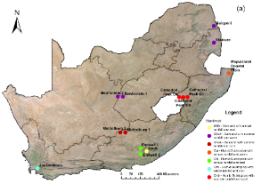 | 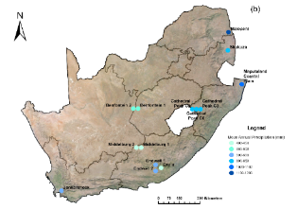 | 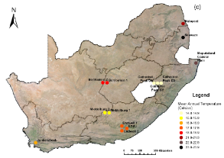
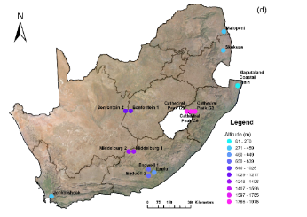 | 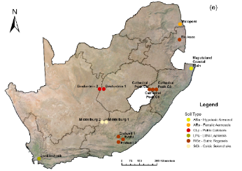 | 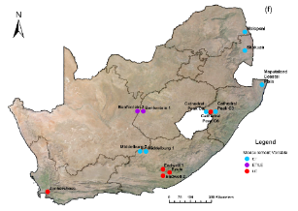
Figure S 1. Maps showing bioclimatic variable characteristics of the flux tower stations including: (a) Bioclimatic zones: Koppen Geiger 2007 classification (Peel et al., 2007) acquired from Step SA-CSIR, (b) Mean Annual Precipitation acquired from CHIRPS v2 dataset (5.5 km spatial resolution) for 2000 – 2020 obtained via Google Earth Engine (Funk et al., 2015), (c) Mean Annual Temperature acquired from LP DAAC LST dataset (1 km spatial resolution) for 2000 – 2020 obtained via Google Earth Engine (Wan et al., 2021), (d) Altitude acquired from the SRTM-DEM v4 dataset (90 m spatial resolution) (Trabucco & Zomer, 2019) obtained via Google Earth Engine, (e) Soil type acquired from the SOTER-ISRIC Data Hub for the year 2004 (Dijkshoorn et al., 2008), and (f) Measurement variable.

Table S 2. Biome flux tower sites and the Köppen-Geiger bioclimatic zones they are in
Flux tower station name | Biome | Köppen-Geiger bioclimatic zone
Cathedral Peak – Catchment 3 | Grassland | Cwb (humid subtropical with summer rainfall and cool)
Cathedral Peak – Catchment 6
Cathedral Peak – Catchment 9
Jonkershoek | Fynbos | Csb (humd subtropical with winter rainfall and cool)
Maputaland Coastal Plain | Indian Ocean Coastal Belt | Cfa (humid subtropical with annual rainfall and warm)
Endwell – Site 1 | Albany Thicket | Cfb (humid subtropical with annual rainfall and cool).
Endwell – Site 2
Ezulu |  | BSfk (semiarid with annual rainfall and cool)
Middelburg – Site 1 | Nama-Karoo | BSwk (semiarid with summer rainfall and cool)
Middelburg – Site 2
Malopeni | Savanna | BSwh (semiarid with summer rainfall and warm),
Skukuza
Benfontein – Site 1
Benfontein – Site 2

.
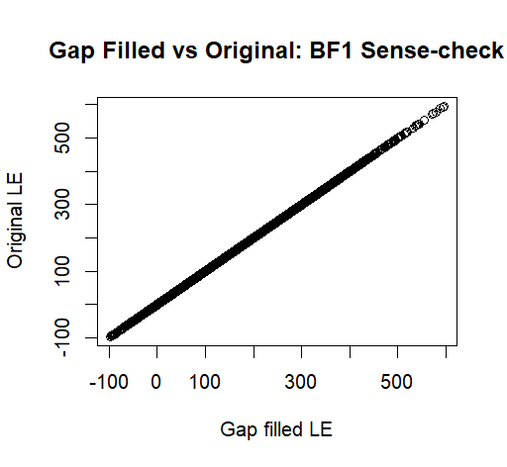 | 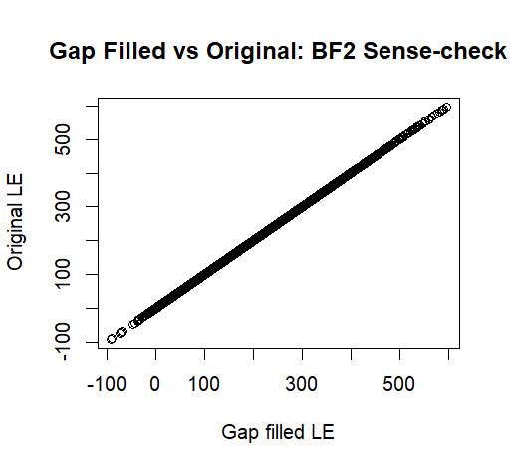 | 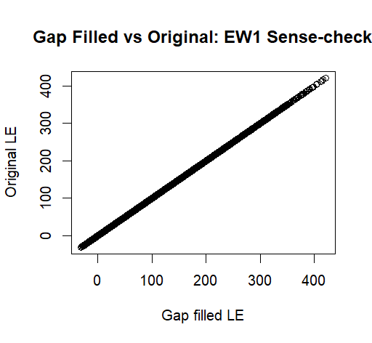 | 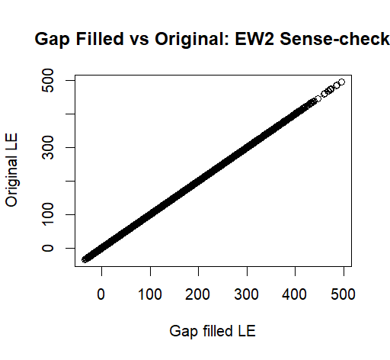
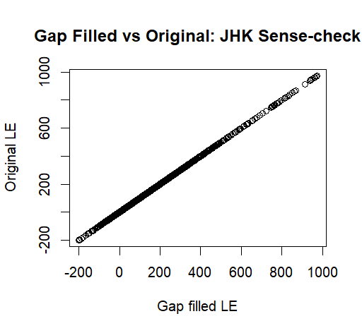 | 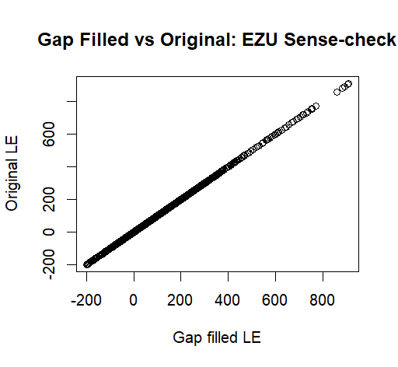 | 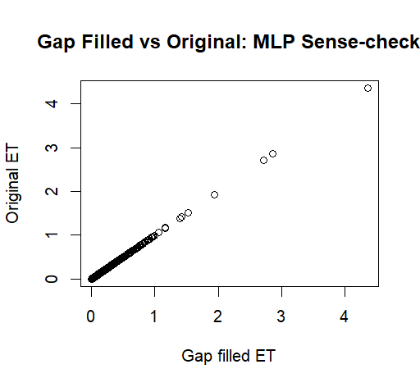 | 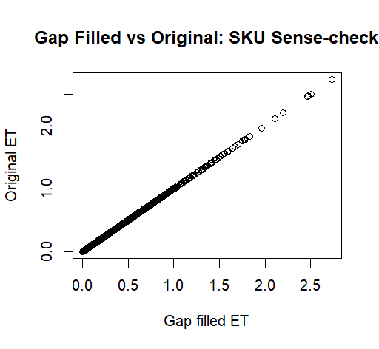
Figure S 2. Gap fill sense-check: Flux tower sites datasets were gap filled in its 30min processed format before aggregating it to a monthly time step. These flux tower sites include: Benfontein – Site 1 (BF1), Benfontein – Site 2 (BF2), Endwell – Site 1 (EW1), Endwell – Site 2 (EW2), Ezulu (EZU), Jonkershoek (JHK), Malopeni (MLP), and Skukuza (SKU). To ensure that the original evapotranspiration data remains unaltered and that only gaps were filled, a graphical sense-check is done by plotting the gap filled data against that of the original data. If the datasets do not match and is not plotted on a straight line, then it indicates that there was an error in the gap filling process.

Product | ET Principle | Imagery/ Sensor | Temporal Coverage | Temporal Resolution | Spatial Coverage | Spatial Resolution | Data Acquisition
- MOD16 | Penman Monteith | MODIS | 2001 - 2024 | 8 day | Global | 500m | Google Earth Engine: https://developers.google.com/earth-engine/datasets/catalog/MODIS_061_MOD16A2
- PT-JPL | Priestly Taylor model | ECOSTRESS | 15/07/2018 - Present | ISS dependant | Global | 70m | NASA AppEEARS: https://appeears.earthdatacloud.nasa.gov/task/point
- GLDAS-2.2 | Penman Monteith | MODIS, TRMM, GRACE, AMSR, SMMR, GPS-RO, CERES | 2003 - 2024 | 3 hourly | Global | 27.83 km | Google Earth Engine: https://developers.google.com/earth-engine/datasets/catalog/NASA_GLDAS_V022_CLSM_G025_DA1D
- WaPOR V3 | Penman Monteith | CHIRPS, Landsat, S2, VIIRS, GEOS-5, and other | Jan 2018 - Present | 10 day/ monthly | African continent | 100m | WaPOR v2: https://data.apps.fao.org/wapor/?lang=en
- SSEBop | Operational SSEB | MODIS thermal and GDAS | 2003 - 2022 | Monthly | Global | 1km | Climate Engine: https://support.climateengine.org/article/110-usgs-modis-et
- TerraClimate | Penman Monteith | JRA55 and CRU TS v4 | 1958 - 2023 | Monthly | Global | 4 km | Google Earth Engine: https://developers.google.com/earth-engine/datasets/catalog/IDAHO_EPSCOR_TERRACLIMATE
- SMAP L4 | Various | SMAP | 2015 - 2024 | 3 hourly | Global | 11 km | Google Earth Engine: https://developers.google.com/earth-engine/datasets/catalog/NASA_SMAP_SPL4SMGP_007#bands
- FLDAS | Penman Monteith and other | MODIS, CHIRPS and MERRA-2 | 1982 - 2023 | Monthly | Global | 9.6 km | Climate Engine: https://support.climateengine.org/article/61-fldas
- OpenET | Ensemble: METRIC, SSEBop, SIMS, SEBAL, PT-JPL, ALEXI | Landsat | 1984 - Present | Monthly/ annual | Western USA | 30m | Open ET:  https://etdata.org/
- GLASS | MOD16, PT-JPL, RRS-PM, MS-PT, UMD-SEMI | MODIS, AVHRR, and ETM+ | 2000 - 2018 | 8 day | Global | 1km | Direct from site: http://www.glass.umd.edu/Download.html
- GLEAM | Priestly Taylor | Various: LST data, Met satellites, LAI, fAPAR | 2003 – Dec 2022 | Daily | Global | 0.25 degrees | https://www.gleam.eu/#downloads
- Fruitlook | SEB | DMC, MODIS | MODIS | 7 day | Western Cape, RSA | 30-250m | https://fruitlook.co.za/portal/my-fields
- EEFLUX | METRIC | Landsat | 1983 - Present | 16 day | Global | 30m | https://eeflux-level1.appspot.com/
- ERA5-Land | IFS (integrated forecast system) | CERES, ASCAT, MODIS, TRMM | 1981-2020 | Daily | Global | 0.25 degrees | https://cds.climate.copernicus.eu/
- WECANN | ANN approach | GOME-2 | 2007-2015 | Monthly | Global | 1 degree | https://avdc.gsfc.nasa.gov/pub/data/project/WECANN/
- Landflux EVAL | Ensemble approach | Ensemble | 1989-2005 | Monthly | Global | 1 degree | https://iac.ethz.ch/group/land-climate-dynamics/research/landflux-eval.html
- BESS | Simplified process based model | MODIS, MPI-BPG | 2000-2015 | 8 day | Global | 1km | https://www.environment.snu.ac.kr/bess-flux & GEE
- FluxCOM | Machine learning method | Machine learning ensemble: ANN, RF, MARS | 2000-2015 | 8 day | Global | 0.0833 degrees | https://www.bgc-jena.mpg.de/geodb/projects/Data.php
- ET Monitor | Penman Monteith, Gash model, Shuttleworth-Wallace | MODIS | 2008-2013 | Daily | Global | 0.005 degrees | https://data.casearth.cn/en/sdo/detail/63291c7e08415d54af833fe5
- PMLv2 | PML model coupled with GPP | MODIS, GLDAS | 2000-2017 | 8 days | Global | 500 m | Climate Engine: https://support.climateengine.org/article/108-pml-v2-et
- REA | Various ensemble | GLDAS, MERRA-2, ERA5 | 1980-2017 | Daily | Global | 0.25 degrees | https://zenodo.org/record/4595941
- EartH2Observe | Various | MODIS, S2, GRACE, SMOS, ERA | 1979-2012 | Daily | Global | 50km | https://wci.earth2observe.eu/portal/
- CMRSET | Priestly Taylor–relationship between EVI&GVMI | MODIS | 2000-2013 | 8 day | Global | 0.002 degrees | http://remote-sensing.nci.org.au/u39/public/html/wirada/index.shtml
- CSIRO-CMRSET | Penman Monteith | MODIS, Landsat | 1981-2012 | Monthly | Australia | 0.5 degrees | https://tern-landscapes.earthengine.app/view/cmrset-landsat-v22
- PRISM | Various | Various | 1991 - 2020 | Monthly/ annual | USA | 800 | https://data.usgs.gov/datacatalog/data/
- LSA SAF | T-ABL (atmospheric boundary layer) model | AVHRR, SEVIRI, EUMETSAT | 2015/2019- Present | Daily/ 30min | Europe, Africa, & South America | 3km | https://landsaf.ipma.pt/en/data/products/evapotranspiration-turbulent-fluxes/
- NTSG | Priestley-Taylor | MODIS | 1982 - 2013 | Monthly | Global | 0.083 degree | http://luna.ntsg.umt.edu/data/.
- ECOSTRESS dis-ALEXI | TSEB | ECOSTRESS | 2018-Present | Daily | Global | 30m | Earth Data: https://lpdaac.usgs.gov/products/eco3etalexiuv001/
- MERRA-2 | Various | NOAA-19, GPSRO, MetOp-A and B, NPP, CrIS | 1980 - 2023 | Daily | Global | 50 km | Climate Engine: https://support.climateengine.org/article/70-merra2
- NLDAS-2 | Various | MODIS and other | 1979 - 2024 | Daily | USA | 12 km | Climate Engine: https://support.climateengine.org/article/76-nldas2
Table S 3. Satellite-derived evapotranspiration product specifications including the evapotranspiration principle, temporal and spatial coverage and resolution.

Table S 4. Algorithmic inputs for each of the eight selected satellite-derived products including TerraClimate, WaPOR ,SMAP, SSEBop, FLDAS, GLDAS, PT-JPL and MOD16
Product | Source | Revisit frequency | Model/method input | Algorithmic inputs | Product output
Terra-  Climate | https://developers.google.com/earth-engine/datasets/catalog/IDAHO_EPSCOR_TERRACLIMATE. Date accessed: 30/04/2024 | Various | Thornwaite-Mather climatic water balance model | Derived from reanalysis product inputs JRA55 WorldClim, and CRU Ts4 which include reference ET, precipitation, temperature and interpolated plant extractable soil water capacity. ET derived from a one-dimensional soil water balance model. | Monthly actual evapotranspiration (mm/month) at 4638 m spatial resolution.
SMAP | https://developers.google.com/earth-engine/datasets/catalog/NASA_SMAP_SPL4SMGP_007. Date accessed: 03/05/2024 | 2-3 days | 2x GEOS models: (i) Catchment Land Surface and Microwave Radiative Transfer Model; (ii) Ensemble-Based Land Data Assimilation Algorithm | Brightness temperatures from the SMAP L1C GEOS, hourly surface meteorology data, NOAA - CPCU gauge based precipitation data, and IMERG precipitation data | 3-Hourly land evapotranspiration flux (kg/m²/s) at a 11 km spatial resolution.
WaPOR | https://data.apps.fao.org/wapor/?lang=en. Date accessed: 01/05/2024 | Various | Penman-Monteith model | Albedo, Soil moisture stress, LST, Light Use Efficiency, NDVI, Precipitation, Solar Radiation, Land cover and other weather data (include wind speed, specific humidity, and air temperature) | Monthly actual evapotranspiration and interception (mm/month) at a 100m spatial resolution after 2018, and 250m spatial resolution prior to 2018.
GLDAS | https://developers.google.com/earth-engine/datasets/catalog/NASA_GLDAS_V022_CLSM_G025_DA1D. Date accessed: 02/05/2024 | Various | Various: Land surface models (LSMs) including Noah LSM, Catchment LSM and Variable Infiltration Capacity | NOAH land surface model, GRACE, and Elevation from GTOPO30 | 3-Hourly evapotranspiration (kg/m²/s) at a 27.83km spatial resolution.
MOD16 | https://developers.google.com/earth-engine/datasets/catalog/MODIS_061_MOD16A2. Date accessed: 14/05/2024 | 1-2 days | Penman-Monteith model | Daily meteorological reanalysis data along with vegetation property dynamics, albedo and land cover | 8-Day evapotranspiration (kg/m²/8day) at a 500m spatial resolution.
PT-JPL | https://appeears.earthdatacloud.nasa.gov/task/point. Date accessed: 14/05/2024 | 1-5 days | Priestley-Taylor model | LAI, NDVI, Rn (net Radiation), Relative Humidity, T(mean temp), T(max temp) | Daily latent heat flux (W/m²) at a 70m spatial resolution.
FLDAS | https://developers.google.com/earth-engine/datasets/catalog/NASA_FLDAS_NOAH01_C_GL_M_V001. Date accessed: 04/06/2024 | Various | Noah Land Surface Model | NOAH land surface model including inputs of precipitation, windspeed, solar radiation, wind speed, relative humidity, land use type, and soil moisture | Monthly evapotranspiration (mm/month) at a 9.6km spatial resolution
SSEBop | https://support.climateengine.org/article/110-usgs-modis-et. Date accessed: 04/06/2024 | 1-2 days | Operational SSEB (Simplified Surface Energy Balance) model | Combines ET fractions generated from MODIS thermal imagery with reference ET using a thermal index approach. Derived from integration of MODIS11A2 LST , maximum air temperature from WorldClim (PRISM) and reference ET from GDAS. Also, elevation from SRTM, Albedo and NDVI from MODIS | Monthly actual evapotranspiration (mm/month) at a 1km spatial resolution.

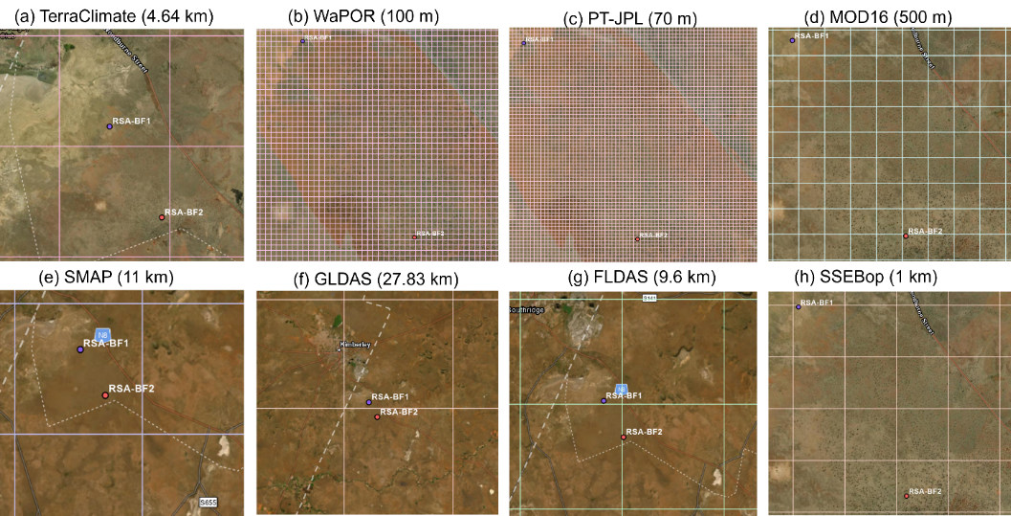
Figure S 3. Satellite-derived evapotranspiration product footprints (grid) over the region of the Benfontein sites

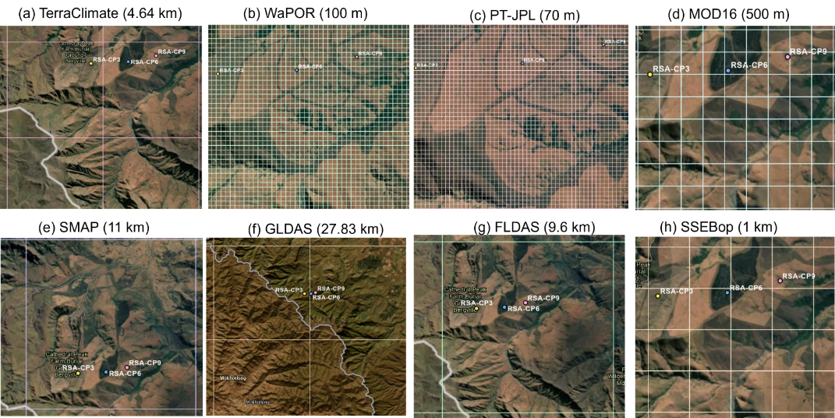
Figure S 4. Satellite-derived evapotranspiration product footprints (grid) over the region of the Cathedral Peak - Catchment sites

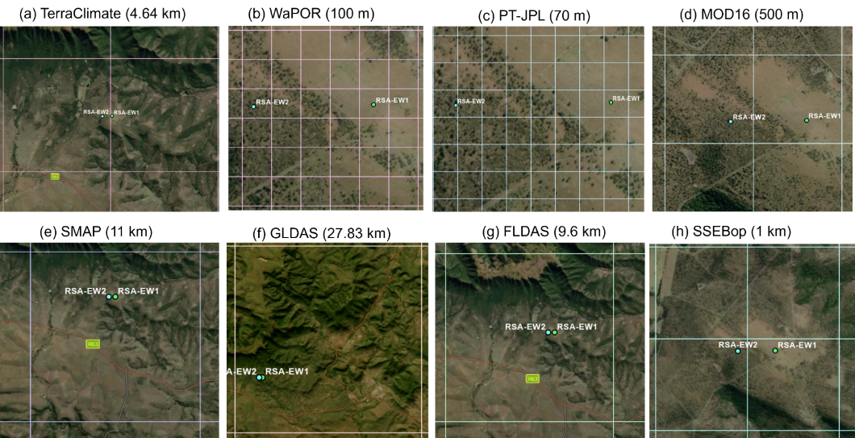
Figure S 5. Satellite-derived evapotranspiration product footprints (grid) over the region of the Endwell sites

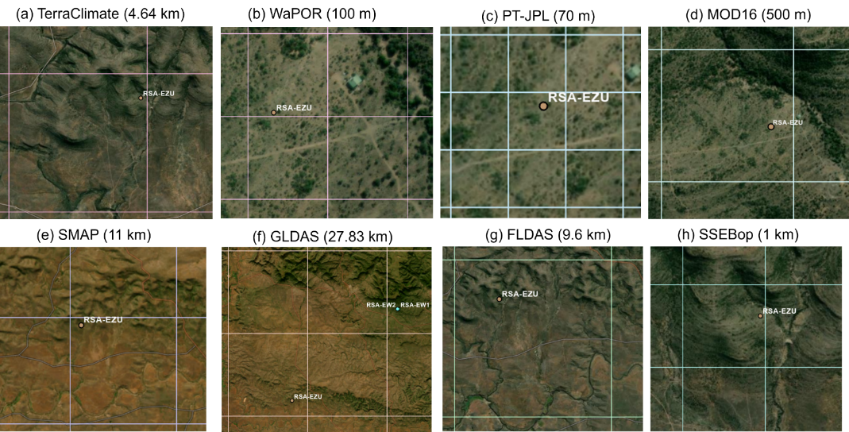
Figure S 6. Satellite-derived evapotranspiration product footprints (grid) over the region of the Ezulu site

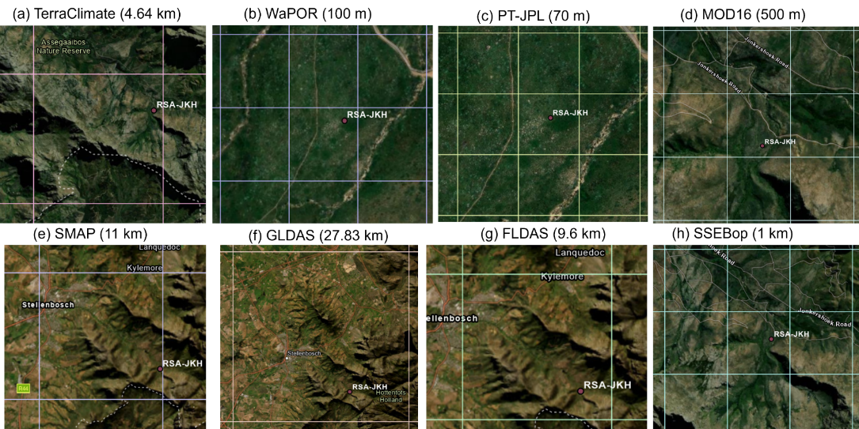
Figure S 7. Satellite-derived evapotranspiration product footprints (grid) over the region of the Jonkershoek site

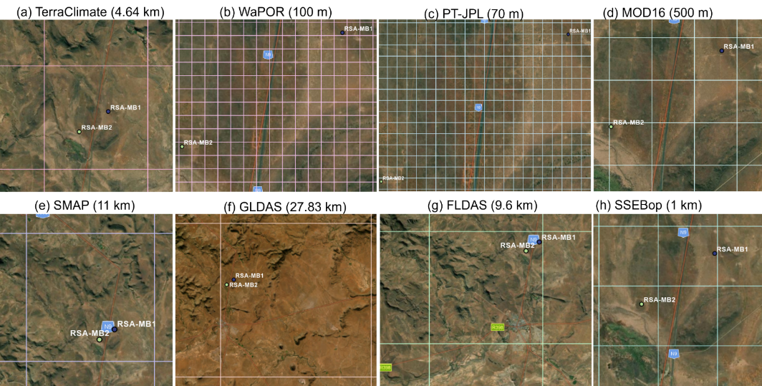
Figure S 8. Satellite-derived evapotranspiration product footprints (grid) over the region of the Middelburg – Sites

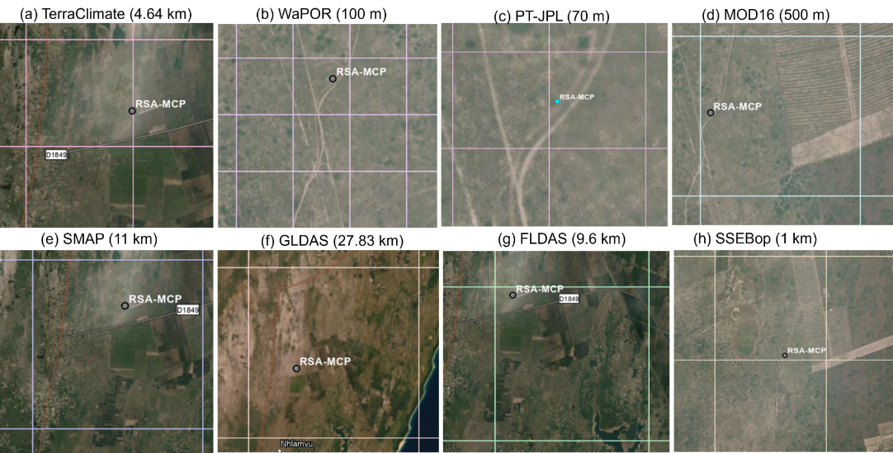
Figure S 9. Satellite-derived evapotranspiration product footprints (grid) over the region of the Maputaland Coastal Plain site

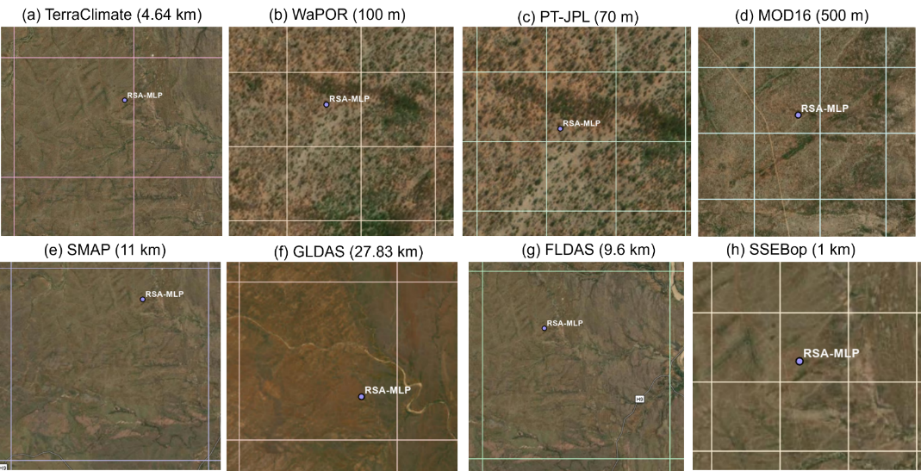
Figure S 10. Satellite-derived evapotranspiration product footprints (grid) over the region of the Malopeni site

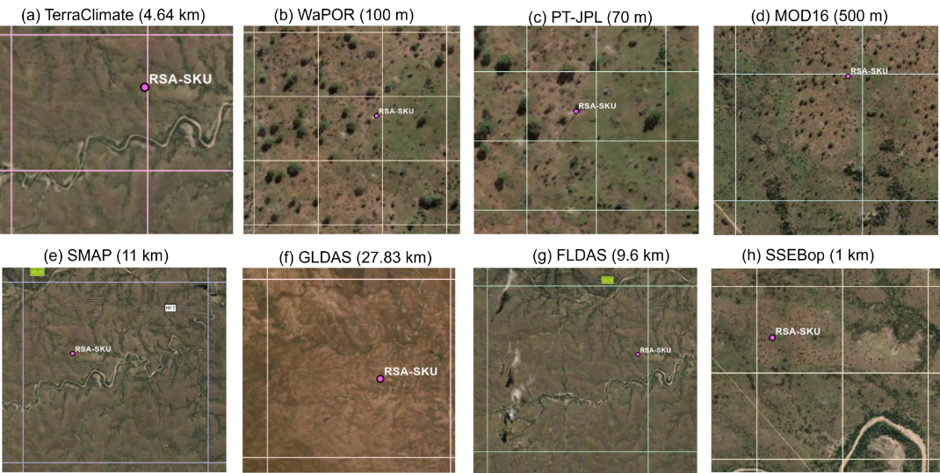
Figure S 11. Satellite-derived evapotranspiration product footprints (grid) over the region of the Skukuza site

Table S 5. The number of monthly comparisons of field-measured evapotranspiration versus satellite-derived evapotranspiration are shown. Certain satellite-derived products have incomplete time series due to irregular temporal resolution (such as PT-JPL which is dependent on the ISS) or limited temporal coverage (such as SSEBop which only have data up to mid-2022). Where the number of monthly observations was three or less, the respective product would be excluded from further correlation analyses. Values are colour coded according to number of observations (n) where lowest n = white and highest n = dark blue.
Product/ Site | Terra-Climate | SMAP | WaPOR | GLDAS | MOD16 | PT-JPL | FLDAS | SSEBop
EW1 | 28 | 28 | 28 | 28 | 28 | 24 | 28 | 28
EW2 | 36 | 36 | 36 | 36 | 36 | 31 | 36 | 36
EZU | 29 | 29 | 29 | 29 | 29 | 0 | 29 | 29
BF1 | 40 | 40 | 40 | 40 | 39 | 26 | 40 | 25
BF2 | 10 | 10 | 10 | 10 | 9 | 3 | 10 | 0
CP3 | 53 | 53 | 53 | 53 | 53 | 26 | 53 | 35
CP6 | 96 | 88 | 96 | 96 | 95 | 36 | 96 | 81
CP9 | 45 | 45 | 45 | 45 | 45 | 25 | 45 | 32
MB1 | 81 | 81 | 81 | 81 | 81 | 44 | 81 | 78
MB2 | 81 | 81 | 81 | 81 | 81 | 44 | 81 | 78
JHK | 41 | 41 | 41 | 41 | 41 | 31 | 41 | 35
MCP | 17 | 17 | 17 | 17 | 16 | 7 | 17 | 11
MLP | 22 | 19 | 22 | 22 | 22 | 1 | 22 | 22
SKU | 42 | 33 | 42 | 42 | 42 | 0 | 42 | 42

Table S 6. The number of annual evapotranspiration samples per site across the different satellite-derived evapotranspiration products are shown. Certain sites (such as Benfontein – Site 2) do not have a complete years’ worth of data and therefore are excluded from interannual analyses. Values are colour coded according to number of observations (n) where lowest n = white and highest n = dark blue.
Product/ Site | Terra-Climate | SMAP | WaPOR | GLDAS | MOD16 | PT-JPL | FLDAS | SSEBop
EW1 | 3 | 3 | 3 | 3 | 3 | 3 | 3 | 3
EW2 | 3 | 3 | 3 | 3 | 3 | 3 | 3 | 3
EZU | 2 | 2 | 2 | 2 | 2 | 0 | 2 | 2
BF1 | 3 | 3 | 3 | 3 | 3 | 3 | 3 | 2
BF2 | 0 | 0 | 0 | 0 | 0 | 0 | 0 | 0
CP3 | 3 | 3 | 3 | 3 | 3 | 3 | 3 | 3
CP6 | 9 | 9 | 9 | 9 | 9 | 6 | 9 | 9
CP9 | 3 | 3 | 3 | 3 | 3 | 3 | 3 | 3
MB1 | 6 | 6 | 6 | 6 | 6 | 4 | 6 | 6
MB2 | 6 | 6 | 6 | 6 | 6 | 4 | 6 | 6
JHK | 3 | 3 | 3 | 3 | 3 | 3 | 3 | 3
MCP | 0 | 0 | 0 | 0 | 0 | 0 | 0 | 0
MLP | 0 | 0 | 0 | 0 | 0 | 0 | 0 | 0
SKU | 2 | 2 | 2 | 2 | 2 | 0 | 2 | 2

Table S 7. The number of seasonal evapotranspiration samples per site for January through to December across the different satellite-derived evapotranspiration products are shown. Values are colour coded according to number of observations (n) where lowest n = white and highest n = dark blue.
Product/ Site | Terra-Climate | SMAP | WaPOR | GLDAS | MOD16 | PT-JPL | FLDAS | SSEBop
EW1 | 12 | 12 | 12 | 12 | 12 | 12 | 12 | 12
EW2 | 12 | 12 | 12 | 12 | 12 | 12 | 12 | 12
EZU | 12 | 12 | 12 | 12 | 12 | 0 | 12 | 12
BF1 | 12 | 12 | 12 | 12 | 12 | 12 | 12 | 12
BF2 | 12 | 12 | 12 | 12 | 12 | 3 | 12 | 12
CP3 | 12 | 12 | 12 | 12 | 12 | 11 | 12 | 12
CP6 | 12 | 12 | 12 | 12 | 12 | 11 | 12 | 12
CP9 | 12 | 12 | 12 | 12 | 12 | 11 | 12 | 12
MB1 | 12 | 12 | 12 | 12 | 12 | 12 | 12 | 12
MB2 | 12 | 12 | 12 | 12 | 12 | 12 | 12 | 12
JHK | 12 | 12 | 12 | 12 | 12 | 12 | 12 | 12
MCP | 10 | 10 | 10 | 10 | 10 | 6 | 10 | 8
MLP | 12 | 12 | 12 | 12 | 12 | 1 | 12 | 12
SKU | 12 | 12 | 12 | 12 | 12 | 0 | 12 | 12

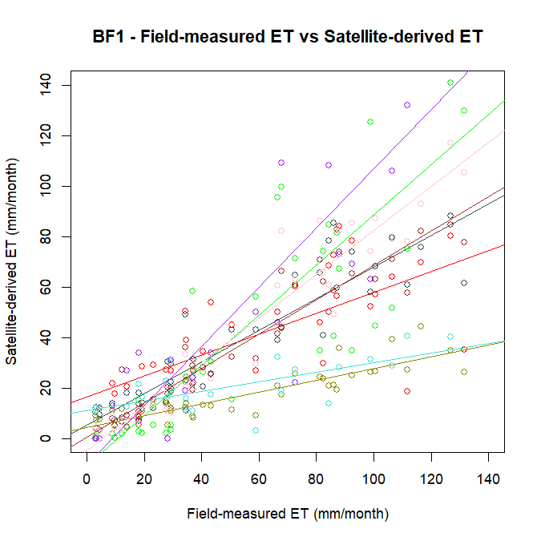 | 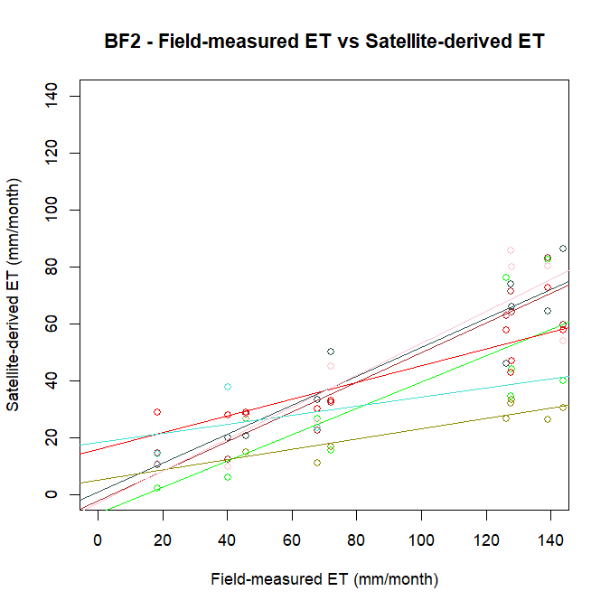 | 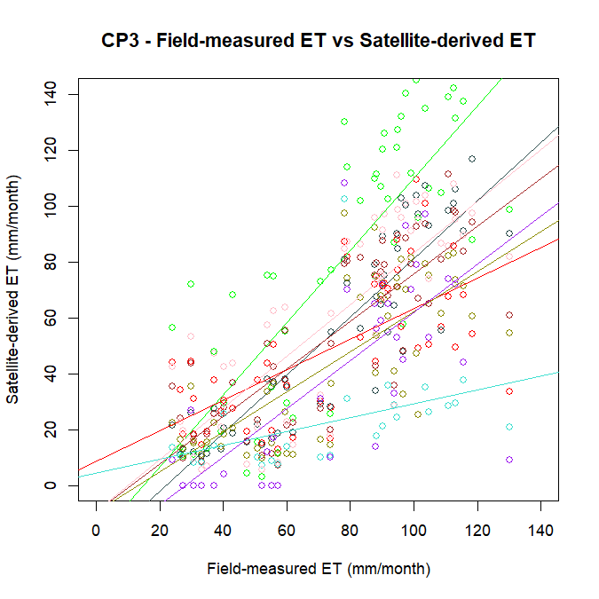 | 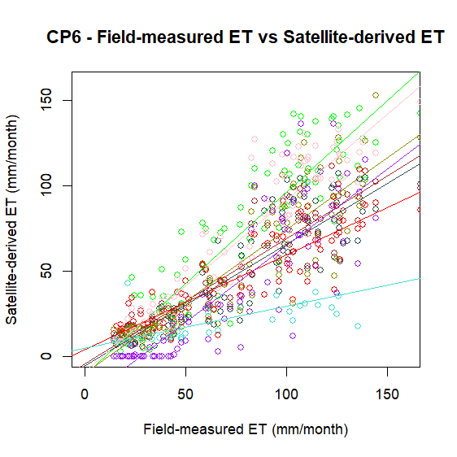 | 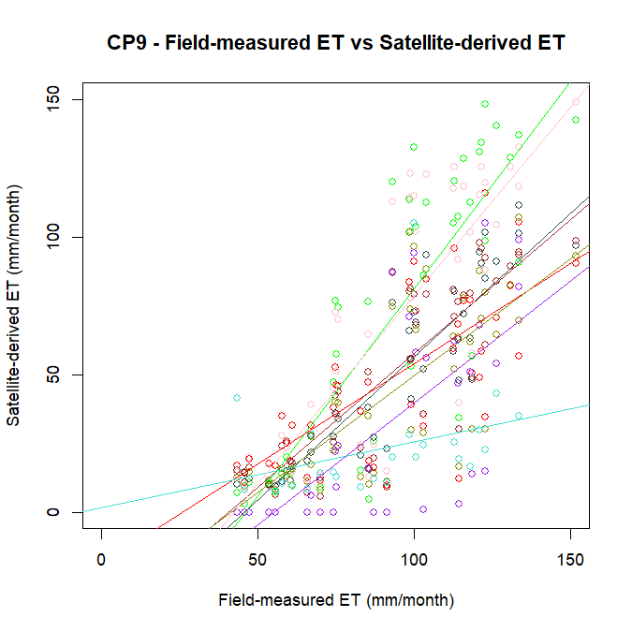
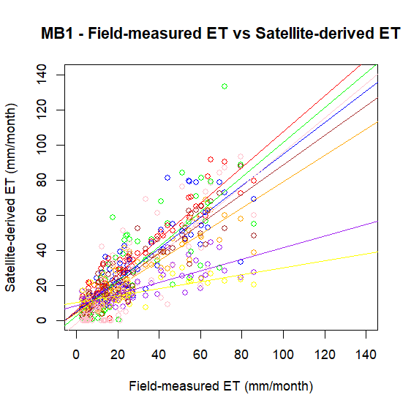 | 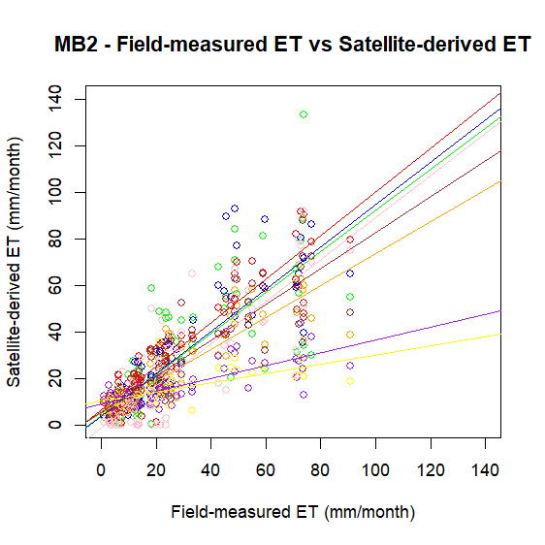 | 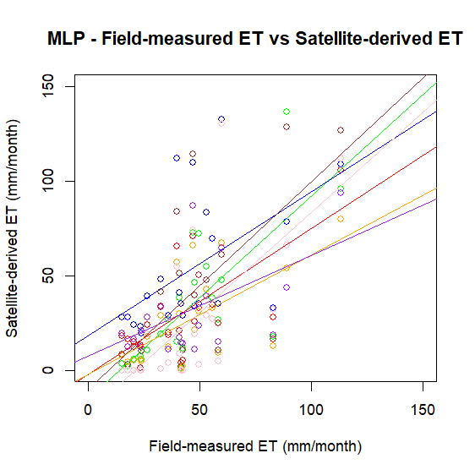 | 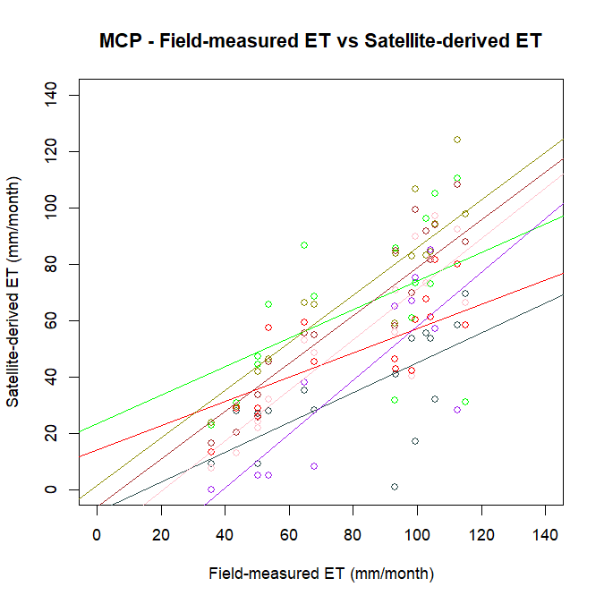 | 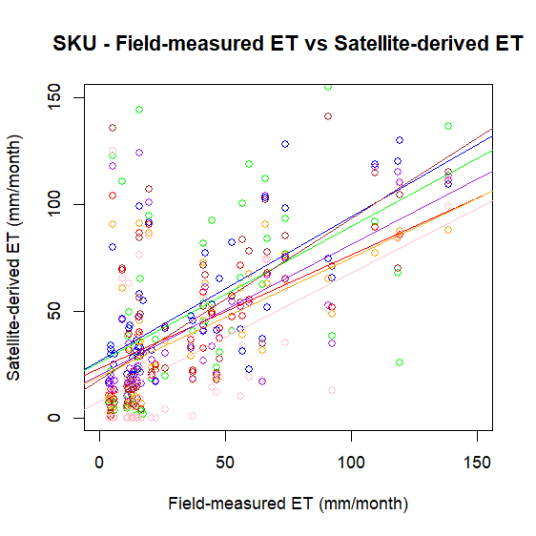
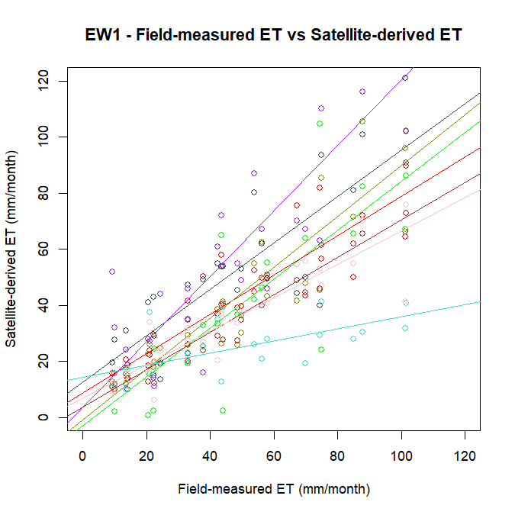 | 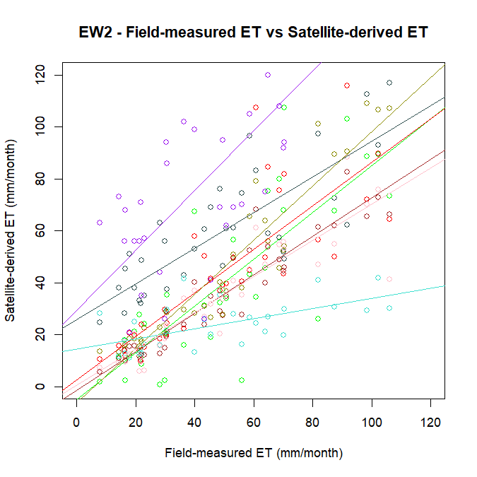 | 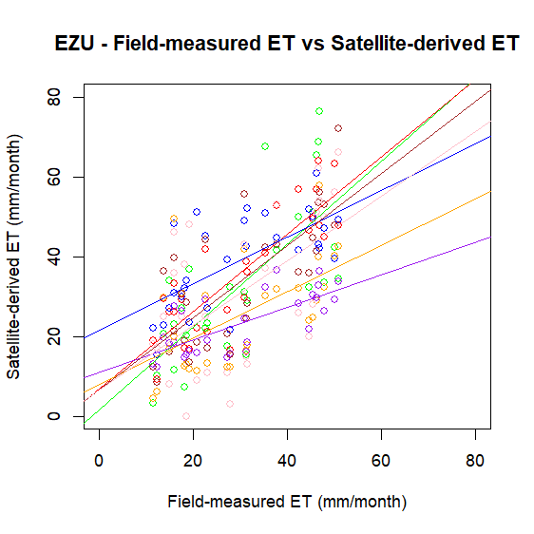 | 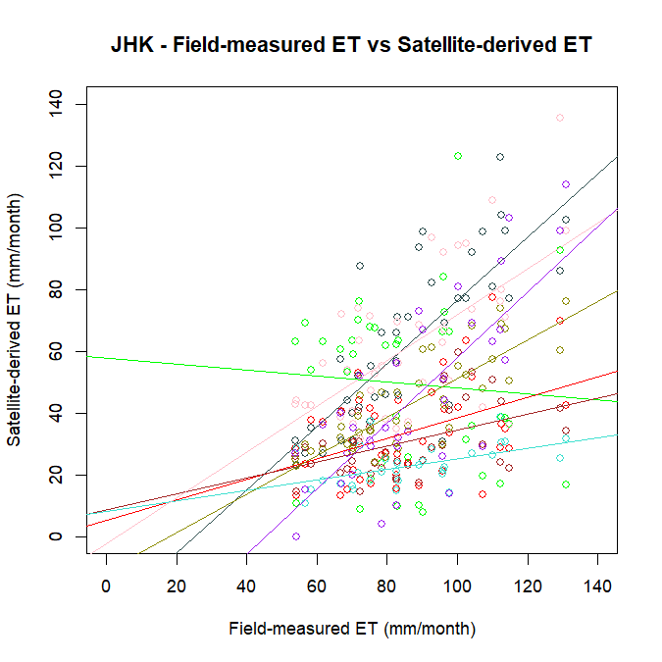
Figure S 12. Field-measured evapotranspiration (mm/month) versus satellite-derived evapotranspiration estimates (mm/month) across the 14 flux tower sites

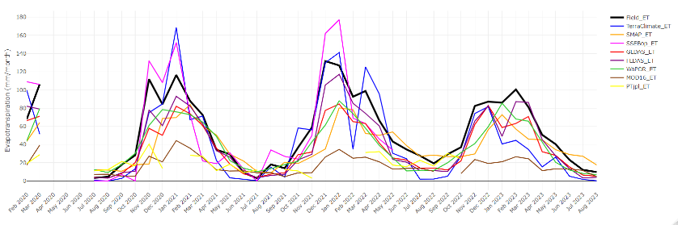
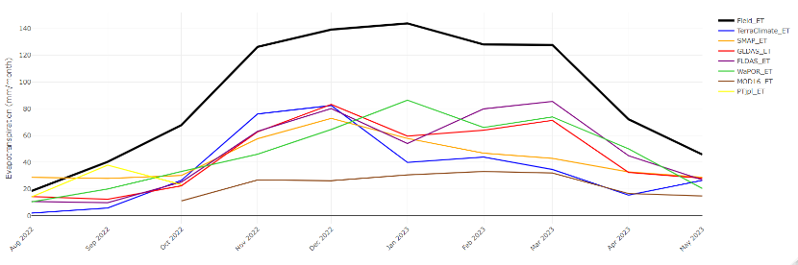
Figure S 13. Time series plots for Benfontein - Site 1 (top) and Site 2 (bottom)

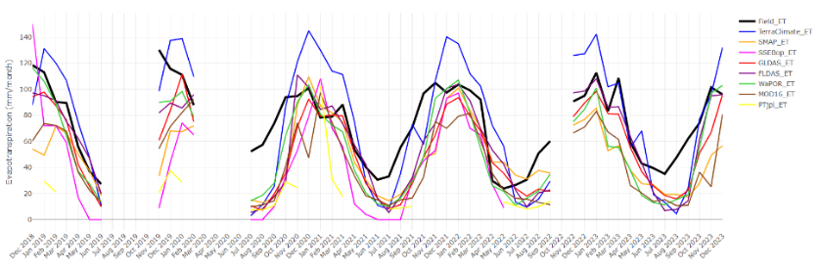
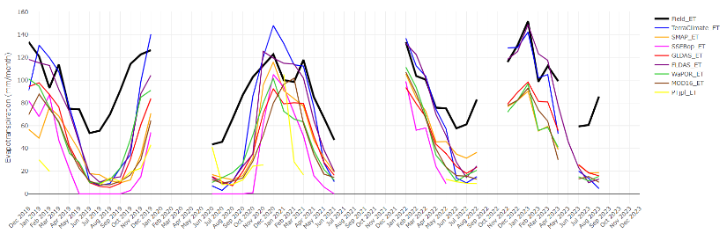
Figure S 14. Time series plots for Cathedral Peak sites - Catchment 3 (top) and Catchment 6 (bottom)

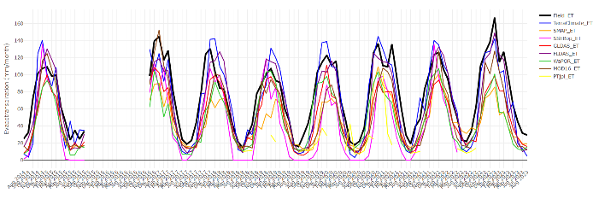
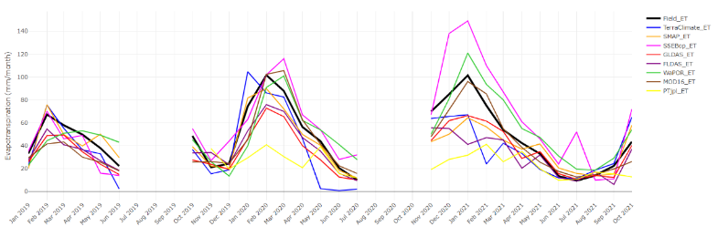
Figure S 15. Time series plots for Cathedral Peak- Catchment 9 site (top) and Endwell – Site 1 (bottom)

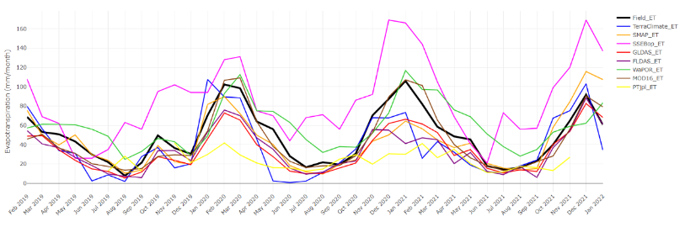
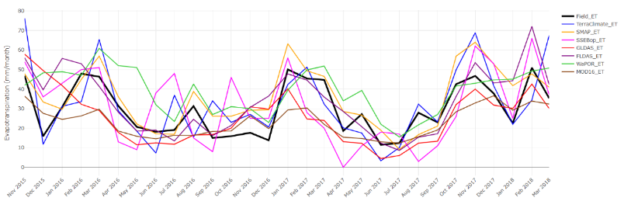
Figure S 16. Time series plot for Endwell – Site 2 (top) and Ezulu (bottom)

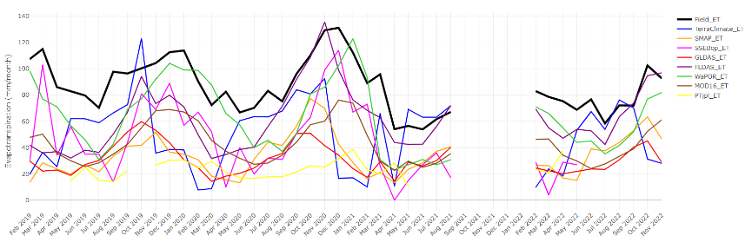
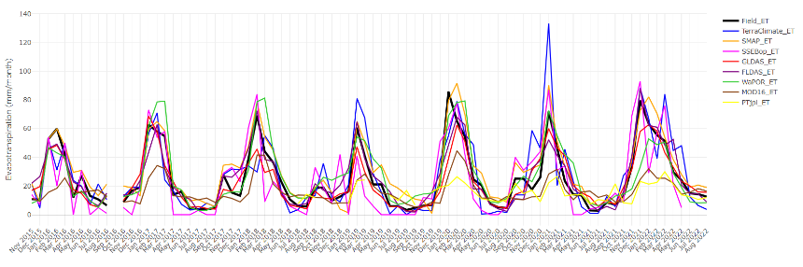
Figure S 17. Time series plot for the Jonkershoek site (top) and Middelburg – Site 1 (bottom)

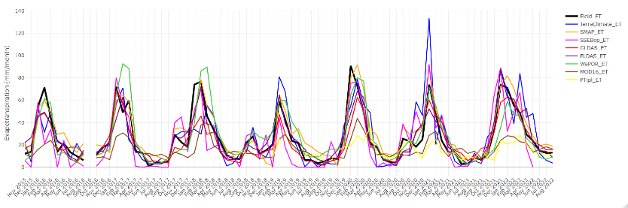
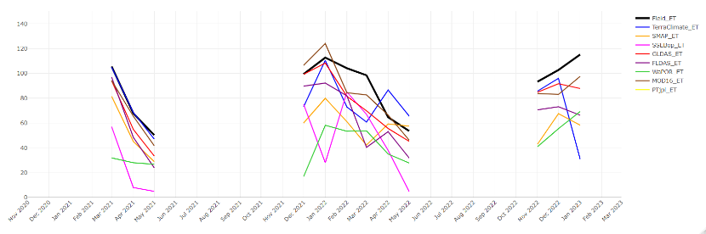
Figure S 18. Time series plots for the Middelburg – Site 2 (top) and Maputaland Coastal Plain site (bottom)

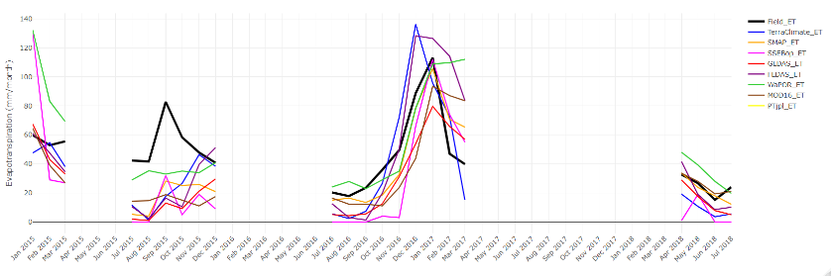
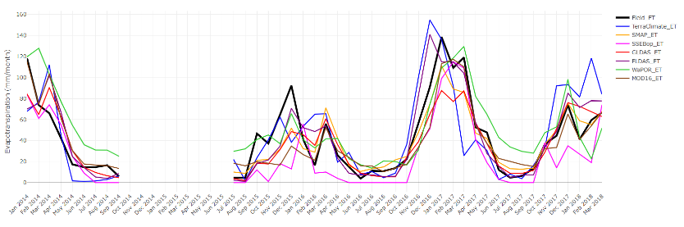
Figure S 19. Time series plot for the Malopeni site (top) and Skukuza site (bottom)

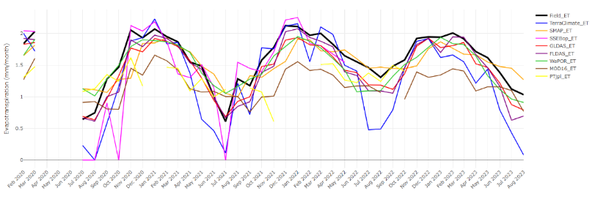
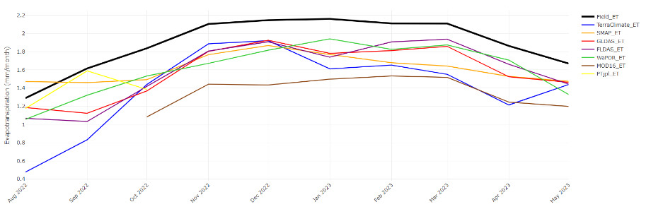
Figure S 20. Log transformed time series plot for the Benfontein – Site 1 (top) and Benfontein – Site 2 (bottom)

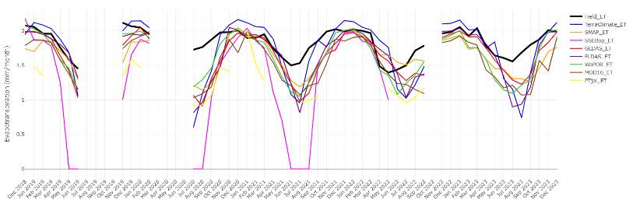
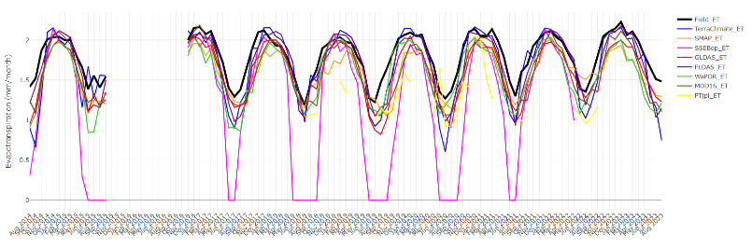
Figure S 21. Log transformed time series plot for the Cathedral Peak sites – Catchment 3 (top) and Cathedral Peak – Catchment 6 (bottom)

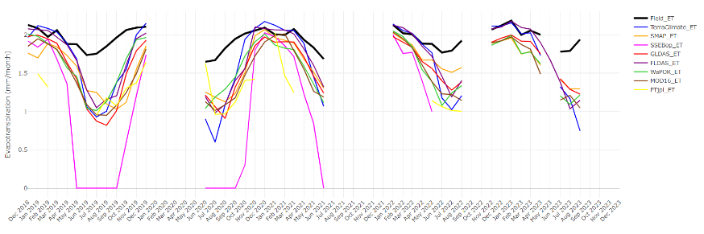
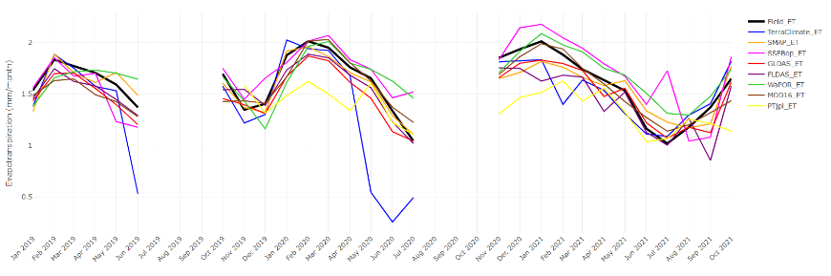
Figure S 22. Log transformed time series plot for the Cathedral Peak – Catchment 9 site (top) and Endwell – Site 1 (bottom)
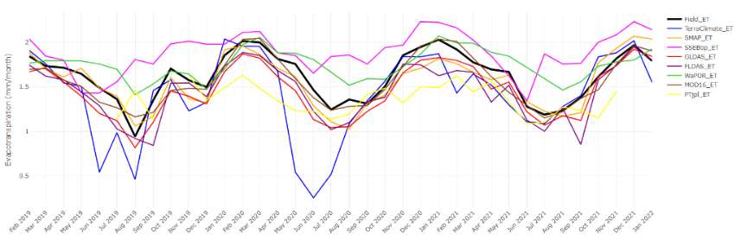
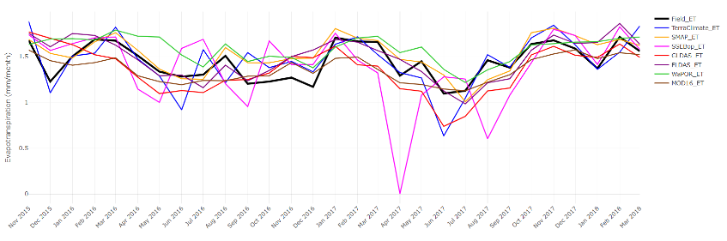
Figure S 23. Log transformed time series plots for the Endwell – Site 2 (top) and Ezulu site (bottom)

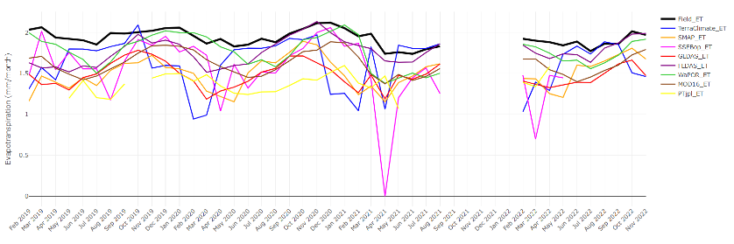
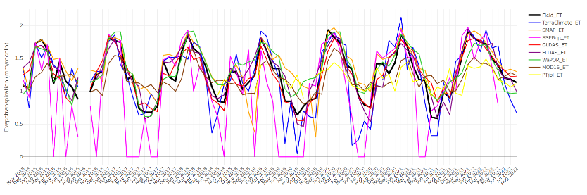
Figure S 24. Log transformed time series plot for the Jonkershoek site (top) and Middleburg – Site 1 (bottom)

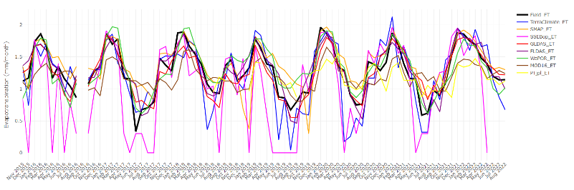
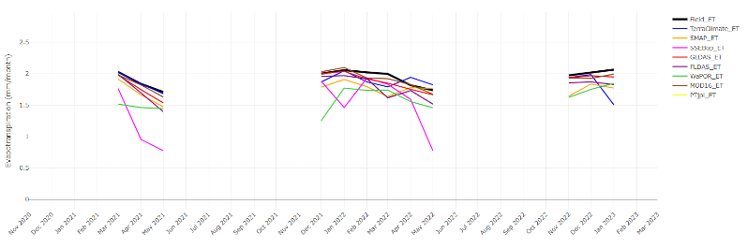
Figure S 25. Log transformed time series plot for the Middelburg – Site 2 (top) and Maputaland Coastal Plain site (bottom)

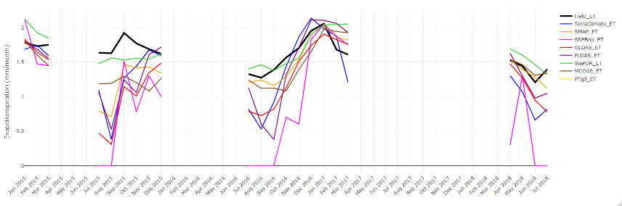
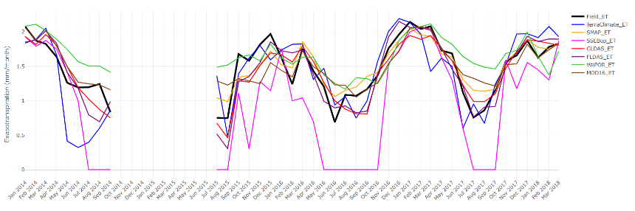
Figure S 26. Log transformed time series plot for the Malopeni site (top) and Skukuza site (bottom)
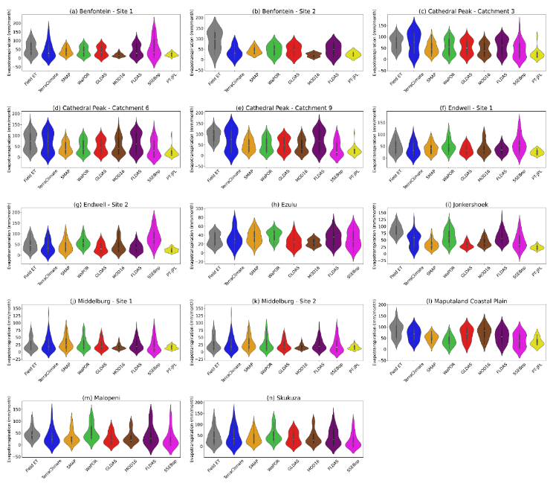
Figure S 27. Violin plots for overall monthly evapotranspiration across all 14 flux tower sites showing distribution of observed field-measured evapotranspiration (Field ET) and the satellite-derived evapotranspiration product evapotranspiration estimates. The mean and ± standard deviation are shown as error bars within each plot

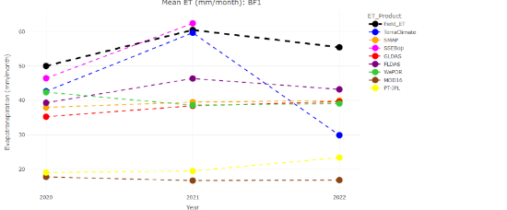  (a) Benfontein – Site 1 | 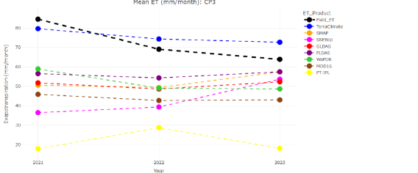  (b) Cathedral Peak – Catchment 3
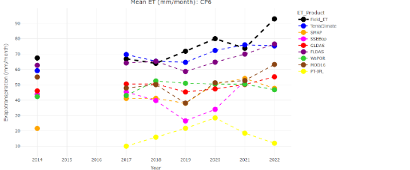  (c) Cathedral Peak – Catchment 6 | 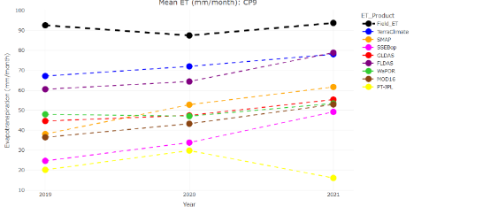  (d) Cathedral Peak – Catchment 9
Figure S 28. Interannual mean evapotranspiration (mm/month) showing field-measured and of satellite-derived product evapotranspiration estimates for (a) Benfontein – Site 1 , (b) Cathedral Peak – Catchment 3, (c) Cathedral Peak – Catchment 6, and (d) Cathedral Peak – Catchment 9

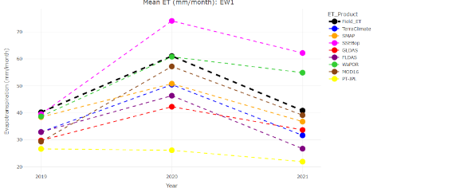  (a) Endwell – Site 1 | 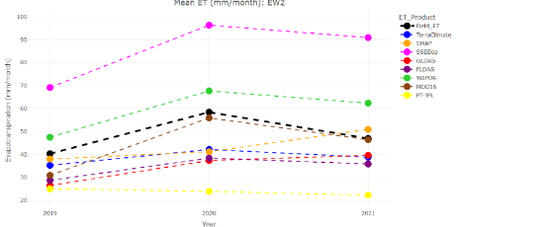  (b) Endwell – Site 2
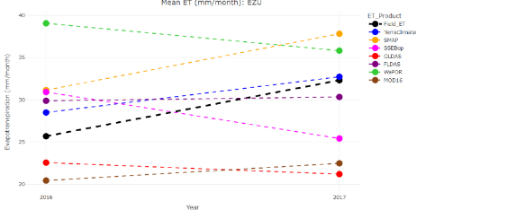  (c) Ezulu | 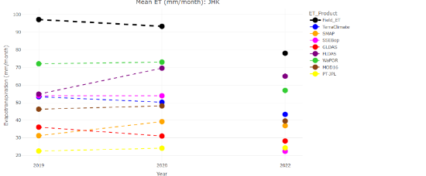  (d) Jonkershoek
Figure S 29. Interannual mean evapotranspiration (mm/month) showing field-measured and of satellite-derived product evapotranspiration estimates for (a) Endwell – Site 1 , (b) Endwell – Site 2, (c) Ezulu, and (d) Jonkershoek

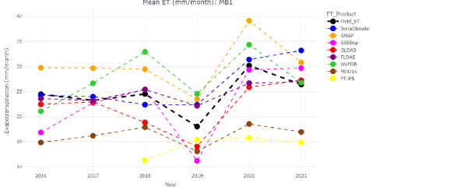  (a) Middelburg – Site 1 | 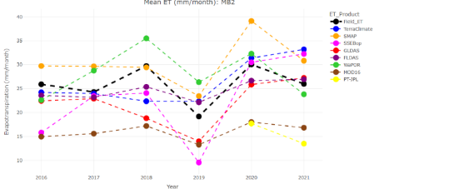  (b) Middelburg – Site 2
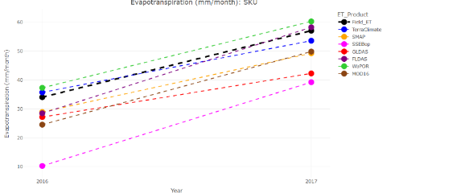
(c) Skukuza
Figure S 30. Interannual mean evapotranspiration (mm/month) showing field-measured and of satellite-derived product evapotranspiration estimates for (a) Middelburg – Site 1 , (b) Middelburg – Site 2, and (c) Skukuza

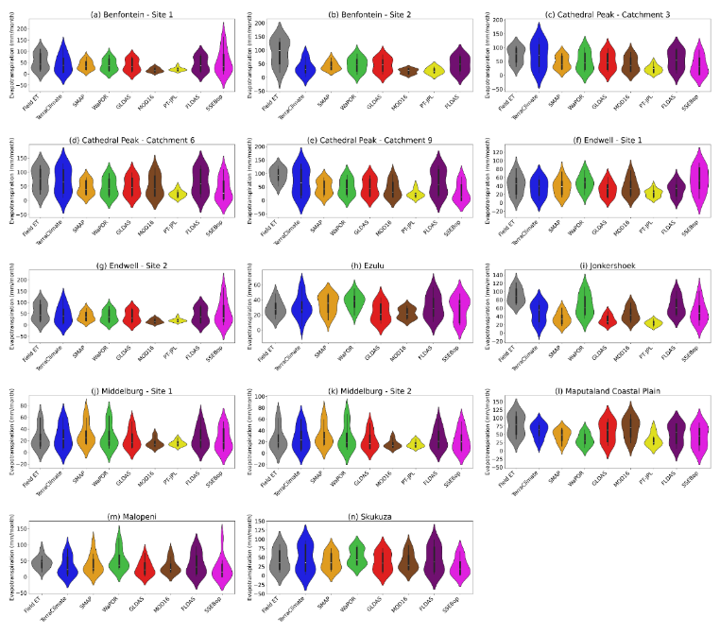
Figure S 31. Violin plots showing overall seasonal evapotranspiration (mm/month) across all 14 flux tower sites showing distribution of observed field-measured evapotranspiration (Field ET) and the satellite-derived evapotranspiration product evapotranspiration estimates. The mean and ± standard deviation are shown as error bars within each plot

Table S 8. The Correlation Coefficient (r_{s}), Kling-Gupta Efficiency (KGE) and Percent Bias (PBias) performance scores of satellite-derived evapotranspiration products for each biome including (i) Albany Thicket, (ii) Fynbos, (iii) Grassland, (iv) Indian Ocean Coastal Belt, (v) Nama-Karoo, and (vi) Savanna.
(i) Albany Thicket |  |  |  | (ii) Fynbos
Product | r_{s} | KGE | PBias | Product | r_{s} | KGE | PBias
TerraClimate | 0.81 | 0.64 | -10.09 | TerraClimate | -0.10 | -0.21 | -42.79
SMAP | 0.85 | 0.75 | -0.72 | SMAP | 0.37 | 0.14 | -60.71
WaPOR | 0.73 | 0.67 | 20.67 | WaPOR | 0.78 | 0.53 | -27.44
MOD16 | 0.87 | 0.72 | -14.04 | MOD16 | 0.80 | 0.41 | -50.73
PT-JPL | 0.67 | 0.09 | -48.94 | PT-JPL | 0.53 | -0.11 | -73.53
SSEBop | 0.71 | 0.34 | 34.57 | SSEBop | 0.68 | 0.33 | -48.69
FLDAS | 0.86 | 0.61 | -14.14 | FLDAS | 0.49 | 0.48 | -28.64
GLDAS | 0.82 | 0.60 | -23.20 | GLDAS | 0.44 | 0.05 | -64.14
(iii) Grassland |  |  |  | (iv) Indian Ocean Coastal Belt
Product | r_{s} | KGE | PBias | Product | r_{s} | KGE | PBias
TerraClimate | 0.85 | 0.45 | -9.48 | TerraClimate | 0.63 | 0.51 | -21.79
SMAP | 0.74 | 0.46 | -40.23 | SMAP | 0.83 | 0.37 | -40.35
WaPOR | 0.90 | 0.58 | -36.73 | WaPOR | 0.77 | 0.32 | -56.47
MOD16 | 0.79 | 0.53 | -41.07 | MOD16 | 0.94 | 0.82 | -13.86
PT-JPL | 0.68 | 0.00 | -70.33 | PT-JPL | 0.25 | -0.08 | -50.06
SSEBop | 0.77 | 0.38 | -51.29 | SSEBop | 0.70 | 0.42 | -51.11
FLDAS | 0.84 | 0.60 | -19.09 | FLDAS | 0.91 | 0.66 | -32.28
GLDAS | 0.85 | 0.59 | -35.17 | GLDAS | 0.92 | 0.75 | -22.28
(v) Nama-Karoo |  |  |  | (vi) Savanna
Product | r_{s} | KGE | PBias | Product | r_{s} | KGE | PBias
TerraClimate | 0.85 | 0.71 | 5.86 | TerraClimate | 0.82 | 0.51 | -25.35
SMAP | 0.90 | 0.77 | 21.36 | SMAP | 0.79 | 0.47 | -29.41
WaPOR | 0.89 | 0.84 | 7.64 | WaPOR | 0.77 | 0.44 | -5.43
MOD16 | 0.66 | 0.26 | -35.78 | MOD16 | 0.76 | 0.27 | -45.68
PT-JPL | 0.67 | 0.12 | -40.56 | PT-JPL | 0.63 | 0.02 | -57.97
SSEBop | 0.78 | 0.74 | -11.51 | SSEBop | 0.84 | 0.50 | -27.2
FLDAS | 0.89 | 0.85 | 0.35 | FLDAS | 0.84 | 0.57 | -20.01
GLDAS | 0.89 | 0.75 | -10.31 | GLDAS | 0.85 | 0.52 | -33.80

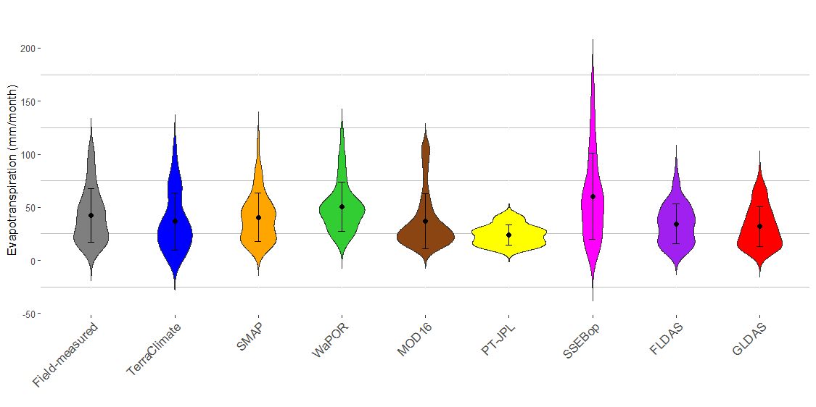  (a) Albany Thicket | 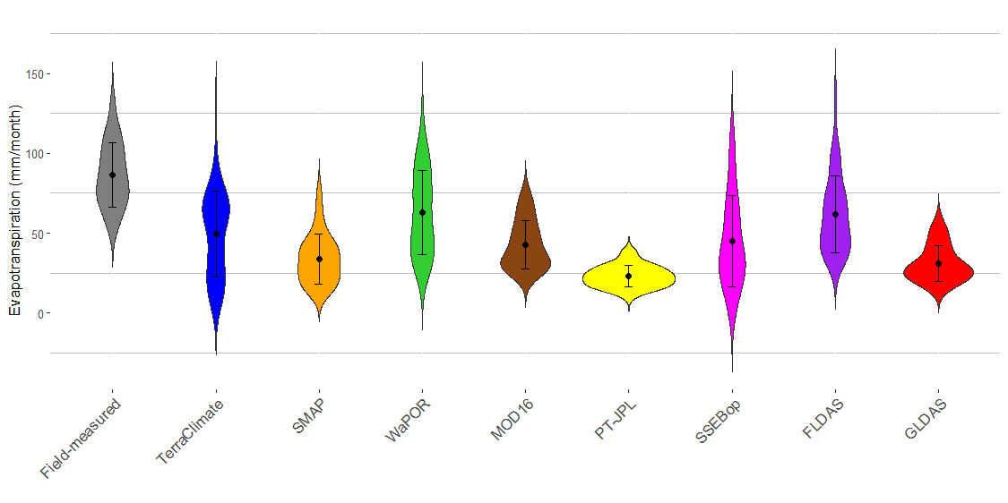  (b) Fynbos
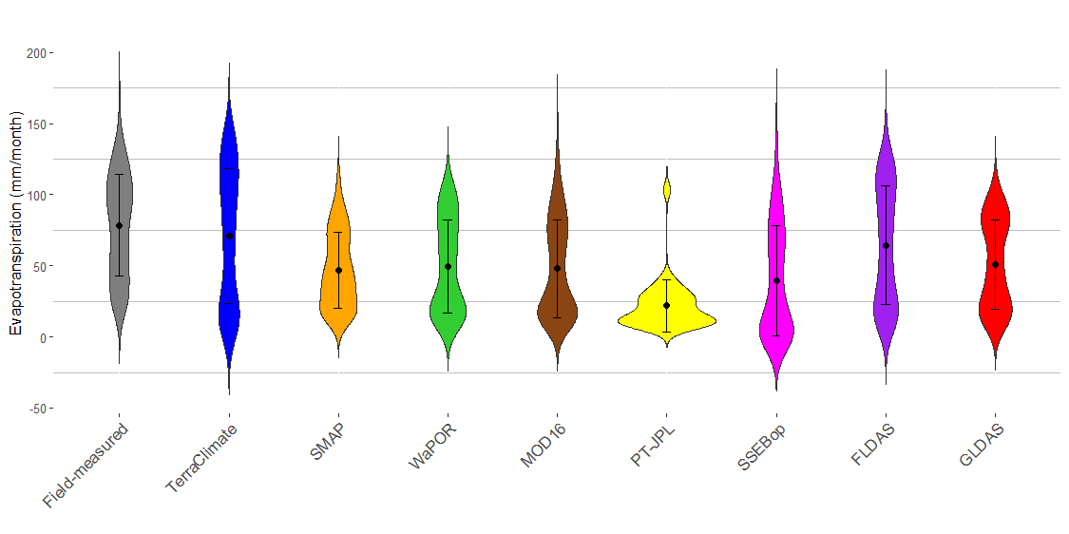  (c) Grassland | 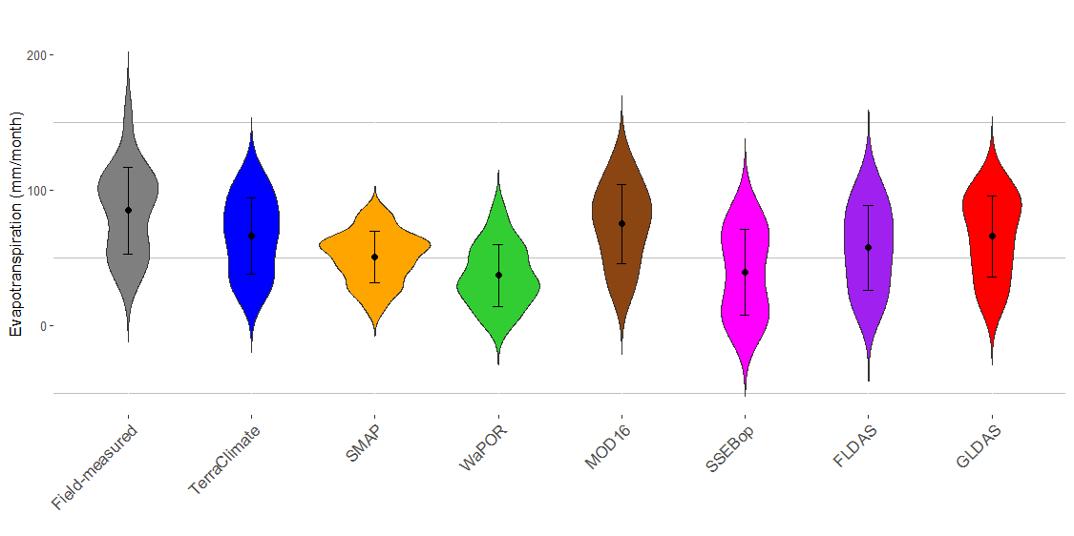  (d) Indian Ocean Coastal Belt
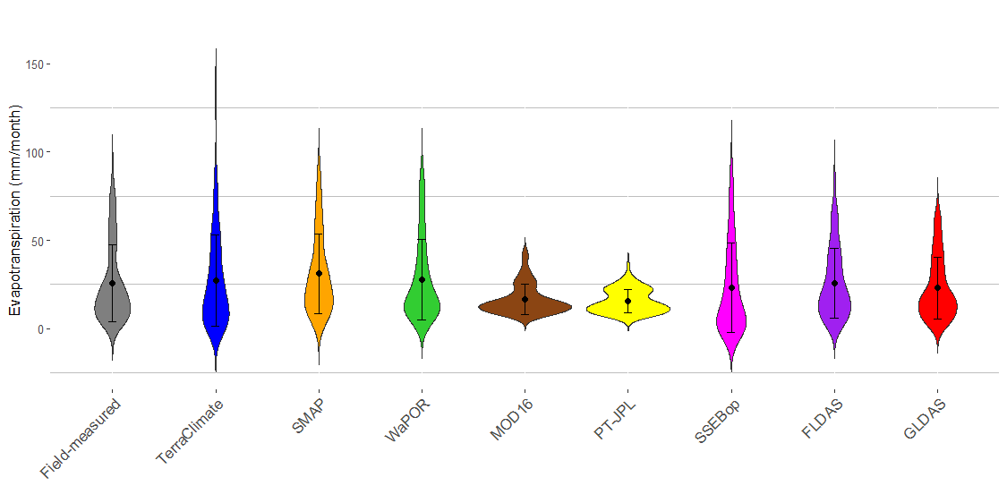  (e) Nama-Karoo | 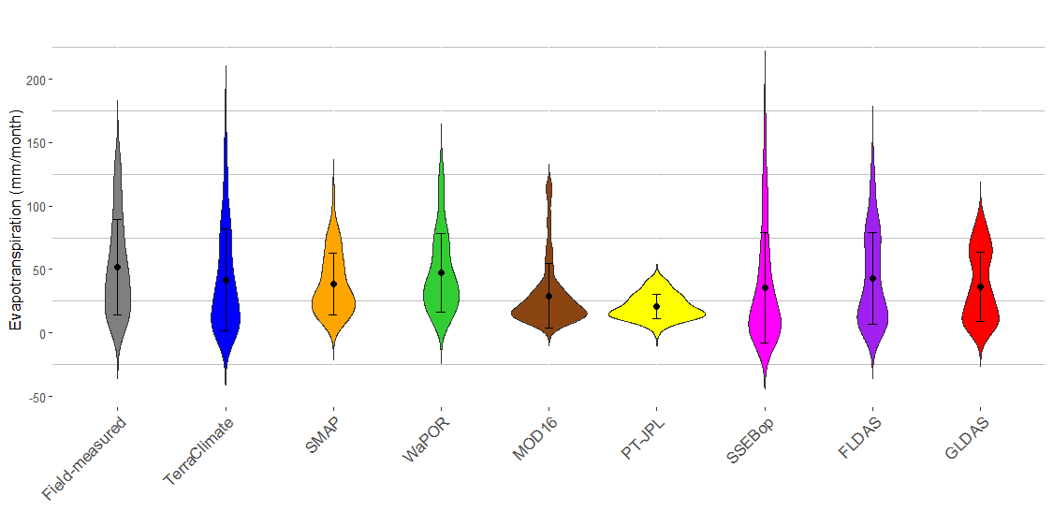  (f) Savanna
Figure S 32. Violin plots showing the distribution of monthly evapotranspiration (mm/month) for field-measured and satellite-derived product estimates for sites grouped according to biome. The mean and ± standard deviation are shown as error bars within each plot.
Table S 9. Table showing the performance of satellite-derived evapotranspiration products across the flux tower sites. Performance metrics include the Spearman Correlation Coefficient (r_{s}), Kling Gupta Efficiency (KGE), Percent Bias (PBias), for the Overall period.
TerraClimate | r_{s} | KGE | PBias | SMAP | r_{s} | KGE | PBias | WaPOR | r_{s} | KGE | PBias | MOD16 | r_{s} | KGE | PBias
BF1 | 0.91 | 0.69 | -20.45 | BF1 | 0.77 | 0.41 | -28.58 | BF1 | 0.90 | 0.57 | -27.73 | BF1 | 0.88 | -0.01 | -68.79
BF2 | 0.80 | 0.23 | -61.17 | BF2 | 0.87 | 0.14 | -53.14 | BF2 | 0.93 | 0.33 | -48.24 | BF2 | 0.92 | -0.11 | -76.77
CP3 | 0.80 | 0.39 | 3.28 | CP3 | 0.65 | 0.48 | -33.74 | CP3 | 0.90 | 0.67 | -26.97 | CP3 | 0.72 | 0.52 | -40.93
CP6 | 0.91 | 0.80 | -7.76 | CP6 | 0.88 | 0.45 | -39.47 | CP6 | 0.89 | 0.57 | -36.29 | CP6 | 0.90 | 0.68 | -29.33
CP9 | 0.84 | 0.15 | -23.96 | CP9 | 0.68 | 0.44 | -47.47 | CP9 | 0.92 | 0.50 | -46.95 | CP9 | 0.75 | 0.40 | -52.96
EW1 | 0.86 | 0.74 | -19.15 | EW1 | 0.88 | 0.74 | -11.27 | EW1 | 0.80 | 0.82 | 9.42 | EW1 | 0.95 | 0.86 | -11.31
EW2 | 0.81 | 0.69 | -20.24 | EW2 | 0.89 | 0.79 | -10.71 | EW2 | 0.77 | 0.67 | 21.86 | EW2 | 0.96 | 0.86 | -8.54
EZU | 0.74 | 0.48 | 9.11 | EZU | 0.80 | 0.72 | 19.81 | EZU | 0.61 | 0.53 | 30.72 | EZU | 0.69 | 0.44 | -22.27
JHK | -0.10 | -0.21 | -42.79 | JHK | 0.37 | 0.14 | -60.71 | JHK | 0.78 | 0.53 | -27.44 | JHK | 0.80 | 0.41 | -50.73
MB1 | 0.85 | 0.69 | 8.59 | MB1 | 0.91 | 0.74 | 24.49 | MB1 | 0.89 | 0.84 | 9.64 | MB1 | 0.69 | 0.30 | -33.61
MB2 | 0.85 | 0.72 | 3.14 | MB2 | 0.89 | 0.81 | 18.24 | MB2 | 0.88 | 0.83 | 5.63 | MB2 | 0.63 | 0.22 | -37.95
MCP | 0.63 | 0.51 | -21.79 | MCP | 0.83 | 0.37 | -40.35 | MCP | 0.77 | 0.32 | -56.47 | MCP | 0.94 | 0.82 | -13.86
MLP | 0.77 | 0.44 | -25.67 | MLP | 0.60 | 0.60 | -27.65 | MLP | 0.61 | 0.34 | 15.61 | MLP | 0.41 | 0.41 | -30.37
SKU | 0.78 | 0.67 | 5.91 | SKU | 0.93 | 0.73 | -8.26 | SKU | 0.64 | 0.52 | 38.63 | SKU | 0.85 | 0.81 | -6.78
SSEBop | r_{s} | KGE | PBias | PT-JPL | r_{s} | KGE | PBias | FLDAS | r_{s} | KGE | PBias | GLDAS | r_{s} | KGE | PBias
BF1 | 0.90 | 0.69 | -0.44 | BF1 | 0.63 | 0.02 | -57.97 | BF1 | 0.96 | 0.76 | -21.57 | BF1 | 0.95 | 0.57 | -30.97
BF2 | N/A | N/A | N/A | BF2 | N/A | N/A | N/A | BF2 | 0.91 | 0.39 | -47.21 | BF2 | 0.95 | 0.32 | -50.48
CP3 | 0.70 | 0.38 | -45.06 | CP3 | 0.69 | 0.01 | -69.18 | CP3 | 0.78 | 0.67 | -20.09 | CP3 | 0.80 | 0.67 | -27.46
CP6 | 0.89 | 0.53 | -44.22 | CP6 | 0.77 | 0.01 | -67.75 | CP6 | 0.92 | 0.85 | -11.77 | CP6 | 0.92 | 0.60 | -32.73
CP9 | 0.73 | 0.21 | -64.59 | CP9 | 0.59 | -0.04 | -74.04 | CP9 | 0.81 | 0.28 | -25.41 | CP9 | 0.84 | 0.50 | -45.32
EW1 | 0.84 | 0.55 | 24.60 | EW1 | 0.71 | 0.10 | -48.07 | EW1 | 0.92 | 0.57 | -25.70 | EW1 | 0.95 | 0.60 | -25.33
EW2 | 0.75 | 0.09 | 76.03 | EW2 | 0.64 | 0.07 | -49.81 | EW2 | 0.92 | 0.62 | -29.33 | EW2 | 0.94 | 0.64 | -29.01
EZU | 0.56 | 0.39 | 3.07 | EZU | N/A | N/A | N/A | EZU | 0.72 | 0.65 | 12.61 | EZU | 0.57 | 0.55 | -15.26
JHK | 0.68 | 0.33 | -48.69 | JHK | 0.53 | -0.11 | -73.53 | JHK | 0.49 | 0.48 | -28.64 | JHK | 0.44 | 0.05 | -64.14
MB1 | 0.77 | 0.72 | -8.42 | MB1 | 0.67 | 0.12 | -40.25 | MB1 | 0.89 | 0.88 | 2.93 | MB1 | 0.90 | 0.78 | -8.00
MB2 | 0.78 | 0.76 | -14.60 | MB2 | 0.67 | 0.12 | -40.87 | MB2 | 0.90 | 0.83 | -2.24 | MB2 | 0.89 | 0.72 | -12.62
MCP | 0.70 | 0.42 | -51.11 | MCP | 0.25 | -0.08 | -50.06 | MCP | 0.91 | 0.66 | -32.28 | MCP | 0.92 | 0.75 | -22.28
MLP | 0.75 | 0.22 | -42.45 | MLP | N/A | N/A | N/A | MLP | 0.59 | 0.26 | -12.15 | MLP | 0.61 | 0.45 | -41.55
SKU | 0.87 | 0.58 | -38.72 | SKU | N/A | N/A | N/A | SKU | 0.91 | 0.86 | 0.89 | SKU | 0.91 | 0.73 | -12.19

Table S 10. Table showing the performance of satellite-derived evapotranspiration products across the flux tower sites. Performance metrics include the Spearman Correlation Coefficient (r_{s}), Kling Gupta Efficiency (KGE), Percent Bias (PBias), for the Overall – Log transformed period.
TerraClimate | r_{s} | KGE | PBias | SMAP | r_{s} | KGE | PBias | WaPOR | r_{s} | KGE | PBias | MOD16 | r_{s} | KGE | PBias
BF1 | 0.85 | 0.35 | -18.60 | BF1 | 0.62 | 0.57 | -4.13 | BF1 | 0.90 | 0.76 | -6.26 | BF1 | 0.88 | 0.48 | -25.34
BF2 | 0.83 | 0.38 | -25.83 | BF2 | 0.69 | 0.46 | -14.57 | BF2 | 0.94 | 0.85 | -14.97 | BF2 | 0.80 | 0.51 | -30.46
CP3 | 0.54 | -0.14 | -4.76 | CP3 | 0.39 | 0.55 | -10.74 | CP3 | 0.90 | 0.35 | -10.89 | CP3 | 0.72 | 0.35 | -15.53
CP6 | 0.83 | 0.45 | -6.47 | CP6 | 0.75 | 0.81 | -11.72 | CP6 | 0.89 | 0.70 | -13.23 | CP6 | 0.90 | 0.73 | -11.04
CP9 | 0.71 | -1.37 | -14.34 | CP9 | 0.46 | -0.15 | -17.44 | CP9 | 0.92 | -0.42 | -18.52 | CP9 | 0.75 | -0.56 | -22.00
EW1 | 0.53 | 0.29 | -11.56 | EW1 | 0.84 | 0.82 | -1.90 | EW1 | 0.80 | 0.71 | 4.05 | EW1 | 0.95 | 0.86 | -2.83
EW2 | 0.50 | 0.18 | -12.85 | EW2 | 0.81 | 0.87 | -3.88 | EW2 | 0.77 | 0.57 | 7.89 | EW2 | 0.96 | 0.93 | -3.21
EZU | 0.56 | 0.50 | 0.10 | EZU | 0.64 | 0.79 | 5.42 | EZU | 0.61 | 0.59 | 9.28 | EZU | 0.69 | 0.57 | -5.82
JHK | 0.01 | -1.33 | -16.20 | JHK | 0.15 | -0.16 | -22.23 | JHK | 0.78 | 0.05 | -8.58 | JHK | 0.80 | 0.47 | -16.36
MB1 | 0.68 | 0.59 | -3.65 | MB1 | 0.70 | 0.81 | 9.27 | MB1 | 0.89 | 0.84 | 4.82 | MB1 | 0.69 | 0.46 | -5.52
MB2 | 0.67 | 0.62 | -4.87 | MB2 | 0.66 | 0.78 | 7.88 | MB2 | 0.88 | 0.88 | 2.23 | MB2 | 0.63 | 0.40 | -7.04
MCP | 0.35 | 0.54 | -6.14 | MCP | 0.64 | 0.74 | -11.84 | MCP | 0.77 | -0.41 | -23.16 | MCP | 0.94 | 0.82 | -3.81
MLP | 0.59 | -0.27 | -18.39 | MLP | 0.28 | 0.30 | -12.79 | MLP | 0.61 | 0.59 | 2.50 | MLP | 0.41 | 0.37 | -12.53
SKU | 0.33 | 0.47 | 4.31 | SKU | 0.43 | 0.57 | 9.77 | SKU | 0.64 | 0.44 | 16.86 | SKU | 0.64 | 0.51 | 8.77
SSEBop | r_{s} | KGE | PBias | PT-JPL | r_{s} | KGE | PBias | FLDAS | r_{s} | KGE | PBias | GLDAS | r_{s} | KGE | PBias
BF1 | 0.90 | 0.43 | -10.16 | BF1 | 0.63 | 0.29 | -16.73 | BF1 | 0.96 | 0.83 | -9.50 | BF1 | 0.95 | 0.89 | -10.05
BF2 | N/A | N/A | N/A | BF2 | N/A | N/A | N/A | BF2 | 0.82 | 0.76 | -15.77 | BF2 | 0.84 | 0.82 | -16.18
CP3 | 0.70 | -1.65 | -30.52 | CP3 | 0.69 | 0.43 | -29.75 | CP3 | 0.78 | 0.10 | -9.31 | CP3 | 0.80 | 0.36 | -10.36
CP6 | 0.89 | -0.90 | -34.78 | CP6 | 0.77 | 0.59 | -27.27 | CP6 | 0.92 | 0.68 | -5.78 | CP6 | 0.92 | 0.76 | -11.25
CP9 | 0.73 | -3.80 | -46.84 | CP9 | 0.59 | -0.10 | -33.13 | CP9 | 0.81 | -0.79 | -12.41 | CP9 | 0.84 | -0.58 | -18.16
EW1 | 0.84 | 0.73 | 5.27 | EW1 | 0.71 | 0.49 | -13.78 | EW1 | 0.92 | 0.85 | -6.96 | EW1 | 0.95 | 0.85 | -6.78
EW2 | 0.75 | 0.56 | 16.39 | EW2 | 0.64 | 0.40 | -14.91 | EW2 | 0.92 | 0.80 | -10.25 | EW2 | 0.94 | 0.86 | -9.95
EZU | 0.56 | -0.18 | -4.53 | EZU | N/A | N/A | N/A | EZU | 0.72 | 0.70 | 2.84 | EZU | 0.57 | 0.52 | -6.27
JHK | 0.68 | -1.92 | -20.23 | JHK | 0.53 | 0.39 | -29.47 | JHK | 0.49 | 0.26 | -8.41 | JHK | 0.44 | 0.22 | -23.37
MB1 | 0.77 | 0.10 | -20.93 | MB1 | 0.67 | 0.34 | -6.49 | MB1 | 0.89 | 0.89 | 1.80 | MB1 | 0.90 | 0.89 | -0.90
MB2 | 0.78 | 0.15 | -22.29 | MB2 | 0.67 | 0.39 | -7.52 | MB2 | 0.90 | 0.88 | 0.51 | MB2 | 0.89 | 0.86 | -2.15
MCP | 0.70 | -1.88 | -28.69 | MCP | 0.25 | 0.20 | -16.94 | MCP | 0.91 | 0.18 | -11.66 | MCP | 0.92 | 0.56 | -7.02
MLP | 0.75 | -1.62 | -43.83 | MLP | N/A | N/A | N/A | MLP | 0.59 | -0.36 | -14.38 | MLP | 0.61 | -0.23 | -23.06
SKU | 0.60 | -0.11 | -30.46 | SKU | N/A | N/A | N/A | SKU | 0.71 | 0.66 | 4.22 | SKU | 0.70 | 0.71 | 3.87

Table S 11. Table showing the performance of satellite-derived evapotranspiration products across the flux tower sites. Performance metrics include the Spearman Correlation Coefficient (r_{s}), Kling Gupta Efficiency (KGE), Percent Bias (PBias), for the Interannual period.
TerraClimate | r_{s} | KGE | PBias | SMAP | r_{s} | KGE | PBias | WaPOR | r_{s} | KGE | PBias | MOD16 | r_{s} | KGE | PBias
BF1 | 0.50 | -0.92 | -20.30 | BF1 | 0.50 | 0.12 | -29.20 | BF1 | -1.00 | -1.04 | -27.58 | BF1 | -1.00 | -1.23 | -69.01
BF2 | N/A | N/A | N/A | BF2 | N/A | N/A | N/A | BF2 | N/A | N/A | N/A | BF2 | N/A | N/A | N/A
CP3 | 1.00 | 0.34 | 4.22 | CP3 | -0.50 | -0.72 | -27.61 | CP3 | 1.00 | 0.46 | -27.96 | CP3 | 0.50 | 0.07 | -39.45
CP6 | 0.77 | 0.68 | -6.68 | CP6 | 0.73 | 0.46 | -42.45 | CP6 | 0.20 | 0.44 | -36.98 | CP6 | 0.77 | 0.68 | -29.07
CP9 | 0.50 | -0.02 | -20.65 | CP9 | 0.50 | -1.78 | -44.27 | CP9 | 1.00 | 0.47 | -45.77 | CP9 | 0.50 | -0.73 | -51.54
EW1 | N/A | N/A | N/A | EW1 | N/A | N/A | N/A | EW1 | N/A | N/A | N/A | EW1 | N/A | N/A | N/A
EW2 | 1.00 | 0.35 | -20.24 | EW2 | 0.50 | 0.04 | -10.71 | EW2 | 1.00 | 0.73 | 21.86 | EW2 | 1.00 | 0.61 | -8.54
EZU | 1.00 | 0.63 | 5.56 | EZU | 1.00 | 0.81 | 18.91 | EZU | -1.00 | -1.08 | 29.11 | EZU | 1.00 | 0.26 | -26.03
JHK | 1.00 | 0.33 | -45.37 | JHK | -0.50 | -0.65 | -60.10 | JHK | 0.50 | 0.73 | -24.81 | JHK | 0.50 | 0.25 | -50.18
MB1 | 0.70 | 0.67 | 7.33 | MB1 | 0.83 | 0.64 | 24.18 | MB1 | 0.77 | 0.48 | 13.28 | MB1 | 0.89 | 0.39 | -33.68
MB2 | 0.54 | 0.35 | 1.50 | MB2 | 0.66 | 0.63 | 17.44 | MB2 | 0.49 | 0.49 | 9.13 | MB2 | 0.94 | 0.31 | -38.16
MCP | N/A | N/A | N/A | MCP | N/A | N/A | N/A | MCP | N/A | N/A | N/A | MCP | N/A | N/A | N/A
MLP | N/A | N/A | N/A | MLP | N/A | N/A | N/A | MLP | N/A | N/A | N/A | MLP | N/A | N/A | N/A
SKU | 1.00 | 0.78 | -1.97 | SKU | 1.00 | 0.82 | -14.19 | SKU | 1.00 | 0.93 | 7.10 | SKU | 1.00 | 0.79 | -18.34
SSEBop | r_{s} | KGE | PBias | PT-JPL | r_{s} | KGE | PBias | FLDAS | r_{s} | KGE | PBias | GLDAS | r_{s} | KGE | PBias
BF1 | 1.00 | 0.47 | -0.98 | BF1 | 0.50 | -0.21 | -62.62 | BF1 | 1.00 | 0.61 | -22.29 | BF1 | 0.50 | 0.29 | -31.65
BF2 | N/A | N/A | N/A | BF2 | N/A | N/A | N/A | BF2 | N/A | N/A | N/A | BF2 | N/A | N/A | N/A
CP3 | -1.00 | -0.85 | -40.45 | CP3 | -0.50 | -0.53 | -70.19 | CP3 | -0.50 | -0.34 | -22.61 | CP3 | -0.50 | -0.21 | -29.76
CP6 | 0.52 | 0.52 | -38.64 | CP6 | 0.26 | -0.26 | -53.97 | CP6 | 0.73 | 0.80 | -12.34 | CP6 | 0.53 | 0.54 | -32.82
CP9 | 0.50 | -1.87 | -60.66 | CP9 | -1.00 | -1.41 | -75.85 | CP9 | 0.50 | -0.98 | -25.55 | CP9 | 0.50 | 0.01 | -46.14
EW1 | N/A | N/A | N/A | EW1 | N/A | N/A | N/A | EW1 | N/A | N/A | N/A | EW1 | N/A | N/A | N/A
EW2 | 1.00 | 0.04 | 76.03 | EW2 | N/A | N/A | N/A | EW2 | 1.00 | 0.45 | -29.33 | EW2 | 0.50 | 0.50 | -29.01
EZU | -1.00 | -1.01 | -2.86 | EZU | -1.00 | -1.09 | -73.68 | EZU | 1.00 | 0.07 | 3.82 | EZU | -1.00 | -1.17 | -24.57
JHK | 0.87 | 0.05 | -51.60 | JHK | -1.00 | -1.09 | -73.68 | JHK | -0.50 | -0.45 | -29.52 | JHK | 1.00 | 0.11 | -64.60
MB1 | 0.89 | 0.15 | -7.91 | MB1 | 0.40 | -0.17 | -28.59 | MB1 | 0.94 | 0.48 | 0.79 | MB1 | 0.71 | 0.72 | -10.54
MB2 | 0.77 | -0.21 | -12.53 | MB2 | 0.20 | -0.18 | -30.64 | MB2 | 0.83 | 0.45 | -4.68 | MB2 | 0.49 | 0.51 | -15.39
MCP | N/A | N/A | N/A | MCP | N/A | N/A | N/A | MCP | N/A | N/A | N/A | MCP | N/A | N/A | N/A
MLP | N/A | N/A | N/A | MLP | N/A | N/A | N/A | MLP | N/A | N/A | N/A | MLP | N/A | N/A | N/A
SKU | 1.00 | 0.48 | -45.68 | SKU | N/A | N/A | N/A | SKU | 1.00 | 0.70 | -4.79 | SKU | 1.00 | 0.58 | -23.78

Table S 12. Table showing the performance of satellite-derived evapotranspiration products across the flux tower sites. Performance metrics include the Spearman Correlation Coefficient (r_{s}), Kling Gupta Efficiency (KGE), Percent Bias (PBias), for the Seasonal period.
TerraClimate | r_{s} | KGE | PBias | SMAP | r_{s} | KGE | PBias | WaPOR | r_{s} | KGE | PBias | MOD16 | r_{s} | KGE | PBias
BF1 | 0.98 | 0.80 | -19.32 | BF1 | 0.91 | 0.43 | -29.25 | BF1 | 0.97 | 0.59 | -28.08 | BF1 | 0.88 | -0.03 | -69.53
BF2 | 0.84 | 0.23 | -61.17 | BF2 | 0.94 | 0.14 | -53.14 | BF2 | 0.94 | 0.33 | -48.24 | BF2 | 0.80 | -0.11
CP3 | 0.85 | 0.37 | -0.22 | CP3 | 0.74 | 0.56 | -35.42 | CP3 | 0.93 | 0.64 | -29.76 | CP3 | 0.73 | 0.55 | -43.00
CP6 | 0.99 | 0.83 | -7.83 | CP6 | 0.96 | 0.45 | -39.16 | CP6 | 0.98 | 0.59 | -36.28 | CP6 | 0.92 | 0.69 | -29.98
CP9 | 0.87 | 0.07 | -26.23 | CP9 | 0.71 | 0.46 | -49.54 | CP9 | 0.95 | 0.47 | -48.32 | CP9 | 0.76 | 0.37 | -55.27
EW1 | 0.91 | 0.80 | -16.53 | EW1 | 0.90 | 0.78 | -12.22 | EW1 | 0.87 | 0.78 | 9.65 | EW1 | 0.97 | 0.84 | -11.85
EW2 | 0.90 | 0.78 | -20.24 | EW2 | 0.97 | 0.88 | -10.71 | EW2 | 0.84 | 0.66 | 21.86 | EW2 | 0.99 | 0.88 | -8.54
EZU | 0.79 | 0.52 | 7.99 | EZU | 0.92 | 0.70 | 19.05 | EZU | 0.72 | 0.60 | 33.10 | EZU | 0.78 | 0.53 | -22.64
JHK | -0.29 | -0.41 | -45.67 | JHK | 0.42 | 0.17 | -60.55 | JHK | 0.92 | 0.51 | -25.33 | JHK | 0.98 | 0.50 | -49.19
MB1 | 0.92 | 0.88 | 8.24 | MB1 | 0.99 | 0.75 | 24.62 | MB1 | 0.98 | 0.87 | 9.71 | MB1 | 0.63 | 0.30 | -33.55
MB2 | 0.94 | 0.93 | 2.74 | MB2 | 0.98 | 0.80 | 18.29 | MB2 | 0.95 | 0.88 | 5.50 | MB2 | 0.59 | 0.22 | -37.93
MCP | 0.85 | 0.60 | -22.21 | MCP | 0.92 | 0.42 | -40.44 | MCP | 0.84 | 0.29 | -56.94 | MCP | 0.97 | 0.84 | -13.89
MLP | 0.84 | 0.37 | -26.43 | MLP | 0.67 | 0.43 | -13.35 | MLP | 0.58 | 0.24 | 19.21 | MLP | 0.38 | 0.51 | -27.36
SKU | 0.92 | 0.75 | 6.45 | SKU | 0.96 | 0.77 | -8.73 | SKU | 0.94 | 0.67 | 20.72 | SKU | 0.88 | 0.77 | -8.42
SSEBop | r_{s} | KGE | PBias | PT-JPL | r_{s} | KGE | PBias | FLDAS | r_{s} | KGE | PBias | GLDAS | r_{s} | KGE | PBias
BF1 | 0.91 | 0.55 | 0.06 | BF1 | 0.57 | -0.07 | -62.36 | BF1 | 0.98 | 0.75 | -22.24 | BF1 | 0.99 | 0.58 | -31.43
BF2 | 0.84 | 0.44 | -50.46 | BF2 | 0.50 | 0.06 | -5.66 | BF2 | 0.82 | 0.39 | -47.21 | BF2 | 0.84 | 0.32 | -50.48
CP3 | 0.96 | 0.53 | -46.96 | CP3 | 0.75 | 0.09 | -64.60 | CP3 | 0.85 | 0.66 | -23.04 | CP3 | 0.78 | 0.67 | -29.94
CP6 | 0.82 | 0.22 | -67.83 | CP6 | 0.80 | 0.00 | -62.76 | CP6 | 0.94 | 0.84 | -11.95 | CP6 | 0.97 | 0.62 | -32.83
CP9 | 0.89 | 0.60 | 24.64 | CP9 | 0.55 | 0.05 | -69.11 | CP9 | 0.78 | 0.16 | -28.16 | CP9 | 0.79 | 0.45 | -47.70
EW1 | 0.76 | 0.07 | 76.03 | EW1 | 0.66 | 0.21 | -46.86 | EW1 | 0.86 | 0.62 | -25.34 | EW1 | 0.97 | 0.63 | -25.28
EW2 | 0.53 | 0.31 | 0.08 | EW2 | 0.84 | 0.15 | -50.68 | EW2 | 0.95 | 0.62 | -29.33 | EW2 | 0.99 | 0.65 | -29.01
EZU | 0.85 | 0.40 | -44.57 | EZU | 0.80 | -0.01 | -73.68 | EZU | 0.87 | 0.52 | 9.00 | EZU | 0.70 | 0.59 | -18.49
JHK | 0.85 | 0.87 | -9.19 | JHK | 0.87 | 0.15 | -36.93 | JHK | 0.75 | 0.60 | -27.37 | JHK | 0.41 | 0.07 | -64.20
MB1 | 0.88 | 0.82 | -14.98 | MB1 | 0.87 | 0.12 | -38.95 | MB1 | 0.97 | 0.93 | 2.51 | MB1 | 0.97 | 0.83 | -8.32
MB2 | 0.64 | 0.45 | -43.93 | MB2 | 0.14 | -0.12 | -25.30 | MB2 | 0.96 | 0.86 | -2.70 | MB2 | 0.96 | 0.74 | -12.98
MCP | 0.74 | 0.06 | -43.03 | MCP | 0.57 | -0.07 | -62.36 | MCP | 0.96 | 0.65 | -34.63 | MCP | 0.94 | 0.75 | -24.35
MLP | 0.89 | 0.55 | -40.33 | MLP | N/A | N/A | N/A | MLP | 0.70 | 0.20 | -10.47 | MLP | 0.67 | 0.51 | -39.32
SKU | 0.91 | 0.55 | 0.06 | SKU | N/A | N/A | N/A | SKU | 0.97 | 0.82 | 1.34 | SKU | 0.94 | 0.83 | -12.15

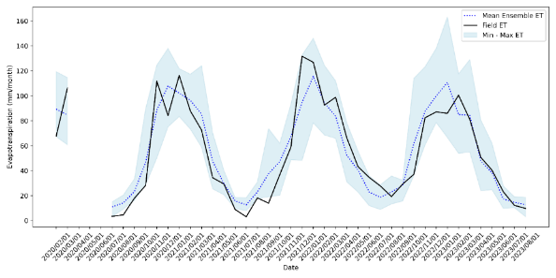
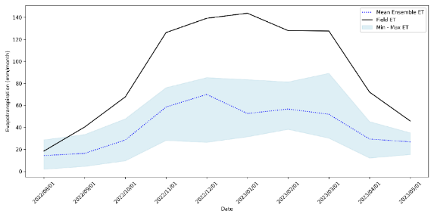
Figure S 33. Ensemble evapotranspiration time series plots for Benfontein - Site 1 (top) and Site 2 (bottom)
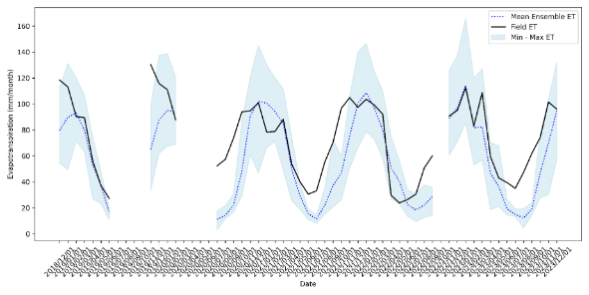
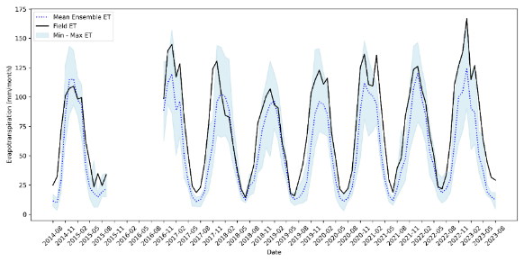
Figure S . Ensemble evapotranspiration time series plots for Cathedral Peak sites - Catchment 3 (top) and Catchment 6 (bottom)
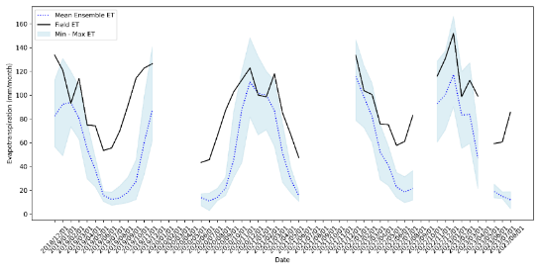
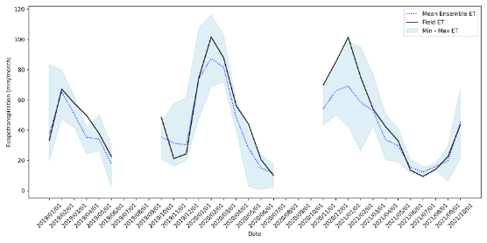
Figure S 35. Ensemble evapotranspiration time series plots for Cathedral Peak- Catchment 9 site (top) and Endwell – Site 1 (bottom)

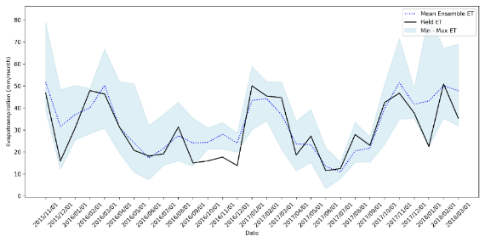
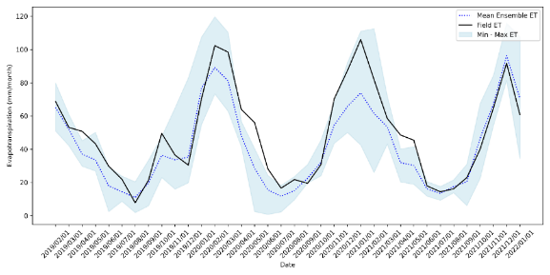
Figure S . Ensemble evapotranspiration time series plots for Endwell – Site 2 (top) and Ezulu (bottom)
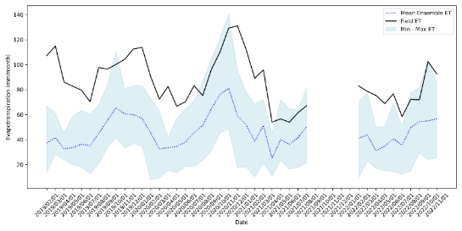
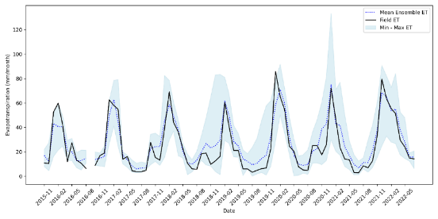
Figure S 37. Ensemble evapotranspiration time series plot for the Jonkershoek site (top) and Middelburg – Site 1 (bottom)

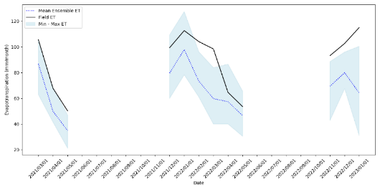
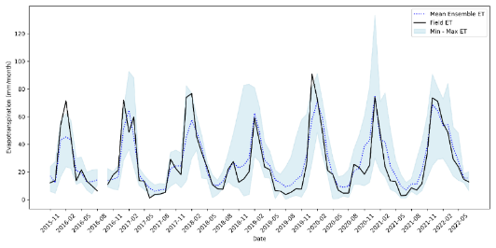
Figure S 38. Ensemble evapotranspiration time series plots for the Middelburg – Site 2 (top) and Maputaland Coastal Plain site (bottom)
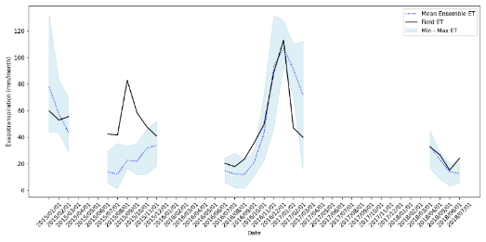
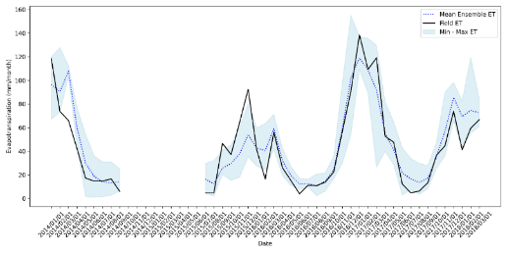
Figure S 39. Ensemble evapotranspiration time series plot for the Malopeni site (top) and Skukuza site (bottom)

Table S 13. Table showing the performance of the ensemble across the flux tower sites. Performance metrics include the Spearman Correlation Coefficient (r_{s}), Kling Gupta Efficiency (KGE), Percent Bias (PBias), for all the frequencies including (i)Overall period, (ii) (ii) Log transformed, (iii) Interannual, and (iv) Seasonal periods.
(i) Normal | r_{s} | KGE | PBias | (ii)Logged | r_{s} | KGE | PBias
BF1 | 0.92 | 0.87 | 3.62 | BF1 | 0.92 | 0.75 | 4.00
BF2 | 0.88 | 0.19 | -55.40 | BF2 | 0.88 | 0.73 | -17.14
CP3 | 0.75 | 0.69 | -20.88 | CP3 | 0.75 | 0.42 | -8.14
CP6 | 0.93 | 0.73 | -24.49 | CP6 | 0.93 | 0.80 | -8.48
CP9 | 0.81 | 0.48 | -39.47 | CP9 | 0.81 | -0.44 | -15.80
EW1 | 0.96 | 0.76 | -12.40 | EW1 | 0.96 | 0.85 | -2.38
EW2 | 0.94 | 0.81 | -14.42 | EW2 | 0.94 | 0.92 | -4.20
EZU | 0.79 | 0.80 | 8.95 | EZU | 0.79 | 0.78 | 3.29
JHK | 0.65 | 0.33 | -46.40 | JHK | 0.65 | 0.62 | -13.97
MB1 | 0.93 | 0.81 | 11.50 | MB1 | 0.93 | 0.73 | 8.31
MB2 | 0.94 | 0.78 | 6.37 | MB2 | 0.94 | 0.72 | 7.06
MCP | 0.81 | 0.63 | -25.06 | MCP | 0.81 | 0.86 | -6.37
MLP | 0.67 | 0.58 | -15.05 | MLP | 0.67 | 0.47 | -7.90
SKU | 0.92 | 0.86 | 6.56 | SKU | 0.92 | 0.74 | 5.79
(iii) Interannual | r_{s} | KGE | PBias | (iv)Seasonal | r_{s} | KGE | PBias
BF1 | 0.50 | 0.21 | 3.71 | BF1 | 0.97 | 0.93 | 3.64
BF2 | N/A | N/A | N/A | BF2 | 0.88 | 0.19 | -55.40
CP3 | 0.50 | -0.05 | -19.36 | CP3 | 0.75 | 0.70 | -23.28
CP6 | 0.79 | 0.43 | -24.31 | CP6 | 0.97 | 0.74 | -24.69
CP9 | 0.50 | -0.53 | -37.83 | CP9 | 0.86 | 0.42 | -41.93
EW1 | 0.50 | 0.73 | -12.36 | EW1 | 0.96 | 0.81 | -11.50
EW2 | 1.00 | 0.48 | -14.42 | EW2 | 0.97 | 0.84 | -14.42
EZU | 1.00 | 0.27 | 3.55 | EZU | 0.90 | 0.88 | 8.00
JHK | 0.50 | 0.11 | -47.08 | JHK | 0.78 | 0.39 | -46.29
MB1 | 0.77 | 0.66 | 11.59 | MB1 | 0.97 | 0.83 | 11.85
MB2 | 0.71 | 0.57 | 6.21 | MB2 | 0.96 | 0.80 | 6.62
MCP | N/A | N/A | N/A | MCP | 0.89 | 0.57 | -25.46
MLP | N/A | N/A | N/A | MLP | 0.72 | 0.53 | -13.37
SKU | 1.00 | 0.95 | -4.69 | SKU | 0.96 | 0.93 | 6.16

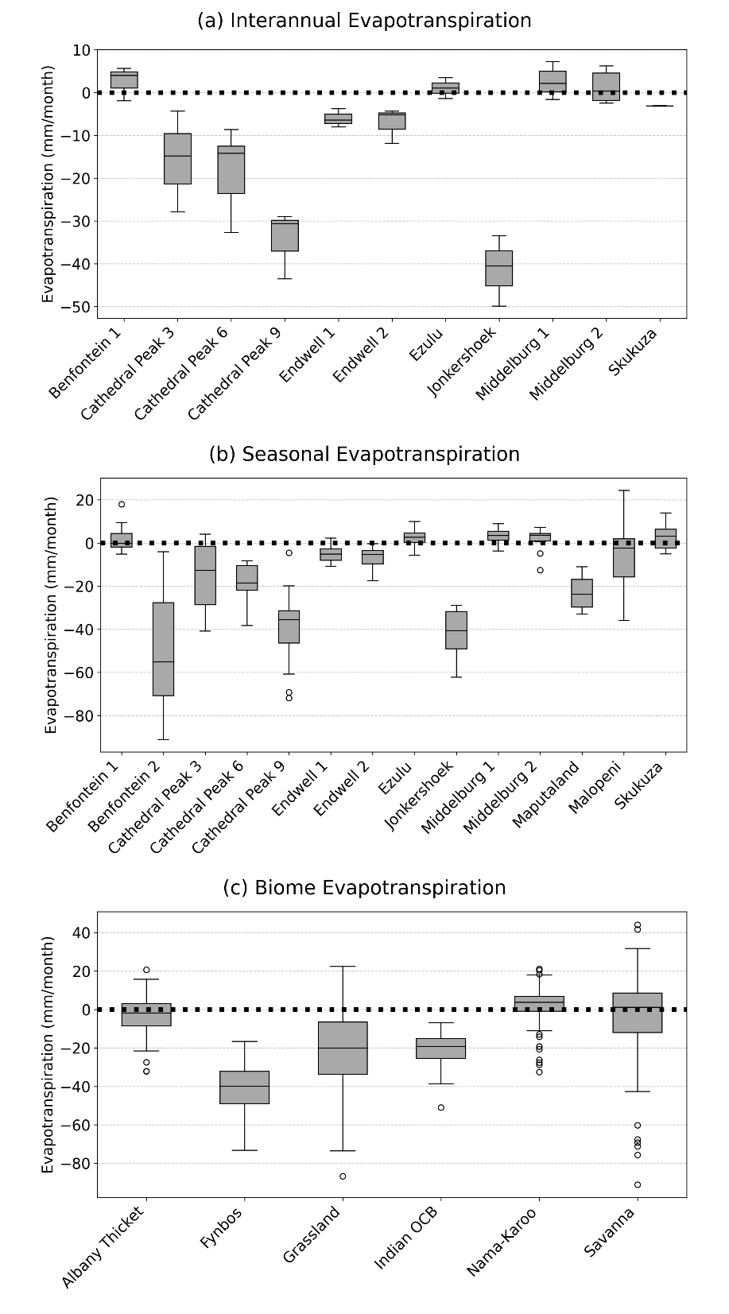
Figure S . Box-whisker plots showing the error in variation of interannual evapotranspiration (mm/month) of the ensemble evapotranspiration estimates from the field-measured evapotranspiration across the 14 flux tower sites.

