Technical Assistance to SADC Secretariat on Intra-ACP Climate Services and Related Applications
Status of implementation of OSF at SADC CSC and SARCOF
SADC Secretariat
August 2024

August 2024

SADC Climate Services Centre
Directorate of Infrastructure
SADC Secretariat



Notice
This document and its contents have been prepared and are intended solely as information for Click here to enter client name. and use in relation to TECHNICAL ASSISTANCE TO SADC SECRETARIAT ON INTRA-ACP CLIMATE SERVICES AND RELATED APPLICATIONS.
AtkinsRéalis assumes no responsibility to any other party in respect of or arising out of or in connection with this document and/or its contents.
This document has 109 pages including the cover.

Document history
Document title: Status of implementation of OSF at SADC CSC and SARCOF.
Document reference: Revision | Purpose description | Originated | Checked | Reviewed | Authorised | Date
1.0 | Status of implementation of OSF at SADC CSC and SARCOF | PW | FC | SDW | AM | 15.08.2024

Client signoff
Client | SADC Secretariat
Project | Technical Assistance to SADC Secretariat on Intra-ACP Climate Services and Related Applications
Job number | Contract no. SADC/3/5/2/50.
Client signature/date

Executive summary 4
1. Introduction 15
1.1 Background 15
1.1.1 About the project 15
1.2 About the report 15
2. OSF implementation status 17
2.1 Status of seasonal forecasting and OSF at CSC prior to commencement of SADC ClimSA 17
2.1.1 SARCOF forecast process and products prior to ClimSA 17
2.2 OSF roadmap developed during ClimSA and its implementation 22
2.2.1 Status of OSF at CSC against the expected Roadmap outcomes 23
2.2.2 Status of OSF at CSC against the WMO OSF principles 28
2.3 Contribution of seasonal forecasting products and activities towards fulfilling WMO RCC requirements by CSC 32
3. Description of implemented tools, products and processes 34
3.1 Climate Expert Meeting Standard Operating Procedure 34
3.1.1 Functionality 34
3.1.2 Operationalisation 34
3.2 SARCOF forecast verification tool (CFT Verification Module) 35
3.2.1 Functionality 35
3.2.2 Operationalisation 36
3.3 Forecast synthesis tool 37
3.3.1 Functionality 37
3.3.2 Operationalisation 38
3.4 Changes to the consensus process 39
3.4.1 Functionality 39
3.4.2 Operationalisation 39
3.5 Changes to the presentation of the consensus forecast 40
3.5.1 Operationalisation 40
4. Regional seasonal forecast processing system at SADC CSC 43
4.1 General functionality 43
4.2 Operationalization 44
4.3 Products available within the automated system as of August 2024 44
5. Future developments and action plan 46
Contents

Executive summary
Background
The ClimSA programme aims to strengthen the climate service value-chain through building the capacities of decision-makers at all levels to make effective use of climate information and services.​As part of that aim the SADC ClimSA project has an objective to improve delivery of effective climate services at the regional and national level. To deliver this objective, one of the necessary pre-requisites to achieving this is the availability of a relevant, reliable, and useful seasonal forecasting system that produces products that are underpinned by robust climate science principles and evidence. For that, the seasonal forecast procedures must be traceable, reproducible, and well documented, i.e., fulfilling the characteristics of the Objective Seasonal Forecast (OSF) as laid down by the World Meteorological Organisation (WMO)’s Guidance on Operational Practices for Objective Seasonal Forecasting.

Objective
This report provides an overview of developments in processes and products related to seasonal forecasting at the Southern African Development Community (SADC) Climate Services Center (CSC) implemented by ClimSA TA and summarizes the current (August 2024) status of these products and processes. Specifically, it sets the developments against:
- OSF principles formulated by WMO (WMO, 2020).
- OSF roadmap developed in the earlier phases of ClimSA (SADC Climsa, 2023).
- Mandatory Regional Climate Center (RCC) functions as determined by WMO RCC requirements (WMO, nd).
Based on the above, recommendations about future activities towards strengthening of OSF processes at SADC CSC are made.
The report is accompanied by two appendices that support OSF implementation:
Appendix A: A manual for the automated system of processing of multi-model ensemble seasonal forecast implemented at SADC CSC.
Appendix B: Evaluation of skill of dynamical models over the SADC region.

Roadmap for implementation of OSF at CSC
The implementation of OSF at SADC CSC was guided by a Roadmap (SADC ClimSA, 2023). The development of that roadmap was based on the following:
- Stocktake of climate services systems at the SADC CSC (SADC ClimSA, 2021).
- Experiences from ClimSA TA contributing to the Southern African Regional Climate Outlook Forum (SARCOF) 26 and 27, including:
  - Revision of training materials used during CEM,
  - Review of the Climate Forecasting Tool (CFT).
- Feedback from members of SARCOF Technical Steering Committee (TSC) established during ClimSA.
- Feedback from National Meteorological and Hydrological Services (NHMS) experts participating in the Climate Expert Meeting (CEM) process.
The guiding principle for the roadmap that emerged from the above was that there was limited understanding and willingness amongst the NHMS forecasters and SADC CSC staff to abandon the consensus process based on statistical forecasts generated at country level and replace it with processing of multi-model ensembles of dynamical forecasts generated by Global Producing Centres (GPCs).
The roadmap focused on implementation of OSF principles in two sub-contexts:
- Enhancing the current SARCOF forecast production process by improving documentation, defining a robust methodology, traceability, as well as incorporating a multi-model ensemble of dynamical forecasts from GPCs. As per WMO recommendations, it was envisaged to initially introduce the multi-model ensemble of dynamical forecasts as a source of information parallel to the traditional (although improved) consensus forecast. The multi-model forecasts, if shown meritorious and useful from the stakeholders' perspective, may with time become the primary basis of the SARCOF outlook.
- At SADC CSC the development of automated data downloads and processing streams for the production of an OSF forecast. That is accompanied by confidence building at SADC CSC to form the basis for i) regular (monthly - frequency to be determined by NMHSs as per OSF guidelines) updates of regional seasonal forecast based on multi-model ensemble of dynamical models, and ii) development of seasonal forecast products other than the mean seasonal rainfall, including tailored products. Those products will then be “mainstreamed” into the SARCOF process as an addition to and extension of the consensus product - to support evolving the forecast process much like that of IGAD Climate Prediction & Applications Centre (ICPAC) allowing more time for national forecast production and sectoral interactions. Additionally, to be published on the SADC CSC website.

Key messages about implementation of OSF
The main messages about the status of implementation of OSF principles at CSC are as follows:

OSF Principle: Follow a traceable, reproducible, and well-documented procedure (including model selection, bias correction, calibration and statistical downscaling) that is amenable to assessments of forecast quality (verification);
At SARCOF: | A forecast synthesis tool and improvements of the process of synthesising multi-source forecast at country level, enable a traceable and relatively objective decision about the forecast signal and confidence. The tool and revised template for presentation of country level forecast allow to keep track of the process of synthesising country-level forecasts.  The consensus process includes mapping of a spatially coherent forecast signal rather than deriving signal for pre-determined zones and incorporation of forecast confidence information, leading to a more objective process underlying consensus forecast.
At CSC: | Developed an automated forecast processing system based on established and well-documented software - International Research Institute for Climate and Society (IRI)’s PyCPT (Munoz et al., 2019). This system generates regular (monthly) forecasts based on a multi-model ensemble of dynamical forecast models from GPCs. This is accompanied by a comprehensive evaluation of the skill of individual models over the SADC region.
Going forwards: | Review and revision of CFT software is needed.
OSF Principle: Use of dynamical climate models, including multi-model ensembles, as the primary basis for seasonal forecasts;
At SARCOF: | Introduced forecasts from Multi-Model Ensembles (WMO, ECMWF, IRI) into the process of deriving the consensus regional forecast, and a statement of forecast from these ensembles is included in the Outlook document.
At CSC: | Developed an automated forecast processing system based on established and well documented software - IRI’s PyCPT. This system generates regular (monthly) forecasts based on a multi-model ensemble of dynamical forecast models from GPCs. This is accompanied by a comprehensive evaluation of skill of individual models over the SADC region leading to a skill-informed multi-model ensemble.
Going forwards: | Comprehensively and regularly investigate skill of SARCOF forecast against the skill of dynamical MME towards generating Outlook document based on best available information.
OSF Principle: Establish and maintain observational databases (including databases associated with reanalysis and other blended analysis products) of adequate quality, length of record and spatial resolution for verification, bias correction and calibration and to monitor drivers of seasonal predictability;
At SARCOF: | The practice of contribution by NHMSs of monthly station data used during the SARCOF CEM process towards regional database trialled during SSARCOF-27.
At CSC: | The WMO led workshop on data sharing as part of ClimSA led to the recommendations for collaboration, data sharing, and mechanisms for improving regional observation networks.  More recently these activities have continued through ClimSA addressing data rescue.  SADC CSC has a key role to play in supporting regional data sharing for the purpose of improving climate services and increasing climate resilience in a changing climate.
Going forwards: | Data sharing processes and a regional database still to be developed (by SADC CSC). Development of station-based products conditional on these.
OSF Principle: Identify and monitor drivers of predictable climate variability and assess their representation and prediction skill in models;
At SARCOF: | Revised presentation for CEM/SARCOF on “current state of climate system” includes hyperlinks to relevant sources of drivers' data and visualizations. Process described in CEM Standard Operating Procedures (SOP).
At CSC: | Not addressed.
Going forwards: | Evaluation of the regionally relevant sources of predictability and design and implementation of an automated system of processing relevant data towards web-based products.
OSF Principle: Ensure that forecasts are verified according to established standards, keep archives of past forecasts, and conduct post-season assessments;
At SARCOF: | Developed CFT verification tool allowing verification of CEM 4-category forecasts according to WMO recommendations.  Evaluation of skill of past SARCOF forecasts.
At CSC: | Forecasts emerging from the automated system are accompanied by a number of skill measures
Going forwards: | Verification or evaluation of the single forecasts from the automated system against observed (station) data can potentially be implemented.
OSF Principle: Provide forecast information together with historical performance (for example, skill and reliability); Use clear and non-technical language to communicate seasonal forecasts, including emphasising the probabilistic nature and inherent uncertainty of seasonal forecasts;
At SARCOF: | Revised the consensus process and the emerging forecast product to include a layer informing on reliability of the forecast. While this is not an expression of skill or performance per se but rather its proxy, this level of information is considered commensurate with the level of detail of disseminated information.  For forecasters participating in the CEM process - a presentation summarizing skill of historical forecasts is available.
At CSC: | Forecast products available through the current SADC CSC website include maps masked by skill and encompass both deterministic and probabilistic information.
Going forwards: | Work towards creating understanding of the nature of the probabilistic forecast and the value of information on forecast skill through UIP activities.
OSF Principle: Collaborate across regions influenced by the same climate drivers in forecast production through mechanisms such as RCOFs;
At SARCOF: | SARCOF is an established process. No additional activities carried out by TA team under ClimSA towards this objective.
Going forwards: | The development of MoUs for research collaboration mechanisms with ICPAC, IOC and ACMAD on African wide challenges would benefit the SADC region.
OSF Principle: Provide seasonal forecasts as well as regular updates on a fixed operational schedule tailored to the applicable decision-making context;
At SARCOF: | SARCOF is an established process with timing aligned to seasons and user needs.
At CSC: | Developed an automated forecast processing system generating a range of monthly and seasonal forecast products or a regular (monthly) basis.
Going forwards: | Further tailor products towards sectoral needs.
OSF Principle: Establish user feedback and product upgrade mechanisms and support co-production of tailored products.
At CSC: | User feedback is key to the development of products that SADC CSC produces. The first point of call for feedback will be established through the UIP helpdesk through the to be developed SADC CSC website. Surveys and questions can be posed to the SADC CSC Community of Practice Whatsapp group for quick interactions and responses on particular challenges or issues.
Going forwards: | In the longer term the Regional Sectoral User Interface Platforms should act as the primary mechanism for co-development of tailored products and evaluating their usefulness.
Key messages from model skill evaluation
The results of the preliminary skill assessment provided a basis for the selection of models and predictors to use in the implemented PyCPT installation at the SADC CSC for the automated generation of seasonal and monthly forecasts (http://csc.sadc.int/en/seasonal-forecast-main/). Based on this assessment, it is recommended that:
Three models (METEOFRANCE8, GCFS2p1, and SPSv3p5) be excluded from the ensemble due to their relatively poor performance when region-average skill is considered.
The multi-model ensemble should thus be composed of the following models: SEAS51, GEOSS2S, CanSIPSIC3, GCFS2p1, CFSv2, CCSM4.
PCR MOS function should be used, as it gives relatively consistently better results than the CCA approach.
SST-global predictor should be used, as it tended to consistently generate forecasts with a satisfactory level of skill across all seasons even though it was outperformed in some instances by other predictors, e.g., by PRCP-sadc in the MAM season averaged over the entire SADC region (Figure B7).
Furthermore, it is recommended that SADC CSC engages further with the process of skill evaluation to improve on the results provided here, in particular that a regional predictability workshop/hackathon is organized to:
further investigate the potential use of another set of predictors that work best in the region.
investigate how forecast skill changes with the different phases of major climate drivers and teleconnections in the region, for example, ENSO and IOD phases have been found to largely drive precipitation patterns in the region (Rouault et al., 2024).
Investigating whether the forecast models correctly capture the atmospheric dynamics and processes behind the teleconnections towards ensuring that the models used are skilful for the right reasons.
Such assessments can provide invaluable insights to GPCs and aid them on how to further improve the models to support climate resilience activities across the SADC region that in turn builds trust and deeper engagement with users.
Key recommendations
Table ES1 presents recommendations of future activities towards strengthening of OSF at SARCOF.
Table ES1 Future developments towards improvement and strengthening of OSF at SARCOF and CSC.
Activity | Priority | Expected impact from OSF perspective
Strengthening SADC CSC human resources to support forecasting processes | Moderate | Moderate
Consultation with WMO towards feedback on achievements, way forward and their support going forwards. | Moderate | Moderate
Ensuring that the processes underlying SARCOF/CEM forecast and described in the CEM SOP are adhered to, particularly in terms of archiving forecast products and data for further use, and that SOP is being regularly reviewed and updated to reflect on-going developments and changes. | High | High
SADC CSC taking full ownership of processes and tools developed during ClimSA. | High | High
Peer review and improvements of CFT software | High | High
Extending the CFT forecast verification tool to include functionality to evaluate single-forecast performance of forecast products other than the 4-category, CEM-style probabilistic forecast, for example - of probabilistic/deterministic forecasts from dynamical multi-model ensembles. | Low | High
Further developments of the presentation of the SARCOF outlook rainfall product, in particular expansion of the documentation of the forecast product, including, but not limited to examples of how the outlook should be interpreted by end users. This could be achieved through a co-productive process within the UIP. | High | High
Extension of the outlook document to include forecast products other than rainfall forecast, such as forecast of temperature, intra-seasonal rainfall characteristics, onset of rainy season, drought, heat waves, sector-specific tailored indices. These can be first implemented in and sourced from the automated system at SADC CSC. | High | High
Initiating UIP activities towards co-development of user-driven forecast skill metrics | Moderate | Moderate
Evaluation of the skill of forecast from a multi-model ensemble of dynamical models (as emerging from the automated system at SADC CSC) vs. that of the SARCOF forecast generated during CEM, building towards informed decision about advantages and disadvantages of dynamical model-based forecasts in the SADC region as a forecast basis for the SARCOF Outlook document. | Moderate | Moderate
Organisation of a regional predictability workshop/hackathon with participants from global/regional research and operational institutions involved in seasonal forecasting and from SADC NHMSs, working towards systematization and improvement of understanding of sources of seasonal predictability in the SADC region, and ultimately, towards incorporation of the most informative predictors in the forecast generation processes. | Moderate | High
Porting the automated system from its current server to HPC. | High | Moderate
Incorporation of the products generated by the system in the new, upgraded SADC CSC website. | High | High
Extension of functionality of the automated system to include forecast of onset of the rainy season, drought and sector-specific tailored indices. | Moderate | Moderate
Comprehensive investigation of optimal predictors for variables other than those evaluated during ClimSA (i.e. other than total seasonal rainfall), and if necessary - adaptation of the currently implemented multi-model ensemble. | Moderate | Moderate
Building on monthly monitoring bulletins - develop monthly forecast bulletins, working towards a comprehensive regional Climate Watch. | High | High
Revive the idea of sharing monthly rainfall data by NHMS to create a coherent regional database of station data to support seasonal forecast verification and generation, and as a pre-requisite to generation of a regional gridded dataset like ENACT product. | Moderate | Moderate

Acronyms
Acronym | Longer Definition
2AFC | Two Alternative Forced Choice
AGRHYMET | Institute of the Permanent Interstate Committee for Drought Control in the Sahel
ARC | African Rainfall Climatology
ASO | August-September-December
AUC | African Union Commission
BOM | Bureau of Meteorology - Australia
CAPC-AC | Climate Application and Prediction Centre of Central Africa
CCA | Canonical Correlation Analysis
CDD | Consecutive Dry Days
CEM | Climate Expert Meeting
CFT | Climate Forecasting Tool
CHIRPS | Climate Hazards Group InfraRed Precipitation with Station data
CHIRTS | Climate Hazards Group InfraRed Temperature with Station data
CPT | Climate Predictability Tool
CS | Climate Services
CSIS | Climate Services Information System
ClimSA | Intra-ACP Climate Services and related Applications Programme
CMO | Caribbean Meteorological Organisation
CWD | Consecutive Wet Days
DJF | December-January-February
DMC | Drought Monitoring Centre
DRC | Democratic Republic of Congo
ECMWF | European Centre for Medium-Range Weather Forecasts
ENACT | Enhancing National Climate Services
ENSO | El-Nino Southern Oscillation
EOF | Empirical Orthogonal Functions
ETCCDI | Expert Team on Climate Change Detection and Indices
ERA5 | ECMWF Reanalysis 5th Generation
EU | European Union
EUMETSAT | European Organisation for the Exploitation of Meteorological Satellites
FEWSNET | Famine Early Warning Systems Network
GPC | Global Producing Centre
GPH | Geopotential Height
GTS | Global Telecommunication System
ICPAC | IGAD Climate Prediction and Applications Centre
IGAD | Intergovernmental Authority on Development
IOC | Indian Ocean Commission
IOD | Indican Ocean Dipole
IRI | International Research Institute for Climate and Society
JRC | European Commission’s Joint Research Centre (JRC)
KEs | Key Experts
LRF | Long Range Forecast
MAM | March-April-May
MME | Multi-Model Ensemble
MOS | Model Output Statistics
MS | Member States
MTR | Mid-Term Review
NDJ | November-December-January
NDVI | Normalized difference vegetation index
NMHS | National Meteorological and Hydrological Services
OACPS | Organisation of African, Caribbean, and Pacific States
OND | October-November-December
OS | Operating System
OSF | Objective Seasonal Forecasting
PCR | Principal Components Regression
PO | Programme Officer
PR | Precipitation
PRCP | Precipitation
RCC | Regional Climate Centre
RCOF | Regional Climate Outlook Forum
ROC | Receiver Operating Characteristic
RPSS | Rank Probability Skill Score
SADC | Southern African Development Community
SADC CSC | Southern African Development Community - Climate Services Centre
SARCOF | Southern Africa Regional Climate Outlook Forum
SARCIS-DR | Southern African Regional Climate Information Services for Disaster Resilience Development
SPI | Standardised Precipitation Index
SPREP | Secretariat of the Pacific Regional Environmental Programme
SST | Seas Surface Temperature
STE | Short-term Experts
T2m | Temperature at 2-meter height
TA | Technical Assistance
TAMSAT | Tropical Applications of Meteorology using Satellite data and ground-based observations
TG | Mean Temperature
TSC | Technical Steering Committee
UK Met Office | Meteorological Office of the United Kingdom
UIP | User Interface Platforms
UN | United Nations
USAID | United States Agency for International Development
WMO | World Meteorological Organisation

Introduction

Background

About the project
The Intra-ACP Climate Services and Related Application (ClimSA) programme was initiated by the Organisation of African, Caribbean, and Pacific Stares (OACPS) Secretariat in partnership with European Union (EU). It is implemented through OACPS regional organisations: Indian Ocean Commission (IOC), Southern African Development Community (SADC), Intergovernmental Authority on Development (IGAD), Institute of the Permanent Interstate Committee for Drought Control in the Sahel (AGRHYMET), Caribbean Meteorological Organisation (CMO), Secretariat of the Pacific Regional Environmental Programme (SPREP) and the African Union (AUC) (www.climsa.org).

The ClimSA programme Technical Partners are: The United Nations (UN) World Meteorological Organisation (WMO), the European Commission’s Joint Research Centre (JRC), and the European Organisation for the Exploitation of Meteorological Satellites (EUMETSAT). In the SADC region ClimSA is implemented by SADC Secretariat through its Climate Services Centre (CSC).
The overall objective of ClimSA in SADC is “To strengthen the climate service value chain through building the capacities of decision-makers at all levels to make effective use of climate information and services.” (Contribution Agreement). ClimSA has five outputs:
- Interaction between the user, researchers, and climate services providers in SADC region is structured through a User Interface Platform;
- Provision of climate services at Regional and National level is effectively guaranteed and secured whilst Climate Services Information System (CSIS) are strengthened;
- Access to Climate Information is improved by strengthening observation network, communication technology, enhancing climate monitoring systems and conducting Research, Climate Modelling and Climate Forecasting;
- Capacity of ACP regions is enhanced to generate and apply climate information and products relevant to their particular concerns; and
- Climate-informed decision-making is enhanced and climate services are mainstreamed into policy processes at regional and national levels.

SADC Secretariat has contracted WS Atkins International Ltd. to implement the ClimSA programme in the SADC region. The implementation is structured and defined through the Technical Assistance to SADC Secretariat on Intra-ACP Climate Services and Related Applications project (SADC ClimSA TA project, or TA project). The TA project team consists of three Key Experts (KEs), a team of Short-term Experts (STEs), as well as a Project Director, Project Manager, and Assistant Project Manager. The implementation of the TA project is carried out in close collaboration with SADC Secretariat through its appointed Task Manager and SADC CSC.

About the report
This report provides a summary of activities implemented through the ClimSA TA Project towards the implementation of Objective Seasonal Forecasting (OSF) at the SADC CSC, including all the activities undertaken to improve the SARCOF CEM processes with the ultimate goal being to meet the best practices as outlines in the OSF RoadMap (SADC ClimSA, 2023). The report was developed towards the contribution of the following Objectives and Activities in the ClimSA Programme:

Outcome 3:
Access to Climate Information is improved by strengthening observation network, communication technology, enhancing climate monitoring systems and conducting Research, Climate Modelling and Climate Forecasting.

Activity-3.5: Provide methods and tools for observational datasets and model inter-comparison at the regional scale to SADC CSC to assess which dataset are fit-for-purpose for the SADC region.
Sub-activity:
c: Build its capacity to produce regionally optimized objective seasonal forecasts, develop regional customisation of the Climate Services Toolkit to meet regional needs

In addition to this specific activity, this report also contributed to the following Activities:

Activity 2.1: Enhance SADC CSC capacity to produce, deliver and improve Climate Service, through Climate Service Information System (CSIS) at regional level.
Sub-activity:
c: Set priorities on the core functions as a potential WMO RCC and describe climate services.

Activity 2.5: Define and develop the Regional thematic products for Climate Services.
Sub-activity:
a: Generate the different sectoral tailored climate services with a focus on climate prediction and projection for socio-economic sectors

Activity-3.2: Ensure SADC CSC and NMHS have improved operational access to climate information made available at global level by international partners (Copernicus, ECMWF, EUMETSAT, others), including the promotion of agreements between RCCs and global information providers to sustain access to global data.

In summary, this report provides an overview of developments in processes and products related to seasonal forecasting at CSC implemented by ClimSA TA and summarizes the current (August 2024) status of these products and processes. Specifically, it sets the developments against:
- OSF principles formulated by WMO (WMO, 2020).
- OSF roadmap developed in the earlier phases of ClimSA (SADC ClimSA, 2023).
- Mandatory RCC functions as determined by WMO RCC requirements (WMO, nd).
Based on the above, recommendations about future activities towards strengthening of OSF processes at CSC are made.
The report is accompanied by two appendices:
Appendix A: A manual for the automated system of processing of multi-model ensemble seasonal forecast implemented at CSC.
Appendix B: Evaluation of skill of dynamical models over the SADC region.

OSF implementation status
The ClimSA programme aims to strengthen the climate service value-chain through building the capacities of decision-makers at all levels to make effective use of climate information and services.​As part of that aim the SADC ClimSA project has an objective to improve delivery of effective climate services at the regional and national level. To deliver this objective, one of the necessary pre-requisites to achieving this is the availability of a relevant, reliable, and useful seasonal forecasting system that produces products that are underpinned by robust climate science principles and evidence. For that, the seasonal forecast procedures must be traceable, reproducible, and well documented, i.e., fulfilling the characteristics of the Objective Seasonal Forecast (OSF) as laid down by the WMO Guidance on Operational Practices for Objective Seasonal Forecasting.

Generation of such Long-Range Forecast (LRF) products is one of the core functions of the SADC CSC as a potential WMO Regional Climate Centre (RCC).

Below, we provide a high-level summary description the status of seasonal forecasting prior to the commencement of ClimSA activities, and subsequently highlight developments and current status (August 2024) set against:
- OSF principles formulated by WMO (WMO, 2020)
- OSF roadmap developed in the earlier phases of ClimSA (SADC Climsa, 2023)
- Mandatory RCC functions as determined by WMO RCC requirements (WMO, nd)

Status of seasonal forecasting and OSF at CSC prior to commencement of SADC ClimSA
Prior to commencement on ClimSA, the only seasonal forecasting activity at CSC was the bi-annual Southern Africa Regional Climate Outlook Forum (SARCOF) process.

The CSC website included an automated seasonal forecasting system based on the Arpege 5 system developed by Meteofrance, but that system was no longer functional, and the relevant web page has been disabled during the initial review of the website and climate services products (SADC ClimSA, 2021).

SARCOF forecast process and products prior to ClimSA
SARCOF is a bi-annual event, first established in 1995, where a regional seasonal forecast is generated by a group of experts from the region’s NHMSs, and that information is presented in the form of a Seasonal Outlook document that also includes sectoral advisories.

Broadly, the SARCOF process is composed of two parts:
- Climate Experts Meeting (CEM) during which the seasonal forecast is generated, and the previous season forecast is evaluated.
- SARCOF stakeholders' workshop - during which forecast is presented to stakeholders and sectoral advisories are developed.

Timing of SARCOF events is adjusted to the seasonality of rainfall in most of the SADC region which experiences a summer (Oct/Nov-Mar/Apr) rainfall regime (Figure 2-1). At the start of the season (July/August) SARCOF event prepares the outlook for the first part and mid-rainy season, while the mid-season review, now mid-season (December/January) event prepares an outlook for the mid and late rainy season.

SARCOF forecast is a zonal forecast expressed in the form of four categories: below normal, below normal to normal, normal to above normal and above normal, with prescribed tercile probabilties:

SARCOF below normal: 25,35,40 - tercile above normal, normal and below normal respectively.
SARCOF below normal to normal: 25,40,35 - tercile above normal, normal and below normal respectively.
SARCOF normal to above normal: 35,40,25 - tercile above normal, normal and below normal respectively.
SARCOF above normal: 40,35,25 - tercile above normal, normal and below normal respectively.

Prior to ClimSA:
Zones used to capture regional differences in forecast signal were prescribed and based on classification of regional climate into season-specific homogeneous regions. That classification was done in the past, and documentation of that process is no longer available.
The forecast was presented without any information about its skill and since the forecast categories were set to always present forecast signal, it was impossible to present a climatological (no-skill) forecast or distinguish regions different in the confidence in the forecast.

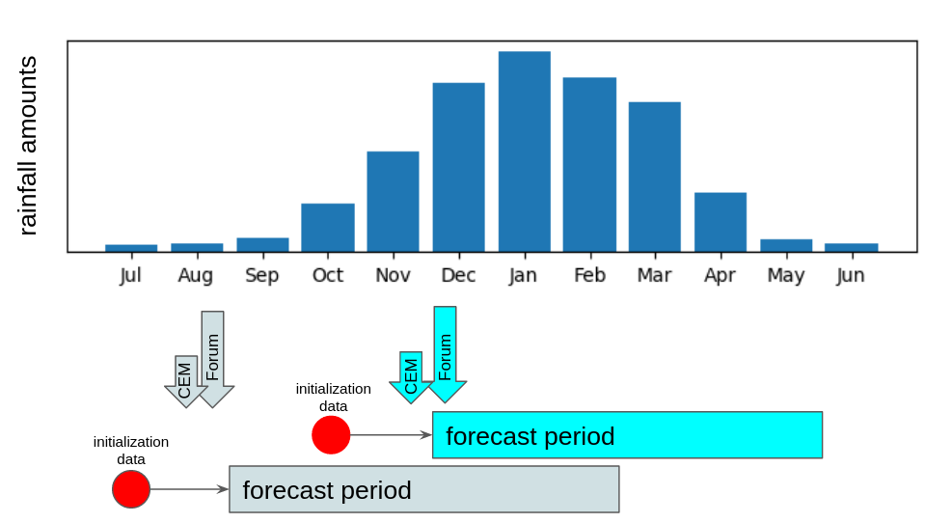
Figure 2-1 - Schematic illustrating timing of SARCOF Fora and CEM events
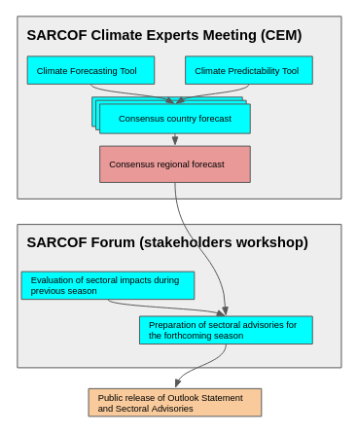
Figure 2-2 - Schematic illustrating the principal elements of SARCOF and CEM processes
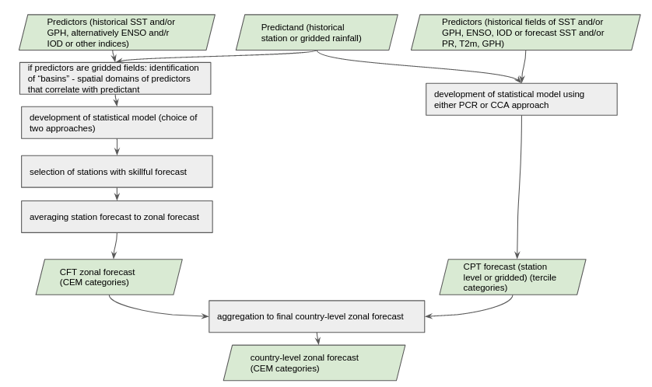
Figure 2-3 - Procedure of derivation of country-level forecast during SARCOF-CEM prior to SARCOF 26
The SARCOF/CEM forecast procedure is relatively complex and involves two main steps:
- Development of country-level forecasts, and
- Aggregation of country forecasts to a regional forecast.

Country level forecast
The country-level forecast is derived based on two parallel analytical approaches - utilising the CFT and the Climate Predictability Tool (CPT) tools (Figure2-2). Each approach involves several choices and modalities (such as selection of predictors, different MOS approaches or different statistical models), and there are no prescribed or even recommended ways of selecting them. The lack of prescribed is in a way appropriate as countries are allowed to make choices that best capture the specificity of their climate. Individual countries typically generate a number of different forecasts based on a range of predictors and statistical models/tools and combine them to generate the final country level forecast.

Prior to ClimSA, there was no structural, formalised way to keep track of the choices made by individual countries. Additionally, there was no guidance on the way of combining results from different predictors or models to generate a country-level forecast. This process was not described in any document, not documented in the material that was archived, and, from observation, not very transparent and subjective. This led to a situation where the building blocks of the regional forecast were created by a variety of untraceable approaches with little consistency across country boundaries.

Regional forecast

Regional level forecast is generated by aggregation of country-level forecasts during the so-called consensus session at CEM (Figure 2-4, Figure 2-5).

Prior to ClimSA, the consensus process, similarly to the process involved in creating the country-level forecast lacked clearly defined rules. The process appeared to be simply a weakly structured discussion that was often influenced by power dynamics amongst participants. Results from the statistical models were rarely interrogated, and contradictions (across country boundaries) were often resolved by referring to the state of ENSO rather than to the statistical models that were the numerical basis for the forecast. The results from dynamical models (multi-model ensembles from GPCs) were rarely considered. There was no structured, formalised way of documenting what factors were considered when the country-level forecast is altered during the consensus session. A large part of the problems arising during that process was the need to derive a single forecast value for each of the pre-determined zones, which often forced individual countries to significantly alter their forecast.

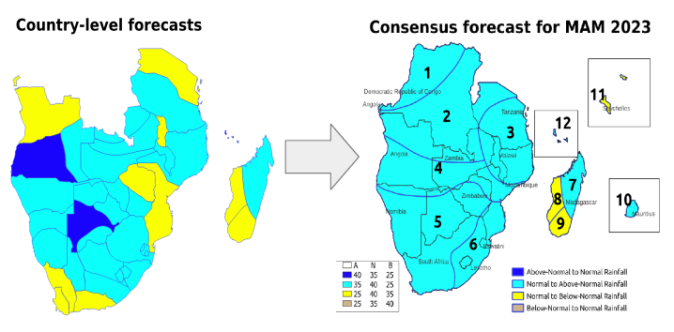
Figure 2-4 - Country-level forecasts for country-level homogeneous climate zones are aggregated to forecast for regional-level homogeneous climate zones, often resulting in a significant loss of information.

Prior to ClimSA, the main analytical tool used in the process - CFT software - lacked documentation other than a rudimentary “how-to-use” power-point presentation, and as a result – it was largely used as a “black box” tool. During ClimSA activities it became evident that the algorithms implemented in CFT have several methodological deficiencies and need to be revised. The main identified deficiencies were:
- Overparameterisation of statistical models developed for individual stations resulting from the use of a large number of correlated explanatory variables.
- Skill measures are not cross validated.
- Disregarding results from stations for which statistical model lacks skill, thus causing zonal forecast to be based on results from often only a small fraction (sometimes as few as one of 20) of all stations that show (questionable, see previous point) skill.

Forecast verification process

The evaluation of individual SARCOF forecasts is done during a dedicated session during CEM.

Prior to ClimSA, that evaluation was done at a regional level by two approaches:
- Visual comparison of the observed anomaly map with a map showing forecast for the same season, although in a different colour scheme (Figure 2-5).
- Calculating intersection of forecast categories and magnitude of observed anomalies, with forecast skill expressed in terms of hits/half-hits/half-misses and misses, which were defined by an intersection of the four forecast and observed classes. The important aspect of the process was that a miss was only possible if the forecast was for a below normal and an above normal category occurred (and vice versa), the remaining intersections created “half” scores, giving an overly optimistic picture of the accuracy of the forecast.

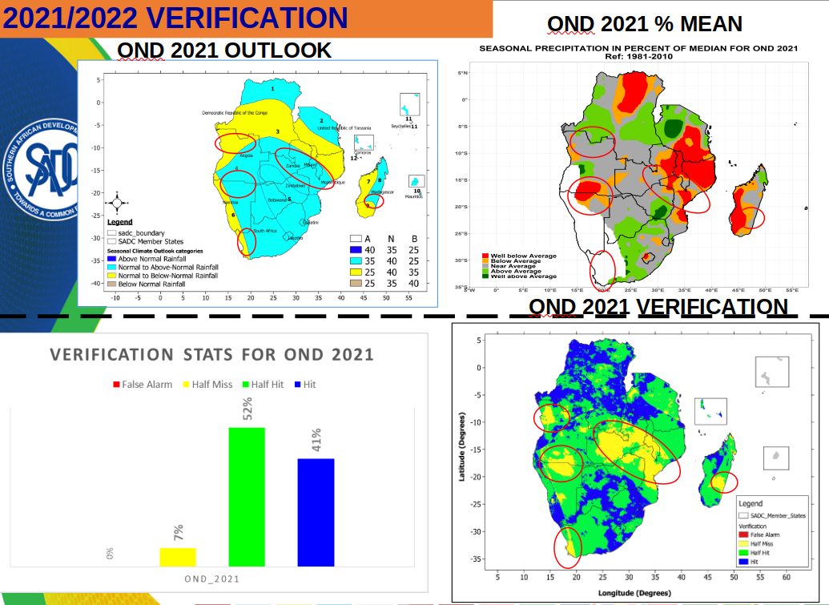
Figure 2-5 - Example of forecast verification prior to introduction of CFT Verification tool.

OSF roadmap developed during ClimSA and its implementation
As part of the ClimSA project the TA team developed a road map towards implementation of OSF at CSC (SADC ClimSA, 2023). The development process was informed by:
- Stocktake of climate services systems at CSC (SADC ClimSA, 2021).
- Experiences from ClimSA TA contributing to SARCOF 26 and 27, including:
  - Revision of training materials used during CEM,
  - Review of the Climate Forecasting Tool.
- Feedback from members of SARCOF Technical Steering Committee (TSC) established during ClimSA.
- Feedback from NHMS experts participating in the CEM process.

The guiding principle for the roadmap that emerged from the above was that there was no willingness amongst the NHMS forecasters and CSC staff to abandon the consensus process based on statistical forecasts generated at country level and replace it with processing of multi-model ensembles of dynamical forecasts generated by Global Producing Centres (GPCs).

The roadmap focused on implementation of OSF principles in two sub-contexts:
- Enhancing the current SARCOF forecast production process to make it better documented, more methodologically sound, and more traceable, as well as incorporating more substantially information sourced from multi-model ensemble of dynamical forecasts. As per WMO recommendations, it was envisaged to initially introduce the multi-model ensemble of dynamical forecasts as a source of information parallel to the traditional (although improved) consensus forecast. The multi-model forecasts, if shown meritorious and useful from the stakeholders' perspective, may with time become the primary basis of the SARCOF outlook.

- At SADC CSC the development of automated data download and processing streams accompanied by confidence building at SADC CSC to form the basis for i) regular (monthly - frequency to be determined by NMHSs as per OSF guidelines) updates of regional seasonal forecast based on multi-model ensemble of dynamical models ii) development of seasonal forecast products other than the mean seasonal rainfall, including tailored products. Those products will then be “mainstreamed” into the SARCOF process as an addition to and extension of the consensus product - to support evolving the forecast process much like that of ICPAC allowing more time for national forecast production and sectoral interactions.

Status of OSF at CSC against the expected Roadmap outcomes
Tables 1 and 2 below summarize the activities envisaged in the Roadmap (SADC ClimSA, 2023) with respect to SARCOF and CSC processes respectively, and their current status. Although not an exhaustive list of tasks it was also recognised throughout the project that not all tasks would be implemented by the TA team and would require action beyond that of ClimSA by SADC CSC, Member State NMHSs and research institutes.

Table 1 - Status of OSF at CSC against the OSF Roadmap activities at SARCOF
Activity | Expected outcome as per OSF roadmap | Implementation status as on August 2024
Finalise development of the CFT verification tool, adopt it through TSC process and external peer review, and include for use in SARCOF. | Verification tool shared and used starting from CEM 27 (peer reviewed from S28) | Verification tool in use during S27 CEM onwards
Revise algorithms in the CFT tool, adopt improvements through TSC process and external peer review. | Peer-reviewed revised CFT used starting at CEM | Out of scope of ClimSA TA work, pending action from CSC.
Develop a comprehensive documentation for CFT. | Documentation and manual available at CEM27 | Powerpoint presentation detailing functionality to be used at CEM provided as a part of CEM SOP.
Develop a formalised record-keeping mechanism for modalities of implementation of CFT and CPT in the process of generating country-level forecast. | Records available at CSC starting from CEM27 | Implemented through the synthesis tool developed and implemented at S28
Develop a rule-based approach and tracking mechanism for the process of deriving zonal country-level forecast from CFT and CPT results. | Records of available at CSC starting from CEM27 | Implemented in the synthesis tool developed and implemented at S28
Develop a rule-based approach and tracking mechanism for the process of consensus outlook production | Records of available at CSC starting from CEM27 | Included in the revised approach to consensus session based on the outputs of the synthesis tool implemented at S28
Introduce presentation of forecast skill into SARCOF Outlook document. | Forecast skill info included starting from S27 | Part of the revised approach to consensus session based on the outputs of the synthesis tool implemented at S28
Introduce the dynamical multi-model ensemble forecast as an addition to consensus forecast into the SARCOF Outlook document, including presentation of forecast skill and discussion of differences between consensus and dynamical model-based results. | Two forecasts included in outlook from S28 | Implemented in SARCOF Outlook document from S27 onwards.
Scrutinize language used in the SARCOF Outlook document from the perspective of readability and user-friendliness and propose changes if necessary. | Revised language used from S28 | Language/template of the SARCOF Outlook revised, but not through a consultative, stakeholder-centred process
Implement functionality of SADC CSC website to present historical SARCOF forecasts and their post-season verification results (as a part of Climate Services Toolkit). | Dedicated web pages available, linked to archive | Not implemented. To be included in the new website by the website developer.
Finalise implementation of the archive of SARCOF forecasts on the SADC CSC system. | Archive organized to be linked to website | Implemented. Archive available on the CSC file system under SARCOF resource directory.
Introduce practice of sharing of monthly station data for generation and verification of country and regional forecasts, linked to the regional database maintained at SADC CSC. | Up-to-date regional station dataset available to experts at CEM | Trailed at S27, but not implemented afterwards.

Table 2 - Status of OSF at CSC against the OSF roadmap activities at CSC
OSF Roadmap Activity | Expected outcome as per road map | Implementation status as of August 2024
Develop an automated data download and processing streams at SADC CSC, to generate seasonal forecast products based on dynamical multi-model ensemble using suitable software package. | Products (data and quicklooks) available for sharing on website and for use at CEM | Implemented
Develop seasonal forecast products based on ensemble of dynamical models (data, visualisations and documentation as well as forecast skill information) to be presented to users through sharing platforms (website, bulletins etc). | Products (data and quicklooks) available for sharing on website and for use at CEM | Implemented. Products available through the current version of the CSC website.
Develop archive of retrospective forecast products (including verification and performance evaluation) based on ensemble of dynamical models to accompany real-time products. | Products (data and quicklooks) available for sharing on website and for use at CEM | Implemented. Skill products and skill-masked versions of forecast products available through the website.
Conduct an interrogation of performance of individual dynamical models and select best models for the SADC region and individual countries according to the current model selection paradigms and including the role of drivers of seasonal predictability in the region. | Defensible multi-model ensemble products shared and used at CEM | Evaluation conducted; ensemble selected. See Appendix B.
Develop data streams, visualisations and documentation allowing presentation of current state of drivers of regional climate at SADC CSC website and feeding into the SARCOF/CEM process. | Products (data and visualizations) available for sharing on website and for use at CEM | Not implemented through the website. Revised presentation for CEM/SARCOF on “current state of climate system” includes hyperlinks to relevant sources of drivers data and visualizations.
Create a monthly station rainfall data archive at SADC CSC aimed at timely collating monitoring data from all SADC states for the purpose of use in regional seasonal forecast development and verification. | Archive available for use to verify forecast at CSC products and at CEM | Not implemented. Out of agreed ClimSA TA scope.
Based on that database, evaluate existing gridded datasets as a source of reference “pseudo-observational” data for SADC-wide seasonal forecast development and verification. | Recommended product used in process of development and verification or regional forecast | Not implemented. Out of agreed ClimSA TA scope.
Develop a library of research material (papers, reports, websites) that describe drivers of regional climate and share it through the SADC CSC website (as a part of Climate Services Toolkit). | Library available through CST | Not implemented. Out of agreed ClimSA TA scope.
Develop appropriate language and information content for the operational MME product to be released by SADC CSC. | Products use adopted language | Not implemented. Out of agreed ClimSA TA scope.
Implement foundational training event for NMHS experts, in collaboration with ICPAC | Foundational training implemented | Implemented.

Status of OSF at CSC against the WMO OSF principles
Table 3 summarizes how the newly implemented products and processes contribute to fulfilment of OSF principles at CSC.
Table 3 - Developments during ClimSA versus the OSF principles.
OSF principle as per WMO | Achievements of ClimSA
Follow a traceable, reproducible, and well-documented procedure (including model selection, bias correction, calibration and statistical downscaling) that is amenable to assessments of forecast quality (verification); | At SARCOF:  - Developed forecast synthesis tool and improvements of the process of synthesising multi-source forecast at country level, enabling a traceable and relatively objective decision about the forecast signal and confidence. The tool and revised template for presentation of country level forecast allow to keep track of the process of synthesising country-level forecasts.  - Improved the consensus process including mapping spatially coherent forecast signal rather than deriving signal for pre-determined zones and incorporation of forecast confidence information, leading to a more objective process underlying consensus forecast.  At CSC:  - Developed an automated forecast processing system based on established and well documented software - IRI’s PyCPT (Munoz et al., 2019). This system generates regular (monthly) forecasts based on a multi-model ensemble of dynamical forecast models from GPCs. This is accompanied by a comprehensive evaluation of skill of individual models over the SADC region.  Going forward: Review and revision of CFT software is needed.
Use of dynamical climate models, including multi-model ensembles, as the primary basis for seasonal forecasts; | At SARCOF:  - Introduced forecasts from Multi-Model Ensembles (WMO, ECMWF, IRI) into the process of deriving the consensus regional forecast, and a statement of forecast from these ensembles is included in the Outlook document.  At CSC:  - Developed an automated forecast processing system based on established and well documented software - IRI’s PyCPT. This system generates regular (monthly) forecasts based on a multi-model ensemble of dynamical forecast models from GPCs. This is accompanied by a comprehensive evaluation of skill of individual models over the SADC region leading to a skill-informed multi-model ensemble.  Going forward: Comprehenisvely and regularly investigate skill of SARCOF forecast against the skill of dynamical MME towards generating Outlook document based on best available information.
Establish and maintain observational databases (including databases associated with reanalysis and other blended analysis products) of adequate quality, length of record and spatial resolution for verification, bias correction and calibration and to monitor drivers of seasonal predictability; | At SARCOF:  - Practice of contribution by NHMSs of monthly station data used during the SARCOF CEM process towards regional database trialled during S27.  At CSC:  - The WMO led workshop on data sharing as part of ClimSA led to the recommendations for collaboration, data sharing, and mechanisms for improving regional observation networks.  - More recently these activities have continued through ClimSA addressing data rescue.  - SADC CSC has a key role to play in supporting regional data sharing for the purpose of improving climate services and increasing climate resilience in a changing climate.  Going forward: Data sharing processes and a regional database still to be developed. Development of station-based products conditional on these.
Identify and monitor drivers of predictable climate variability and assess their representation and prediction skill in models; | At SARCOF:  - Revised presentation for CEM/SARCOF on “current state of climate system” includes hyperlinks to relevant sources of drivers' data and visualizations. Process described in CEM SOP.  At CSC:  - Not addressed.  Going forward: Evaluation of the regionally relevant sources of predictability and design and implementation of an automated system of processing relevant data towards web-based products.
Ensure that forecasts are verified according to established standards, keep archives of past forecasts, and conduct post-season assessments; | At SARCOF:  - Developed CFT verification tool allowing verification of CEM 4-category forecasts according to WMO recommendations.  - Evaluation of skill of past SARCOF forecasts.  At CSC:  - Forecasts emerging from the automated system are accompanied by a number of skill measures  Going forward: Verification (single forecast) of the forecasts from the automated system against observed data can potentially be implemented.
Provide forecast information together with historical performance (for example, skill and reliability);  Use clear and non-technical language to communicate seasonal forecasts, including emphasising the probabilistic nature and inherent uncertainty of seasonal forecasts; | At SARCOF:  - Revised the consensus process and the emerging forecast product to include a layer informing on reliability of the forecast. While this is not an expression of skill or performance per se but rather its proxy, this level of information is considered commensurate with the level of detail of disseminated information.  - For forecasters participating in the CEM process - a presentation summarizing skill of historical forecasts is available.  At CSC:  - Forecast products available through the CSC website include maps masked by skill and encompass both deterministic and probabilistic information.  Going forward: Work towards creating understanding amongst forecast users and producers of the nature of the probabilistic forecast and the value of information on forecast skill through UIP activities.
Collaborate across regions influenced by the same climate drivers in forecast production through mechanisms such as RCOFs; | SARCOF is an established process. No additional activities carried out by TA team under ClimSA towards this objective.
Provide seasonal forecasts as well as regular updates on a fixed operational schedule tailored to the applicable decision-making context; | SARCOF is an established process with timing aligned to seasons and user needs.  at CSC:  - Developed an automated forecast processing system generating a range of monthly and seasonal forecast products or a regular (monthly) basis.  Going forward: Further tailor products towards sectoral needs.
Establish user feedback and product upgrade mechanisms and support co-production of tailored products. | User feedback is key to the development of products that SADC CSC produces. The first point of call for feedback will be established through the UIP helpdesk through the to be developed SADC CSC website. Surveys and questions can be posed to the SADC CSC Community of Practice Whatsapp group for quick interactions and responses on particular challenges or issues. In the longer term the Regional Sectoral User Interface Platforms should act as the primary mechanism for co-development of tailored products and evaluating their usefulness.

Contribution of seasonal forecasting products and activities towards fulfilling WMO RCC requirements by CSC

The contribution of the newly implemented products and processes towards WMO RCC requirements by CSC is presented in Table 4.
Table 4 - CSC operational activities on seasonal forecasting to support RCC functions
RCC function | Implementation status | Legacy data products/processes | Newly implemented products & improvements to the process | Gaps
Interpret and assess relevant LRF products from Global Producing Centres (GPCs), distribute relevant information to RCC Users; and provide feedback to GPCs | Partially implemented | To our knowledge - no operational processes or one-off products available | Presentation of GPC’s multi-model ensemble forecasts is used to support the CEM forecast development process and includes skill information. Comprehensive evaluation of forecast skill of nine dynamical models post-processed at CSC is available. | It is recommended that CSC starts a process of providing feedback to GPCs. This should be carried out with support from WMO.
Generate regional and sub-regional tailored products, relevant to RCC User needs, including seasonal outlooks etc. | Implemented | No products available on operational basis other than bi-annual SARCOF Outlook. | Implemented automated system to generate a range of products based on statistical post-processing of multi-model ensemble forecasts from GPCs, using PyCPT software. List of currently available products in Table 7. | The system includes several basic products but can be extended to provide tailored products.
Generate consensus statement on regional or sub-regional forecasts. | Implemented | At SARCOF Seasonal precipitation consensus forecast. Updated two times a year and the products are posted on the CSC website. | Process improved though:  - Revision of training material used during CEM  - Generation of CEM SOP  - Introduction of verification module suitable for the SARCOF/CEM and compliant with WMO requirements  - Revision of the approach to synthesis of forecast at country level  - Changes in approach to generating consensus forecast at regional level, with the explicit inclusion of results from MME of dynamical forecast models from GPCs | Review and revision of the CFT software used at CEM is an imperative.
Perform verification of RCC quantitative LRF products, including the exchange of basic forecasts and hindcast data. | Partly implemented | No products available. | Performed comprehensive evaluation of forecast skill of nine post-processed dynamical models. | Clarification on what “exchange of basic forecast and hindcast data” means.
Provide online access to RCC products/services to RCC Users. | Partly implemented | Seasonal forecast products pages of CSC website defunct. | Forecast products available through web interface. | To be implemented in the new website currently under development.

Description of implemented tools, products and processes

Climate Expert Meeting Standard Operating Procedure
A Standard Operating Procedures (SOP) document for the SARCOF Climate Experts Meeting (CEM) was created with the following objectives:
- To streamline and systematize the SARCOF forecast production process in alignment with WMO recommended practices for OSF ​(WMO, 2020).
- To ensure consistency of the process of forecast generation at CEM.
- To facilitate creation of “institutional memory” and support capacity building as new staff/forecasting experts are recruited to join the CSC team.

Functionality
The SOP describes the following:
- Timing and scope of SADC CSC actions related to CEM.
- Details of preparatory processes such as:
  - Preparation of event resource directory to archive data, resources and products related to the particular SARCOF event.
  - Review and update of training materials and presentations
- Details of the activities involved in preparation of data and products to be used during CEM and SARCOF Forum, in particular:
- Preparation of last season’s review.
- Preparation of presentation on the state of regional climate and its drivers.
- Preparation of regional seasonal forecast to be used at CEM.
- Preparation of datasets to assist country experts in generation of country-level forecasts during CEM.
- Sources of data for forecast and forecast skill for the WMO, IRI and ECMWF Multi-Model Ensemble forecasting systems, to be used in the consensus session and to be interpreted for the section of the Outlook document that summarizes forecasts from dynamical model ensembles.
- Details of the process of preparation and conducting of consensus forecast session, including pre-generation of regional level forecast based on the country level forecasts.

Operationalisation
The CEM SOP is a live evolving document, intended to capture changing processes as the operational practices for objective seasonal forecasting (OSF) progresses and as scientific research develops into operational tools. There is a need for periodically revising this document as new datasets and information sources become available, as new methods are being incorporated into the SARCOF process (as OSF is mainstreamed) and as new stakeholders needs emerge and are being responded to.

The document should be consulted as the process of preparation for CEM is initiated, and revisited/updated should new elements of the forecast generation process be introduced.

SARCOF forecast verification tool (CFT Verification Module)
The purpose of the CFT Verification Module is to extend the functionality of the SADC Climate Forecasting Tool (CFT) to enable verification of an individual SARCOF forecast, and in effect improving the seasonal forecasting process and its outcomes in the SADC region.

This is in response to the need for objective verification of forecast products required by the OSF methodology, as defined in WMO Guidance on Operational Practices for Objective Seasonal Forecasting ​(WMO, 2020)​.

The CFT Verification Module implements verification approaches recommended by WMO Guidance on Verification of Operational Seasonal Climate Forecasts ​(WMO, 2018)​ with respect to individual forecast maps.

Functionality
The tool is a module of the CFT software, and it enables calculating skill measures for a single “SARCOF style” forecast, i.e. a forecast that has the form of a probabilistic tercile forecast presented using 4-categories with pre-determined tercile probabilities.

In particular:
- Implements a user-selected set of forecast skill measures (Table 5).
- Skill measures are evaluated by comparing forecast to observations over the period for which the forecast was issued, alongside the observed values over the longer-term climatological period are also used in the process.
- The climatological reference period is user-defined.
- Observations can be provided in the form of time series of gridded datasets or as time series data for individual stations.
- Skill measures are presented in the form of:
  - Spatial maps
  - Average values over spatial regions
- The regions for which the forecast is evaluated over can be those for which the forecast was issued, or alternatively, a different set of zones can be provided by the user (e.g., country, or provincial boundaries).
- The outputs are maps generated in the form of images (in jpeg format), but also in the form of data in netCDF format. The data can be used for further analyses or plotting using alternative software.

Table 5 - Skill measures implemented in the CFT Forecast Verification Tool
Product | Is WMO recommended? | Purpose
Forecast category (CEM) | Pre-requisite for skill measures | Evaluation
Forecast tercile category | Pre-requisite for skill measures | Evaluation
Observed Rainfall | Pre-requisite for skill measures | Evaluation
Observed Rainfall Climatology | Pre-requisite for skill measures | Evaluation
Observed Percentile Anomaly | WMO required | Evaluation
Observed Relative Anomaly (%) | Additional | Evaluation
Observed tercile | Additional | Evaluation
Observed CEM Category | Pre-requisite | Evaluation
Heidke skill score | WMO required | Skill/Verification
Ignorance Score | WMO required | Skill/Verification
Average Interest Rate | WMO recommended | Skill/Verification
CEM Hits and Misses | Tailored | Skill/Verification
Ranked Probability Skill Score | Additional | Skill/Verification

Operationalisation
The tool is available as a module to the CFT - a software that is used to generate statistical forecasts by NHMS experts during the CEM meeting. That software is also used by several NHMSs to generate seasonal forecasts at country level for use within the country.

Note:
The Verification module is designed to work with the “SARCOF style” 4-category forecast, and as such its use with other types of forecasts is not possible.

The tool is intended to be implemented at CEM to provide evaluation of the previous forecast:
- At country level, generated by individual countries, to be presented during the CEM
- The verification assessment of the previous SARCOF outlook document, to be presented during the Forecast Evaluation Session at SARCOF.

Forecast synthesis tool
The Forecast synthesis tool - a module of the SADC CFT - was developed and introduced to the CEM process with the following objectives:
- To systematize and structure the CEM process of synthesizing results from multiple forecasts generated by countries towards a “consensus” country-level forecast, and in particular - to increase the level of transparency and objectivity in that process.
- To enable traceability of the country-level forecast (and consequently - the consensus regional forecast).
- To improve record-keeping for country-level forecast.
- To introduce the concept of forecast uncertainty and skill into the process of country level forecast generation through articulation of spatially specific level of “confidence” in the forecast.
- To generate country level forecast outputs in identical form and format to facilitate their compilation into a combined product to be used in the consensus session and thus facilitate propagation of the “confidence” information from country-level to the regional level forecast.

Functionality
The forecast synthesis tool generates a forecast map with an accompanying map of level of confidence in the forecast.

These are determined based on forecaster’s input of:
- Subjectively determined “consensus” forecast category.
- Level of agreement of forecast signal between the various sources of forecast (derived using different tools, e.g. CPT and CFT) and different predictors (e.g. SST or geopotential height), as well as originating from dynamical model ensembles, e.g. WMO or IRI ensemble),
- Assessment of the overall level of skill of these different sources of forecasts.

The two outputs of the tool are:
- Map of forecast category. This simply replicates the forecaster-provided forecast category.
- Map showing level of confidence in the forecast. That is derived using a rule-based decision matrix based on user input of assessment of the level of agreement and the overall level of skill of the forecast, as shown in Table 6. Four levels of confidence of the forecast are used - low, moderate, high and very high.

User input and generated maps are stored as GIS data layers that can subsequently be con-catenated to generate regional map.

The tool is accompanied by a template for presentation of the outputs of forecasts from individual tools/predictors, as shown in Figure 2-6. That template includes three elements:
- Forecast maps from each of the tools/predictors.
- Skill maps from each of the tools/predictors.
- Expression of level of confidence assigned (subjectively) to results of a particular tool/predictor.

The template serves three purposes:
- It is used to present country-level results at the CEM session.
- Provides means for evaluating the overall forecast signal, agreement of different methods/predictors and the overall level of skill.
- Together with the outputs of the Synthesis Tool, it Is used to archive the country-level results for future reference.

Table 6 - Decision matrix facilitating rule-based evaluation of confidence in the forecast. Entries in blue are derived from forecaster’s input in the Synthesis Tool, entries in red - are intended to inform decision about the “consensus” forecast sign
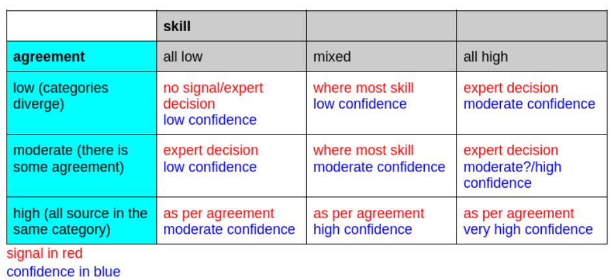
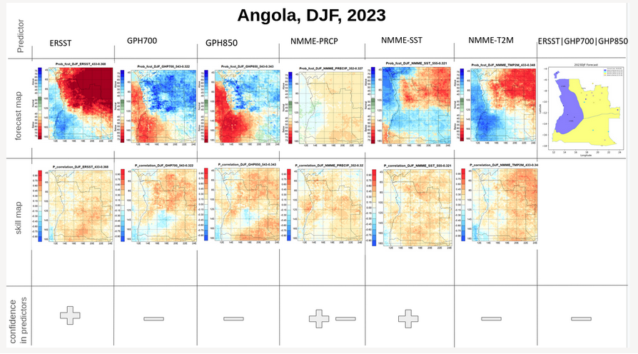
Figure 3-1 – Template for presentation of country level forecast from multiple sources to provide input to the Forecast Synthesis Tool

Operationalisation
Synthesis tool and the accompanying template for presentation of forecasts from multiple sources is used during CEM, in the process of generation of country level forecasts. The Tool and the template, and their objective should be introduced through a dedicated presentation prior to commencement of the country forecast generation session. The process is detailed in CEM SOP document.

Changes to the consensus process
This section describes the changes to the consensus process that are intended to provide traceability of the process and enable an explicit introduction of an indirect expression of forecast uncertainty - namely the information on the confidence in the forecast.

Functionality
There are a number of newly introduced elements of the regional forecast consensus process:
- Compilation of country-level forecast results into “preliminary” regional forecast maps is automated using a dedicated python script (available in SARCOF resource directory on the CSC file system) (Figure 3-1).
- It is recommended that a “preliminary” or “proposed” regional aggregate forecast map is prepared by consensus session facilitator prior to the session. In this way - the focus on discussions during the session can be shifted towards approval of the proposed forecast, rather than on derivation of the signal, allowing for more in-depth discussions, and better focus on the information about confidence in the forecast.
- The information about the confidence in the forecast that is provided for country-level forecasts in the form of four classes (low, moderate, high and very high) is translated into two classes: lower and higher.
- The process where regional forecast is derived for pre-determined “homogeneous” zones is revised. In the new process, the final forecast zones are determined by the spatial coherence of the forecast signal emerging from country-level forecasts, and only informed by the homogeneous zones. In that - the final forecast zones may be aligned with the pre-determined homogeneous zones if the spatial coherence of the country forecast signal facilitates that. Otherwise - zones are aligned with the signal.

Operationalisation
The process of the revised CEM consensus session is detailed in CEM SOP document, and require:
- A short presentation from the facilitator introducing the process, and particularly the importance of the confidence information.
- Work by the facilitation team prior to the session, to compile country level forecasts (files emerging from the Synthesis Tool) and to derive the preliminary, proposed regional forecast. The decisions taken by the facilitation team in this process should be documented in the form of meeting minutes and archived.
- Appropriate facilitation of discussion around the aggregated regional-level boundaries of forecast and confidence zones recognizing the need to aggregate local scale information and the role of confidence information.
- Documentation of discussion and decisions taken, with minutes archived together with all other data/materials for future use.

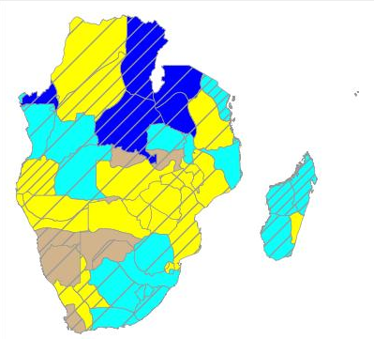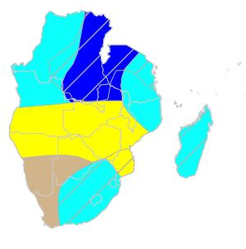
Figure 3-2 - Example of an aggregated country level forecast (left hand side panel) and output aggregated regional forecast (right-hand side panel) generated during SARCOF 28

Changes to the presentation of the consensus forecast
This section describes the changes to the presentation of the consensus forecast. The changes are intended to provide the following:
- Introduction of the concept of forecast uncertainty into the product communicated to end users.
- Introduction of messages from dynamical model forecasts into the Outlook document.
- Cleaning up and clarifying language and concepts used in the Outlook document.

Operationalisation
The forecast maps are presented as in Figure 3-2, and accompanied by the following explanation of confidence information:

“In addition to forecast categories, the outlook maps present information about forecast confidence. This has been derived based on 1) level of agreement of various forecasting approaches in terms of direction and magnitude of forecasted anomalies, 2) ability of these approaches to correctly predict anomalies during previous forecasts and 3) level of confidence in the forecast expressed
by the forecasters based on their knowledge and understanding of the regional climate system. Increased level of confidence in the forecast reflects the higher likelihood that the forecast is correct.”

Additionally, the following information is introduced:

“The colours for each zone indicate four forecast categories (above normal, normal to above normal, normal to below normal and below normal) representing different probabilities of rainfall anomalies.
• The first colour (blue) indicates that the above normal rainfall has the highest probability of occurring.
• The second colour (cyan) indicates the highest probability of normal rainfall, but with increased probability of above normal.
• The third colour (yellow) indicates the highest probability of normal rainfall but with increased chance for below-normal rainfall.
• The last colour (brown) indicates that the below normal rainfall has the highest probability of occurring.
The probabilities associated with each category are listed in inset in the bottom-right corner of the figure. For example, Figure 1, for Zone 2 with the colour yellow, depicts that there is the highest probability of normal rainfall (40% chance), but with increased probability of below normal (35% chance) and lower probability of above normal rainfall (25% chance).”

The synthesis of forecasts by dynamical models may take the following form:

“OVERVIEW OF DYNAMICAL MODELS FORECAST FROM GLOBAL PRODUCING CENTRES”
The outlook presented above is broadly consistent with the forecasts generated with the multi-model ensemble of international dynamical climate forecast models presented by the Global Producing Centres mandated by World Meteorological Organization.
In summary, increased probability of above normal rainfall conditions are forecasted by the dynamical models over Tanzania and eastern DRC as well as over small island states. Below normal conditions are forecasted for all other countries within the continental part of SADC, apart from the south-eastern coast of South Africa, where normal conditions are expected.

The dry anomalies are forecasted to be particularly strong over the central-western part of SADC region - southern Angola, Namibia, western Botswana, and western South Africa.

Over Madagascar - above normal conditions are forecasted for its northern part, while below normal for its southern part
These forecasts are relatively consistent across the February to June 2024 period, with minor differences between sub-seasons. Different multi-model forecasting systems agree relatively well in the overall direction of the anomalies, although their demonstrated skill varies.

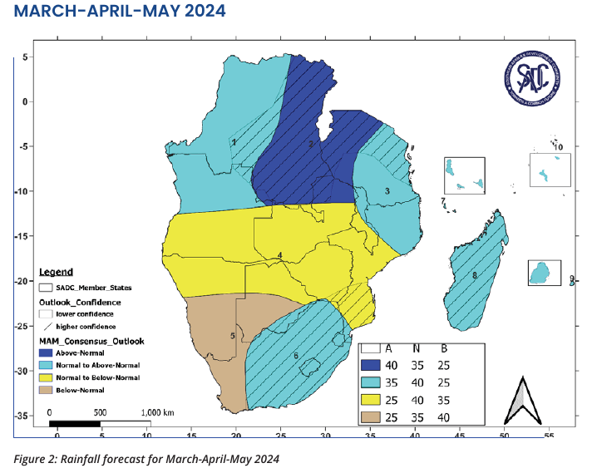
Figure 3-3 - Example of the forecast map introduced at SARCOF28, with articulated confidence in the forecast.

Regional seasonal forecast processing system at SADC CSC

This section describes the data processing system that is designed to generate a set of forecast data products for the SADC region, in support of climate services provided by SADC Climate Services Centre (SADC CSC), and towards SADC CSC fulfilling requirements of a WMO Regional Climate Centre (RCC) (WMO, 2008),and be aligned to the WMO recommendations for Objective Seasonal Forecasting (WMO, 2020). The system and products generated create a basis for populating Climate Watch bulletins introduced through the ClimSA project (SADC CSC, 2024) and supporting the SARCOF process.
Note
As of August 2024, the system utilizes the current SADC CSC website for distribution of products/maps. It was beyond the scope of the ClimSA project to provide functionality within that website to access/share the actual data products. The system will have to be adapted once the updated version of the CSC website is available. In future SADC CSC should consult with the web developer on its inclusion.

General functionality
The system is designed to have the following characteristics:
- Forecast data products are generated through the process of statistical downscaling (or calibration) of the ensemble of forecasts by global dynamical forecasting models.
- The system utilizes the functionality of PyCPT - statistical forecast generation software developed and maintained by IRI (International Research Institute for Climate and Society) (https://iri-pycpt.github.io/) (Munoz et al., 2019).
- The system utilizes dynamical forecast data available through the IRI Data Library as predictors in the used statistical model. As predictands in that model - the system allows using either data from IRI Data Library or data sourced from the Monitoring System implemented by ClimSA TA at CSC.
- The system generates a variety of seasonal forecast products including monthly and seasonal rainfall, mean temperature, as well as intra-seasonal attributes such as dry spells and (limited) extreme rainfall indices (see Table 7 for detailed list of products) but can be extended to include forecasts of other variables.
- The system is intended to run automatically, with no human intervention other than troubleshooting and further extending the range of products.
- The system is intended to generate products with minimal latency, i.e. as soon as forecast data from dynamical models are available on the providers’ servers.
- The data products are generated in the form of CSC/SADC branded maps (in jpg or png format), and in the form of data files (in the netCDF format) ready to be shared.

Operationalization
The system is implemented through a combination of bash and python scripts.

Note
Currently (August 2024) the system is set up to run on the “old Climate Station” server (192.168.1.2) under csis user and is operated from /home/csis/osf directory.

The functionality implemented in the system is as follows:

- Generation of predictand data from locally stored outputs of the Monitoring System. This is only needed for predictands that are based on this system and not for predictands that can be downloaded from the IRI data library.
- Generation of single model-based forecasts. This process includes:
  - Download of predictand and predictor data from IRI Data Library - both for the current forecast (i.e. the forecast being generated) and for a set of hindcasts and historical observations.
  - Statistical calibration of the forecast using PyCPT functions.
  - Plotting of forecast maps.
- Generation of multi-model forecasts. This process includes:
  - Reading results of single model forecasts saved during single model processing.
  - Calculation of multi-model forecast.
  - Plotting of forecast maps.
- Synchronization of data products with website.

There are separate sets of scripts for each step. Unlike in the Monitoring System (SADC ClimSA, 2024), data download, processing and plotting are not operated by separate scripts but integrated within each of the forecast processing scripts. Synchronization with website is done separately, with a single script, which synchronizes all product maps.

Similarly to the Monitoring System, however, the set of scripts have been designed in such a way that processing of a particular single model forecast or a multi-model forecast can be done automatically or manually, using the same main “workhorse” scripts.

More details about the system are provided in the Appendix A - Forecast System User Manual.

Products available within the automated system as of August 2024
The forecast system contains a complex set of multi-dimensional data, spanning combinations of various models, domains, basetimes and variables (or indices). Products available as of August 2024 are listed in Table 7.

Total seasonal and monthly rainfall products are generated against CHIRPS v2.0 data (predictand) downloaded from IRI Data Library. Other rainfall data products are generated against the CHIRPS v2.0 sourced from the Monitoring System. This is because the IRI Data Library provides only total annual rainfall.

For air temperature forecasts, only CHIRTS data are available from IRI Data Library as a predictand. That dataset extends only till 2016, and while it is possible to generate a forecast using it as a predictand, results of such forecast cannot be interpreted in the context of recently observed anomalies or verified against a recent anomaly data. Thus, the system.

Table 7 - Forecast products available through CSC website and generated automatically on a monthly basis.
Variable (predictand) | Predictand’s source | Spatial domain | Model | Predictor | Basetime | Attributes | Skill measures
PRCP (total precipitation) | CHIRPS from IRI library | SADC | SEAS5.1  CFSv2.0  CCSM4  GEOSs2s | global SST | seasonal  monthly | deterministic  absolute anomaly  percent anomaly | Spearman correlation
 |  |  | Multi-model ensemble |  | seasonal  monthly | probabilistic tercile | Generalized ROC
TG (mean temperature) | ERA5 from CSC monitoring system | SADC | SEAS5.1  CFSv2.0  CCSM4  GEOSs2s | global SST | seasonal  monthly | deterministic,  absolute anomaly | Spearman correlation
 |  |  | Multi-model ensemble |  | seasonal  monthly | probabilistic tercile | Generalized ROC
Rx5day | CHIRPS from CSC monitoring system | SADC | SEAS5.1  CFSv2.0  CCSM4  GEOSs2s | global SST | seasonal | deterministic,  absolute anomaly | Spearman correlation
 |  |  | Multi-model ensemble |  | seasonal | probabilistic tercile | Generalized ROC
CDD | CHIRPS from CSC monitoring system | SADC | SEAS5.1  CFSv2.0  CCSM4  GEOSs2s | global SST | seasonal | deterministic,  absolute anomaly | Spearman correlation
 |  |  | Multi-model ensemble |  | seasonal | probabilistic tercile | Generalized ROC

Future developments and action plan
As outlined above, the process of generation of the SARCOF forecast and the subsequent set of forecast products emerging from that, and from the automated forecast system at CSC are aligned to the main principles of OSF. Further developments should thus focus on objectives of improving the quality of forecast products and on ensuring and strengthening adherence of processes and products to the OSF principles.

Although this was not an objective of this report, it is clear from other reports emerging from ClimSA TA (CS stocktake, RCC roadmap) that the main limiting factor to sustainability of technical activities and their further expansion at CSC are human resources. It is thus an imperative and a pre-requisite that any further developments of seasonal forecasting activities are accompanied by an increase in the level of commitment available and/or the number of experts supporting these activities.

In terms of technical developments, Table 8 presents activities that are deemed to be necessary in order to fulfill the above-mentioned objectives in the near future.

Table 8 Future developments towards improvement and strengthening of OSF at SARCOF and CSC.
Activity | Priority | Expected impact from OSF perspective
Strengthening CSC human resources to support forecasting processes | Moderate | Moderate
Consultation with WMO towards feedback on achievements, way forward and their support going forwards. | Moderate | Moderate
Ensuring that the processes underlying SARCOF/CEM forecast and described in the CEM SOP are adhered to, particularly in terms of archiving forecast products and data for further use, and that SOP is being regularly reviewed and updated to reflect on-going developments and changes. | High | High
CSC taking full ownership of processes and tools developed during ClimSA. | High | High
Peer review and improvements of CFT software | High | High
Extending the CFT forecast verification tool to include functionality to evaluate single-forecast performance of forecast products other than the 4-category, CEM-style probabilistic forecast, for example - of probabilistic/deterministic forecasts from dynamical multi-model ensembles. | Low | High
Further developments of the presentation of the SARCOF outlook rainfall product, in particular expansion of the documentation of the forecast product, including, but not limited to examples of how the outlook should be interpreted by end users. This could be achieved through a co-productive process within the UIP. | High | High
Extension of the outlook document to include forecast products other than rainfall forecast, such as forecast of temperature, intra-seasonal rainfall characteristics, onset of rainy season, drought, heat waves, sector-specific tailored indices. These can be first implemented in and sourced from the automated system at CSC. | High | High
Initiating UIP activities towards co-development of user-driven forecast skill metrics | Moderate | Moderate
Evaluation of the skill of forecast from a multi-model ensemble of dynamical models (as emerging from the automated system at CSC) vs. that of the SARCOF forecast generated during CEM, building towards informed decision about advantages and disadvantages of dynamical model-based forecasts in the SADC region as a forecast basis for the SARCOF Outlook document. | Moderate | Moderate
Organisation of a regional predictability workshop/hackathon with participants from global/regional research and operational institutions involved in seasonal forecasting and from SADC NHMSs, working towards systematization and improvement of understanding of sources of seasonal predictability in the SADC region, and ultimately, towards incorporation of the most informative predictors in the forecast generation processes. | Moderate | High
Porting the automated system from its current server to HPC. | High | Moderate
Incorporation of the products generated by the system in the new, upgraded CSC website. | High | High
Extension of functionality of the automated system to include forecast of onset of the rainy season, drought and sector-specific tailored indices. | Moderate | Moderate
Comprehensive investigation of optimal predictors for variables other than those evaluated during ClimSA (i.e. other than total seasonal rainfall), and if necessary - adaptation of the currently implemented multi-model ensemble. | Moderate | Moderate
Building on monthly monitoring bulletins - develop monthly forecast bulletins, working towards a comprehensive regional Climate Watch. | High | High
Revive the idea of sharing monthly rainfall data by NHMS to create a coherent regional database of station data to support seasonal forecast verification and generation, and as a pre-requisite to generation of a regional gridded dataset like ENACT product. | Moderate | Moderate

Manual for the automated seasonal forecast processing system

Objectives of the system
The data processing system that is subject of this report is designed to generate a set of forecast data products for the SADC region, in support of climate services provided by SADC Climate Services Centre (SADC CSC), and towards SADC CSC fulfilling requirements of a World Meteorological Organisation (WMO) Regional Climate Centre (RCC) (WMO, 2008), and be aligned to the WMO recommendations for Objective Seasonal Forecasting (WMO, 2020). The system and products generated create a basis for populating Climate Watch bulletins and publication on the SADC CSC website, all of which were introduced through the ClimSA project (SADC CSC, 2024) and supporting the SARCOF process.

Note:
As of August 2024, the system utilizes the currently obsolete CSC website for distribution of products/maps. It was beyond the scope of the ClimSA project to provide functionality within that website to access/share the actual data products. The system will have to be adapted once the updated version of the CSC website is available.

The system is designed to have the following characteristics:
- Forecast data products are generated through the process of statistical downscaling (or calibration) of the ensemble of forecasts by global dynamical forecasting models.
- The system utilizes the functionality of PyCPT - statistical forecast generation/calibration software developed and maintained by IRI (International Research Institute for Climate and Society) (https://iri-pycpt.github.io/).
- The system utilizes dynamical forecast data available through the IRI Data Library - these are predictors used in a statistical model. As predictands in that model - the system allows using predictands either from IRI Data Library or sourced from the Monitoring System implemented by ClimSA TA.
- The system generates a variety of seasonal forecast products including forecast of monthly and seasonal rainfall, mean temperature, as well as intra-seasonal attributes such as dry spells and (limited) extreme rainfall indices (see Table 7 for detailed list of products) but can be extended to include forecasts of other variables.
- The system is intended to run automatically, with no human intervention other than troubleshooting and further extending the range of products.
- The system is intended to generate products with minimal latency, i.e. as soon as forecast data from dynamical models are available on the providers’ servers.
- The data products are generated in the form of CSC/SADC branded maps (in jpg or png format), and in the form of data files (in the netCDF format) ready to be shared.

General functionality
The functionality of the system is achieved through a set of scripts that handle the following processes:

- Generation of predictand data from locally stored outputs of the Monitoring System. This is only needed for predictands that are based on this system and not for predictands that can be downloaded from the IRI data library.
- Generation of single model-based forecasts. This process includes:
- download of predictand and predictor data from IRI Data Library - both for the current forecast (i.e. the forecast being generated) and for a set of hindcasts and historical observations,
- statistical calibration of the forecast,
- plotting of forecast maps.
- Generation of multi-model forecasts. This process includes:
- reading results of single model forecasts saved during single model processing,
- calculation of multi-model forecast,
- plotting of forecast maps.
- Synchronization of products with website

Unlike in the Monitoring System (ref), download, processing and plotting are integrated within each of the forecast processing scripts. Synchronization with the website is done separately, with a single script, which synchronizes all product maps.

Similarly to the Monitoring System, however, the processing has been designed in such a way that it can be run automatically or manually. This is achieved through each processing step being handled by a set of scripts that include:
- a list file providing a set of arguments defining what is to be processed. That list file is passed to a bash script as an argument,
- a “workhorse” bash (shell) script that parses the list file and calls a “workhorse” python script,
- a “workhorse” python script that executes data processing.
In the operational, automated setting, the bash script is invoked by another - “operational” - bash script which calls the “workhorse” bash script with a dedicated “operational” list file.

In the manual mode - the “workhorse” bash script can be called “by hand” and can be provided with an ad-hoc list file. In this way, manual processing/reprocessing of data is possible with the same “workhorse” script without disturbing/interrupting the automated process.

List file
Processing scripts - those that generate predictand data, and the scripts to generate single model forecast and the ensemble forecast use list files (.lst) to determine which models/ensembles/domains/basetimes are to be processed.

The list file to be read is passed to the script as an argument, e.g.:

./multimodel.sh listfile.lst

This is to allow easier control over which models are processed. Apart from separating the automated and manual processing, a separate list file can be created to calculate forecasts for seasonal and monthly basetime, or separate for rainfall or temperature variables.
There is no strict naming convention for list files, but for the sake of convenience, the files have names corresponding to the “parent” script that uses them, e.g. the list file for automated, operational use of onemodel.sh is named as follows: onemodel_operational.lst.

Period over which forecast is processed
The processing shell scripts are designed so that data from a certain period (time window) will be processed, with first and the last date of the period to be processed passed to the script as an argument, i.e.:

./multimodel.sh listfile.lst {start_date} {end_date}

Arguments are optional, and the period over which data will be processed is set up as follows:

- Calling script without date argument, e.g.: ./multimodel.sh listfile.lst will attempt to process the current (ie. the most-recent) forecast. That most recent forecast is defined as a forecast issued in the current month, if it is later than the 10th of the month, or issued in the previous month, if it is earlier than the 10th of the month.
- Calling script with one date argument, e.g.: ./multimodel.sh listfile.lst 20200101 will attempt to process forecasts from that date and the current date.
- Calling script with two date arguments, e.g.: ./multimodel.sh listfile.lst 20200101 20201231 will attempt to process forecasts from the period starting on the first provided date and ending on the last provided date.

For example:
./multimodel.sh multimodel.lst 20220101 20220330

List files are plain text files. They differ slightly for single model and multi-model processing scripts, but in principle are structured as follows:
- Each line defines a product to be processed
- Only lines that DO NOT START with # will be read
- Lines starting with # will be ignored
- Each line to be processed has to contain a set of arguments separated by a comma. For example, the list file for single model forecast will have the following arguments:

{model},{predictor_variable},{predictor_domain},{predictand_institution},{predictand_variable},{predictand_domain},{mos},{basetime},{plot_masked},{overwrite}

- All arguments are to be separated by a comma, without spaces anywhere in the line.

The sequence and meaning of arguments in each list file is explained in comments included in that file and also in the section describing processing scripts below.

Running in the automated mode
Schematic of automatic operations is shown in Figure 5-1, and all scripts called in the automated mode are listed in Table 9.

In the automated mode, forecast processing is triggered by a scheduler.

Note:
As of August 2024, crontab of user csis on server 192.168.1.2 (old climate station) is used as scheduler.

In order to facilitate scheduling of forecast processing, while enabling the use of the “workhorse” scripts in manual mode, an “operational” bash scripts have been created that call processing scripts. So, for example, script ./onemodel_operational.sh calls the “workhorse” processing script with an operational list file, i.e. onemodel.sh onemodel_operational.lst. In this setting, only the ./onemodel_operational.sh has to be scheduled, while the “workhorse” script ./onemodel.sh can also be run manually with an ad-hoc created list file, when a need arises, without disturbing the automated process.

In the automated mode, the processing bash script is run without specifying the time range over which data are to be processed, and the forecast processing is done for the most recent forecast.

The “workhorse” bash script is iterating through the entries in the list file and calls the “workhorse” python script to process a particular dataset and index.

Triggering of scripts in the automated mode causes their output to be written to log files. Log files are located in the osf/logs directory. Housekeeping script (housekeeping.sh) is run every day at midnight, and it saves logs from that day into subdirectory of the logs file - e.g. logs from 31 July 2024 will be saved to csis/logs/20240731.

Note:
Preparation of predictand data sourced from the CSC Monitoring System is done manually, and is executed by manually running:

./prep_localprdctnd.sh prep_localpredictnd.lst

This process is not scheduled as there is only a need to run this once a year.
Table 9 - Details of scripts used to run the system in the automated mode
Scheduled operational script | Processing bash scripts | Operational list files
download, processing and plotting forecasts by individual models
onemodel_operational.sh | onemodel.sh | onemodel_operational.lst
processing of multi-model ensemble forecast
multimodel_operational.sh | multimodel.sh | multimodel_operational.lst
Synchronization of maps with web server
sync_website.sh | NA | NA
housekeeping - keeping logs in order
housekeeping.sh

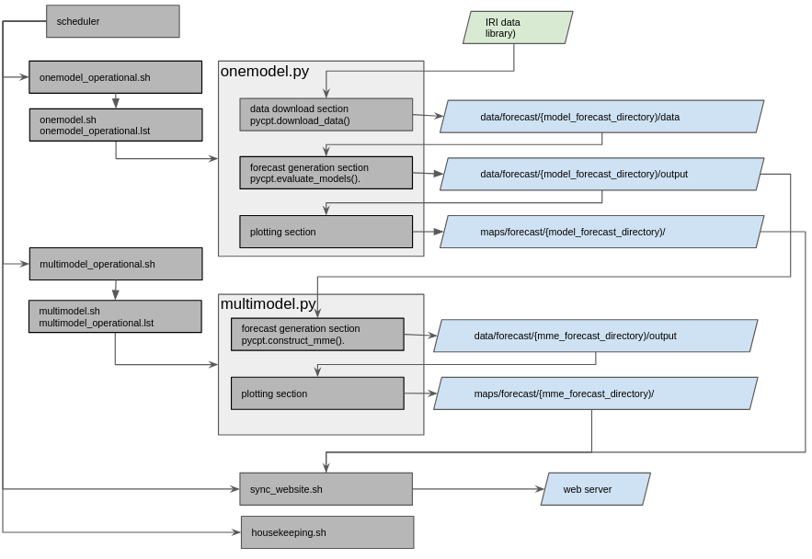
Figure 5-1 - Schematic of the process of automated generation of forecasts

Running in the manual mode
Individual processing scripts can be executed manually, by invoking relevant processing scripts “by hand”, and calling them with the arguments, i.e. with the relevant list file and the datetime arguments reflecting the period over which data are to be processed.

This can typically be done in three contexts:

- reprocessing already generated forecasts. This may happen if some changes to the products are needed - for example, a change of colour scheme, or some changes in formatting of maps, or if some processing errors were identified.

- processing forecasts retrospectively

If maps for historical forecasts are needed, one can create a temporary list file including only the models/models of interest and trigger processing manually by running the forecast processing script with that list file and relevant time period arguments.

- troubleshooting - identifying issues that might arise during the operation of the system, e.g. if files are not processing timely and there is a need to identify causes.

Preparation of predictand data sourced from the CSC Monitoring System is done manually, and is executed by manually running

./prep_localprdctnd.sh prep_localpredictnd.lst

This process is not scheduled as there is only a need to run this once a year.

Troubleshooting
If forecast data products do not appear on the web interface, the following steps should be followed:
- Check if the map product for a particular date, variable, model, domain etc. is available in the relevant products directory on the webserver (as of August 2024 in:
/www/html/media/data/rccsadc/csc/{forecast_type} on 192.168.1.12)

if YES:
Check the name of the file, and interrogate the functionality of the website

if NO:
- Check if the map product for a particular date, variable, model, domain etc. is available on the storage server (as of August 2024 in:
/storageserver/RCC/maps/forecast/{model}/{basetime}/{domain}/{var}/{fcst_date}/)

if YES:
Inspect the sync_website.log file located in the osf/logs directory, and if needed rerun sync_website.sh script manually and inspect output for error messages.

if NO:
- Check if the data product for a particular date, variable, model, domain etc. is available on the storage server (as of August 2024 in:
/storageserver/RCC/data/forecast/{model}/{basetime}/{domain}/{var}/{fcst_date}-{target_period}/{predictor_var}-{predictor_domain}/output/)

if YES:
Inspect the relevant log file located in osf/logs/ (multimodel_operational.log for multi-model or onemodel_operational.log for single model processing) and if needed - run onemodel.sh or multimodel.sh script with a manually created list file that contains only the entry for the basetime,variable, model and domain of interest, and inspect output for errors.

if NO:
- Check if the input data files for the forecast of interest are available on the storage server in the directory containing input (predictor and predictand) data (as of August 2024 in:
/storageserver/RCC/data/forecast/{model}/{basetime}/{domain}/{var}/{fcst_date}-{target_period}/{predictor_var}-{predictor_domain}/data/)

if YES:
Run the relevant processing script (e.g. onemodel.sh or multimodel.sh) with a manually created list file that contains only the entry for the variable, mode and domain of interest, and inspect output for errors.

if NO:
- Identify whether the missing input file contains hindcast predictor data, forecast predictor data or historical predictand data.
  - If the missing data file is to be downloaded from IRI Data Library - check if the source files are available on that library by interrogating the https://iridl.ldeo.columbia.edu/ “by hand”, and by picking up the download request created by pycpt.download_data(), which is written in the log file and looks similarly to: https://iridl.ldeo.columbia.edu/SOURCES/.Models/.NMME/.NASA-GEOSS2S/.FORECAST/.MONTHLY/.tref/%5BM%5D/average/Z/2/VALUES/S/%280000%201%20Jul%202024%29/VALUES/L/3.5/3.5/RANGEEDGES/%5BL%5D//keepgrids/average/Y/-40/10/RANGEEDGES/X/5/60/RANGEEDGES/-999/setmissing_value/%5BX/Y%5D%5BL/S/add%5D/cptv10.tsv
if data are available and the pycpt.dowload_data() request does not return data or throws an error - report an issue to IRI.

  - If the missing data file is sourced from the CSC Monitoring system - inspect the local_predictand directory (as of August 2024:
/storageserver/RCC/data/local_predictand/{predictand_dataset}/{basetime}/{domain}/{predictant_variable}/)
if data files are present - inspect them for integrity with ncdump or ncview, and if corrupted - run prep_localpredctnd.sh with manually created list file containing only entry for the missing data and inspect output for errors.

Further developments

Establishing a comprehensive multimodel ensemble
The currently implemented multi-model ensemble includes four models: SEAS51, CFSv2, CCSM4 and GEOSs2s. The work on evaluation of skill of individual models in forecasting rainfall over the SADC region concluded that 6 models demonstrate skill. Unfortunately, at the time of finalizing the ClimSA TA work on the system, two of these models were upgraded on the IRI system, and their data were not available. Further work should be carried out on evaluation and inclusion of new versions of these models into the multi-model ensemble forecast at CSC.

Expansion of the range of data products
The current (August 2024) implemented system provides a relatively comprehensive coverage of products when considering a landscape of seasonal forecast products available globally. Most forecasting systems provide only basic forecasts of mean rainfall and mean temperature, while the implemented system generates two intra-seasonal indices (Rx5day and CDD). Extension of the system to generate a broader range of intra-seasonal products based on a straightforward ETCCDI indices is relatively simple. For that a straightforward process can be followed:
- Identify ETCCDI product from the Automated Monitoring System to be included in the forecast.
- Make sure that monthly data for that variable are available over the period of 1991-to date.
- Prepare a list file to use with the prep_localpredictand.sh script to generate that variable’s data in PyCPT format.
- Include that variable in the onemodel_operational.lst
- Include that variable in the dictionaries defining processing and plotting arguments located in the dictionaries/ directory
- Include that variable in the sync_website.sh
- Include that variable in the formatting template of the website.

The above applies to ETCCDI variables only, however, and this process cannot be used to generate forecasts of tailored or more specific variables such as drought index or onset of the rainy season.
Generation of tailored variables such as probability of drought will require extending the system to implement the PyCPT flexible forecast function pycpt.construct_flex_fcst(). This has to be done by implementing a set of scripts wrapping that function in a similar way to the multimodel.sh and multimodal.py.

Known deficiencies/gaps of the implemented system
The following elements of the system can be improved or revised:
- PyCPT provides functionality to plot diagnostic figures such as EOF and CCA modes through pycpt.plot_cca_modes() and pycpt.plot_eof_modes(). As these plots are used by forecasters and not public facing, there is no need to create plotting functions replacing the PyCPT ones. The plotting of these diagnostics was, however, not implemented. This is partly caused by the fact that during work on the system, pycpt.plot_eof_modes() included errors, and thus not functional. That was reported to IRI, but the problem was not resolved by the time of writing this report. Once that function is fully functional, the plotting of diagnostics can relatively easily be done by modifying onemodel.py code. The default location of the output figures is the {fcst_directory}/figures directory, and this directory is created during the process of creation of customized directory structure.
- The current configuration of the existing website in which the products are presented imposes significant constraints on the naming of files and process of synchronization between the file system and the web server. File names of generated files should include all relevant information allowing for identification of the source of the product from file name alone. Currently, predictor domain is, for example, not included, and predictor and MOS information are bundled together as one element. That should be revised when the new website is implemented.

Maintenance needs
Action | Means | Who | Frequency | Implications
Check if products up-to-date | Inspection of products available on website and in the directory structure, inspection of daily logs, delete older log files | System operator (csis user) | Monthly | Troubleshoot if products missing
Keep OS on the processing computer up-to-date | apt-get | Root user | Monthly | No specific
keep Python packages up-to-date | mamba | System operator (csis user) | Annual | Might require updating python code if some functionality is deprecated.
keep PyCPT library up to date | https://iri-pycpt.github.io/installation/ | System operator (csis user) | Check monthly, update if new version is available. | Might require updating code if some functionality is deprecated

Functionality of processing scripts

Preparation of local predictand
Preparation of local predictand is done using prep_localprdctnd.sh and prep_localprdctnd.py.

prep_localprdctnd.sh does the following:
- Reads list file provided as an argument,
- Iterates through the list file entries,
- Calls prep_localprdctnd.py with arguments corresponding to each list file entry.

The prep_localprdctnd.py utilizes xarray library to process data from netCDF files found in the monitoring data directory (as of August 2024 - in /storageserver/RCC/data) and does the following:
- Reads monthly data files for a variable corresponding to the list file entry from the local directory,
- Extracts data for each of the possible target month (or season if predictand data are requested to be on seasonal basetime, aggregating monthly data to seasonal), reformats data (changes variable and coordinate names) into the format that can be ingested by PyCPT,
- Writes data into the data/local_predictand directory into netCDF files for each possible target season (i.e. into 12 files that store data for each calendar month, or for each possible 3-month season).

The prep_localprdctnd.py script includes a possibility of “coarsening” of input data, i.e. reducing the spatial resolution of the source data. This is to allow lower resolution of CHIRPS data (or other high-resolution data) as a basis for forecast in order to reduce processing time. This is justified as there is likely no gain in forecast robustness, but likely increase in noise if a high resolution predictand is used. A coarsening factor of 5 is implemented for CHIRPS 0.05 deg data, which generates CHIRPS-based predictand data at 0.25 deg resolution.

The list file used by prep_localprdctnd.sh contains the following:
{dataset},{data_type},{predictand_domain},{basetime},{predictand_variable},{coarsening_factor},{time_aggregation}

Example:
ERA5,reanalysis,sadc,mon,TG,1,mean

Single model forecast
Single model forecast is processed using onemodel.sh that calls onemodel.py with a set of arguments read from a list file.

The shell script (onemodel.sh):
- Reads list file (and start and end dates if those dates are provided),
- Iterates through dates (months on which forecast was issued),
- Iterates through entries in the list file,
- Calls onemodel.py with arguments corresponding to each list file entry and the current date,

The onemodel.py is a custom-written wrapper for functions from pycpt library and provides the following functionality:
- Downloading predictor data for a single model/predictand_variable, and if requested - predictand data from IRI library. This is done using the pyCPT function: pycpt.download_data()
- Processing forecast data. This is done using pyCPT function: pycpt.evaluate_models()
- Plotting resulting forecast maps. While pyCPT provides a function to plot forecast maps, onemodel.py does not use it but rather implements a customized function. This allows for a better control of formatting and branding of the output maps. The plotting function is implemented in functions_plot.py

This functionality of the onemodel.py script is implemented in the following steps:
- Reading provided arguments.
- Preparing arguments to the pycpt.download_data() function including definition of model, predictor variable, forecast month, target season, predictand variable, predictor and predictand domains.
- Iterating through lead times. For each lead time:
- Downloading data for a particular combination of predictor, predictand, their domains, forecast month and lead time (calling pycpt.download_data.py with arguments)
- Opening predictand and predictor files
- Processing downloaded data (calling pycpt.evaluate_models.py with arguments that include xarray arrays)
- Plotting maps

During execution, onemodel.py reads a number of json dictionaries that are stored in osf/dictionaries directory:
- predictor_domains.json - storing definitions of predictor domains
- predictand_domains.json - storing definitions of predictand domains
- local_predictands.json - storing codes for institutions/dataset names and predictand variables that will be read from the local file system rather than downloaded from IRI Data Library
- obs_ncvars.json - defines variable codes used in IRI Data Library netCDF files and in CSC Monitoring System netCDF files
- fcst_metric_params.json - defines parameters for plotting of forecast variable maps
- skill_metric_params.json - defines parameters for plotting skill maps
- labels.json - defines labels used in maps
- units.json - defines units for variables to be used in plotting map legend

There are also a number of parameters to the pycpt.evaluate_models() function that are defined in the onemodel.py code directly in a dictionary named cpt_args:
cpt_args = {
'transform_predictand': None, # transformation to apply to the predictand dataset - None, 'Empirical', 'Gamma'
'tailoring': None, # tailoring None, 'Anomaly'
'cca_modes': (1,3), # minimum and maximum of allowed CCA modes
'x_eof_modes': (1,8), # minimum and maximum of allowed X Principal Componenets
'y_eof_modes': (1,6), # minimum and maximum of allowed Y Principal Components
'validation': 'crossvalidation', # the type of validation to use; only 'crossvalidation' is supported for now
'drymask': False, #whether or not to use a drymask of -999
'scree': True, # whether or not to save % explained variance for eof modes
'crossvalidation_window': 5, # number of samples to leave out in each cross-validation step
'synchronous_predictors': True, # whether or not we are using 'synchronous predictors'
}

One of the functionalities of the onemodel.py is to alter the directory structure that is used by pyCPT to store input and forecast data so that it corresponds to the standard adopted for the CSC Monitoring System/CSIS. In the original implementation of pyCPT the directory structure is provided by the pycpt.setup() function. In the onemodel.py wrapper that function is not used, and a customized structure is created instead, described below in the Data Model section. One element of the original pyCPT directory structure is, however, retained in the structure adopted here, as it is embedded in the pycpt.download_data() and pycpt.evaluate_models() functions. This is the location of input and output data, which are stored in: {forecast_directory}/data and {forecast_directory}/outputs respectively, where forecast_directory is the customized directory structure.

List file utilized by onemodel.sh has to have the following entries:
{model},{predictor_variable},{predictor_domain},{predictand_institution},{predictand_variable},{predictand_domain},{mos},{basetime},{plot_masked},{overwrite}

In the above:
- model - is model code of forecast models available from the IRI Data Library.
- predictor_variable - is the code of the variable which is to be used as a predictor for the forecast. Predictor variables are sourced from IRI Data Library, and possible codes are: SST, GPH, PRCP, T2M.
- predictor_domain - is the spatial domain over which the predictor is taken into account. Predictor domains are defined in a json dictionary dictionaries/predictor_domains.json
- predictand_institution - is the code for an institution that generates predictand (observed) data, if predictand data are downloaded from IRI Data Library, or code for a dataset, if predictand data are sourced from the CSC Monitoring System. For CHIRPS rainfall data sourced from IRI Data Library - this code is UCSB, for CHIRPS data sourced from the Monitoring System, this code will be CHIRPS-v2.0-p05-merged, for the ERA5 air temperature data sourced from the Monitoring System it will be ERA5.
- predictand_variable - is a code of the predictand variable. For CHIRPS total rainfall data sourced from IRI Data Library it will be PRCP, for variables sourced from the CSC Monitoring System it will be the code used in this system, for example - TG for mean temperature, TX for maximum temperature, Rx5day for maximum 5-day rainfall.
- predictand_domain - is the code for the domain over which the predictand is considered. Possible domains are defined in a json dictionary: dictionaries/predictand_domains. json
- mos is the post-processing approach that is implemented by PyCPT. Possible values: PCR or CCA.
- basetime - is the temporal resolution of the forecast. Possible values: seas for seasonal (rolling 3-month periods) and mon for monthly forecasts.
- plot_masked is a code expressing whether or not skill-masked forecast and skill maps will be plotted. Possible values: no (do no plot skill masked maps), yes (plot skill masked maps), both - plot both skill masked and non-skill masked maps.
- overwrite - whether or not datafiles and maps are to be overwritten when existing already in the file system

Example of list file entry for onemodel.sh:
SEAS51,SST,global,CHIRPS-v2.0-p05-merged,Rx5day,sadc,PCR,seas,both,0

The customized plotting function included in the onemodel.py allows for plotting of all indices generated by PyCPT, namely: deterministic forecast, probabilistic tercile forecast - probabilities of below, normal and above normal categories, and skill indices (Pearson’s correlation, Spearman’s correlation, Generalized ROC score, ROC score for below and above normal, RPSS).

Multi-model ensemble
Multi-model ensemble generation is done by multimodel.sh and multimodel.py scripts with a set of arguments read from a list file.

The shell script (multimodel.sh):
- Reads arguments from list file (and start and end dates if those dates are provided)
- Iterates through dates (months on which forecast was issued)
- Iterates through entries in the list file
- Calls multimodel.py with arguments corresponding to those entries and the date

The multimodel.py is a custom-written wrapper for functions from the pycpt library and provides the following functionality:
- Reading of individual model forecasts generated earlier by onemodel.py
- Generating ensemble forecast. This is done using pyCPT function: pycpt.generate_mme()
- Plotting resulting forecast maps. While pyCPT provides a function to plot forecast maps, similar to onemodel.py, multimodel.py does not use it but rather implements a customized function. This allows for a better control of formatting and branding of the output maps. The plotting function is implemented in functions_plot.py.

There are also a number of parameters to the pycpt.construct_mme() function that are defined in the multimodel.py code directly in a dictionary named cpt_args:
cpt_args = {
'transform_predictand': None, # transformation to apply to the predictand dataset - None, 'Empirical', 'Gamma'
'tailoring': None, # tailoring None, 'Anomaly'
'cca_modes': (1,3), # minimum and maximum of allowed CCA modes
'x_eof_modes': (1,8), # minimum and maximum of allowed X Principal Componenets
'y_eof_modes': (1,6), # minimum and maximum of allowed Y Principal Components
'validation': 'crossvalidation', # the type of validation to use; only 'crossvalidation' is supported for now
'drymask': False, #whether or not to use a drymask of -999
'scree': True, # whether or not to save % explained variance for eof modes
'crossvalidation_window': 5, # number of samples to leave out in each cross-validation step
'synchronous_predictors': True, # whether or not we are using 'synchronous predictors'
}

List file utilized by multimodel.sh has to have the following entries:
{mme_code},{predictand_institution},{predictand_variable},{predictand_domain},{mos},{basetime},{plot_masked},{overwrite},{model1},{predictor_variable1},{predictor_domain1},{mos1},{model2},{predictor_variable2},{predictor_domain2},{mos2}...

In the above:
- mme_code - is code of the multimodel ensemble. It is user-defined and determines the name of the directory in which input and output data are stored.
- predictand_institution - is the code for an institution that generates predictand (observed) data, if predictand data are downloaded from IRI Data Library, or code for a dataset, if predictand data are sourced from the CSC Monitoring System. For CHIRPS rainfall data sourced from IRI Data Library - this code is UCSB, for CHIRPS data sourced from the Monitoring System, this code will be CHIRPS-v2.0-p05-merged, for the ERA5 air temperature data sourced from the Monitoring System it will be ERA5.
- predictand_variable - is a code of the predictand variable. For CHIRPS total rainfall data sourced from IRI Data Library it will be PRCP, for variables sourced from the CSC Monitoring System it will be the code used in this system, for example - TG for mean temperature, TX for maximum temperature, Rx5day for maximum 5-day rainfall.
- predictand_domain - is the code for the domain over which the predictand is considered. Possible domains are defined in a json dictionary: dictionaries/predictand_domains. json
- basetime - is the temporal resolution of the forecast. Possible values: seas for seasonal (rolling 3-month periods) and mon for monthly forecasts.
- plot_masked is a code expressing whether or not skill-masked forecast and skill maps will be plotted. Possible values: no (do no plot skill masked maps), yes (plot skill masked maps), both - plot both skill masked and non-skill masked maps.
- overwrite - whether or not datafiles and maps are to be overwritten when existing already in the file system

The subsequent arguments define the single model forecasts that contribute to the MME through defining the model,predictor institution/dataset, and MOS. There can be as many consecutive “groups” of arguments as required. Each group should have the following arguments:
- model - is the code of the model as per IRI Data Library
- predictor_variable - is the code of the variable which is to be used as a predictor for the forecast. Predictor variables are sourced from IRI Data Library, and possible codes are: SST, GPH, PRCP, T2M.
- predictor_domain - is the spatial domain over which the predictor is taken into account. Predictor domains are defined in a json dictionary dictionaries/predictor_domains.json
- mos is the post-processing approach that is implemented by PyCPT. Possible values: PCR or CCA.

Example of list file for multimodel.sh:
MME01,CHIRPS-v2.0-p05-merged,Rx5day,sadc,seas,both,0,SEAS51,SST,global,PCR,CFSv2,SST,global,PCR,CCSM4,SST,global,PCR,GEOSS2S,SST,global,PC

This will create a multi-model ensemble coded MME01, that combines forecasts from SEAS51, CFSv2 and GEOSS2S models.

Synchronization with website
Synchronization with the website is done by a shell script sync_website.sh
This script iterates through individual forecast models and target variables and synchronizes relevant maps.

Data model
Data of the forecasting system are organized within a data model (directory structure) shared with the automated system for generation of monitoring products. Due to constraints imposed by functionality of PyCPT, there are, however, some differences between the directory structure for monitoring data and for forecast data:
- In contrast to the automated system for generation of monitoring products, the forecasting system does not use the incoming directory to store the raw data. Instead, the downloaded data and generated forecast data are stored in the model-specific subdirectories of the data directory.
- The forecast system utilizes subdirectory data/local_predictand to store predictand data sourced from the monitoring system in the format that can be read by PyCPT.

Ultimately, directory structure of the forecast system includes only two highest-level directories, namely:

data
maps

Data directory
Input and output forecast data are stored in the data/forecast directory (as of August 2024, when accessed from csis user of 192.16.1.2 server, this directory is available as /storageserver/RCC/data/forecast).

The forecast sub-directory has the following structure:

data/forecast/{model}/{basetime}/{domain}/{var}/{fcst_date}-{target_period}/{predictor_var}-{predictor_domain}

where:
- model - is the code of model as per IRI Data Library
- basetime - is the code of time aggregation of the forecast, possible values: mon and seas
- domain - is the spatial domain of predictand, or target forecast variable, possible values: sadc
- var - is the code of the predictand variable, as per IRI library, or, if local predictand used - as variable names used in the CSC Monitoring System.
- fcst_date - code for year and month on which forecast was issued, e.g. 202407
- target_period - code for target period of the forecast. For monthly basetime this is an abbreviation of the target month name, e.g. Jan, for seasonal basetime this is abbreviation of the target season, e.g. DJF
- predictor_var - code for predictor variable, corresponding to codes used in IRI Data Libraries, e.g. SST, GPH
- predictor_domain - code for spatial domain over which predictor data are used. These are defined dictionaries/predictor_domains. json dictionary.

Example:
data/forecast/SEAS51/mon/sadc/PRCP/202407-Sep/SST-global/

As mentioned earlier, input and output forecast data are stored in a directory structure imposed by PyCPT. Input data (predictand and predictor data) are stored in:
data/forecast/{model}/{basetime}/{domain}/{var}/{fcst_date}-{target_period}/{predictor_var}-{predictor_domain}/data

output data files are stored in:
data/forecast/{model}/{basetime}/{domain}/{var}/{fcst_date}-{target_period}/{predictor_var}-{predictor_domain}/outputs

Input and output file names are automatically generated by PyCPT, and thus follow the naming convention adopted in that software. See documentation of PyCPT for file naming patterns.

Maps directory
Forecast maps are stored in the following directory structure:

data/forecast/{model}/{basetime}/{domain}/{var}/{fcst_date}

Example: maps/forecast/SEAS51/mon/sadc/PRCP/202407

Map files have the following naming convention, which in turn is imposed by the functionality of the (old) CSC website.

{predictand_var}_{index}_{model}_{predictor_var}-{mos}_{fcst_date}_{target_period}.jpg

where:
- index - is code for plotted index. The codes are internal to the forecasting system, but correspond to the names of indices generated by PyCPT as follows:
  - det - deterministic forecast
  - det-absanom - anomaly of the deterministic forecast expressed as absolute value
  - det-percanom - anomaly of the deterministic forecast expressed as percentile
  - prob-tercile - probability of the tercile with the highest probability
  - 2afc - 2AFC skill score
  - spearman - Spearman’s correlation
  - pearson - Pearson’s correlation
  - genroc - Generalize ROC score

In addition, a suffix -m is added to the index name for maps that include the skill mask.

Example:
PRCP_prob-tercile-m_SEAS51_SST-PCR_2024-Jul_Aug.jpg - name of file for map with skill mask,
PRCP_prob-tercile_SEAS51_SST-PCR_2024-Jul_Aug.jpg - name of file for map without skill mask.

Local predictand directory
The directory structure for local predictand data is as follows:

{predictand_var}_{index}_{model}_{predictor_var}-{mos}_{fcst_date}_{target_period}.jpg

Example: data/local_predictand/CHIRPS-v2.0-p05-merged/seas/sadc/CDD/

Contents of data and product directories as of August 2024

data/forecast directory
forecast
├── CCSM4
│ └── seas
│ └── sadc
│ └── PRCP
│ ├── 202306-SON
│ ├── 202307-SON
│ ├── 202308-SON
│ ├── 202309-DJF
│ ├── 202309-SON
│ ├── 202310-DJF
│ ├── 202311-DJF
│ ├── 202312-DJF
│ ├── 202312-MAM
│ ├── 202401-MAM
│ ├── 202402-MAM
│ ├── 202403-MAM
│ ├── 202407-ASO
│ ├── 202407-JAS
│ ├── 202407-OND
│ ├── 202407-SON
│ └── global-SST
├── CFSv2
│ ├── mon
│ │ └── sadc
│ │ ├── PRCP
│ │ │ ├── 202407-Aug
│ │ │ ├── 202407-Jul
│ │ │ ├── 202407-Nov
│ │ │ ├── 202407-Oct
│ │ │ └── 202407-Sep
│ │ └── TG
│ │ ├── 202407-ASO
│ │ ├── 202407-JAS
│ │ ├── 202407-OND
│ │ └── 202407-SON
│ └── seas
│ └── sadc
│ ├── PRCP
│ │ ├── 202306-SON
│ │ ├── 202307-SON
│ │ ├── 202308-SON
│ │ ├── 202309-DJF
│ │ ├── 202309-SON
│ │ ├── 202310-DJF
│ │ ├── 202311-DJF
│ │ ├── 202312-DJF
│ │ ├── 202312-MAM
│ │ ├── 202401-MAM
│ │ ├── 202402-MAM
│ │ ├── 202403-MAM
│ │ ├── 202407-ASO
│ │ ├── 202407-JAS
│ │ ├── 202407-OND
│ │ └── 202407-SON
│ └── TG
│ ├── 202407-ASO
│ ├── 202407-JAS
│ ├── 202407-OND
│ └── 202407-SON
├── CanSIPSIC3
│ └── seas
│ └── sadc
│ └── PRCP
│ ├── 202306-SON
│ ├── 202307-SON
│ ├── 202308-SON
│ ├── 202309-DJF
│ ├── 202309-SON
│ ├── 202310-DJF
│ ├── 202311-DJF
│ ├── 202312-DJF
│ ├── 202312-MAM
│ ├── 202401-MAM
│ ├── 202402-MAM
│ ├── 202403-MAM
│ ├── 202407-ASO
│ ├── 202407-JAS
│ ├── 202407-OND
│ ├── 202407-SON
│ └── global-SST
├── GCFS2p1
│ └── seas
│ └── sadc
│ └── PRCP
│ ├── 202306-SON
│ ├── 202307-SON
│ ├── 202308-SON
│ ├── 202309-DJF
│ ├── 202309-SON
│ ├── 202310-DJF
│ ├── 202311-DJF
│ ├── 202312-DJF
│ ├── 202312-MAM
│ ├── 202401-MAM
│ ├── 202402-MAM
│ ├── 202403-MAM
│ └── 202407-JAS
├── GEOSS2S
│ └── seas
│ └── sadc
│ └── PRCP
│ ├── 202306-SON
│ ├── 202307-SON
│ ├── 202308-SON
│ ├── 202309-DJF
│ ├── 202309-SON
│ ├── 202310-DJF
│ ├── 202311-DJF
│ ├── 202312-DJF
│ ├── 202312-MAM
│ ├── 202401-MAM
│ ├── 202402-MAM
│ ├── 202403-MAM
│ ├── 202407-ASO
│ ├── 202407-JAS
│ ├── 202407-OND
│ ├── 202407-SON
│ └── global-SST
├── METEOFRANCE8
│ ├── mon
│ │ └── sadc
│ │ └── PRCP
│ │ ├── 202405-Aug
│ │ ├── 202405-Jul
│ │ ├── 202405-Jun
│ │ ├── 202405-May
│ │ └── 202405-Sep
│ └── seas
│ └── sadc
│ └── PRCP
│ ├── 202306-SON
│ ├── 202307-SON
│ ├── 202308-SON
│ ├── 202309-DJF
│ ├── 202309-SON
│ ├── 202310-DJF
│ ├── 202311-DJF
│ ├── 202312-DJF
│ ├── 202312-MAM
│ ├── 202401-MAM
│ ├── 202402-MAM
│ ├── 202403-MAM
│ ├── 202405-ASO
│ ├── 202405-JAS
│ ├── 202405-JJA
│ ├── 202405-MJJ
│ └── 202407-JAS
├── MME01
│ └── seas
│ └── sadc
│ └── PRCP
│ ├── 202407-ASO
│ ├── 202407-JAS
│ ├── 202407-OND
│ └── 202407-SON
├── SEAS51
│ ├── mon
│ │ └── sadc
│ │ └── PRCP
│ │ ├── 202404-Apr
│ │ ├── 202404-Aug
│ │ ├── 202404-Jul
│ │ ├── 202404-Jun
│ │ ├── 202404-May
│ │ ├── 202405-Aug
│ │ ├── 202405-Jul
│ │ ├── 202405-Jun
│ │ ├── 202405-May
│ │ ├── 202405-Sep
│ │ ├── 202407-Aug
│ │ ├── 202407-Jul
│ │ ├── 202407-Nov
│ │ ├── 202407-Oct
│ │ └── 202407-Sep
│ └── seas
│ └── sadc
│ ├── PRCP
│ │ ├── 202306-SON
│ │ ├── 202307-SON
│ │ ├── 202308-SON
│ │ ├── 202309-DJF
│ │ ├── 202309-SON
│ │ ├── 202310-DJF
│ │ ├── 202311-DJF
│ │ ├── 202312-DJF
│ │ ├── 202312-MAM
│ │ ├── 202401-MAM
│ │ ├── 202402-MAM
│ │ ├── 202403-MAM
│ │ ├── 202404-AMJ
│ │ ├── 202404-JAS
│ │ ├── 202404-JJA
│ │ ├── 202404-MJJ
│ │ ├── 202405-ASO
│ │ ├── 202405-JAS
│ │ ├── 202405-JJA
│ │ ├── 202405-MJJ
│ │ ├── 202406-JJA
│ │ ├── 202407-ASO
│ │ ├── 202407-JAS
│ │ ├── 202407-OND
│ │ └── 202407-SON
│ ├── PRCPTOT
│ │ └── 202405-MJJ
│ └── TG
│ ├── 202407-ASO
│ ├── 202407-JAS
│ ├── 202407-OND
│ └── 202407-SON
├── SPEAR
│ └── seas
│ └── sadc
│ └── PRCP
│ ├── 202306-SON
│ ├── 202307-SON
│ ├── 202308-SON
│ ├── 202309-DJF
│ ├── 202309-SON
│ ├── 202310-DJF
│ ├── 202311-DJF
│ ├── 202312-DJF
│ ├── 202312-MAM
│ ├── 202401-MAM
│ ├── 202402-MAM
│ ├── 202403-MAM
│ ├── 202404-AMJ
│ ├── 202405-MJJ
│ ├── 202406-JJA
│ ├── 202407-ASO
│ ├── 202407-JAS
│ ├── 202407-OND
│ └── 202407-SON
└── SPSv3p5
└── seas
└── sadc
└── PRCP
├── 202306-SON
├── 202307-SON
├── 202308-SON
├── 202309-DJF
├── 202309-SON
├── 202310-DJF
├── 202311-DJF
├── 202312-DJF
├── 202312-MAM
├── 202401-MAM
├── 202402-MAM
├── 202403-MAM
└── 202405-MJJ

maps/forecast directory
forecast
├── CCSM4
│ └── seas
│ └── sadc
│ └── PRCP
│ ├── 202306
│ ├── 202307
│ ├── 202308
│ ├── 202309
│ ├── 202310
│ ├── 202311
│ ├── 202312
│ ├── 202401
│ ├── 202402
│ ├── 202403
│ └── 202407
├── CFSv2
│ ├── mon
│ │ └── sadc
│ │ └── PRCP
│ │ └── 202407
│ └── seas
│ └── sadc
│ ├── PRCP
│ │ ├── 202306
│ │ ├── 202307
│ │ ├── 202308
│ │ ├── 202309
│ │ ├── 202310
│ │ ├── 202311
│ │ ├── 202312
│ │ ├── 202401
│ │ ├── 202402
│ │ ├── 202403
│ │ └── 202407
│ └── TG
│ └── 202407
├── CanSIPSIC3
│ └── seas
│ └── sadc
│ └── PRCP
│ ├── 202306
│ ├── 202307
│ ├── 202308
│ ├── 202309
│ ├── 202310
│ ├── 202311
│ ├── 202312
│ ├── 202401
│ ├── 202402
│ └── 202403
├── GCFS2p1
│ └── seas
│ └── sadc
│ └── PRCP
│ ├── 202306
│ ├── 202307
│ ├── 202308
│ ├── 202309
│ ├── 202310
│ ├── 202311
│ ├── 202312
│ ├── 202401
│ ├── 202402
│ └── 202403
├── GEOSS2S
│ └── seas
│ └── sadc
│ └── PRCP
│ ├── 202306
│ ├── 202307
│ ├── 202308
│ ├── 202309
│ ├── 202310
│ ├── 202311
│ ├── 202312
│ ├── 202401
│ ├── 202402
│ ├── 202403
│ └── 202407
├── METEOFRANCE8
│ └── seas
│ └── sadc
│ └── PRCP
│ ├── 202306
│ ├── 202307
│ ├── 202308
│ ├── 202309
│ ├── 202310
│ ├── 202311
│ ├── 202312
│ ├── 202401
│ ├── 202402
│ └── 202403
├── MME01
│ └── seas
│ └── sadc
│ └── PRCP
│ └── 202407
├── SEAS51
│ ├── mon
│ │ └── sadc
│ │ └── PRCP
│ │ └── 202407
│ └── seas
│ └── sadc
│ ├── PRCP
│ │ ├── 202306
│ │ ├── 202307
│ │ ├── 202308
│ │ ├── 202309
│ │ ├── 202310
│ │ ├── 202311
│ │ ├── 202312
│ │ ├── 202401
│ │ ├── 202402
│ │ ├── 202403
│ │ ├── 202405
│ │ ├── 202406
│ │ └── 202407
│ ├── PRCPTOT
│ │ └── 202405
│ └── TG
│ └── 202407
├── SPEAR
│ └── seas
│ └── sadc
│ └── PRCP
│ ├── 202306
│ ├── 202307
│ ├── 202308
│ ├── 202309
│ ├── 202310
│ ├── 202311
│ ├── 202312
│ ├── 202401
│ ├── 202402
│ └── 202403
└── SPSv3p5
└── seas
└── sadc
└── PRCP
├── 202306
├── 202307
├── 202308
├── 202309
├── 202310
├── 202311
├── 202312
├── 202401
├── 202402
└── 202403

Dictionary describing format of products to be read by CSC website
Example for seasonal multi-model ensemble data, implemented at:
http://csc.sadc.int/administrator/index.php?option=com_products&view=directory&id=36

{
"prefixe" : "",
"suffixe" : "",
"separator" : "_",
"exclude" : "Trim",
"parameters": {
"Variable": {
"PRCP":"Rainfall",
"TG":"Mean temperature",
"CDD":"Consecutive dry days",
"Rx5day":"Maximum 5-day rainfall"
},
"Product": {
"det": "Value/Amount",
"det-m": "Value/Amount, skill-masked",
"det-absanom": "Anomaly",
"det-absanom-m": "Anomaly, skill-masked",
"det-percanom": "Percent Anomaly",
"det-percanom-m": "Percent Anomaly, skill-masked",
"prob-tercile": "Tercile probabilities",
"prob-tercile-m": "Tercile probabilities, skill-masked",
"spearman": "Forecast skill: Spearman's correlation",
"spearman-m": "Forecast skill: Spearman's correlation, masked",
"genroc": "Forecast skill: Generalized ROC score",
"genroc-m": "Forecast skill: Generalized ROC score, masked"
},
"System": {
"MME01":"Multi-Model Ensemble"
},
"Issued in": {},
"Forecast for": {}
}
}

Evaluation of performance of individual forecasting

Introduction
Forecast verification is a critical step required in the process of generating forecasts. The verification is necessary to provide information about the quality of the forecasts provided, thereby assisting forecasters to demonstrate the value in generating the forecasts (WMO, 2018). The verification process needs to identify the goodness of the forecast by addressing five main qualities of a good forecast, namely, resolution, discrimination, reliability, sharpness, and skill ​(Mason, 2015; WMO, 2018)​. With the installation of PyCPT at SADC CSC to generate seasonal forecasts automatically, it was found necessary to undertake a preliminary forecast verification process in order to aid in the selection of models and predictors that can be used for the forecasts. The selected models and predictors were then used to implement the multi-model ensemble forecast using a functionality embedded in the PyCPT forecasting system. This section describes the methodology and preliminary results, leading to the forecasts that have been made available in the SADC-CSC website (http://csc.sadc.int/en/seasonal-forecast-main/).

Methodology

Region of Interest
The verification was done over the continental SADC region and Madagascar which was further divided into sub-regions (Figure B1 and Table B1). The sub-regions were defined based on a slight modification to the climatological rainfall regions usually used for forecasting the February-April rainfall in the SADC region. It is however noted that further work needs to be carried out in the future to define appropriate climate regions based on this kind of analysis.
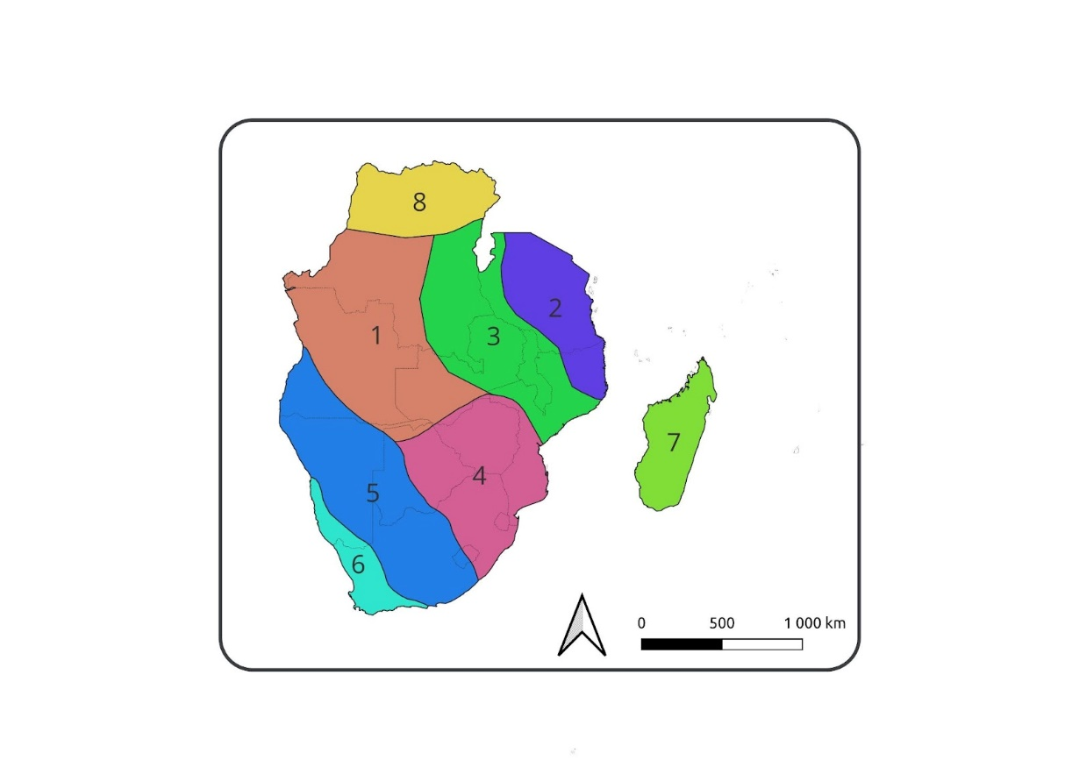
Figure B1-- Map of the regions used in the verification process
Table B1 - Description of regions defined for the verification process (Figure B1)
Region | Description
1 | Covers southwestern DRC, bulk of Angola, western Zambia and northern most parts of Botswana and the Caprivi strip of Namibia
2 | Covers the bulk of Tanzania and the northern parts of Mozambique
3 | Covers central Mozambique, Malawi, eastern half of Zambia, western fringes of Tanzania and eastern DRC
4 | Covers the whole of Zimbabwe and Eswatini, eastern to central Botswana, eastern half of Lesotho, eastern South Africa and southern Mozambique
5 | Covers southwestern Angola, western Botswana, the bulk of Namibia, central South Africa and the western half of Lesotho
6 | An austral winter rainfall region covering the southwestern parts of South Africa into southwest Namibia
7 | Madagascar
8 | An austral winter rainfall region covering the northern parts of the DRC

Description of Methods
Regional averages of skill for each zone and forecast model (Table B1) are estimated for the various forecast verification metrics (Table B2) that have been implemented in the PyCPT installation at the SADC CSC. For consistency, forecasts for each model are calibrated and verified over a common period of 1993-2016 even though some of the models have hindcasts available over a longer period on the IRI repository. The verification is done by cross-validation against observations (predictand) for individual model forecasts using the available hindcasts (Munoz et al., 2016). The PyCPT installation is currently set to automatically generate forecasts every month based on the Canonical Correlation Analysis (CCA) and Principal Components Regression (PCR) Model Output Statistics (MOS) for several forecast model-based predictors, namely Sea-surface Temperatures over the NINO 3.4 region in the eastern Pacific Ocean (SST-nino34), global sea surface temperatures (SST-global), Geopotential Height over the wider Southern African region (GPH-saf) and precipitation over the SADC region (PRCP-sadc). All of the predictors are forecasts from the global forecasting models described in Table B11. For the predictand, the CHIRPS rainfall estimates are currently being used for rainfall forecasts. While the PyCPT implementation has been set up to generate forecasts for temperature, and some extreme event indices, e.g., consecutive dry days (ETCCDI-CDD) and maximum 5-day rainfall (ETCCDI-Rx5day), the focus here is on seasonal total rainfall forecasts. The verification is performed for the September-October-November (SON), December-January-February (DJF) and March-April-May (MAM) seasons up to a 3-month lead time representing the number of months the first month of the forecast season is valid from the month of forecast initialization.

Table B2 - List of seasonal forecast models used in the verification process, their developing institutions, available hindcasts on the IRI repository and references to documentation on the models
No | Model Abbreviation | Developing institution | Available Hindcast period | Reference
1 | METEOFRANCE8 | Météo-France | 1993-2016 | Batté et al., 2021
2 | CanSIPSIC3 | Environment and Climate Change Canada (ECCC)’s Canadian Meteorological Centre (CMC) | 1991-2020 | Lin et al., 2020
3 | SPSv3p5 | Centro Euro-Mediterraneo sui Cambiamenti Climatici (CMCC) | 1993-2016 | Sanna et al., 2017
4 | GCFS2p1 | Deutscher Wetterdienst (DWD) | 1993-2016 | Fröhlich et al., 2021
5 | CFSv2 | National Centers for Environmental Prediction (NCEP)’s Climate Prediction Center (CPC) | 1991-2020 | Saha et al., 2014
6 | SEAS51 | European Centre for Medium-Range Weather Forecasts (ECMWF) | 1991-2016 | Johnson et al., 2019
7 | GEOSS2S | National Aeronautics and Space Administration (NASA) | 1991-2020 | Molod et al., 2020
8 | CCSM4 | National Center for Atmospheric Research (NCAR)/University of Miami | 1991-2020 | Gent et al., 2011
9 | SPEAR | Geophysical Fluid Dynamics Laboratory (GFDL) | 1991-2020 | Delworth et. al., 2020

Table B3 summarizes the skill scores that are implemented in the PyCPT, with the supporting references where details of how they are defined and how they have been applied in verification and assessment of forecast skill. Since PyCPT generates both the deterministic and probabilistic forecasts, the skill metrics are further categorized into the types of forecasts they provide skill for, that is, either categorical (probabilistic) forecasts or continuous (deterministic).

Table B3 - List of skill metrics that have been implemented with the PyCPT installation at the SADC CSC. Bolded skill scores have been used in the current analysis
Skill Name | Abbreviation (as defined in PyCPT) | Skilful Threshold | Reference (Categorical or continuous)
Pearson's correlation | pearson | 0.3 | De´que´, (2012, pp 74) - continuous
Spearman's correlation | spearman | 0.3 | De´que´, (2012, pp 74) - continuous
2AFC score | two_alternative_forced_choice | 60 | Mason and Weigel (2009) - categorical
ROC score for below normal | roc_area_below_normal | 50 | Mason and Stephenson (2008) - categorical
ROC score for above normal | roc_area_above_normal | 50 | Mason and Stephenson (2008) - categorical
Generalized ROC | generalized_roc | 50 | Mason and Weigel (2009) - categorical
Rank Probability Skill Score (RPSS) | rank_probability_skill_score | 60 | Weigel (2012, pp 161) - categorical
Ignorance Score | ignorance | 1.7 | Mason (2015, pp 56) - categorical

Estimates of the percentage of the area in every region that is skilful based on a predefined threshold (Table B3) for each skill metric are also provided. The thresholds are defined based on literature, following how they have been used in previous studies and applications e.g., as defined at https://iri.columbia.edu/our-expertise/climate/forecasts/verification/ . Results are presented in the form of bar charts for averages over the entire region and individual sub-regions as well as maps that capture the spatial patterns of skill. A selection of skill metrics, namely Spearman’s correlation, Receiver Operating Characteristic (ROC) score for below normal, generalized ROC, and the Two Alternative Forced Choice (2FAC) scores are used for the analysis averaged over the entire SADC region, while the Pearson‘s correlation score is employed over the regional analysis.

NOTE: The results for the Pearson and Spearman’s correlation scores are almost identical hence there is no major implication in the outcomes of the results of the region-wide averages and regional analysis.

Results

SADC Region-wide Analysis
In this section, results for the skill assessment averaged over the entire SADC region are provided. The results are provided as bar graphs, first looking at how the choice of MOS function affects skill, followed by the impact of forecast lead time on skill across different predictors. Examples of plots available for further consideration, if one wants to investigate the performance of individual forecasting models and regions, are also provided.

Skill as a function of MOS over the SADC region
Figures B12, B13, and B14 provide a comparison of the area-averaged skill scores based on the CCA and PCR MOS functions for each of the 9 forecast models and four predictors at a 0-month lead time for the SON, DJF and MAM seasons respectively. Additional plots for the 1-, 2-, and 3-month lead times are available as additional information. The PCR MOS function-based forecasts tend to have higher skill scores across most models, seasons, predictors and lead times. Subsequent results presented here will therefore focus on the PCR MOS even though plots for the CCA MOS are also provided.

While the PCR MOS function has been found to perform relatively well in most cases across the whole of the SADC region, it should be noted that the level of skill is generally low especially when looking at the Spearman’s correlation coefficient. Overall, the level of skill is greatest in the DJF season (Figure B3) indicating improved predictability for that season compared to the SON and MAM seasons.

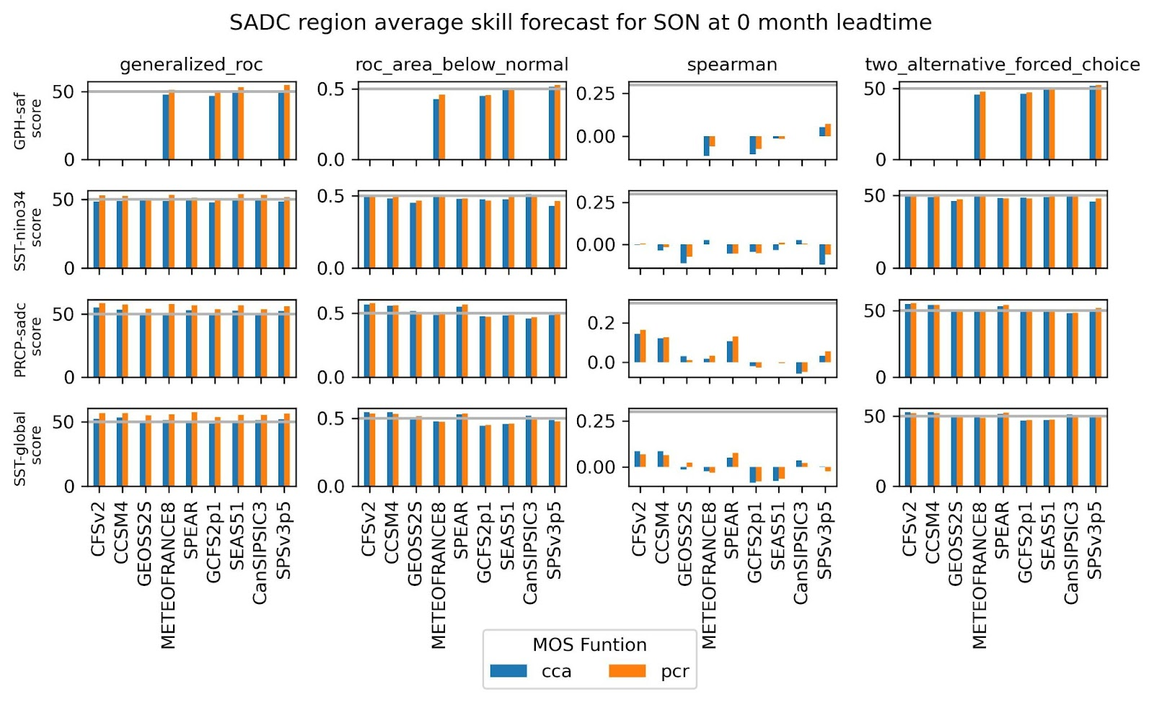
Figure B2- - Bar plots comparing the skill scores of the different MOS functions for the individual predictors averaged over the entire SADC region at a forecast lead time of 0 months for the SON season.
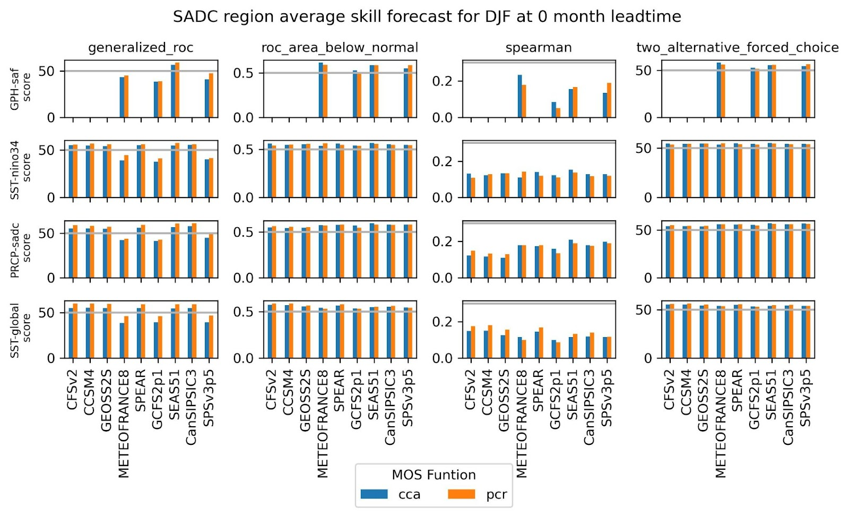
Figure B3- - Same as Figure B2 but for the DJF season
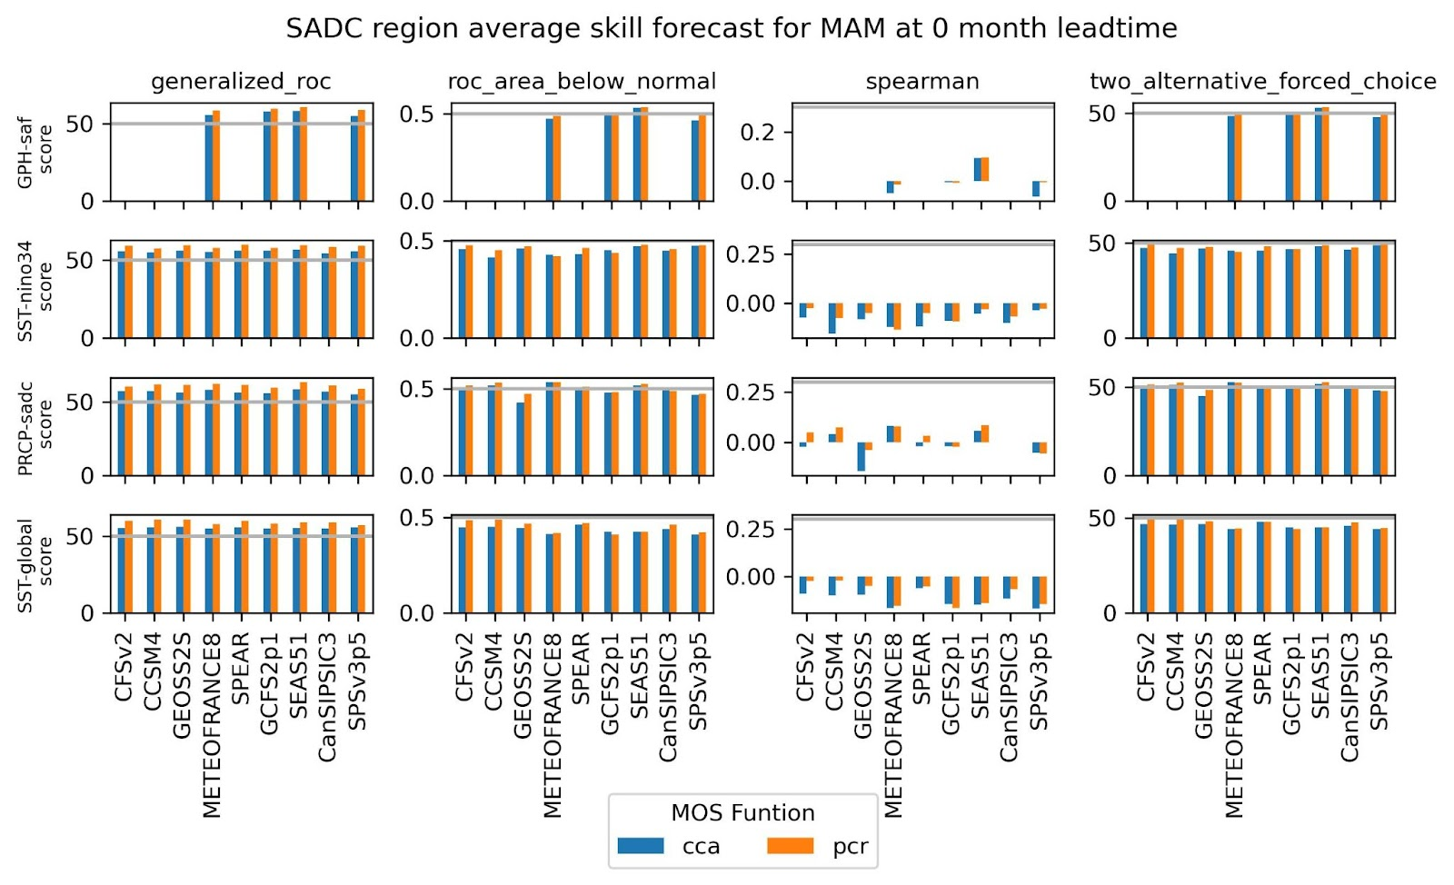
Figure B4- - Same as Figure B2 but for the MAM season

Skill as a function of Predictors over the SADC region
Figures B5 - B7 compare the SADC region’s average skill scores for each model and predictor at the different forecast lead times, and for the different seasons considered based on the PCR MOS function. While there seem to be consistency in the generalised roc skill score at different lead times across most models in the SON (Figure B5) and MAM (Figure B7) seasons, three models (METEOFRANCE8, GCFS2p1 and SPSv3p5) have a relatively poor skill in the DJF season for all predictors. Excluding the three models above, the SST-global based forecasts tend to have more skill in the DJF season based on the generalised ROC and ROC-area-below-normal and Spearman’s correlation skill scores for most models (Figure B6).

In the SON and MAM season, the ROC area-below normal, Spearman’s correlation and 2FAC skill scores indicate relatively poor performance of the forecasts for all predictors at all forecast lead times, even though the PRCP-sadc showed an increased level of skill in the SON season for the CFSv2, CCSM4 and SPEAR models (Figures B5 and B7). PRCP-sadc based forecasts have been found to outperform forecasts based on the SST-nino34 predictor in most models.

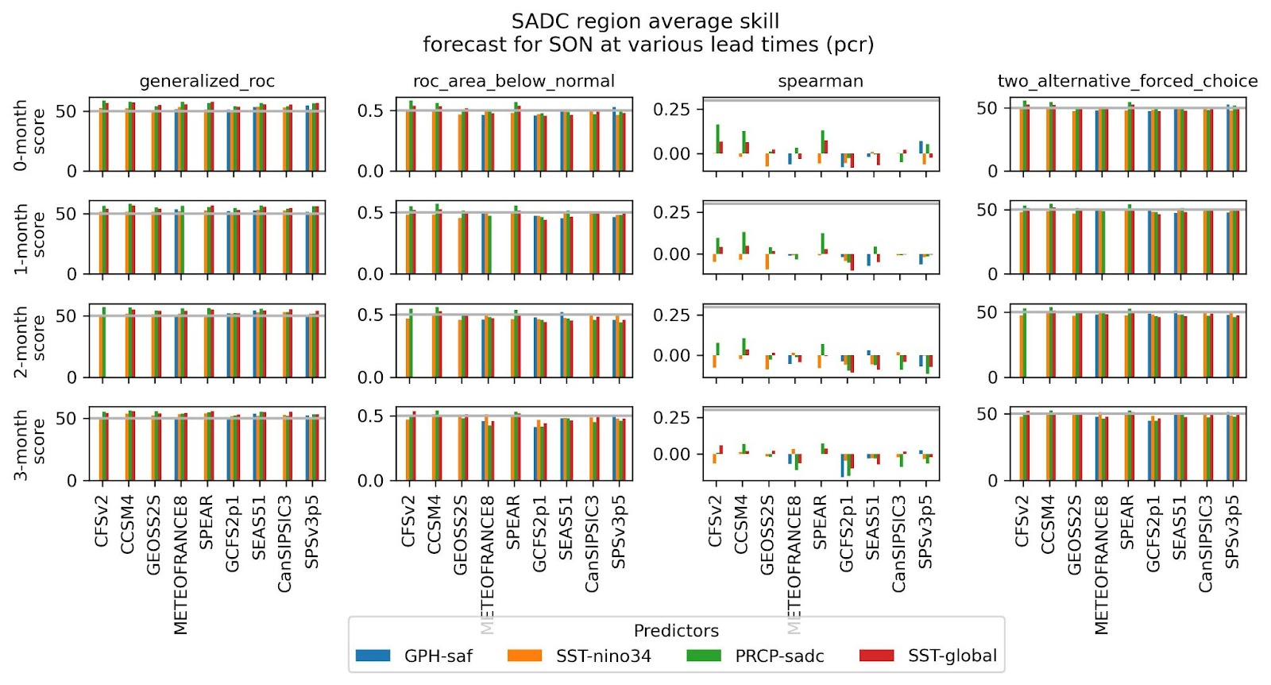
Figure B5: Bar plots comparing the skill scores for the different predictors at different lead times over the entire SADC region for the SON season based on the PCR MOS function.

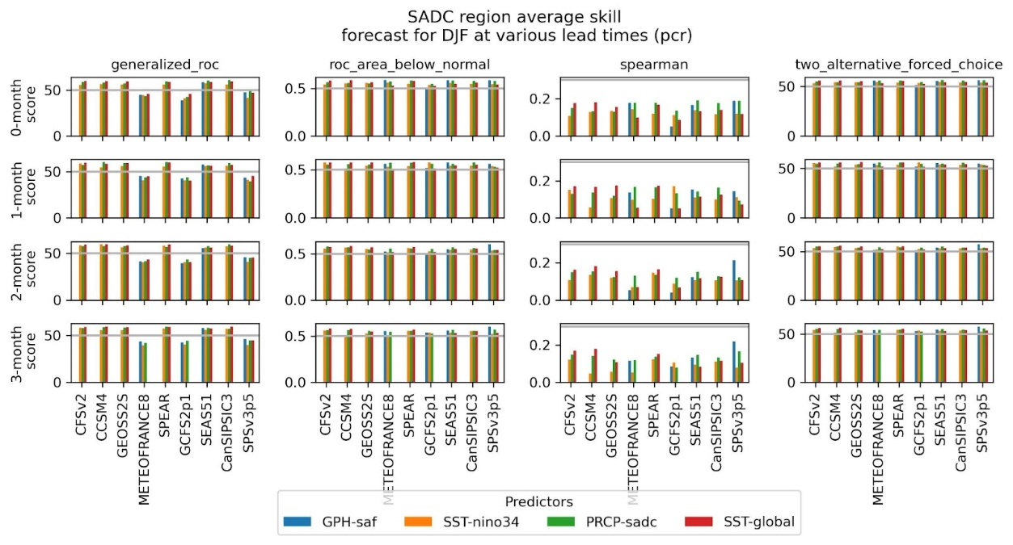
Figure B6: Same as Figure B5 but for the DJF season

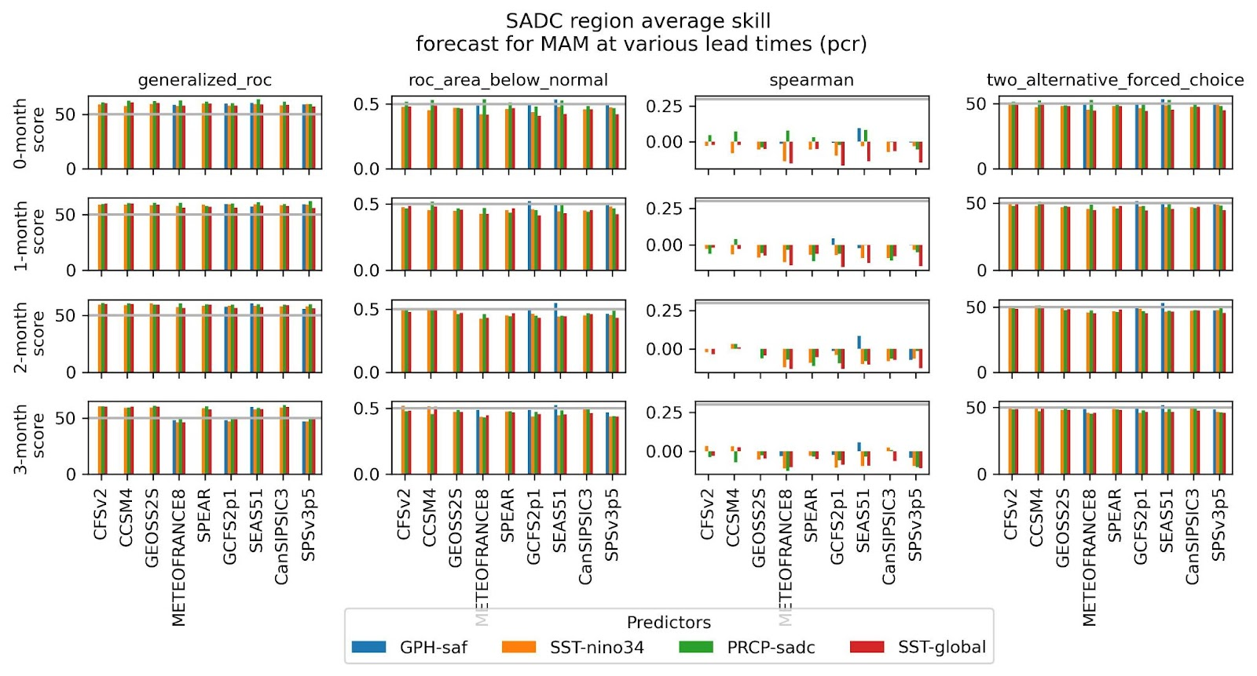
Figure B7: Same as Figure B5 but for the MAM season

Skill as a function of lead time over the SADC region
Figures B8, B9, and B10 show how forecast skill changes with lead time for the different models given different predictors. As expected, even though not the case for all the models and different lead times, skill tends to be highest at 0-month lead time, decreasing with increased forecast lead time. For the MAM season using the SST-global as a predictor, the forecast skill, while still below the defined thresholds tends to increase with increasing lead times considering the ROC area below normal, Spearman correlation, and 2FAC skill scores (Figure B10). It can however be noted that as shown in the previous section, for the whole of the SADC region predictability is generally low for the SON (Figure B8) and MAM (Figure B10) seasons compared to the DJF season (Figure B7).
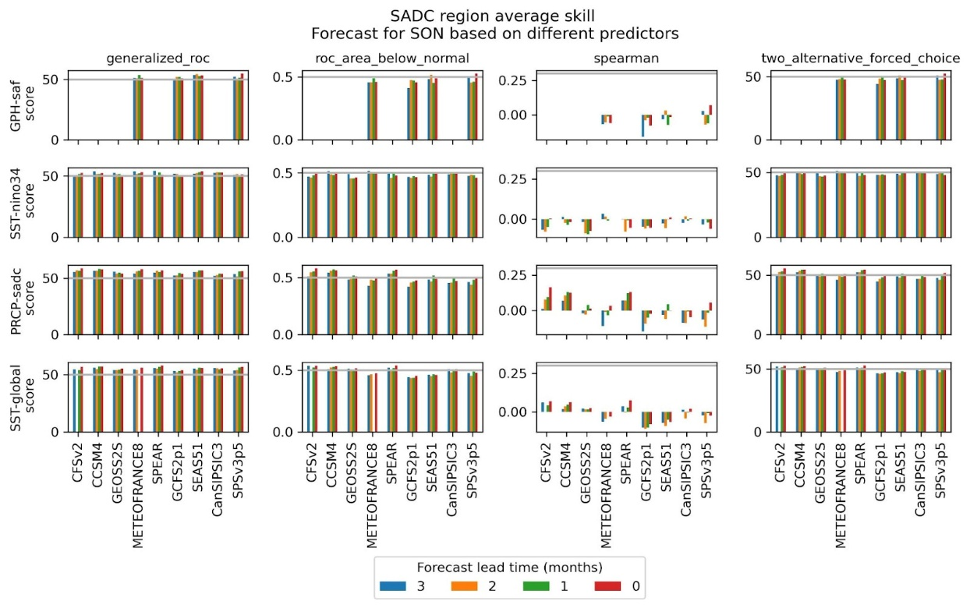
Figure B8- - Bar plots comparing the skill scores at different lead times for different the various predictors averaged over the entire SADC region for the SON season based on the PCR MOS function.

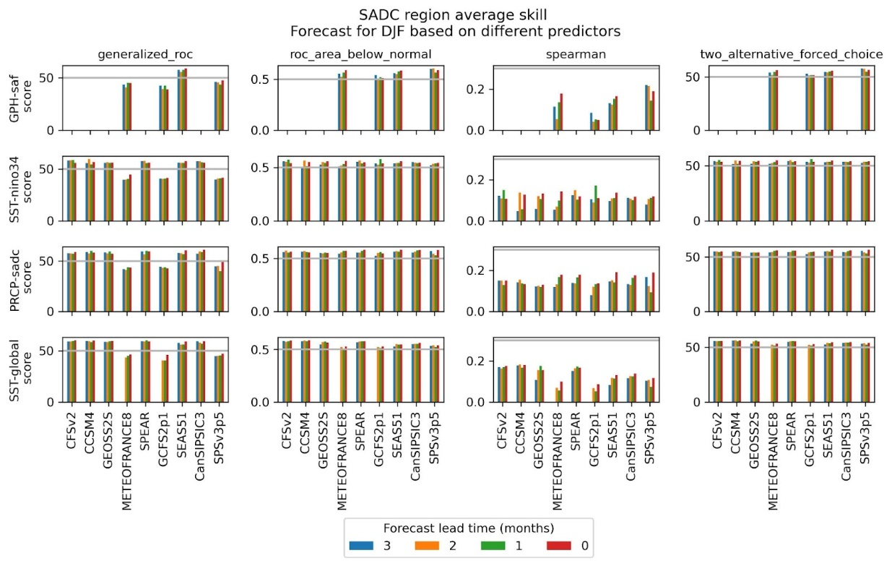
Figure B9- - Same as Figure B8 but for the DJF season

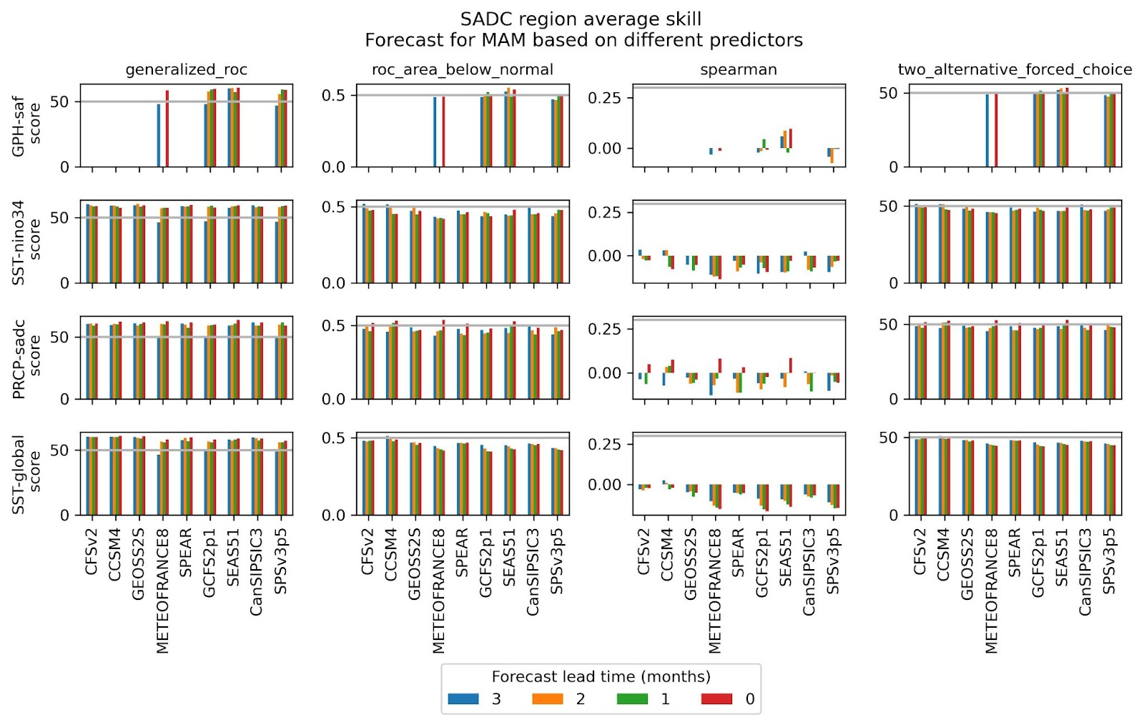
Figure B10- - Same as Figure B8 but for the MAM season

Regional Average Analysis
In this section, results for regional averages of the regions defined in Figure B1 are used to describe the spatial patterns of skill based on predictors obtained from the various seasonal forecasting global models at different forecast lead times are provided. We first compare the skill metrics for each season, followed by how the skill changes based on the season being forecasted, then how the forecast lead time impacts on skilfulness of forecasts across the different models.

Illustration of the general pattern of differences in the model-skill measure matrix
Using a forecast lead time of 3 months, corresponding to the furthest into the future the current models can provide useful forecasts, we here provide a comparison of how the different skill scores map across the different seasons of the year for each of the predictors that have been implemented.
September-October-November (SON)
Figure B11 and B12 respectively provide the spatial pattern of each model’s regional area-average skill scores (Pearson’s correlation, ROC area below normal, 2FAC and the Generalised ROC scores) and the percentage area of each region that is skilful for the SON forecast using the SST-global predictor and PCR MOS. When looking at the area averages of the skill scores, Figure B8 shows that the pattern of skill is relatively similar for each model except for the Generalised ROC score that tends to be different from the other 3 skill scores. The pattern however changes when considering the percentage of each region that is skilful, with the Pearson’s correlation skill score having a tendency to indicate poor model performance across most of the region (Figure B12), while the Generalised ROC score tends to give higher percentages of area that is skilful over the top half of the region including the island of Madagascar (regions 1, 2, 3, 7 and 8). The 2FAC and ROC area below normal skill scores were observed to have similar patterns of the percentage of skilful area (Figure B12). The SEAS51, SPSv3p5, CCSM4, GCFS2p1 and METOFRANCE8 models have a similar pattern of skilfulness that can also be observed in the percentage area that is skilful while CanSIPSIC3, CFSv2 and the GEOSS2S model showed similar patterns especially for the ROC area below normal skill score over all regions except region 6 where the CFSv2 model has low skill (Figure B9). It is not entirely clear why the CanSIPSIC3, CFSv2 and GEOSS2S models tend to have similar patterns of skill but could be related to the fact that they are all developed by institutions in North America and Canada, something that requires further investigation.
December-January-February (DJF)
For the DJF season, while noting that the GCFS2p1 and METEOFRANCE8 models did not have data at the forecast lead time of 3 months, Figures B13 and B14 respectively provide the spatial pattern of each model’s regional area-average skill scores (Pearson’s correlation, ROC area below normal, 2FAC and the Generalised ROC scores) and the percentage area of each region that is skilful using the SST-global predictor and PCR MOS. As observed in the SON season, even though the DJF season has an increased level of skill compared to the SON season, the pattern of average skill scores tends to be similar across skill scores except for the Generalised ROC score. While further investigation is required, the reason for the generalised ROC score having a different pattern of skill compared to the rest may be because forecasts are able to better discriminate whether one observation is wetter than the other given two observations (Mason, 2012, pp 212).
March-April-May (MAM)
A similar pattern of skill as in the SON season emerges in the MAM season (Figures B15 and B16) where most of the regions have low skills across the different skill metrics except for the generalised ROC. As in the SON season, the models that had a similar pattern of skill tend to be grouped together prompting a need for further investigation for why that is.
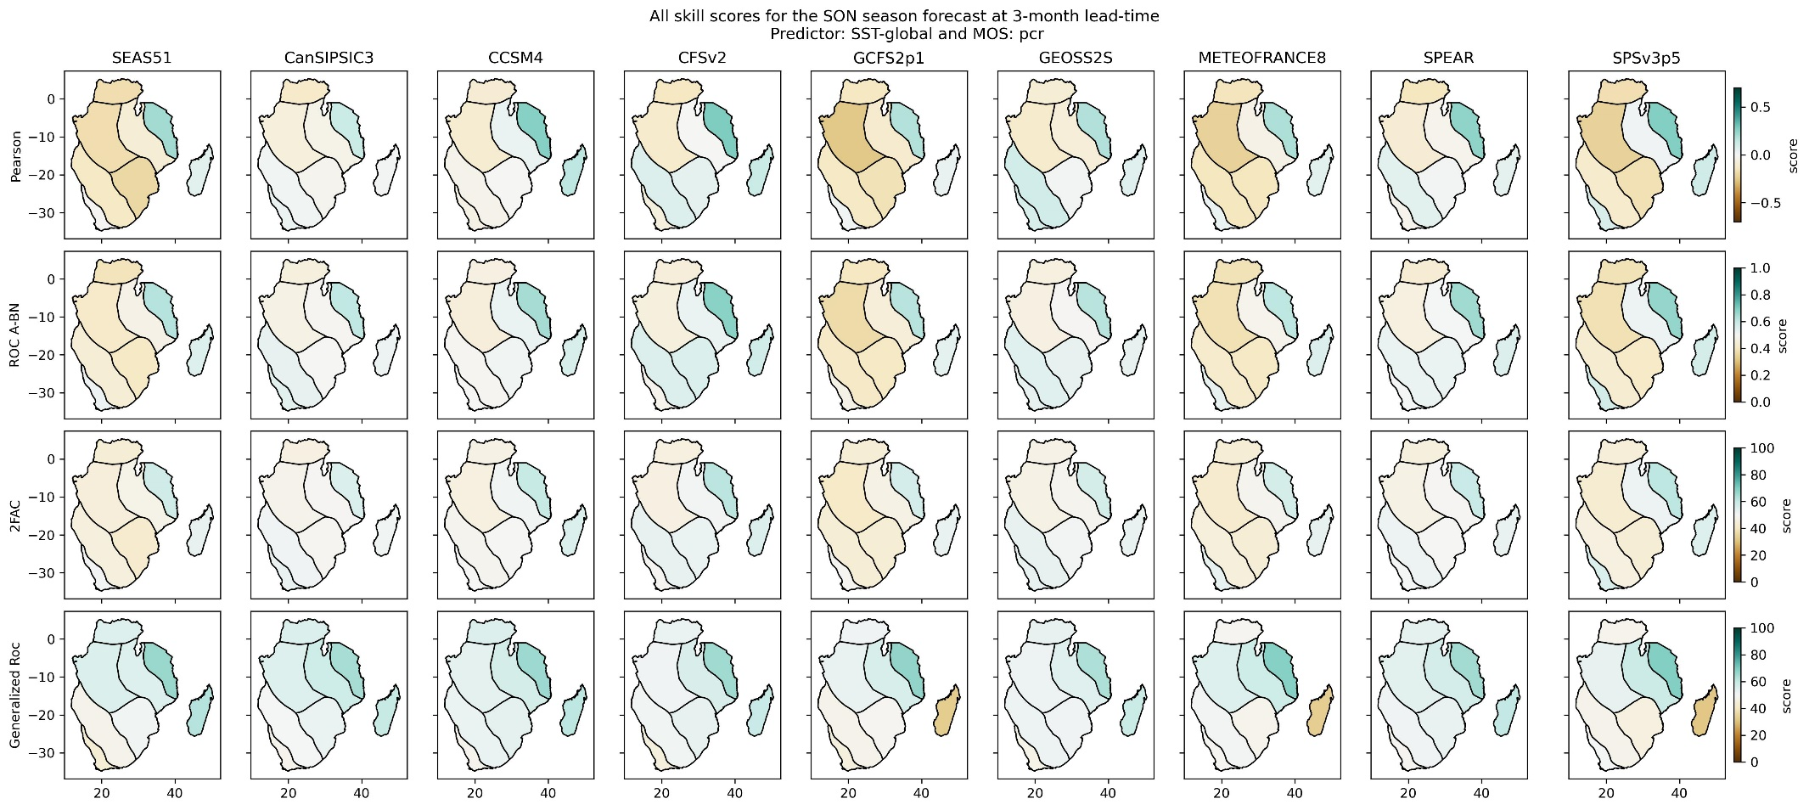
Figure B11- - Plots of regional average skill scores for the individual models for the SON season using SST-global as a predictor and the PCR MOS function at 3-months lead time. Pearson (row 1), ROC below normal (row 2), 2FAC (row 3), generalized ROC (row 4).
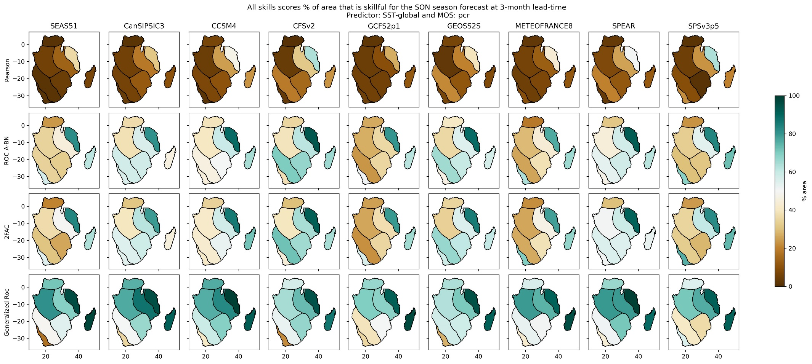
Figure B12- - Plots of the percentage of regional area that is skilful for the different skill scores in the SON season using SST-global as a predictor and the PCR MOS function at 3-months lead time. Pearson (row 1), ROC below normal (row 2), 2FAC (row 3), generalized ROC (row 4).
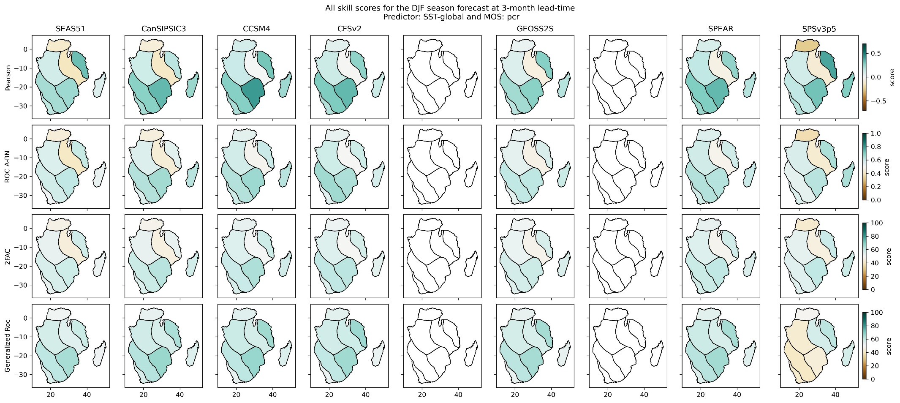
Figure B13- - Same as Figure B11 but for the DJF season
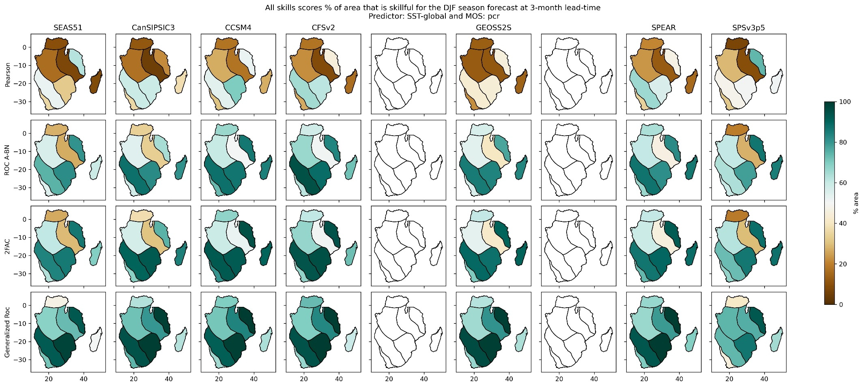
Figure B14- - Same as Figure B12 but for the DJF season

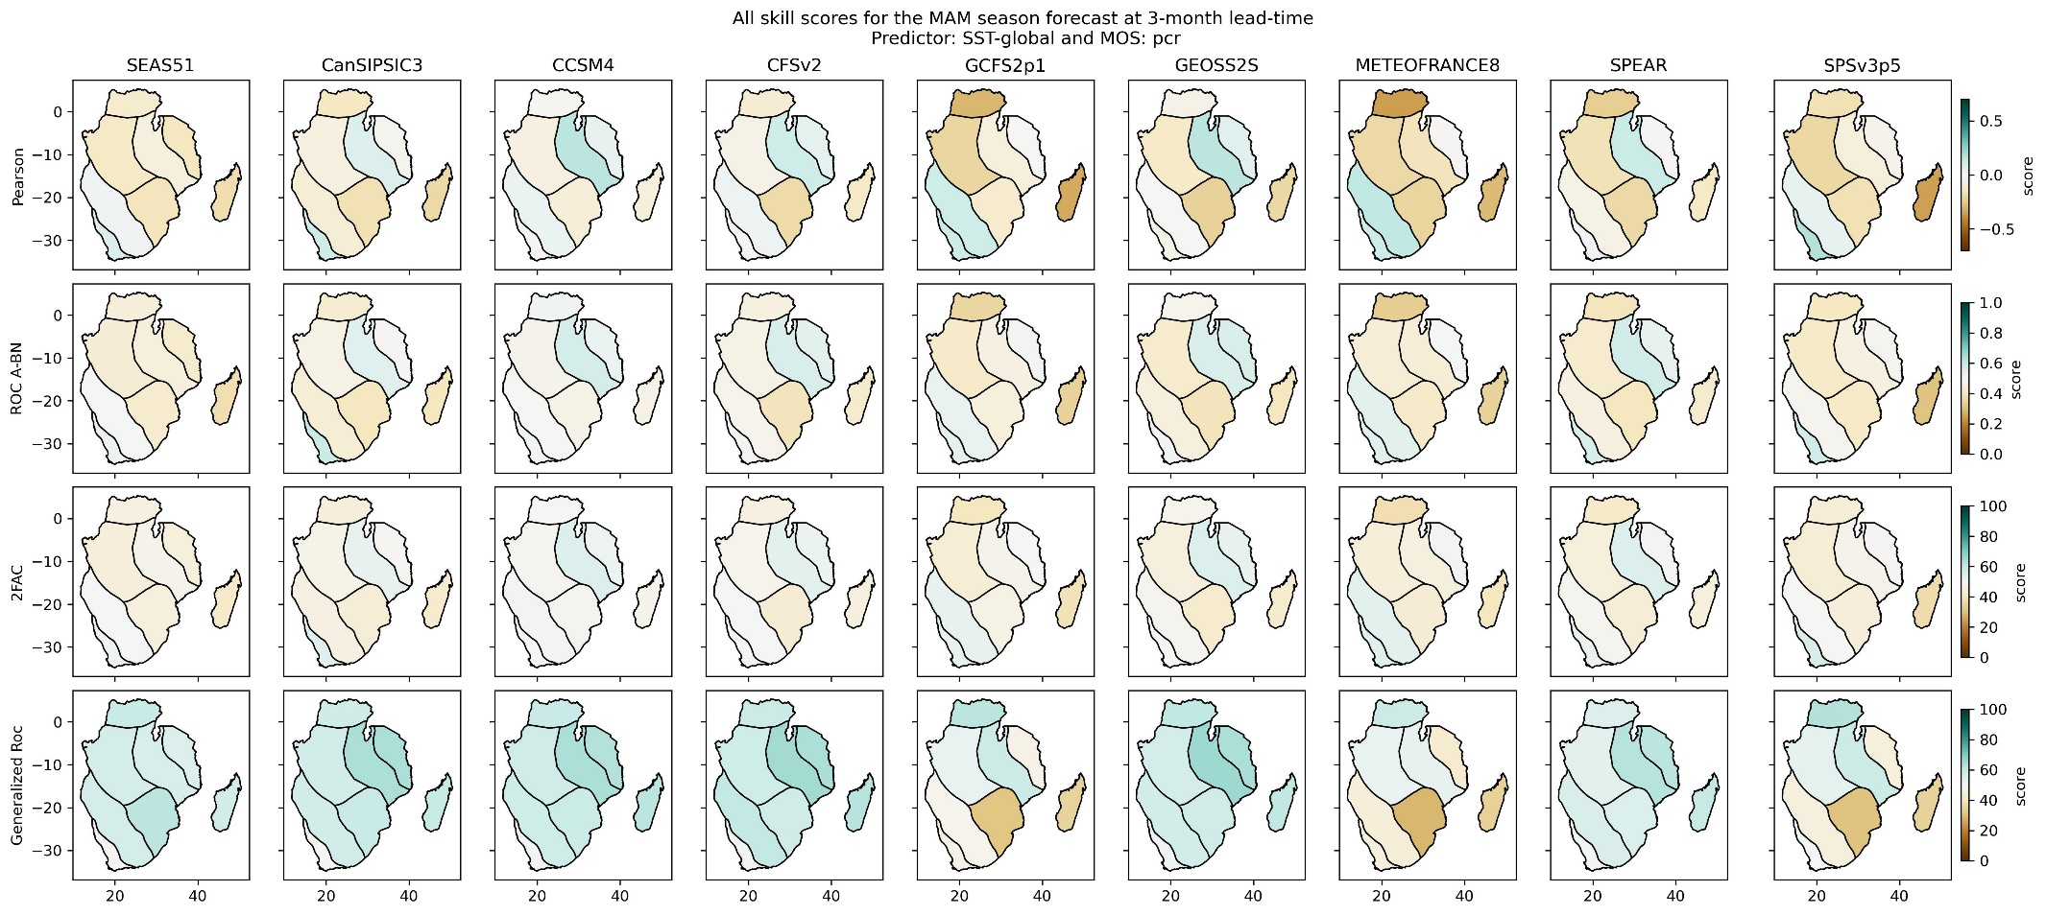
Figure B15- - Same as Figure B11 but for the MAM season
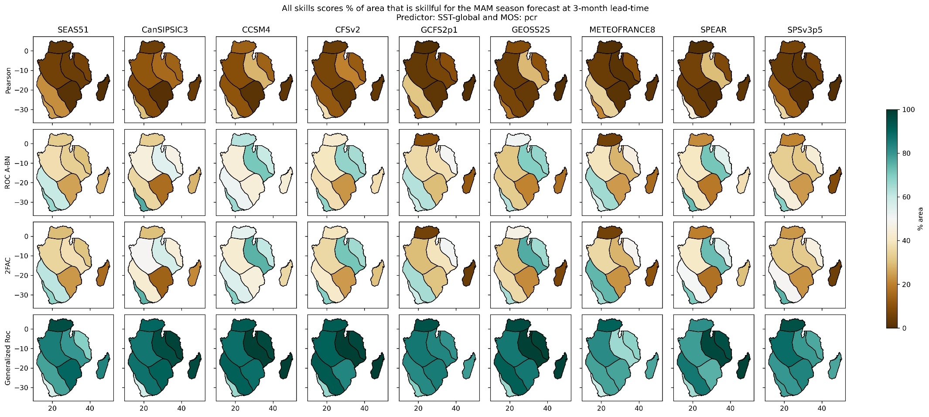
Figure B16- - Same as Figure B12 but for the MAM season

Comparison of skill across seasons
To compare how skilful forecasts are across the seasons, we use the forecast lead time of three months for the SST-global, SST-nino34, and PRCP-sadc predictors using the PCR MOS function (Figure B17 to Figure B19). The results of the GPH-saf predictor are not shown as only 3 models had been processed. In general, most of the models indicate a high level of predictability over most regions in the DJF season across all predictors. Exceptions are regions 8 and 3 where the Pearson correlation skill score tends to be consistently low across most models and predictors. Even though there is a general indication that the DJF season has more predictability, it must be noted that the percentage of the regions that is skilful at times can be very low, indicating high skill scores only in a small fraction of the region of interest. For example, in Figure B14, with SST-global as the predictor, the CanSIPSC3 model indicates a relatively high Peason’s correlation score in region 4, but less than 40% of the region is skilful (Figure B18).
Looking at the spatial distribution of regions with a larger percentage of the region that is skilful, regions 4 and 5 representing the bulk of Namibia, Botswana, Zimbabwe, southern-Mozambique, Lesotho, Eswatini and the bulk of South Africa, as well as region 2 representing the bulk of Tanzania and northern Mozambique tend to have higher levels of skill for forecasts based on SST-global as predictor in the DJF season. More plots including percentage of region skilful, different predictors and lead times are available as supplementary information.

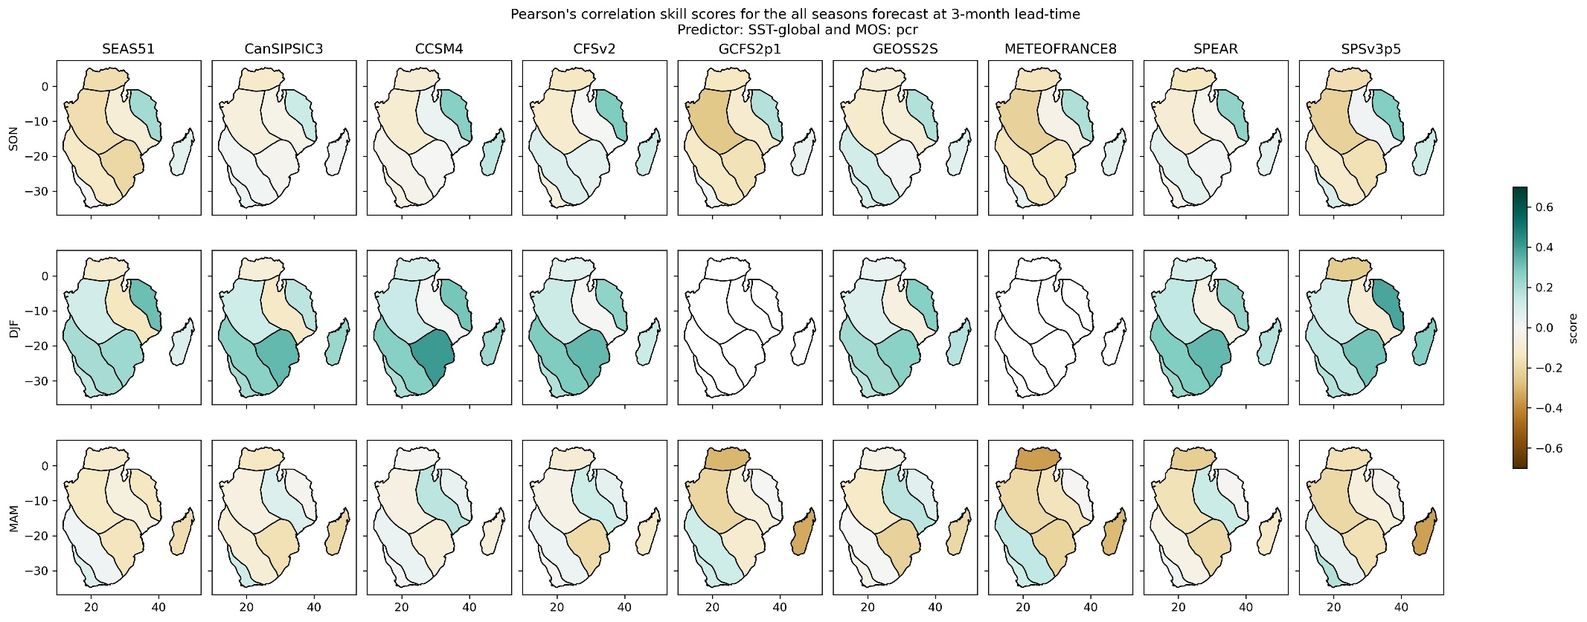
Figure B17 - Plots of regional average Pearson’s correlation skill score for the individual models across the SON, DJF and MAM seasons using SST-global as a predictor and the PCR MOS function at 3-months lead time (Note: blank maps had no data at the time of processing)

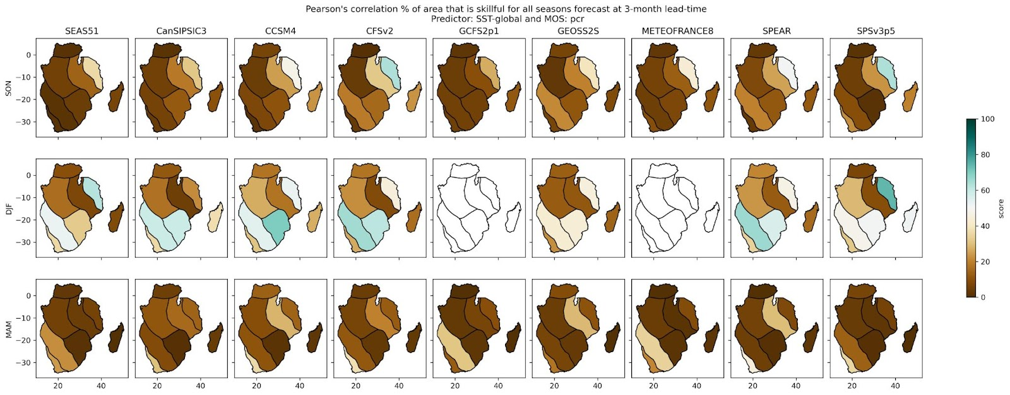
Figure B18 - Plots of the percentage of regional area that is skilful based on Pearson’s correlation skill score for the individual models across the SON, DJF and MAM seasons using SST-global as a predictor and the PCR MOS function at 3-months lead time (Note: blank maps had no data at the time of processing)

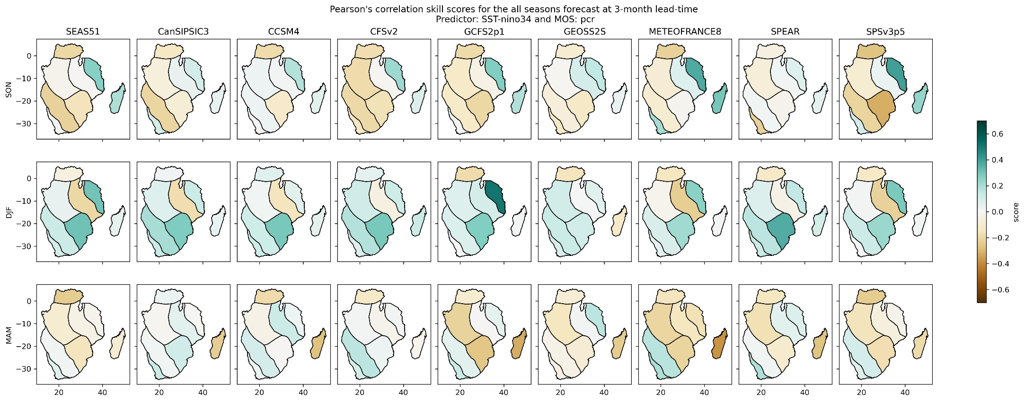
Figure B19: Same as Figure B17 but for SST-nino34 as a predictor

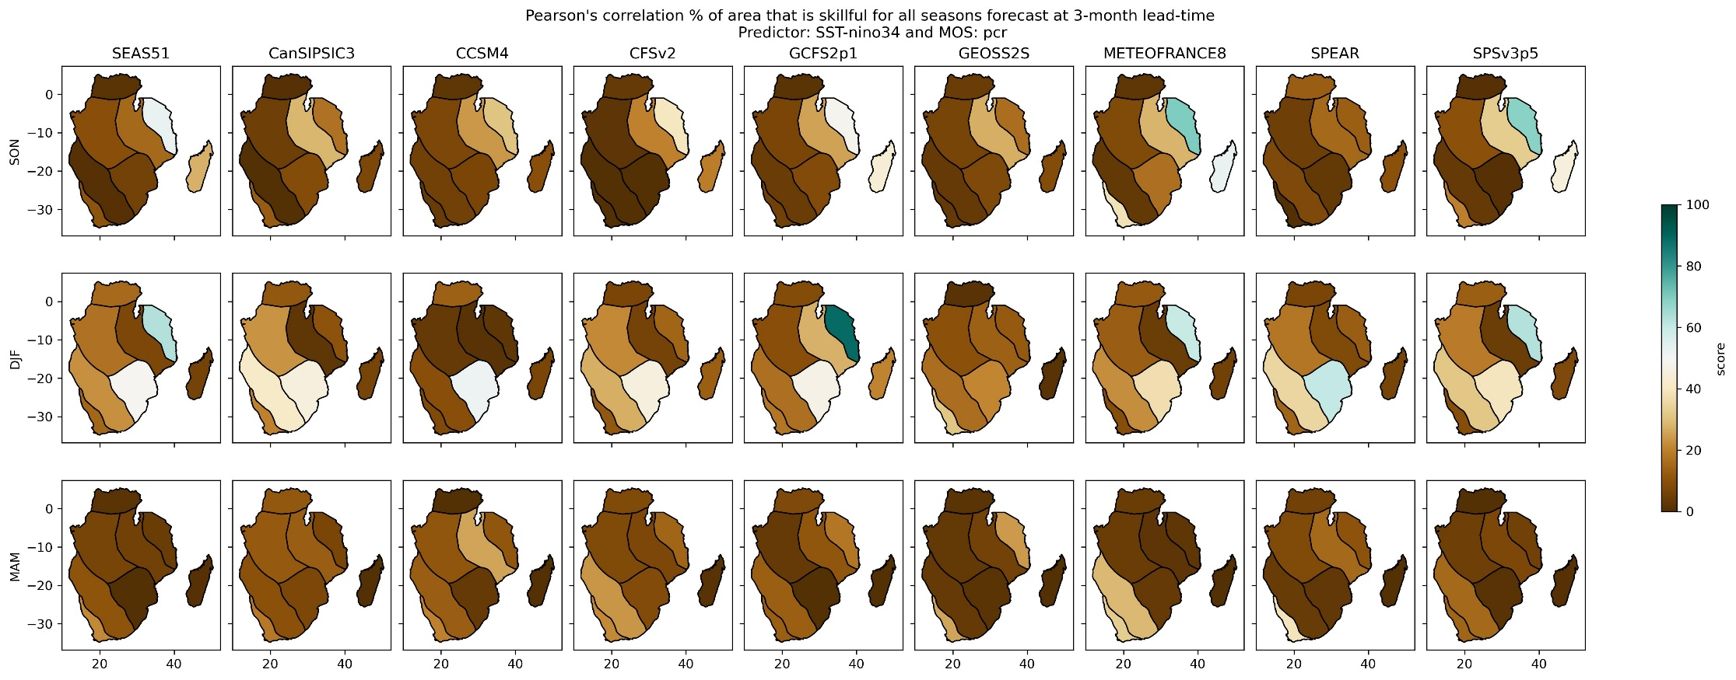
Figure B20 - Same as Figure B18 but for SST-nino34 as a predictor
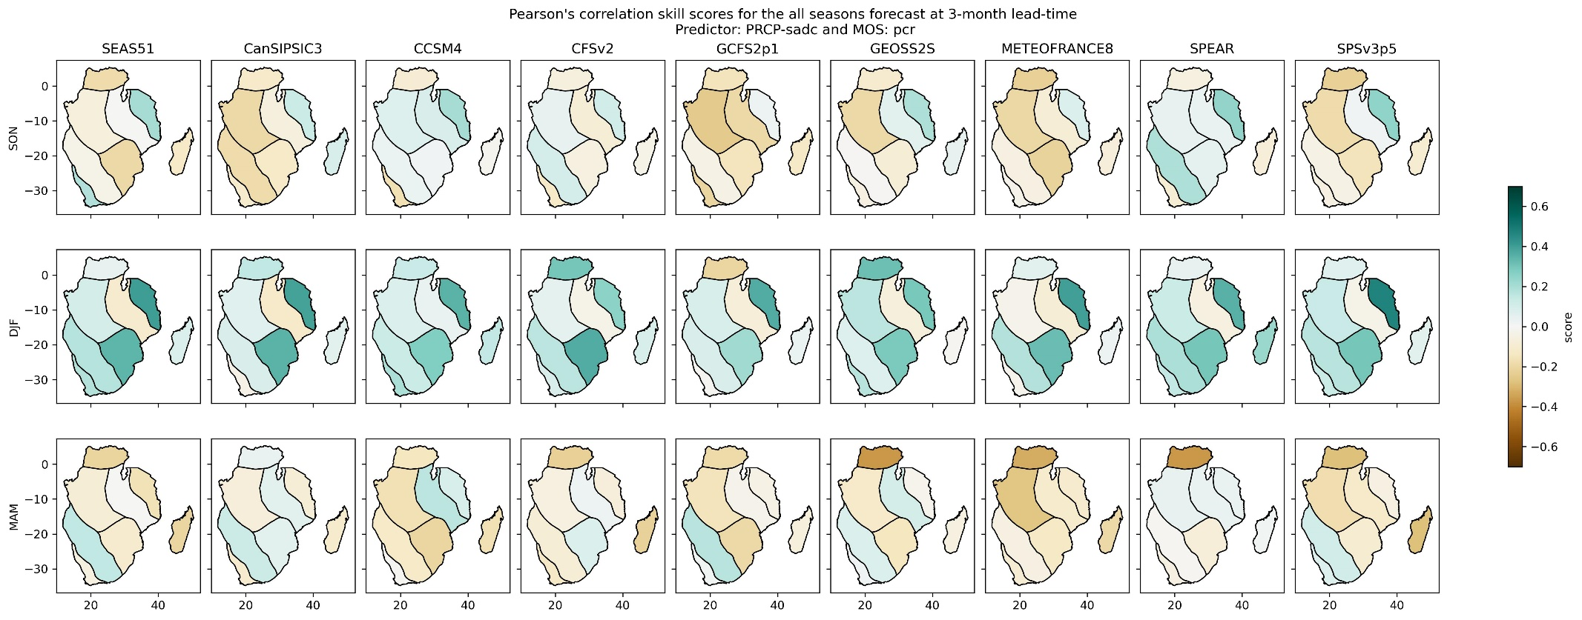
Figure B21 - Same as Figure B17 but for PRCP-sadc as a predictor
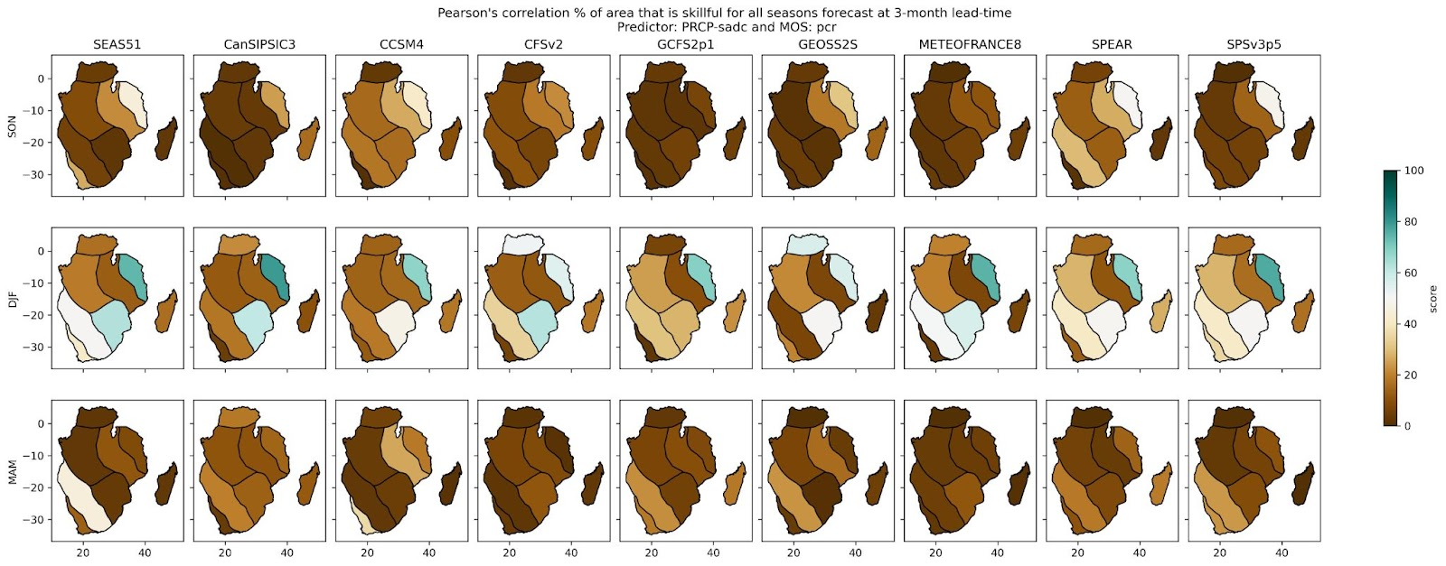
Figure B22 - Same as Figure B18 but for PRCP-sadc as a predictor

Illustration of the general pattern of change of skill with lead time
In this section, we provide results to show how the forecast skill changes with lead time at regional level. Bar plots mapping how the forecast skills in each region change with lead time for different predictors are available for the different seasons as well as maps showing how the skill is spatially distributed for each of the models and predictors available.

Using an example of the SON season, Figure B23 shows how the skill changes for each of the 8 regions, models, and predictors. Like results for region-wide averages in Section B3.1.2, while there are some cases where there’s not a clear indication of whether skill improves or decreases with lead time, (e.g., with GPH-saf as predictor), the skill is generally at its best at the shortest lead time (i.e., 0-month). It is worth highlighting that the GCFS2p1, METEOFRANCE8, and SPSv3p5 models performed poorly averaged over the entire SADC region in the DJF season (Section B3.1.2), it becomes clear here that the poor performance is due to the low skill in most regions except regions 1, 2 and 3, noting that region 2 generally tends to have the most skilful forecasts. Similarly, in Figure B24 and Figure B25, the pattern of skill tends to remain largely unchanged with forecast lead time across all models with a few exceptions, e.g., CCSM4 model where a clear reduction in skill with increased forecast lead time is evident.
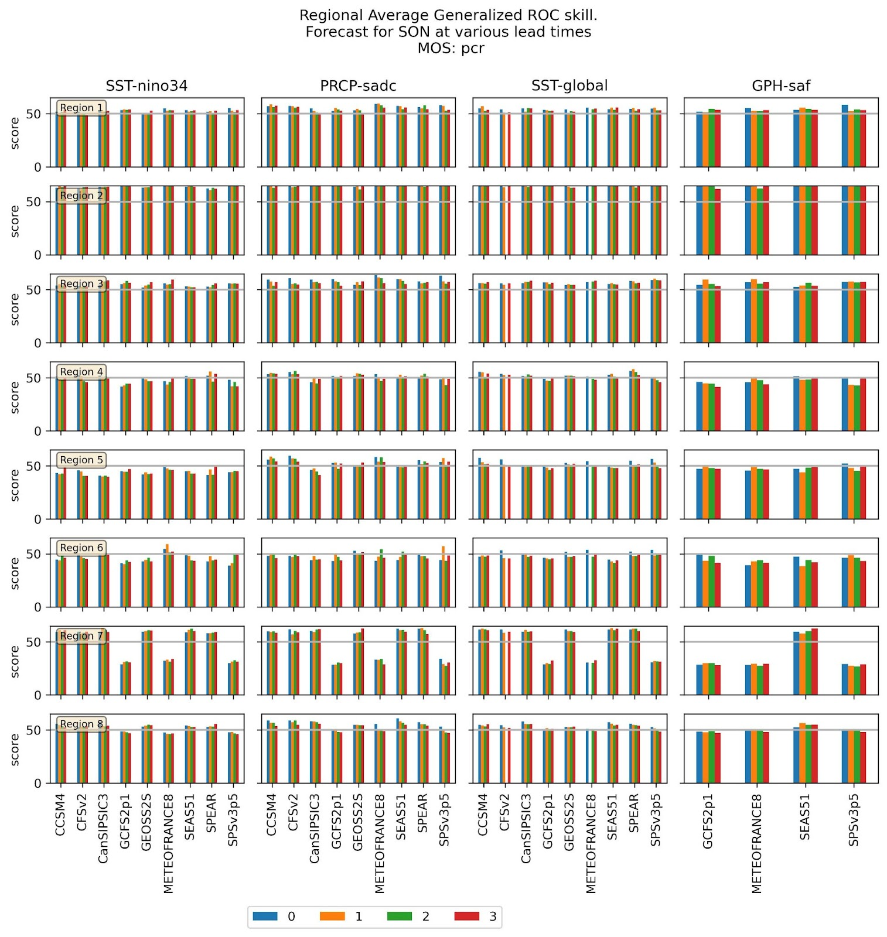
Figure B23 - Bar plots comparing the Generalised skill scores for the various predictors averaged over each of the eight regions at different lead times for the SON season. The forecasts are based on the PCR MOS function.

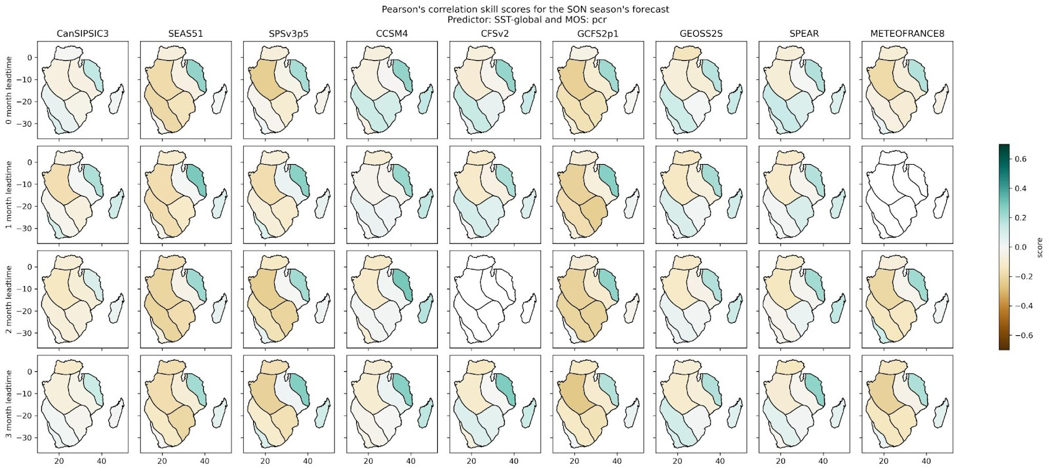
Figure B24 - Plots of regional average Pearson’s correlation skill score for the individual models for the SON season at different forecast lead times using SST-global as a predictor and the PCR MOS function (Note: blank maps had no data at the time of processing)
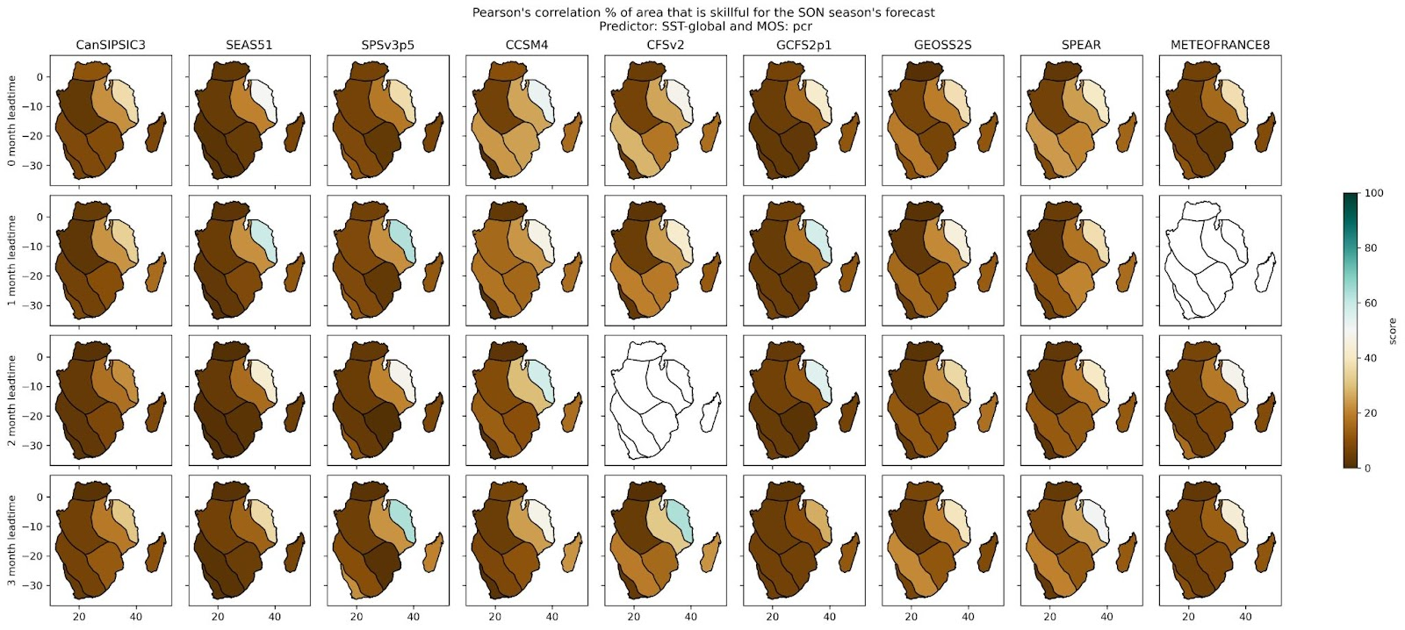
Figure B25- Plots of the percentage of regional area that is skilful based on the Pearson’s correlation skill score for the individual models. The forecasts are for the SON season at different forecast lead times using SST-global as a predictor and the PCR MOS function (Note: blank maps had no data at the time of processing)

Individual Model Maps
For each of the individual models and seasons, maps comparing the skill in by each predictor at different lead times were generated. These maps help to assess which predictors work best for the individual models and how the level of skill changes as a function of lead time. Figure B26 and Figure B27 are example maps of regional area averages and the percentage of region that is skilful for the SEAS51 model’s SON season forecast skills using the Pearson correlation scores and the Generalised ROC scores.

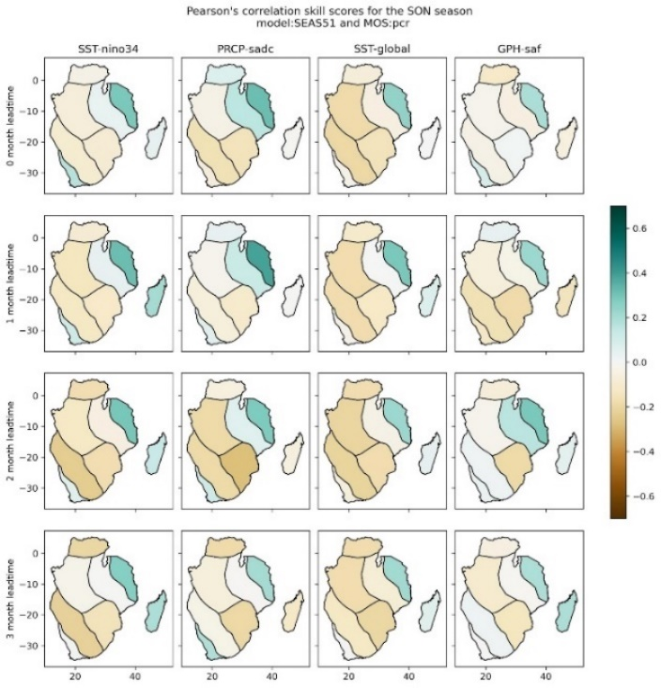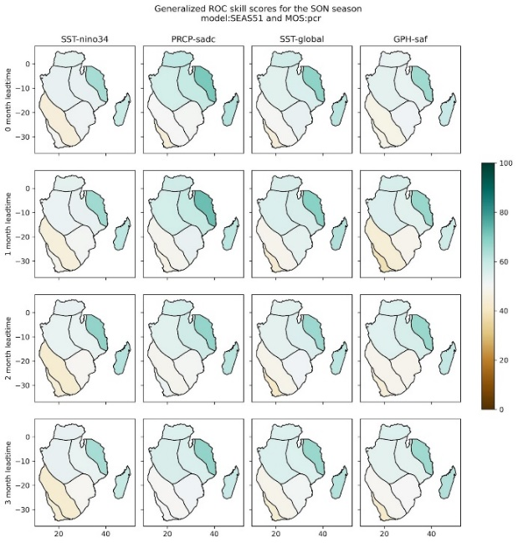
Figure B26 - Plots of regional average Pearson’s correlation and Generalized ROC skill scores for the SEAS51 model in the SON season at different forecast lead times and all available predictors based on the PCR MOS function
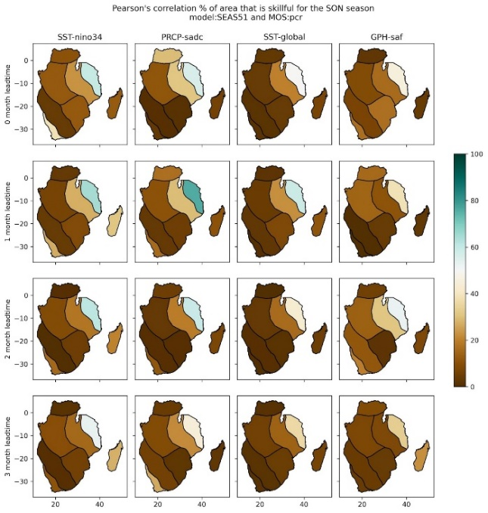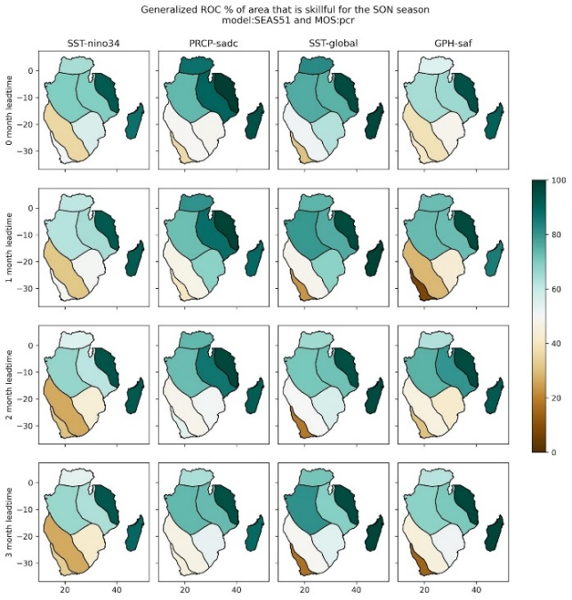
Figure B27 - Similar to Figure B26 but with the percentage of area that is skilful in each region

Plots for Individual Regions
Using an example of region 4, Figure B28 and B29 are bar graphs of all the available skill scores averaged over the region. Using these plots, one can decide on the best predictors and models to use if a forecast is to be generated for areas that fall within the region. In the case of the DJF forecast at a 3-month lead time (Figure B28), three models, GCFS2p1, METEOFRANCE8 and SPSv3p5, can be observed to perform poorly in general irrespective of the predictor, except for SPSv3p5 that shows improved forecast skill in most of the skill scores for the GPH-saf predictor. The performance of these models is found to be consistent across all lead times (Figure B29). It can also be observed that forecasts based on the SST-global predictor are for most models, consistently indicating the highest level of skill. Based on this, it can be recommended that for this region (region 4), season (DJF) and forecast lead time (3-month), the SST-global predictor be selected to create an ensemble comprised of the CCSM4, CFSv2, CanSIPSIC3, SEAS51 and SPEAR models.
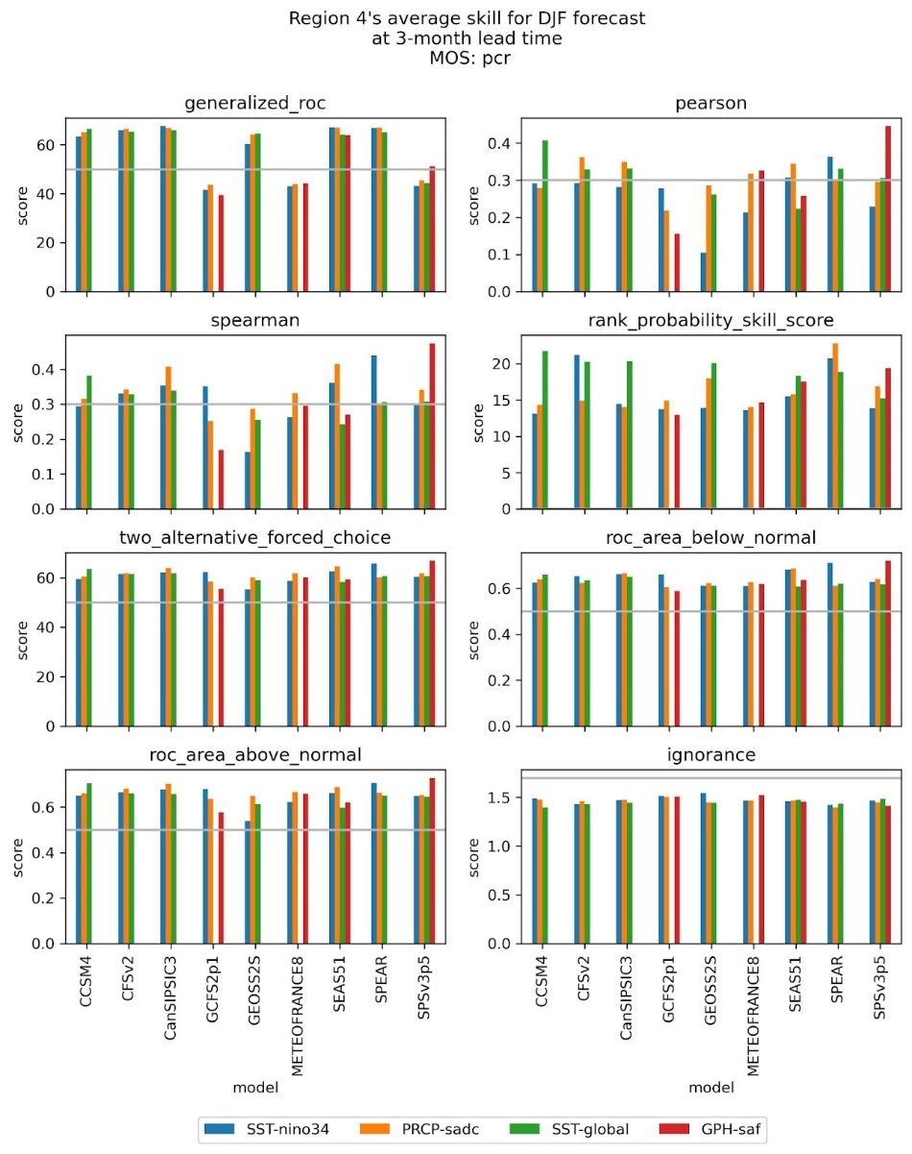
Figure B28 - Bar plots comparing the skill scores for the various predictors averaged over region 4 for the DJF season at a 3-month lead time. The forecasts are based on the PCR MOS function.

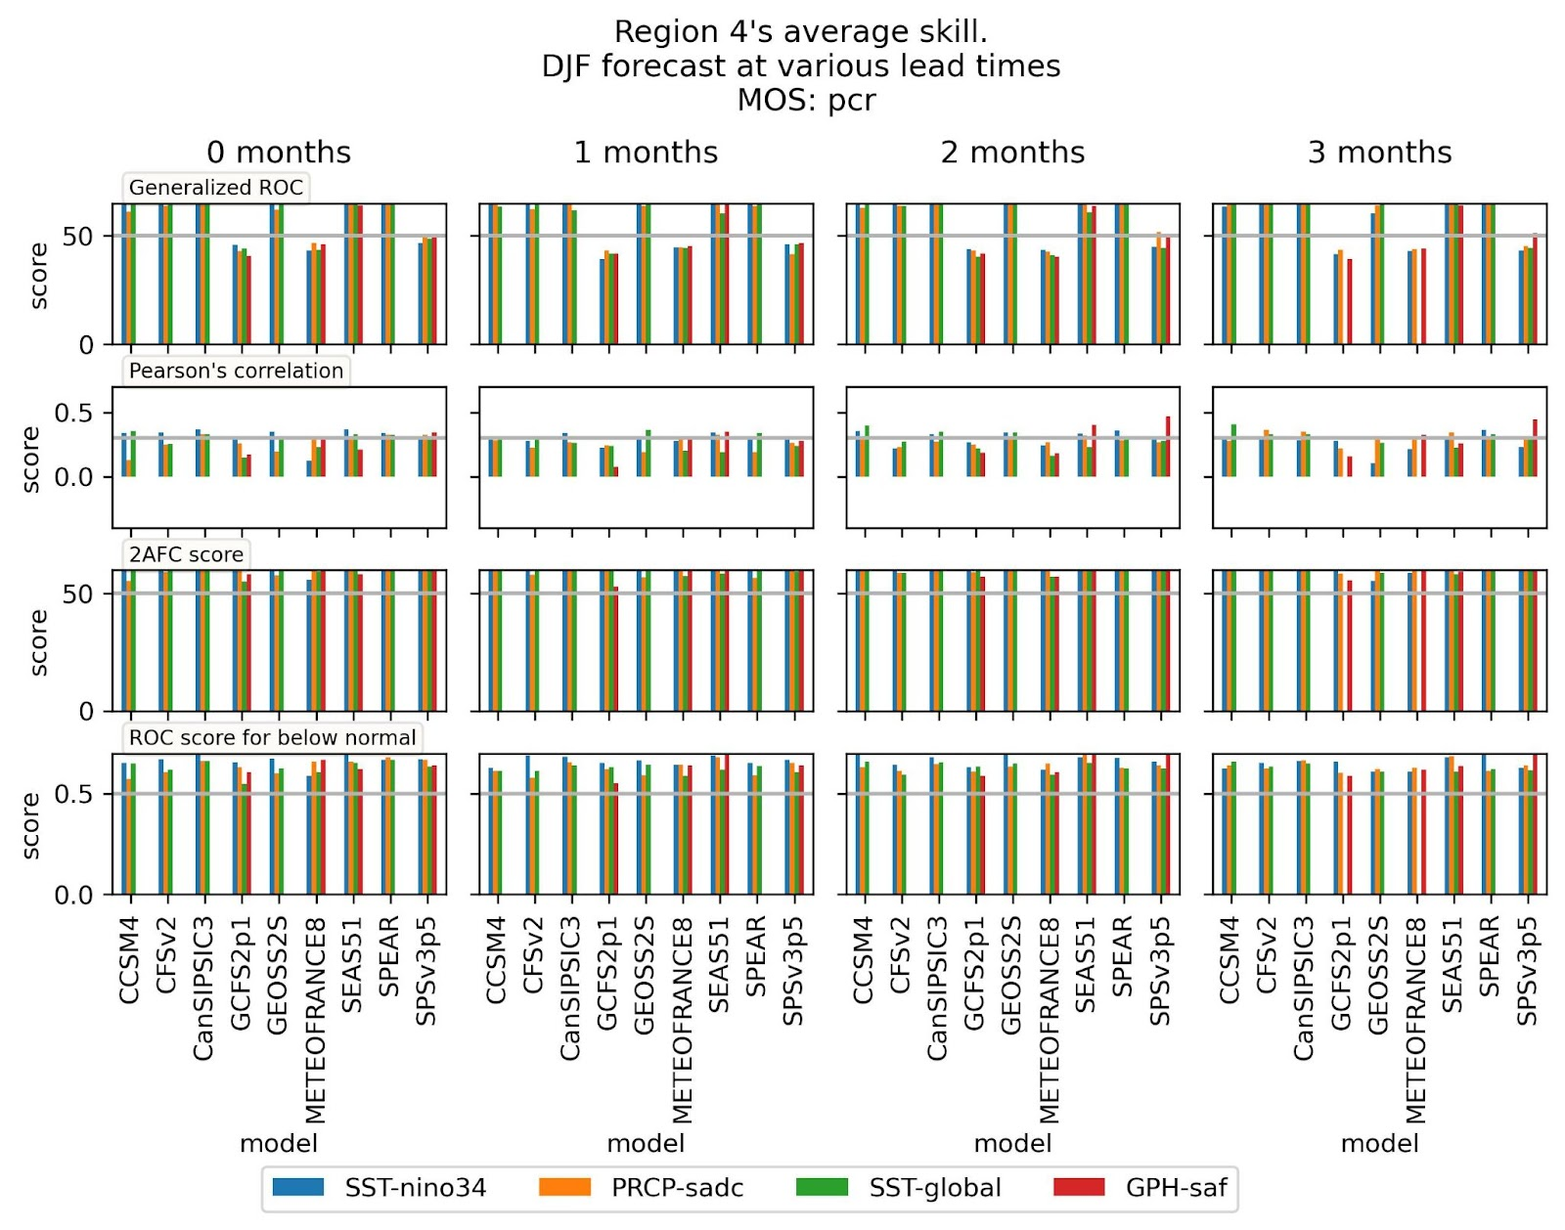
Figure B29 - Bar plots comparing selected skill scores for the various predictors averaged over region 4 for the DJF season at different lead times based on the PCR MOS function.

Conclusions
The results of the preliminary skill assessment documented here were used to provide a basis for the selection of models and predictors to use with the implemented PyCPT installation at the SADC CSC for the automated generation of seasonal and monthly forecasts (http://csc.sadc.int/en/seasonal-forecast-main/). Based on this assessment, selected models and predictors highlighted here are being used in the generation of a multi-model ensemble forecast. Based on the assessment, it was recommended that three models (METEOFRANCE8, GCFS2p1, and SPSv3p5) be excluded from the ensemble due to their relatively poor performance and that the PCR MOS function be used. It was found that the level of skill is very low for forecasts for the SON and MAM seasons while the DJF season indicated an enhanced level of predictability especially over regions 2, 4, and 5. It was also found that the SST-global predictor tended to consistently generate forecasts with a satisfactory level of skill across all seasons even though it was outperformed in some instances by other predictors, e.g., by PRCP-sadc in the MAM season averaged over the entire SADC region (Figure B7).
Due to the limited time available to undertake this assessment, while we were able to come up with some useful findings and recommendations, the recommendations are mostly generalised. It would therefore be of added value if the SADC CSC took time to engage further with the outputs to improve on the results provided here. It is highlighted again that some of the forecasts (models/predictors) were not processed as they were not available from the IRI data library and hence could not be fairly compared with the rest of the models. For example, the forecasts based on the GPH-saf predictor were not available for most models making it difficult to fairly include them in the assessment. It is therefore recommended that the SADC CSC through the proposed regional predictability workshop/hackathon, further investigate the potential use of another set of predictors that work best in the region. Furthermore, the workshop/hackathon can be used to further investigate how forecast skill changes with the different phases of major climate drivers and teleconnections in the region, for example, ENSO and IOD phases have been found to largely drive precipitation patterns in the region (Rouault et al., 2024). Investigating whether the forecast models can correctly capture the atmospheric dynamics and processes behind the teleconnections is critical towards ensuring that the models used are skilful for the right reasons. Such assessments can provide invaluable insights to GPCs and aid them on how to further improve the models to support climate resilience activities across the SADC region that in turn builds trust and deeper engagement with users.

References
Baté, L., Dorec, L., Ardicouze, C., Guéréey, J. 2021. Documentation of the METEO-FRANCE seasonal forecasting system 8. Météo-France, C3S_D330_3.3.1. https://www.umr-cnrm.fr/IMG/pdf/system8-technical.pdf

Delworth, T. L., Cooke, W. F., Adcroft, A., Bushuk, M., Chen, J.-H., Dunne, K. A., et al. 2020. SPEAR: The next generation GFDL modeling system for seasonal to multidecadal prediction and projection. Journal of Advances in Modeling Earth Systems, 12, e2019MS001895. https://doi.org/10.1029/2019MS001895

De´que´, M., 2012. Chapter 5: “Deterministic forecasts of Continuous Variables”. In Jolliffe I. and Stephenson D. B., Forecast verification: a practitioner’s guide in atmospheric science – second edition. Wiley and Sons Ltd, Chichester, West Sussex, England, pp 77-94

Fröhlich, K., Dobrynin, M., Isensee, K., Gessner, C., Paxian, A., Pohlmann, H., et al. 2021. The german climate forecast system: GCFS. Journal of Advances in Modeling Earth Systems, 13, e2020MS002101. https://doi.org/10.1029/2020MS002101

Gent, P.R., Danabasoglu, G., Donner, L.J., Holland, M.M., Hunke, E.C., Jayne, S.R., Lawrence, D.M., Neale, R.B., Rasch, P.J., Vertenstein, M. and Worley, P.H., 2011. The community climate system model version 4. Journal of climate, 24(19), pp.4973-4991.

Johnson, S.J., Stockdale, T.N., Ferranti, L., Balmaseda, M.A., Molteni, F., Magnusson, L., Tietsche, S., Decremer, D., Weisheimer, A., Balsamo, G. and Keeley, S.P., 2019. SEAS5: the new ECMWF seasonal forecast system. Geoscientific Model Development, 12(3), pp.1087-1117.

Lin H., Merryfield W.J., Muncaster R., Smith G.C., Markovic M., Dupont F., Roy F., Lemieux J.-F., Dirkson A., Kharin V.V., Lee W.-S., Charron M., Erfani A. 2020. The Canadian seasonal to interannual prediction system version 2 (Cansipsv2). Weather and Forecasting, 35 (4), pp. 1317 - 1343. 10.1175/WAF-D-19-0259.1

Mason, S. J., and Stephenson, D. 2008. “How do we know whether seasonal climate forecasts are any good?” In Troccoli A., et al., Eds., Seasonal Climate: Forecasting and Managing Risk, NATO Science Series: IV, Springer, pp 259–289.

Mason, S. J. 2012. “Seasonal and Longer-range forecasts” in In Jolliffe I. and Stephenson D. B., Forecast verification: a practitioner’s guide in atmospheric science – second edition. Wiley and Sons Ltd, Chichester, West Sussex, England, pp 203-220

Mason, S. J. 2015. Guidance on Verification of Operational Seasonal Climate Forecasts. Available online at: https://iri.columbia.edu/wp-content/uploads/2016/12/CCl-verification-recommendations-final.pdf

Mason, S.J. and Weigel, A.P., 2009. A generic forecast verification framework for administrative purposes. Monthly Weather Review, 137(1), pp.331-349.

Molod, A., Hackert, E., Vikhliaev, Y., Zhao, B., Barahona, D., Vernieres, G., Borovikov, A., Kovach, R.M., Marshak, J., Schubert, S. and Li, Z., 2020. GEOS‐S2S version 2: The GMAO high‐resolution coupled model and assimilation system for seasonal prediction. Journal of Geophysical Research: Atmospheres, 125(5), p.e2019JD031767.

Muñoz, Á., Goddard, L., Mason, S. and Robertson, A. (2016). Cross–Time Scale Interactions and Rainfall Extreme Events in Southeastern South America for the Austral Summer. Part II: Predictive Skill. Journal of Climate 29(16) pp. 5915-5934. Available at: https://journals.ametsoc.org/view/journals/clim/29/16/jcli-d-15-0699.1.xml

Munoz A., Robertson A. W., Mason S. J., Goddard L. M., Pons D., Turkington T., Acharya N., Siebert A., Chourio X. M.. 2019. NextGen: A Next-Generation System for Calibrating, Ensembling and Verifying Regional Seasonal and Subseasonal Forecasts. AGUFM, 2019, pp. A23U-3024. Available online at: https://ui.adsabs.harvard.edu/abs/2019AGUFM.A23U3024M/abstract

Rouault, M., Dieppois, B., Tim, N., Hünicke, B., Zorita, E. (2024). Southern Africa Climate Over the Recent Decades: Description, Variability and Trends. In: von Maltitz, G.P., et al. Sustainability of Southern African Ecosystems under Global Change. Ecological Studies, vol 248. Springer, Cham. https://doi.org/10.1007/978-3-031-10948-5_6

Saha, S., Moorthi, S., Wu, X., Wang, J., Nadiga, S., Tripp, P., Behringer, D., Hou, Y.T., Chuang, H.Y., Iredell, M. and Ek, M., 2014. The NCEP climate forecast system version 2. Journal of climate, 27(6), pp.2185-2208.

Sanna A., A. Borrelli, P. Athanasiadis, S. Materia, A. Storto, A. Navarra, S. Tibaldi, S. Gualdi. 2016. CMCC-SPS3: the CMCC Seasonal Prediction System 3. CMCC Research Paper, No.RP0285. https://www.cabidigitallibrary.org/doi/full/10.5555/20183059769

Weigel, A. P., 2012. “Ensemble Forecasts” in In Jolliffe I. and Stephenson D. B., Forecast verification: a practitioner’s guide in atmospheric science – second edition. Wiley and Sons Ltd, Chichester, West Sussex, England, pp 97-120

​WMO. (2018). Guidance on Verification of Operational Seasonal Climate Forecasts. (Simon J. Mason, Ed.). World Meteorological Organization.

Graydon Jeal
AtkinsRéalis
Woodcote Grove
Ashley Road
Epsom
KT18 5BW

Mobile: +447803259773
graydon.jeal@atkinsglobal.com

© AtkinsRéalis except where stated otherwise

